THE MESSENGER

A Bi-Monthly Newsletter of the
NORTH WEST OHIO MISSION DISTRICT-NALC
August-September 2016

NALC ANNUAL CONVOCATION
The annual Convocation of the North American Lutheran Church met from August 9 thru August 12 in Anaheim, California. 256 Clergy, 129 Laity and 128 Visitors gathered around the theme of “Holy God, Holy Lives.”
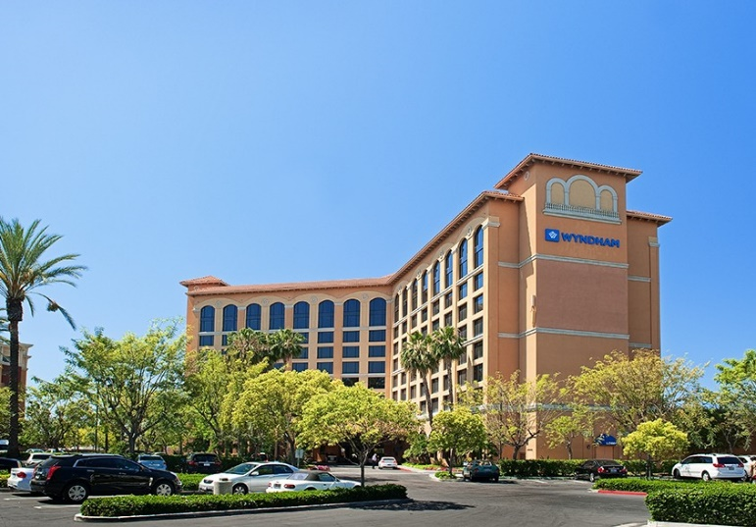
The Women of the NALC met all day on Tuesday, the Braaten and Benne Lectures began Tuesday afternoon and finished Wednesday before noon. The Mission Festival began Wednesday afternoon and continued after Supper. NALC Mission Districts met for an hour and a half Wednesday evening, completing a Mission Festival task regarding Mission Teams and Mission Needs and then had time for any business needs.
The Convocation meeting began Thursday morning and ended a half hour early Friday afternoon. Keynote Speakers: Malcom Guite and Steve Bell offered poetry and song centered around the Holy Scriptures. It was inspiring and reflective. Rev. Dr. James Nestingen preached on Tuesday and taught a Bible Study Friday morning.
Elections for various offices took place during the Convocation. The NALC website has the names and positions of all those who were elected. The delegates of

voted to approve a deficit budget for 2016-2017 as there were resources available to utilize if necessary. However, each of us was supposed to bring up to our congregations the need for giving to the NALC at the 5%-8% level. Overall our giving to the NALC is around 2%.
P-CAT Teams:
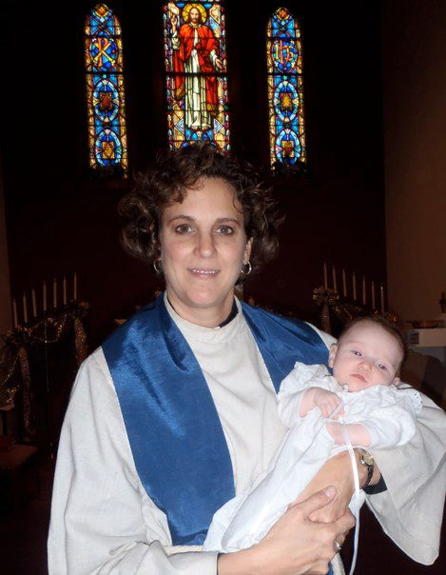
Pastor-Congregation Action Teams (P-CAT) are being formed in each Mission District. They will be teams of three persons who will be trained to go into Congregations in conflict with them-selves and/or with their pastor and assist them to resolution. For Mission Districts in Ohio we will use a Regional system. Rev. Dr. Amy Little will coordinate the training and assignment of all of the Ohio P-CAT Teams. Anyone interested in learning more about P-CAT Teams should call or email Rev. William Maki, Dean of the NWOMD.
NWOMD Mission Team Coordinator:
Rev. Kent Hollis, Grace-Jackson Center, has agreed to serve as Mission Team Coordinator for the North West Ohio Mission District. He will assist Mission District congregations in their efforts to become more mission focused and he will liason between our District and the NALC. Each congregation is being encouraged to support a local mission, a regional mission and a global mission.
News Around the District:
St John’s Montpelier - St. John’s Lutheran Church, Montpelier (together with First Presbyterian Church and Sacred Heart Catholic Church) held Vacation Bible School during the first week in August. The theme this year was “Cave Quest”, and every morning began with the misadventures of hapless spelunking student Clark Cavern (aka Pastor Paul Gruetter). Over 80 students each day learned how “Jesus gives us hope”, Jesus gives us direction”, and much more. Thanks to the artistic talents of McCrae Kidston and her team, the entire church building was transformed into a cave setting – watch out for the bats! The decorations in the basement are staying up for a little while longer, as Rally Day will also have a cave theme.

“Bean Days”, Montpelier’s annual festival, is a busy time for the people of St. John’s Lutheran Church. The men’s group sold over 1000 sausage sandwiches to neighbors, festival participants, and at least one Pokemon player. After their sandwiches, many people walked to the next table where the St. John’s women’s group was selling root beer floats. On Sunday morning – for the first time anyone can remember – the churches of Montpelier came together for a joint community worship service, on the lawn at St. John’s (conveniently, tents and tables and chairs were still set up from the food stands). Over 230 people gave thanks to God for the blessings he has shared in our community.

Early on the morning of July 10, thirteen adults and youth from St. John’s Lutheran Church met in the parking lot, loaded their vehicles, and headed to Birmingham, Alabama for a mission trip. While in Birmingham, they partnered with our good friends Monte and Kim Brennaman, who operate a ministry named “Next Step Storm”. Monte is called and sent by his home congregation as a “construction missionary”. Monte and Kim originally felt called to Birmingham because of a cluster of serious tornados that hit the city in 2011. For St. John’s congregation, this is their fourth trip to Birmingham (and probably tenth mission trip overall – we’ve lost count!). On this year’s trip, the crews built a deck with a handicap ramp, prepared and painted an entire house, and replaced a roof.
One of the principles of the mission trip is that members of the crew always have permission to stop working and talk to the homeowner and the neighbors. We come bearing the light of Christ, and we value the opportunity to meet people and talk about our faith.

We’re already beginning to plan Mission Trip 2017, and we’d love to have you join us! To learn more, contact St. John’s at stjohnsmontpelier@gmail.com or check Monte’s website, www.nextstepstorm.org.
CONTRIBUTE TO THE NEXT NEWSLETTER
Please send any Up Coming Events or mission trip stories, or other congregational events that you would like to see published in this Newsletter to me, Rev. William Maki, Dean of the NWOMD, by September 23, 2016. My email is: wem1@aol.com
Also, use our Facebook page https://www.facebook.com/nwomdnalc1/ to publish pictures, and use our Twitter account @nwomdNalc

Pictures from the NALC Convocation:
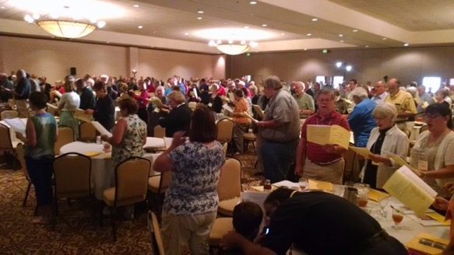
Opening Worship for the NALC Convocation.

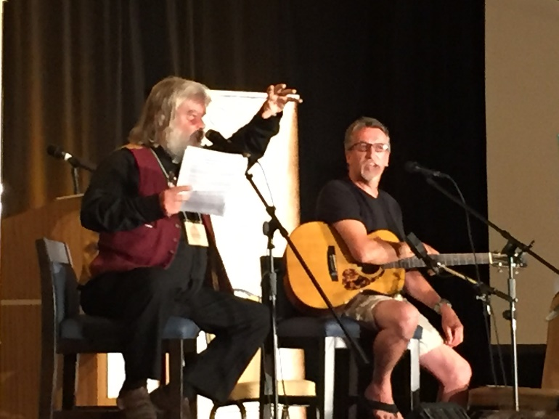
Malcolm Guite and Steve Bell Keynote speakers.

