Zion Lutheran Church
210 North Wayne Street
Saint Mary, Ohio 45885

December 25, 2022
8:00 a.m.

Setting 10

Prelude

Announcements

GATHERING SONG “Good Christian Friends, Rejoice” #288

Advent Candle lightning

CONFESSION AND FORGIVENESS Page 94
P In the name of the Father, and of the + Son, and of the Holy Spirit.
C Amen.
P Almighty God, to whom all hearts are open, all desires known, and from whom no secrets are hid: cleanse the thoughts of our hearts by the inspiration of your Holy Spirit, that we may perfectly love you and worthily magnify your holy name, through Jesus Christ our Lord.
C Amen.
P Let us confess our sin in the presence of God and of one another.

P Most merciful God,
C we confess that we are captive to sin and cannot free ourselves.
We have sinned against you in thought, word, and deed, by what we have done
and by what we have left undone.
We have not loved you with our whole heart;
we have not loved our neighbors as ourselves.
For the sake of your Son, Jesus Christ,
have mercy on us.
Forgive us, renew us, and lead us,
so that we may delight in your will
and walk in your ways,
to the glory of your holy name.
Amen.
P In the mercy of almighty God,
Jesus Christ was given to die for us,
and for his sake God forgives us all our sins.
As a called and ordained minister of the church of Christ, and by his authority,
I therefore declare to you
the entire forgiveness of all your sins,
in the name of the Father,
and of the + Son,
and of the Holy Spirit
C Amen.

GREETING
L The grace of our Lord Jesus Christ, the Word who became flesh and dwelt among us; the love of the Father who created us in his own image; and the communion of the Holy Spirit, the giver of all good gifts, be with you all.
C And also with you.

KYRIE Page 203
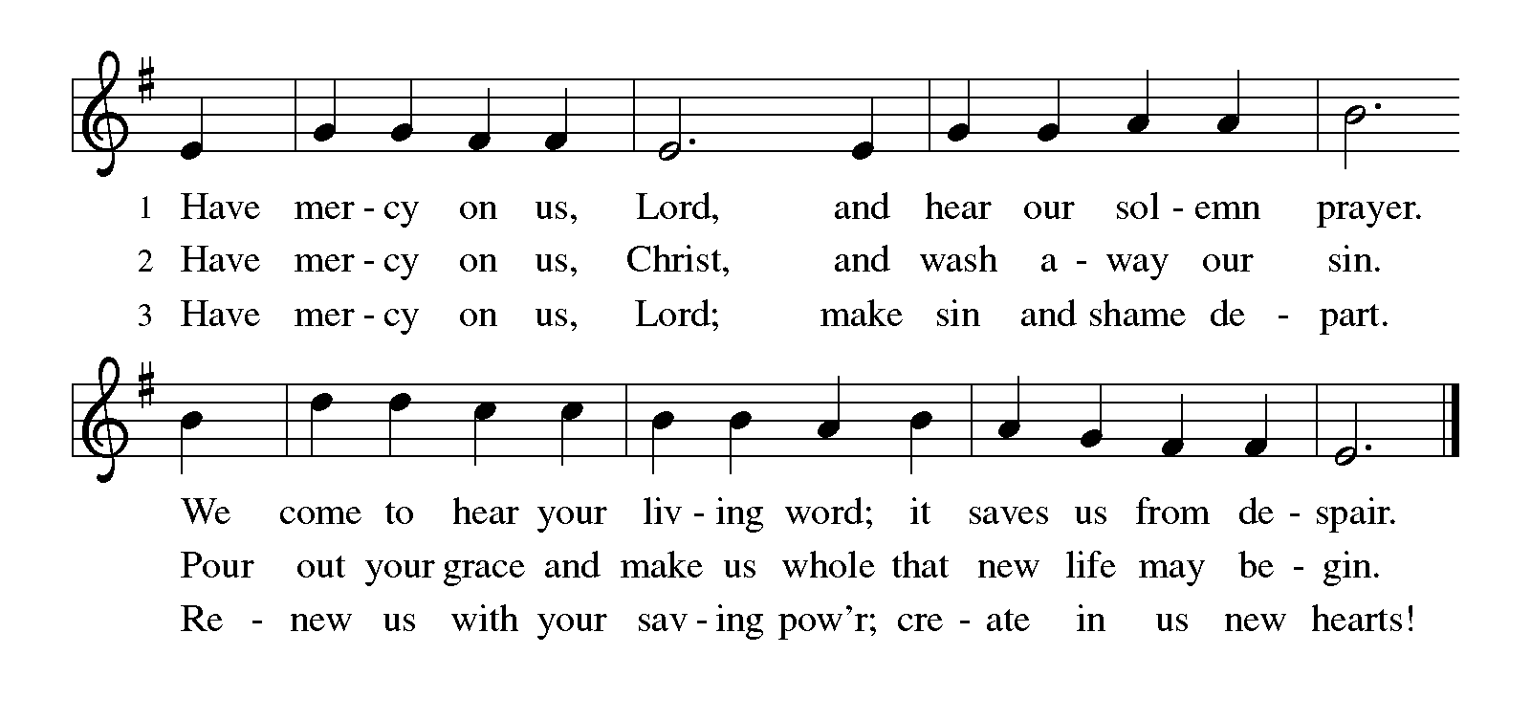

CANTICLE OF PRAISE Page 204
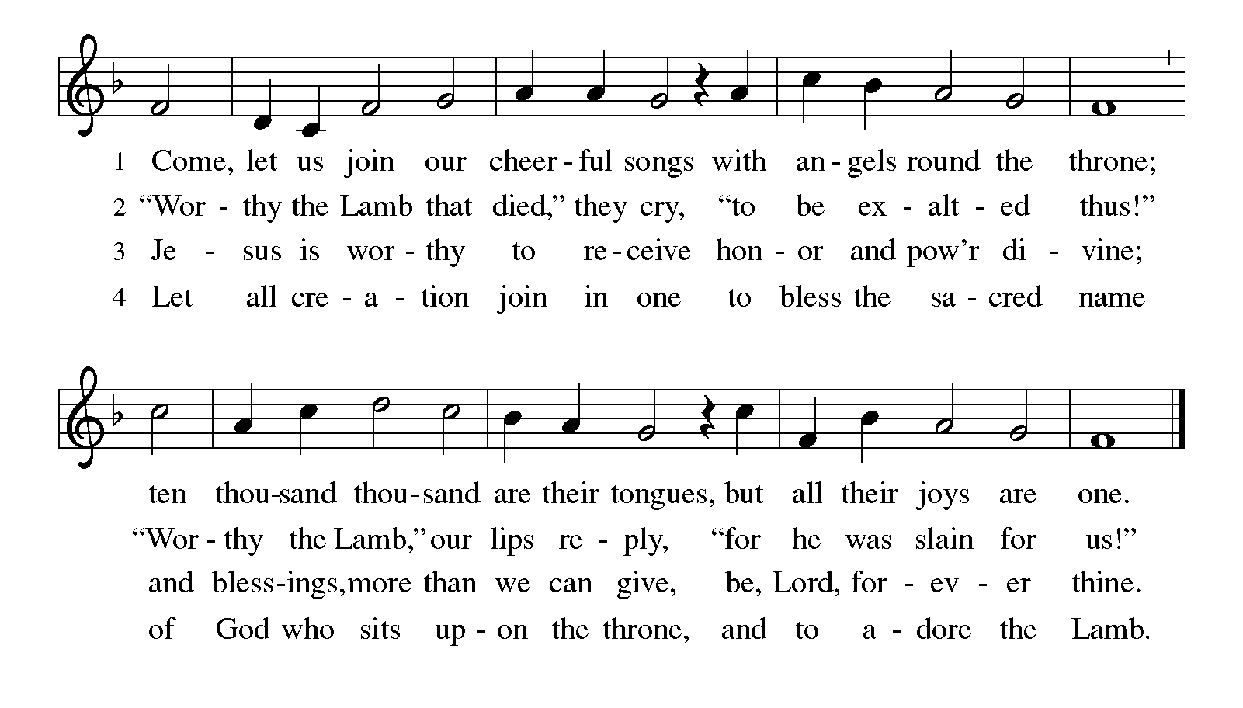

Prayer of the Day Insert
First Reading Isaiah 52:7-10 Insert
Psalm 2 Insert
Second Reading Hebrews 1:1-6 Insert

GOSPEL ACCLAMATION Page 205
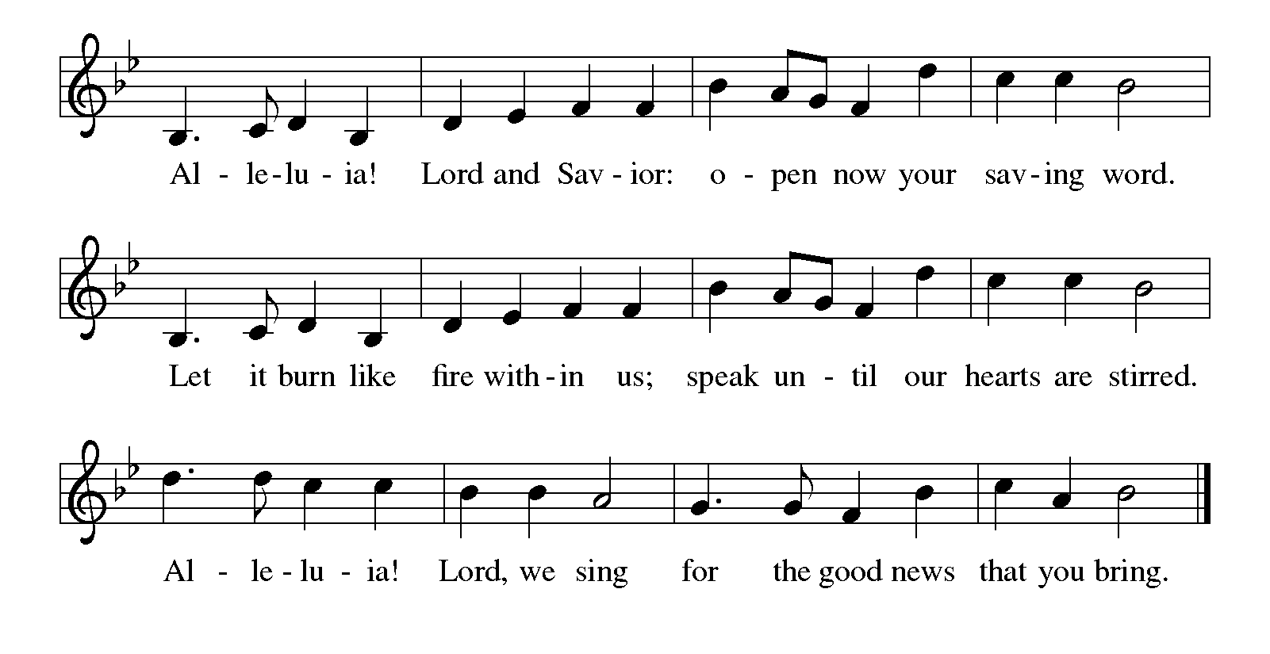

P The holy gospel according to Saint John the first chapter.
C Glory to you, O Lord.

Gospel John 1:1-14 Insert

P The gospel of the Lord.
C Praise to you, O Christ.

Sermon Pastor Bill

Hymn of the Day “Love Has Come” #292

NICENE CREED
We believe in one God, the Father, the Almighty, maker of heaven and earth, of all that is, seen and unseen.
We believe in one Lord, Jesus Christ, the only Son of God, eternally begotten of the Father, God from God, Light from Light, true God from true God, begotten, not made, of one Being with the Father; through him all things were made. For us and for our salvation he came down from heaven, was incarnate of the Holy Spirit and the virgin Mary and became truly human. For our sake he was crucified under Pontius Pilate; he suffered death and was buried. On the third day he rose again in accordance with the scriptures; he ascended into heaven and is seated at the right hand of the Father. He will come again in glory to judge the living and the dead, and his kingdom will have no end.
We believe in the Holy Spirit, the Lord, the giver of life, who proceeds from the Father and the Son, who with the Father and the Son is worshiped and glorified, who has spoken through the prophets.
We believe in one holy catholic and apostolic church. We acknowledge one baptism for the forgiveness of sins. We look for the resurrection of the dead, and the life of the world to come. Amen.

PRAYERS OF INTERCESSION Page 206
L Lord in your mercy…
C Hear our prayer.

Peace
P The peace of Christ be with you always.
C And also with you.

OFFERING

OFFERTORY RESPONSE HYMN #182
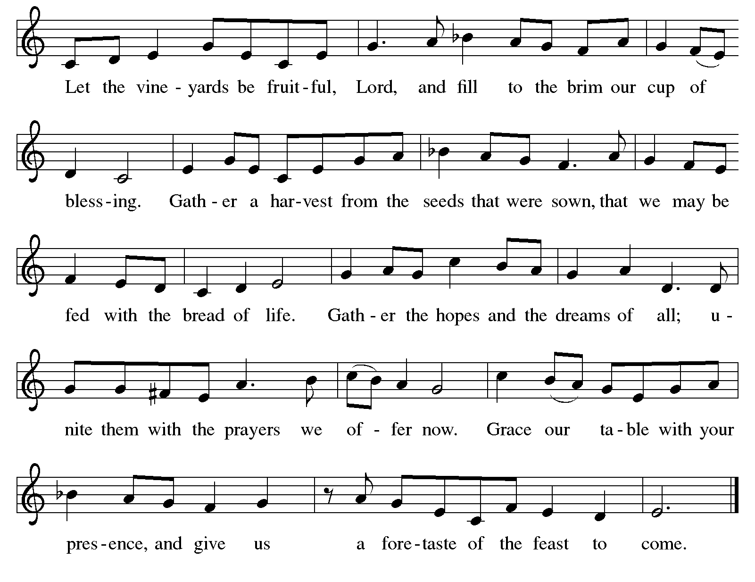
Offering Prayer
L Let us pray.
Loving God, we give you thanks for the generous gifts you have first given us. May that which we offer to you, come joyfully from our hearts and be pleasing in your sight.
C Amen.

DIALOGUE Page 206
P The Lord be with you.
C And also with you.

P Lift up your hearts.
C We lift them to the Lord.

P Let us give thanks to the Lord our God.
C It is right to give our thanks and praise.

PREFACE
P It is indeed right, our duty and our joy, that we should at all times and in all places give thanks and praise to you, almighty and merciful God, through our Savior Jesus Christ. In the wonder and mystery of the Word made flesh you have opened the eyes of faith to a new and radiant vision of your glory, that beholding the God made visible, we may be drawn to love the God whom we cannot see. And so, with all the choirs of angels, with the church on earth and the hosts of heaven, we praise your name and join their unending hymn:

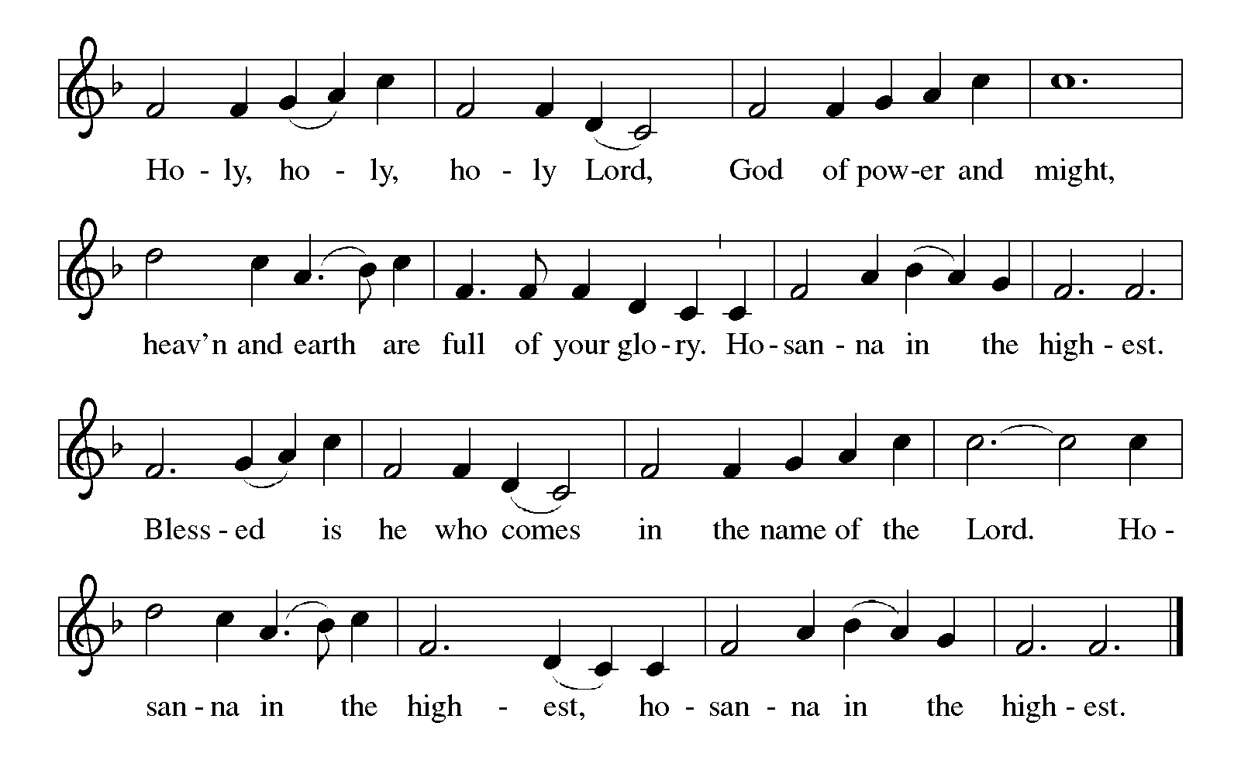
THANKSGIVING AT THE TABLE

P In the night in which he was betrayed,
our Lord Jesus took bread, and gave thanks; broke it, and gave it to his disciples, saying:
Take and eat; this is my body, given for you.
Do this for the remembrance of me.

Again, after supper, he took the cup, gave thanks,
and gave it for all to drink, saying:
This cup is the new covenant in my blood,
shed for you and for all people for the forgiveness of sin. Do this for the remembrance of me.

LORD'S PRAYER Page 112
Our Father, who art in heaven, hallowed be thy name, thy kingdom come, thy will be done, on earth as it is in heaven. Give us this day our daily bread; and forgive us our trespasses, as we forgive those who trespass against us; and lead us not into temptation, but deliver us from evil. For thine is the kingdom, and the power, and the glory, forever and ever. Amen.

Communion Song
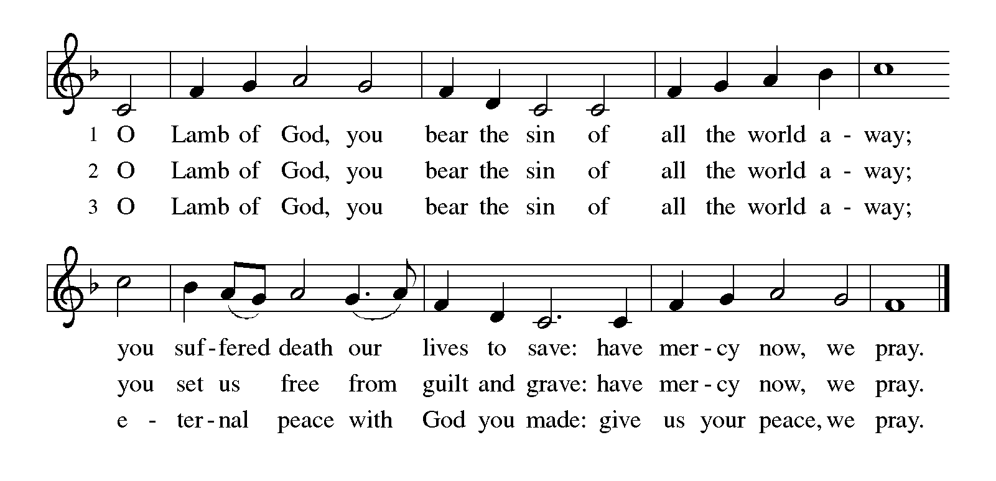

Communion
P The body of Christ, given for you.
The blood of Christ, shed for you.
C Amen.

COMMUNION HYMNS
“The First Noel” #300

Post Communion Blessing

PRAYER AFTER COMMUNION
L We give you thanks, O God, that you have fed us with Christ’s precious body and blood, forgiven us through this Sacrament, and given us a new beginning. Send us now into the world you love, to share Christ’s sacrificial love with all we meet.
C Amen.

Blessing
P As you go from this place, remember that with God, nothing is impossible. May God the Father, Son, + and Holy Spirit go before you, beside you, and with you wherever you go. (Luke 1:37)
C Amen.

SENDING “Go Tell It on the Mountain” #290

DISMISSAL
P Go in peace! God’s Word has been fulfilled.
C Thanks be to God.

Postlude

[Copyright element(s)] [Copyright notice]. Used by permission of Augsburg Fortress under license #SB156669

Memory Verse John 1:9
The true light, which gives light to everyone, was coming into the world.

Happy Birthday Savannah!

The Altar Flowers are given to the Glory of God in celebration of Savannah Slater’s 19th birthday on December 31st.

Today, December 25*
Acolyte: Zoey Lampert
Communion Assistant: Jody Slemmons
Crucifer: Braylon Lampert
Ushers: Jeanne Wurster, Bob Hinschlager, Chris White,
Rhonda Weaver
Fellowship Table: Sandy Wierwille
Greeters: Judy Schultz, Vic Von Blon
Reader: Linda Yahl

Next Sunday, January 1*
Acolytes: 8AM: Hunter Coldiron
10:30am: Allison Ankerman
Communion 8AM: Jody Slemmons
Assistants: 10:30AM: Cheryl Macklem
Crucifer: 8AM: Bennett Glass
10:30AM: Aiden Meinerding

Ushers: 8AM: Jeanne Wurster, Bob Hinschlager,
Chris White, Rhonda Weaver
10:30AM: Dan Macklem, Stan & Debbie Brown,
Darl Bishir
Fellowship 8AM: Kraig & Miriam Johns
Table: 10:30am: Kathy & Craig Miller
Greeters: 8AM: Becky Harvey, Chris White
10:30AM: Joni Immenschuh, Sandy Wierwille
Readers: 8AM: Doris Cook
10:30AM: Stephanie Ross
*Subject to change, correct as of time printed
ATTENDANCE Last Wednesday: 56
Sunday 8 a.m.: 54, 10:30 a.m.: 31, Total for the Day: 85
Total for the Week: 141
PIANIST Miriam Johns
DIRECTOR OF BOARD OF PARISH EDUCATION
Mindy Thiebeau, zionbpe@gmail.com
CONGREGATION PRESIDENT……… Neal Brady
OFFICE MANAGER Kathy Bishir, kbishir@hotmail.com
OFFICE ASSISTANT Ann Maki, annmmaki@yahoo.com
LAY LEADER Heidi Yahl, heidiyahl@yahoo.com
PASTOR………………………….William Maki, wllmmaki@yahoo.com
MINISTERS All Members of Zion
CHURCH WEBSITE www.zionstmarys.org
CHURCH OFFICE………………………………………………….419-394-3115
S/25 8:00 a.m. Christmas Day Worship Service⁺*
Calendar for December 25, 2022—January 8, 2023

T/27 9:30 a.m. Dorcas Quilting
12:30 p.m. Bulletin Information Deadline
F/30 6:00 p.m. Schramm/Gillis Rehearsal
S/31 3:00 p.m. Christian Schramm/Brittany Gillis Wedding
S/1 8:00 a.m. Service of Lessons & Carols⁺*
9:15 a.m. Adult Sunday School
10:30 a.m. Service of Lessons & Carols*
M/2 Office Closed
T/3 9:00 a.m. Dorcas Quilting
W/4 11:00 a.m. Staff Meeting
12:30 p.m. Bulletin Information Deadline
1:00 p.m. Book Club
6:30 p.m. Worship*
7:00 p.m. Confirmation Class
S/7 10:00 a.m. Take Down Christmas Decorations
S/8 8:00 a.m. Baptism of Our Lord Sunday Worship⁺*/
Recognition & Installations of Councils
9:15 a.m. Sunday School
10:30 a.m. Baptism of Our Lord Sunday Worship*/ Recognition & Installations of Councils
*Holy Communion
⁺Livestreamed on zionstmarys.org & broadcasted on WCSM 96.7
We invite you to include the following people in your daily prayers: Janet Dicke, Judy Von Blon, Brent Paulus, Sandi Deerhake, Alma Kuffner, Caleb Yahl, Michael Moore, Tom Kaster, Kason Thobe, Ann Morris, John & Katie, Darlene Henkener, Margaret Moore, Pastor Phil Gagnon, Amelia Green, Kelsey, Karen Vornholt, Mark & Dana, Vicki Bishir, Amy Grewe, Family of Jordan Brelsman, Lisa Suchland, Dolores Irish, Lillian, Beth Olberding, Bill & Carolyn Slemmons, Emily Henkle, Dave Frahm, Ed Danner III, Eileen Zimmerman, Kristin Hemmelgarn, Mary Willmann, Marla Puthoff, Family of Susan Wicker, Family of Family of Rick Adams, the Family of Larry Haberkamp and the Family of Roger Hesse.

Please pray for Sean Lawler, Andrew Johnson, Michael Carroll, Nathan Adams, Jacob Yahl, Jason Gross, Daniel C. Lukac IV, Michael Franklin and Kyle Schmehl who are in the service. Please pray for them, their family, and their safe return home.

Please include in your prayers the upcoming marriage of Christian Schramm and Brittany Gillis, who will be married next Saturday.

Christian Sympathy to the Family of Roger Hesse, brother of John Hesse.

Thank you to everyone for the cards, prayers and gifts. Wishing you a blessed year ahead. Pastor Bill

Our loose offerings each Wednesday and Sunday for the month of December are earmarked to support the Institute of Lutheran Theology. For more information on this institution, check out your December Newsletter.
The loose plate offerings for Christmas Eve will go toward Zion’s current expenses.

The church office will be closed on Monday, December 26, and Monday, January 2. There will be limited hours Tuesday, December 27 through Friday, December 30. The hours will be from 8:30 a.m. to 2:30 p.m.
There will be NO Wednesday night worship service on December 28.

Service of Lessons & Carols: Our Service of Carols and Lessons will be held on Sunday, January 1, at both our 8 a.m. and 10:30 a.m., worship services. We invite you to bring your family and friends.

Help Needed on Saturday, January 7, to take down Christmas decorations at 10 a.m. If you can help, please sign up on your “I Worshiped Today”.

The recognitions of our 2022 Congregation Council and Women’s Council and installation of the 2023 councils will take place at both services on Sunday, January 8, 2023. If you were a member of council or a newly elected council member, please plan to attend one of the worship services on that day.

The Creative Crafters will be making homemade vanilla extract on Sunday, January 8, at 1:30 p.m., in the church kitchen. Sign up in the binder provided in the Narthex. A sample is there on display.
The first part of the 2023 Flower Chart is on the bulletin board by the alley entrance. We invite you to select the date you wish to provide flowers. On the Tuesday before the date you selected, order your arrangement from your favorite florist, and contact the church office, 419-394-3115, to let us know what information you would like included in the bulletin.
Pianist: We are looking for an additional pianist for our Wednesday night worship service. They would play once or twice a month. If you are interested in this paid position, please contact the church office, 419-394-3115.
Dorcas Quilting has been a part of Zion for over 120 years. We need people who can hand sew to help make quilts. There have been 4 members coming to quilting but 2 are going to quit. If we cannot get any more people to come, we will have to disband Dorcas Quilting. If you or someone you know would be interested, please call the church office, or just come to quilting on Tuesdays at 9 a.m.

We have installed equipment for livestreaming of our worship services. The worship services can be found on our Facebook page. Volunteers are needed to help with recording each of the services. Please contact the church office, 419-394-3115, or Pastor Bill about this ministry.

Our 8 a.m. worship service is broadcast live on WCSM radio 96.7 FM. Thank you to our primary sponsor of our WCSM radio broadcast–St. Marys Chrysler. Volunteers are needed to help with the sound board. No experience needed! Anyone interested in running the sound board during worship will be trained. We would like to have more people for rotation purposes. Contact the church office, 419-394-3115, or Pastor Bill if you can help.

Weekly Needs  51 Week | Budget  Y-T-D | Received  12/18 | Offerings  Y-T-D | On Hold
Current $6,068.75 | $309,519 | $5,529 | $263,818 | $0
NALC Offering $290 | $14,790 | $167 | $6,978
Bank Balance as of 12/19: |  | $76,247

