Zion Lutheran Church
210 North Wayne St.
St. Marys, OH 45885

June 26, 2022
8:00 a.m. & 10:30 a.m.
Setting 10

PRELUDE

ANNOUNCEMENTS

GATHERING SONG “Give Me Jesus” #770

CONFESSION AND FORGIVENESS Page 94
P In the name of the Father, and of the + Son, and of the Holy Spirit.
C Amen.

P Almighty God, to whom all hearts are open, all desires known, and from whom no secrets are hid: cleanse the thoughts of our hearts by the inspiration of your Holy Spirit, that we may perfectly love you and worthily magnify your holy name, through Jesus Christ our Lord.
C Amen.

P Let us confess our sin in the presence of God and of one another.

P Most merciful God,
C we confess that we are captive to sin and cannot free ourselves.
We have sinned against you in thought, word, and deed, by what we have done
and by what we have left undone.
We have not loved you with our whole heart;
we have not loved our neighbors as ourselves.
For the sake of your Son, Jesus Christ,
have mercy on us.
Forgive us, renew us, and lead us,
so that we may delight in your will
and walk in your ways,
to the glory of your holy name.
Amen.

P In the mercy of almighty God,
Jesus Christ was given to die for us,
and for his sake God forgives us all our sins.
As a called and ordained minister of the church of Christ, and by his authority,
I therefore declare to you
the entire forgiveness of all your sins,
in the name of the Father,
and of the + Son,
and of the Holy Spirit.
C Amen.

GREETING
P: The grace of our Lord Jesus Christ who grants us life eternal, the glory of the Father who created us in love, and the power of the Holy Spirit who forgives and renews our life, be with you all.
C: And also with you.
KYRIE Page 203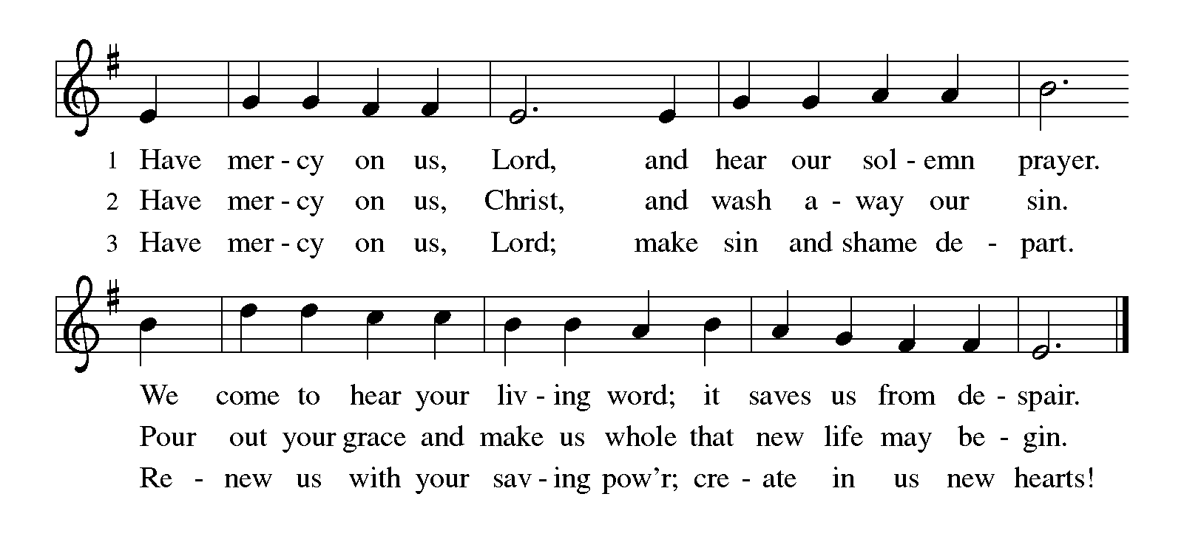

CANTICLE OF PRAISE Page 204
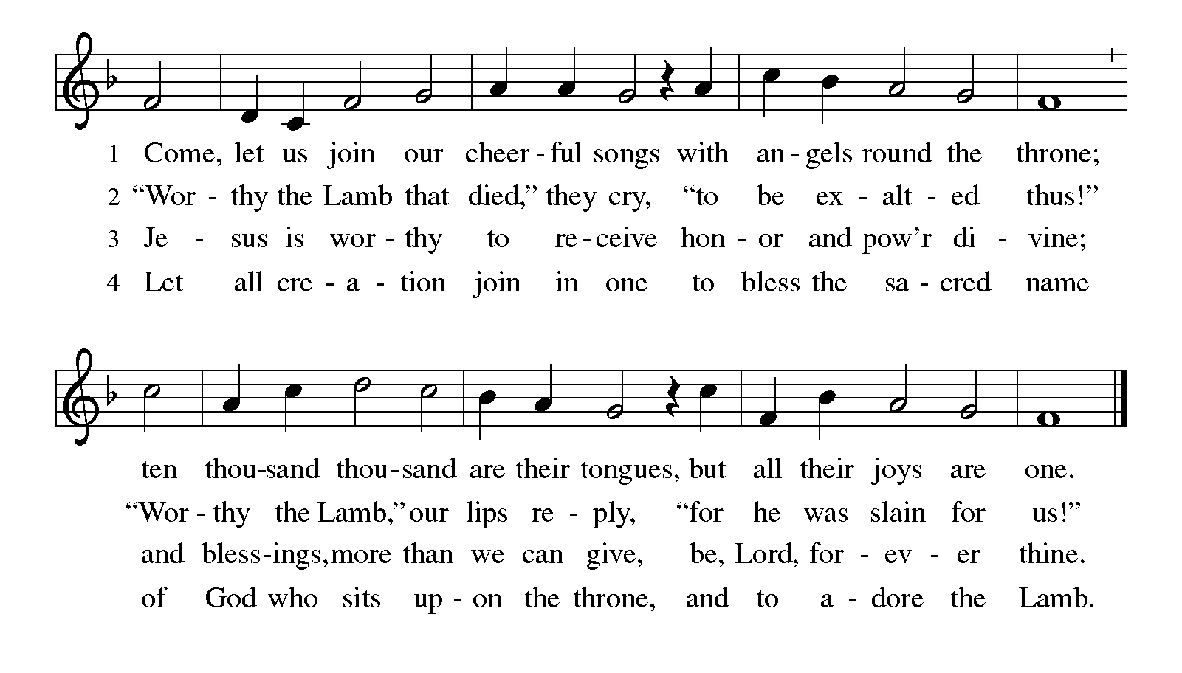

Prayer of the Day Insert
First Reading 1 Kings 19:9b-21 Insert
Psalm 16 Insert
Second Reading Galatians 5:1, 13-25 Insert

GOSPEL ACCLAMATION Page 205
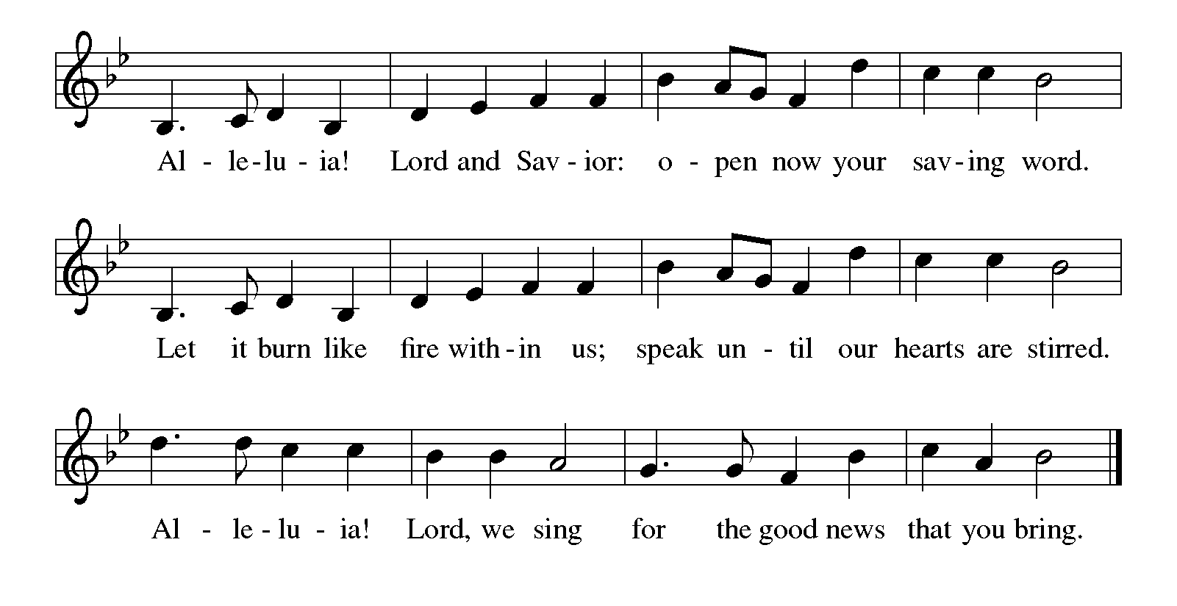

P The holy gospel according to Saint Luke the ninth chapter.
C Glory to you, O Lord.

Gospel Luke 9:51-62 Insert

P The Word of the Lord.
C Praise to you, O Christ.

Sermon Pastor Bill

Hymn of the Day “Be Thou My Vision” #793

Apostles’ Creed
I believe in God, the Father almighty, creator of heaven and earth.
I believe in Jesus Christ, God's only Son, our Lord, who was conceived by the Holy Spirit, born of the virgin Mary suffered under Pontius Pilate, was crucified, died, and was buried; he descended to the dead. On the third day he rose again; he ascended into heaven, he is seated at the right hand of the Father, and he will come to judge the living and the dead.
I believe in the Holy Spirit, the holy catholic church, the communion of saints, the forgiveness of sins, the resurrection of the body, and the life everlasting. Amen.

PRAYERS OF INTERCESSION Page 206
P Lord in your mercy…
C Hear our prayer.

Peace
P The peace of Christ be with you always.
C And also with you.

OFFERING

OFFERTORY RESPONSE HYMN #186
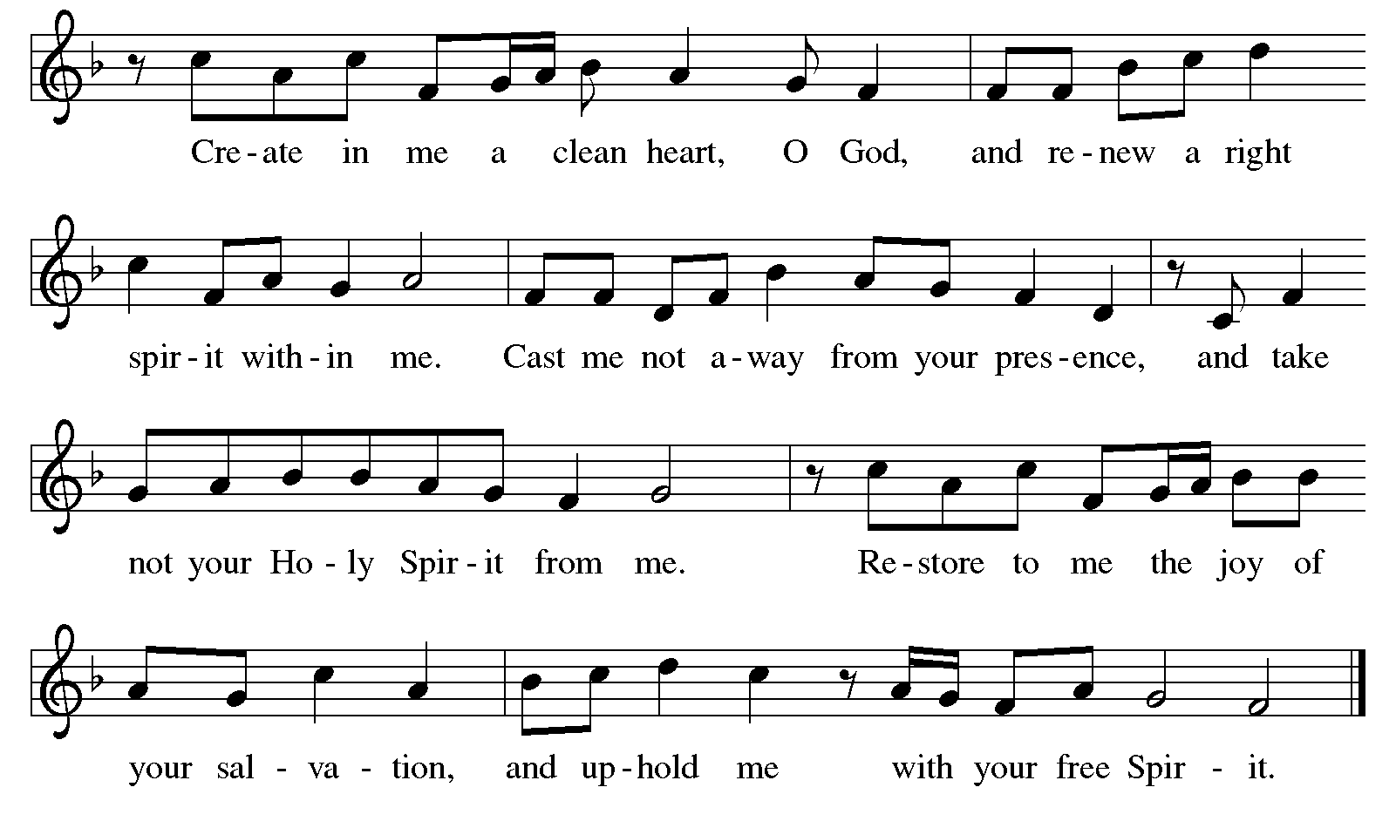

Offering Prayer
P Benevolent God, you have granted us in abundance all the good things that life has to offer. May we be truly grateful for our daily bread, even as we return a portion of what you have first given us as a sign of our humility and thanksgiving for your bounteous gifts. Let the treasures we have received from you be used to serve the world you love.
C Amen.

Lord's Prayer
Our Father, who art in heaven, hallowed be thy name, thy kingdom come, thy will be done, on earth as it is in heaven. Give us this day our daily bread; and forgive us our trespasses, as we forgive those who trespass against us; and lead us not into temptation, but deliver us from evil. For thine is the kingdom, and the power, and the glory, forever and ever. Amen.

Blessing
P The Lord bless you and keep you,
The Lord make his face shine on you
and be gracious to you.
The Lord look upon you with favor
And give you peace.
C Amen.

SENDING “Precious Lord, Take My Hand” #773

Dismissal
P: Go in peace. Serve the Lord.
C: Thanks be to God!

Postlude

[Copyright element(s)] [Copyright notice]. Used by permission of Augsburg Fortress under license SB156669
Memory Verse Galatians 5:25

If we live by the Spirit, let us also keep in step with the Spirit.

The Altar Flowers are given to the Glory of God in honor of Don & Susan Nuss’ 55th Wedding Anniversary. A pair of roses have also been placed on the altar in honor of their anniversary.

Today, June 26*

Acolytes: 8:00 AM: Grady Hughes
10:30 AM: Aiden Meinerding
Ushers: 8:00 AM: Steve & Dora McAfee, John & Amy Hesse
10:30 AM: Dan Macklem, Keith Fledderjohann,
John & Donna Ankerman
Fellowship 8:00 AM: Marilyn & Jody Slemmons
Table: 10:30 AM: Sandy Wierwille
Greeters: 8:00 AM: Ryan & Brandy Yahl
10:30AM: Steve & Dora McAfee
Readers: 8:00 AM: Dora McAfee
10:30 AM: Ruth Hoenie

Next Sunday, July 3*

Acolytes: 8:00 AM: Allison Ankerman
10:30 AM: Makenna Meinerding
Communion 8:00 AM: Mark Torsell
Assistant: 10:30 AM: Allison Ackroyd
Crucifers: 8:00 AM: Genevieve Brown
10:30 AM: Bennett Glass
Ushers: 8:00 AM: Jeanne Wurster, Doug Stetler,
Connie Torsell, Judy Schultz
10:30 AM: Dan Macklem, Keith Fledderjohann,
Darl Bishir, Dwayne Hoenie
Fellowship 8:00 AM: Joyce Finke
Table: 10:30 AM: Sue & John Vogel
Greeters: 8:00 AM: John & Amy Hesse
10:30AM: Jeremy & Alexa Kemmann
Readers: 8:00 AM: Linda Yahl
10:30 AM: Dwayne Hoenie
*Subject to change, correct as of time printed.
ATTENDANCE Last Wednesday: 15
Sunday 8 a.m.: 52, 10:30 a.m.: 32, Total for the Day: 84
Total for the Week: 99
DIRECTOR OF BOARD OF PARISH EDUCATION
Mindy Thiebeau, zionbpe@hotmail.com
OFFICE MANAGER Kathy Bishir, kbishir@hotmail.com
OFFICE ASSISTANT Ann Maki, annmmaki@yahoo.com
PASTOR………………………….William Maki, wllmmaki@yahoo.com
MINISTERS All Members of Zion
CHURCH WEBSITE www.zionstmarys.org
CHURCH OFFICE………………………………………………….419-394-3115
S/26 8:00 a.m. Traditional Worship Service⁺
Calendar for June 26—July 10, 2022

9:15 a.m. Congregational Meeting
10:30 a.m. Traditional Worship Service
1:30 p.m. Creative Crafters
T/28 9:00 a.m. Dorcas Quilting
T/29 12:30 p.m. Bulletin Information Deadline
6:30 p.m. Worship
7:00 p.m. Boy Scout Leadership Meeting
T/30 3:30 p.m. Council Report Deadline
3:30 p.m. Dish Pickup Deadline
5:00 p.m. Elders’ Meeting
S/3 8:00 a.m. Traditional Worship Service⁺*
9:15 a.m. Adult Sunday School Class
10:30 a.m. Traditional Worship Service*
M/4 Independence Day/Office Closed
T/5 9:00 a.m. Dorcas Quilting
6:00 p.m. Trustee Meeting
7:00 p.m. Council Meeting
W/6 11:00 a.m. Staff Meeting
12:30 p.m. Bulletin Information Deadline
1:00 p.m. Book Club
6:30 p.m. Worship*
S/9 8:00 a.m. Golf Outing at Celina Lynx
S/10 8:00 a.m. Traditional Worship Service⁺
9:15 a.m. Adult Sunday School Class
10:30 a.m. Traditional Worship Service
1:30 p.m. Creative Crafters
*Holy Communion
⁺Livestreamed on zionstmarys.org & broadcasted on WCSM 96.7
We invite you to include the following people in your daily prayers: Janet Dicke, Judy Von Blon, Brent Paulus, Sandi Deerhake, Alma Kuffner, Caleb Yahl, Mark, Amelia Green, Michael Moore, Tom Kaster, Kason Thobe, Ann Morris, Craig Raney, Ken Ankerman, John & Katie, Darlene Henekener, Margaret Moore, Deb Ranly, Linda Diers, Cathy, Ron & Sandy Suchland, Diane (Applegate) Swartz, Pastor Phil Gagnon, Bruce Pannabecker, Eileen Zimmerman, Bill Nuss, Kristin Hemmelgarden, Allen Merricle, Warren Menchhofer, Joan Stetler, Deb Henning, Members of Wayne Street United Methodist Church and the Family of Carolyn Harrod.

Please pray for Sean Lawler, Andrew Johnson, Michael Carroll, Nathan Adams, Jacob Yahl, Jason Gross, Daniel C. Lukac IV, Michael Franklin and Kyle Schmehl who are in the service. Please pray for them, their family, and their safe return home.

Please include in your prayers the marriage of Steve & Shirley Rismiller who were married yesterday.

A huge thank you to all the VBS volunteers this year! Without you, we wouldn't have had such a successful VBS! Because of you, we were able to have 23 children up to their elbows in farming fun as they learned one simple Bible truth; Jesus will always love us! Because of you, we were able to plant God's Word in kids' hearts! Thank you again!

Our loose offerings each Sunday/Wednesday for the month of June is earmarked to support Water Mission International of N. Charleston, SC.

There will be two Ukrainian missionaries in our area on Thursday, June 30. The women of Zion are invited to attend a meal at 12:30 p.m., at Do Good Ministries, for a luncheon. Group limit is 65, please text Sharon Day, 419-305-3586, if you plan to attend. A love offering will be collected. Each guest will be paying for their own meal and/or beverages of your choice.

We have a collection of dishes left from funeral dinners. They are located on the coat rack by the alley entrance. Please stop and pick yours up. Bowls and dishes left over six months to a year will be given to Agage, which will be after June 30.

Golf Scramble will be Saturday, July 9. We will meet at 8 a.m., at Celina Lynx. All are welcome. There is a $40 fee per person. Pease sign up in the church office or on your “I Worshiped Today” by Wednesday, July 6, and you can pay now or at the golf course.

Creative Crafters will meet in July to paint a Steppingstone from a design kit. The fee is $7, all are welcome (ages 8 and up). Sign up in the binder in the Narthex. The activity will be held on Sunday, July 10, at 1:30 p.m.

Our congregation picnic will be held on Sunday, July 17, at 11:45 a.m. We are planning to provide a tent with table and chairs. It will be held on the front lawn with a bouncy house like last year. The chicken (fried/baked), beverages and table service will be provided by the church. Bring a potluck dish for the meal. Mark this event on your calendar and bring your family and friends. Call the church office or sign up on your “I Worshiped Today” if you plan to attend. Also, please indicate how many people will be in your group.
Trustees Need Your Help with trimming shrubs on Saturday, July 30, beginning at 9 a.m. Please bring your own tools.
The trustees are giving away the blond upright piano from the auditorium. Please contact the church office, 419-394-3115, if you are interested in this piano. Pick up/delivery will be your responsibility.
There are three projects that the trustee’s plan to pursue in 2022. 1.) Replace the carpet in the sanctuary. 2.) Replace the drapes in the educational building, due to age and extreme deterioration. 3.) Update the church kitchen: which will include the electrical breakers, update the kitchen sink, and add more storage. Funds have been set up to help defray the cost of each of these projects: “carpet”, “drapes”, and “kitchen” . Earmark your check or offering envelope with the project of your choice.

We have installed equipment for livestreaming of our worship services. The worship services can be found on our Facebook page.

Our 8 a.m. worship service is broadcast live on WCSM radio 96.7 FM. Thank you to our primary sponsor of our WCSM radio broadcast–St. Marys Chrysler.

Weekly Needs  25 Week | Budget  Y-T-D | Received  6/19 | Offerings  Y-T-D | On Hold
Current $6,068.75 | $151,725 | $5,329 | $134,090 | $0
NALC Offering $290 | $7,250 | $87 | $3,536
Bank Balance as of 6/20: |  | $80,923

