 | The Mustang Memo  …a newsletter for Zion Grade School’s families and the congregations of Zion and St. Mark’s

Issue 16 Dec. 13, 2017
Sharing Hope, Teaching Christ!
Christ Centered – Academically Strong – Respectfully Operated
…walk in a manner worthy of the calling to which you have been called, ²with all humility and gentleness, with patience, bearing with one another in love, ³eager to maintain the unity of the Spirit in the bond of peace. Ephesians 4:1-3  FROM THE School Administrator…  Greetings! Congratulations to the girls 7/8 grade basketball team on the 2nd place finish in the tournament. THANK YOU to all the parents who helped in so many different ways at the Girls Basketball Tournament. The many hands were appreciated! Especially I would like to thank Lisa Kubasch for organizing concessions and being here for the entire tournament. Also, thank you to all the parents that helped clean up on Saturday after the tournament.  Thank you to Heather Henning and Kristin Iverson for coordinating and working the cookie walk. Also, thank you to all the parents who baked lots of delicious treats for the event.  Please join us for our Preschool-8th grade Christmas Service on Wednesday, Dec. 21 at 7:00 pm at Mayer Lutheran High School. We will have practice at Mayer Lutheran (for K-8) on Monday, Tuesday, and Wednesday of next week. We will walk to the high school, so please make sure students are dressed appropriately for the weather.  As we start another sports season, I would like to remind parents of our after school policy. All students are to be picked up by 3:05. Any students remaining at 3:05 will be sent to Extended Care. If students are staying to watch basketball games, parents must be here at 3:05 or the students will be sent to Extended Care. Students/children should be in the gym watching the games and not running around the building. The reason for this policy is to make sure that all children are safe.  PRAYER CORNER  Please keep the following students in your prayers on the day indicated:  Monday, Dec. 18 – Zoe Zajicek  Tuesday, Dec. 19 – Ashley Ford  Wednesday, Dec. 20 – Makenzie Hartwig    SECOND QUARTER MISSION CHAPEL OFFERINGS WILL GO TO…….  James May – Lutherans in Africa & Kenya Mission Trip  Forming African Christians to be Teachers of the Faith!  James and his coworkers strive to translate material and then spend weeks in the field teaching and distributing it. Their teaching has a ripple effect as elders, teachers, evangelists, and pastors in many areas take what is learned to their own communities. The result – Lutherans singing Lutheran hymns while they work during the daytime, children reciting the Small Catechism and singing Lutheran hymns in their schools, leaders of congregations reading aloud from the Augsburg Confession in order to teach those around them.  Second quarter goal: $400.00  Offerings to date: $206.73    Y.I. Stamp Program  This Thursday, December 14, 2017, is the final time this calendar year that Donna Lindstrom will be at Zion with the Y.I. Club stamps. Last week five students added to their existing accounts. Do not forget about sending in the ‘Extra Credit for Community Service Form’ and the ‘Extra Credit for Good Grades Form’ to add extra dollars into your steward account. Lots more information and activities on the web site: yiclub.lcef.org or call Donna Lindstrom 952-955-2106.    GREAT JOB! The first Lego League Tournament won the Judges Award for their 3-D project presentation.  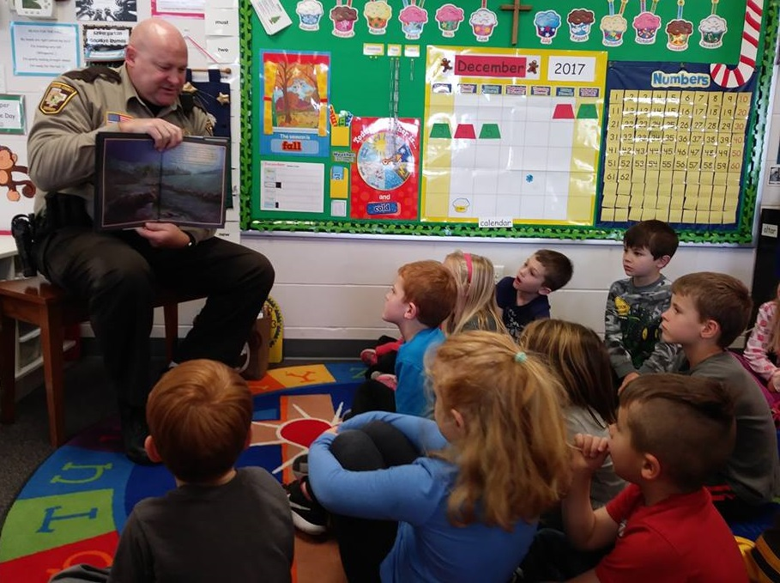  Can you guess who the mystery reader #1 was in the Kindergarten class?    Mystery Reader #2 read to the Kindergarten class.    Just a reminder that  December 20th is a bag  lunch day. | Do you know a family that has a child that will be entering either preschool or kindergarten next school year? If yes, please send me the following information: child’s name, parent’s name, and home address. I would like to send out personal invitations to our open houses during National Lutheran Schools Week.  In His service,  Mr. Joshua Baumann  We will start walking to Lutheran High for practice for the Christmas service. On Dec. 18th, 19th and 20th we will be walking, so please make sure they are dressed warm on those days.     Pre-8 Christmas Service will be Wed., Dec. 20th at 7:00pm at LHS.    You will find your cookie containers from the Cookie Walk on top of the coat rack, when you walk into the door by the school office.    MEET A NEW STUDENT AT ZION: This week we welcome Jacob Bouma to Zion’s kindergarten class. Jacob was born on September 28, 2011 in Maple Grove, MN. Jacob has two sisters. His family lives in Mayer. Some of Jacob’s favorites include: Food: Peanut Butter & Jam Sandwiches; Color: Yellow; Hobby: Building things and riding his scooter; Sport: Hockey. When Jacob grows up he would like to be a builder. Jacob’s family likes going for walks, camping, going to the beach and splash parks, traveling and swimming. Welcome to Zion, Jacob. We are very excited to have you and your family with us!    Jacob Bouma – Kindergarten  SCRIP  Are you ready for your Christmas party celebrations? Don’t forget to pick up gas & grocery Scrip cards for your holiday travel and family parties. We stock Cenex, Kwik Trip, Holiday and Mobil for gas stations and Coborn’s, Cub, Mackenthuns, Walmart & Whole Foods for your grocery needs.    CELEBRATING A BIRTHDAY  Week of Dec. 14 – Dec. 20  Friday, Dec. 15 – Warner Iverson  Monday, Dec. 18 – Reagan Neaton  Wednesday, Dec. 20 – Russell Klevann  Happy Birthday and God’s many blessings in the coming year!  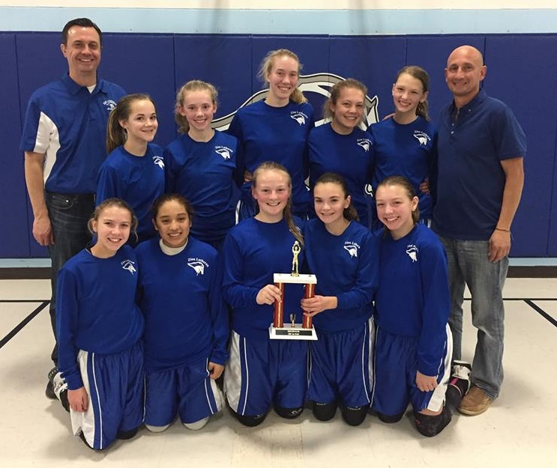  Zion 7/8th grade girls take 2nd Place in the preseason tournament!    BASKETBALL SCHEDULE:  Grades 7-8 Boys/Girls  Thurs. Dec. 14  3:15 – 4:45 girls practice at Zion  Boys Away vs. St. James Howard Lake 3:45  Mon. Dec. 18  3:15 – 4:45 boys  4:30 – 6:00 girls  Tues. Dec. 19  Away vs. St. Joe’s, Waconia – Girls @ 4:00  Boys @ 5:00  Wed. Dec. 20 – No Practice – Advent Service    MARK YOUR CALENDAR…..  Dec. 17 – Sunday School Christmas Program 4:00  Dec. 20 – Chapel 8:30 led by Pastor Woodford  Dec. 20 – Bag Lunch Day  Dec. 20 – Pre-8 Christmas Service at LHS 7:00 p.m.  LOOKING AHEAD……  Dec. 21 – Jan.2 - Christmas Break – No School  Jan. 7 – 5-8 Sing at Zion 10:30  Jan. 8 – PTL Meeting 7:00  Jan. 21 – 26 – National Lutheran Schools Week

