Service of Prayer and Preaching
Lutheran Service Book 260

Opening Versicles: Lent Ps 118:24; Ps 113:3; Joel 2:13; Matt 16:24; Is 53:5
L This is the day which the Lord has made;
C let us rejoice and be glad in it.
L From the rising of the sun to its setting,
C the name of the Lord is to be praised.
L Return to the Lord, your God, for He is gracious and merciful,
C slow to anger, and abounding in steadfast love, and repents of evil.
L Jesus said: If any man would come after Me,
C let him deny himself and take up his cross and follow Me.
L Christ was wounded for our transgressions.
C He was bruised for our iniquities.
L From the rising of the sun to its setting,
C the name of the Lord is to be praised.

Old Testament Canticle: Create in Me LSB 956
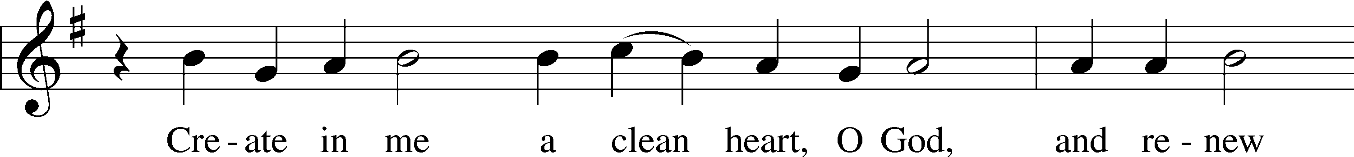
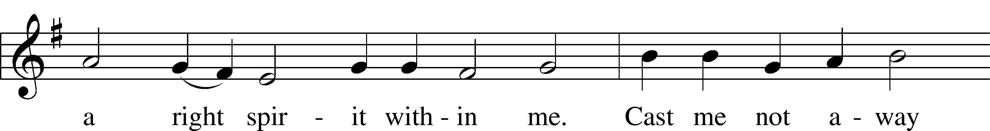
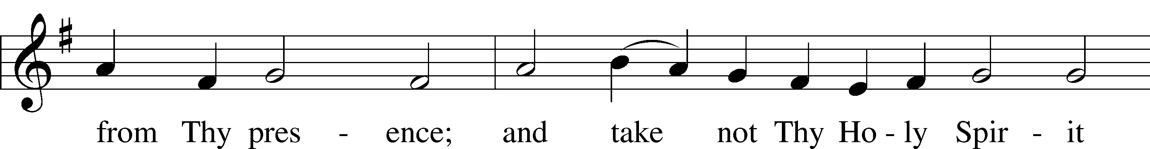
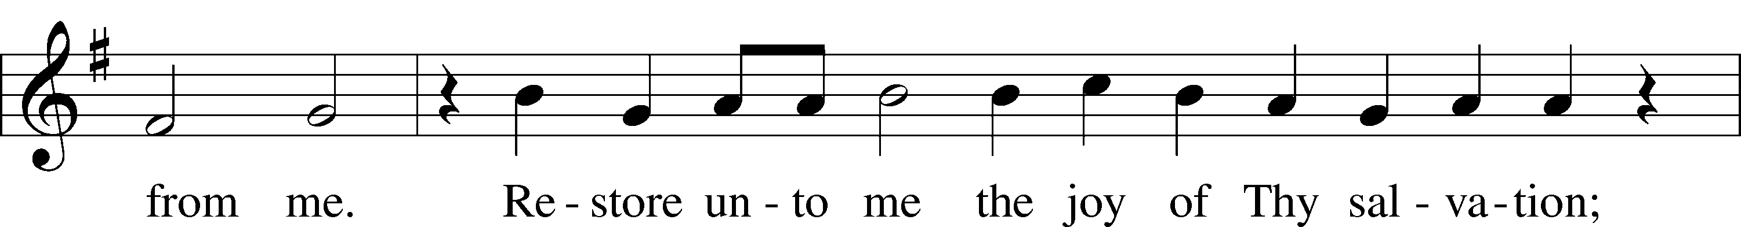
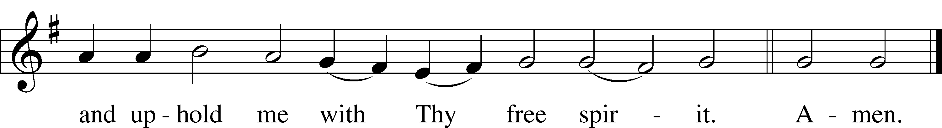
Text and tune: Public domain

Reading Psalm 130
L A reading from Psalm one hundred thirty.

1Out of the depths
I cry to you, O Lord!
2O Lord, hear my voice!
Let your ears be attentive
to the voice of my pleas for mercy!
3If you, O Lord, should mark iniquities,
O Lord, who could stand?
4But with you there is forgiveness,
that you may be feared.
5I wait for the Lord, my soul waits,
and in his word I hope;
6my soul waits for the Lord
more than watchmen for the morning,
more than watchmen for the morning.
7O Israel, hope in the Lord!
For with the Lord there is steadfast love,
and with him is plentiful redemption.
8And he will redeem Israel
from all his iniquities.

L This is the Word of the Lord.
C Thanks be to God.

Responsory: Lent LSB 263; 1 John 2:1; [Mark 10:33]; Psalm 32:1
L We have an advocate with the Father: Jesus Christ, the Righteous One.
C He was delivered up to death; He was delivered for the sins of the people.
L Blessed is the one whose transgression is forgiven, whose sin is covered.
C He was delivered up to death; He was delivered for the sins of the people.
L We have an advocate with the Father; Jesus Christ, the Righteous One.
C He was delivered up to death; He was delivered for the sins of the people.

Ten Commandments Exodus 20:2-17
C You shall have no other gods.
You shall not misuse the name of the Lord your God.
Remember the Sabbath day by keeping it holy.
Honor your father and your mother.
You shall not murder.
You shall not commit adultery.
You shall not steal.
You shall not give false testimony against your neighbor.
You shall not covet your neighbor’s house.
You shall not covet your neighbor’s wife, or his manservant or maidservant, his ox or donkey, or anything that belongs to your neighbor.

Apostles’ Creed
C I believe in God, the Father Almighty,
maker of heaven and earth.

And in Jesus Christ, His only Son, our Lord,
who was conceived by the Holy Spirit,
born of the virgin Mary,
suffered under Pontius Pilate,
was crucified, died and was buried.
He descended into hell.
The third day He rose again from the dead.
He ascended into heaven
and sits at the right hand of God the Father Almighty.
From thence He will come to judge the living and the dead.

I believe in the Holy Spirit,
the holy Christian Church,
the communion of saints,
the forgiveness of sins,
the resurrection of the body,
and the life T everlasting. Amen.

Lord’s Prayer Matthew 6:9-13
C Our Father who art in heaven,
hallowed be Thy name,
Thy kingdom come,
Thy will be done on earth
as it is in heaven;
give us this day our daily bread;
and forgive us our trespasses
as we forgive those
who trespass against us;
and lead us not into temptation,
but deliver us from evil.
For Thine is the kingdom
and the power and the glory
forever and ever. Amen.

Small Catechism: Confession, Part 1
What is Confession?
Confession has two parts. First, that we confess our sins, and second, that we receive absolution, that is, forgiveness, from the pastor as from God Himself, not doubting, but firmly believing that by it our sins are forgiven before God in heaven.

What sins should we confess?
Before God we should plead guilty of all sins, even those we are not aware of, as we do in the Lord’s Prayer; but before the pastor we should confess only those sins which we know and feel in our hearts.

Which are these?
Consider your place in life according to the Ten Commandments: Are you a father, mother, son, daughter, husband, wife, or worker? Have you been disobedient, unfaithful, or lazy? Have you been hot-tempered, rude, or quarrelsome? Have you hurt someone by your words or deeds? Have you stolen, been negligent, wasted anything, or done any harm?

Catechetical Instruction: Confession
Hymn: From Depths of Woe I Cry to Thee LSB 607
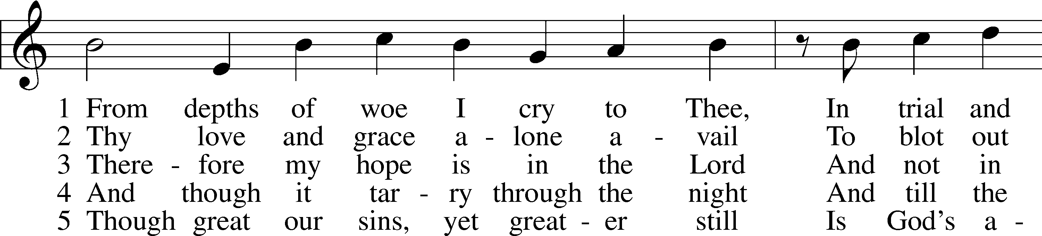
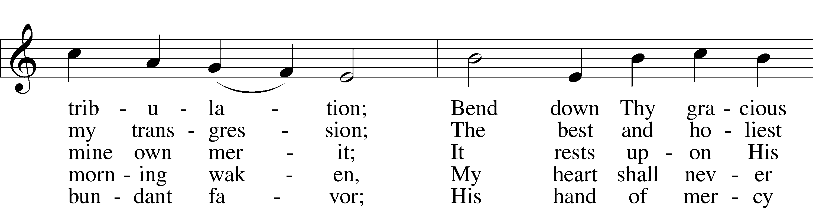
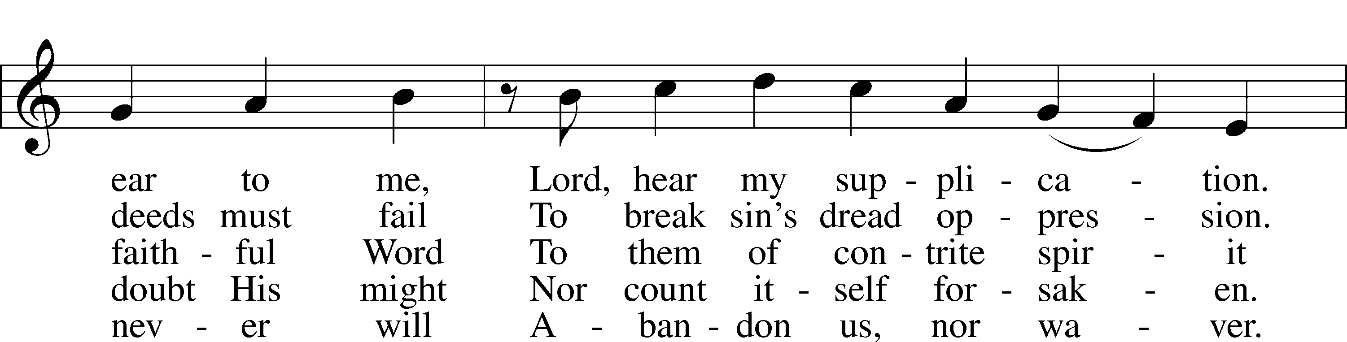
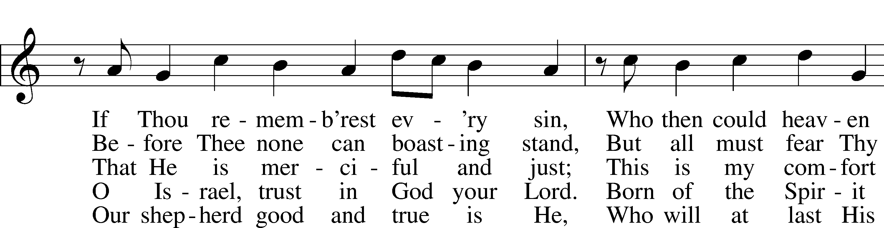
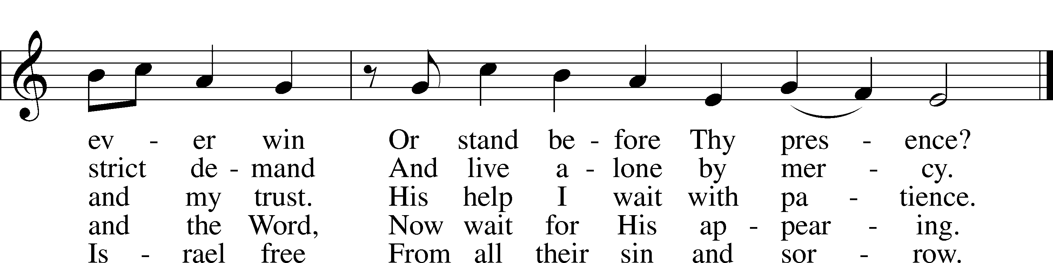
Text and tune: Public domain

Prayer
L In peace let us pray to the Lord:
C Lord, have mercy.
L For the gift of divine peace and of pardon, with all our heart and with all our mind, let us pray to the Lord:
C Lord, have mercy.
L For the holy Christian Church, here and scattered throughout the world, and for the proclamation of the Gospel and the calling of all to faith, let us pray to the Lord:
C Lord, have mercy.
L For this nation, for our cities and communities, and for the common welfare of us all, let us pray to the Lord:
C Lord, have mercy.
L For seasonable weather and for the fruitfulness of the earth, let us pray to the Lord:
C Lord, have mercy.
L For those who labor, for those whose work is difficult or dangerous, and for all who travel, let us pray to the Lord:
C Lord, have mercy.
L For all those in need, for the hungry and homeless, for the widowed and orphaned, and for all those in prison, let us pray to the Lord:
C Lord, have mercy.
L For the sick and dying and for all those who care for them, let us pray to the Lord:
C Lord, have mercy.
L For . . . [additional bids for prayer may be inserted here] . . . let us pray to the Lord:
C Lord, have mercy.
L Finally, for these and for all our needs of body and soul, let us pray to the Lord:
C Lord, have mercy. Christ, have mercy. Lord, have mercy.

Collect of the Day
L Almighty God, by Your great goodness mercifully look upon Your people that we may be governed and preserved evermore in body and soul; through Jesus Christ, Your Son, our Lord, who lives and reigns with You and the Holy Spirit, one God, now and forever.
C Amen.

Collect for the Word
L Blessed Lord, You have caused all Holy Scriptures to be written for our learning. Grant that we may so hear them, read, mark, learn, and inwardly digest them that, by patience and comfort of Your holy Word, we may embrace and ever hold fast the blessed hope of everlasting life; through Jesus Christ, our Lord.
C Amen.

Morning Prayer
C I thank You, my heavenly Father, through Jesus Christ, Your dear Son, that You have kept me this night from all harm and danger; and I pray that You would keep me this day also from sin and every evil, that all my doings and life may please You. For into Your hands I commend myself, my body and soul, and all things. Let Your holy angel be with me, that the evil foe may have no power over me. Amen.

Canticle: All You Works of God, Bless the Lord! LSB 930
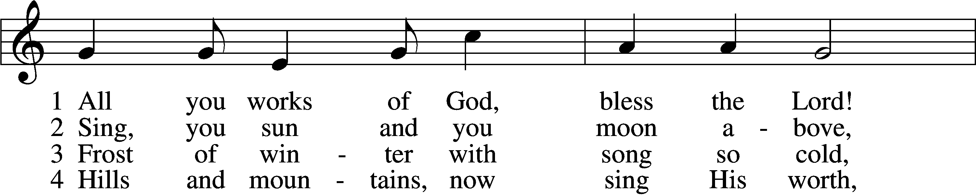
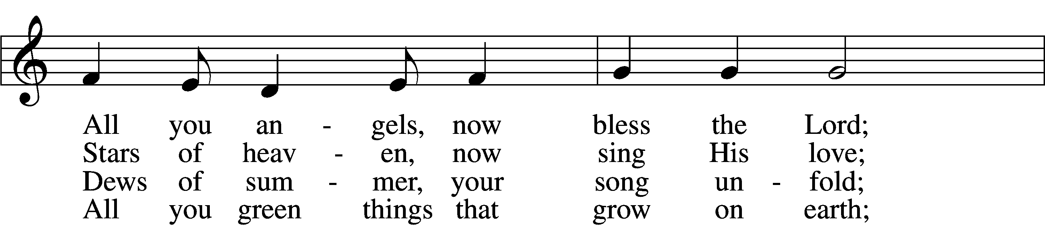
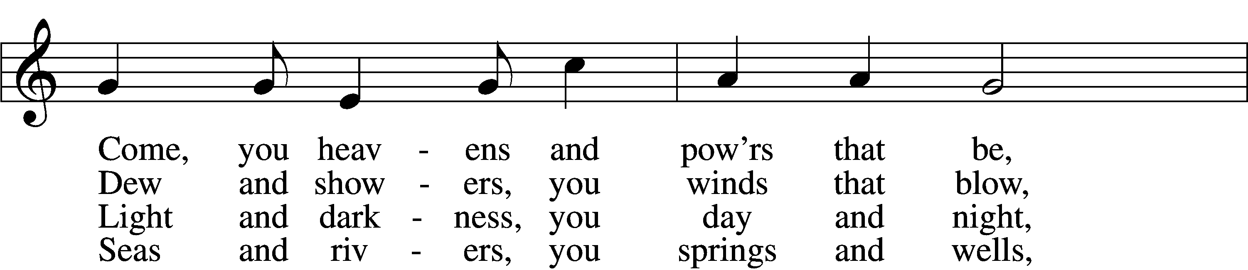
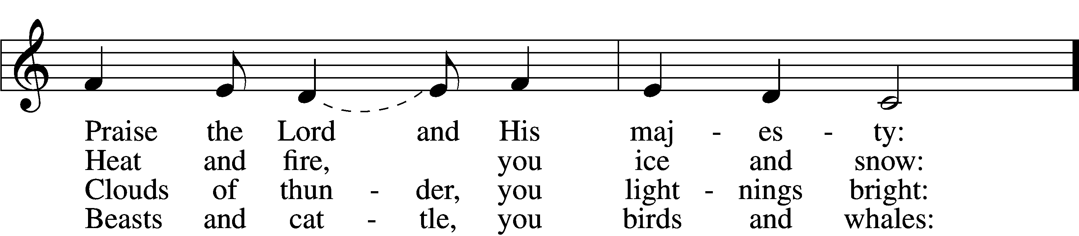
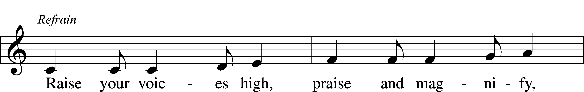
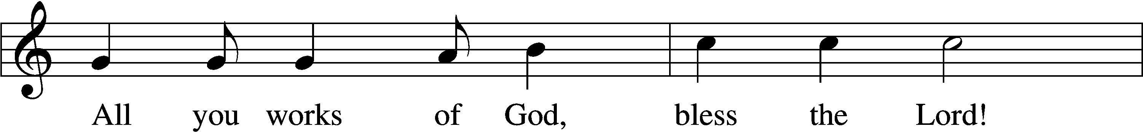
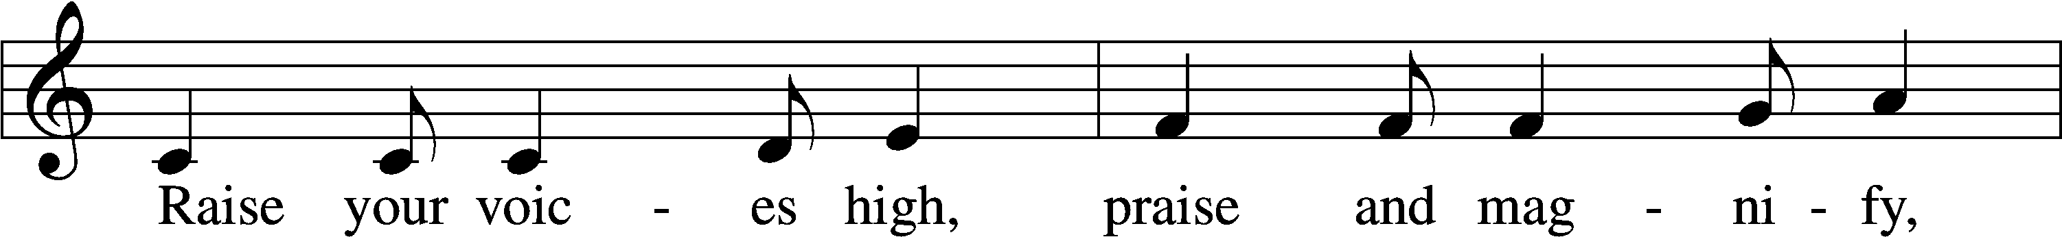
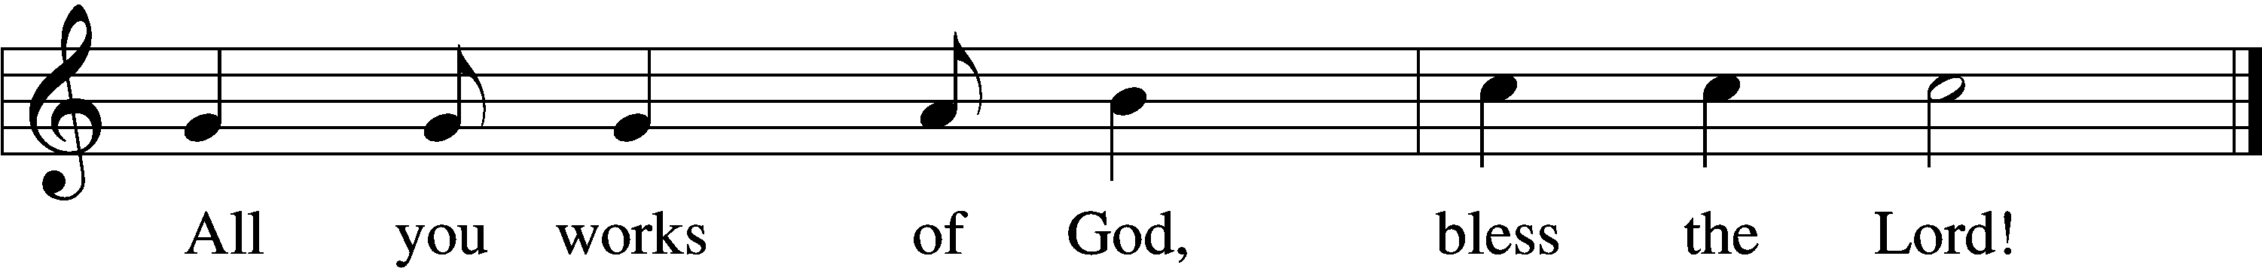

5 Come, humanity, sing along,
Sing, you people of God, a song;
Priests and servants, your Lord now bless,
Join, you spirits and souls at rest: Refrain

D 6 Bless the Lord, all you pure of heart;
All you humble, His praise impart;
God the Father and Son adore,
Bless the Spirit forevermore! Refrain
Tune: © 1975 Hope Publishing Co. Used by permission: LSB Hymn License no. 110001013
Text: © 1995 Stephen P. Starke, admin. Concordia Publishing House. Used by permission: LSB Hymn License no. 110001013

Benedicamus [Psalm 103:1]
L Let us bless the Lord.
C Thanks be to God.

Benediction
L The almighty and merciful Lord, the Father, the T Son, and the Holy Spirit, bless and preserve you.
C Amen.

Acknowledgments
Service of Prayer and Preaching from Lutheran Service Book
Unless otherwise indicated, Scripture quotations are from the ESV® Bible (The Holy Bible, English Standard Version®), copyright © 2001 by Crossway, a publishing ministry of Good News Publishers. Used by permission. All rights reserved.
Created by Lutheran Service Builder © 2018 Concordia Publishing House.

