Zion Lutheran Church

314 S Main St, Chamberlain, SD 57325
Divine Service
Saturday Evening 7:00 p.m.
Sunday Morning 9:00 a.m.
Pastor Robert Hinckley—605-413-2671
Email: rmhjr2@gmail.com
Church Office: 605-234-9466
Email: zionlutheran@midstatesd.net
Website: zionchamberlain.com

Welcome! We are so glad you joined us this season of Pentecost when we celebrate the gift of the Holy Spirit to Christ’s holy church! May God richly bless and be with us all at this time of year. If you have any announcements or prayer requests, please let us know.
It is the mission of our church to share the love of Christ. Romans 5:5 says “God’s love has been poured into our hearts through the Holy Spirit who has been given to us.” May the Lord be with us as we hear the Gospel and receive the Sacraments for the strengthening of our faith and making disciples of all nations!
HOLY COMMUNION
"Given and Shed for You for the Remission of Sins"
"Take eat, this is My body...Drink ye all, this is My blood"

"Let a person examine themselves, and so let them eat of this bread and drink of this cup" - 1 Cor. 11:28. I have examined myself whether: 1) I truly admit and repent of my sins; 2) I believe that Christ is really present in the Sacrament and that with the Bread and the Wine I receive His true Body and Blood; 3) I believe in Jesus Christ for the forgiveness of my sins; 4) and I promise with God's help to improve my sinful life.

As a worthy guest at Holy Communion, I will receive these blessings: 1) the forgiveness of my sins; 2) strength to lead a holy life; 3) give testimony of my faith. If you have any questions about attending Holy Communion, please speak with the pastor or an elder.

Divine Service Setting 4 * Lutheran Service Book p. 203
All Saints’ Day
November 5 & 6, 2022

Confession and Absolution

Hymn of Invocation: 672 Jerusalem the Golden
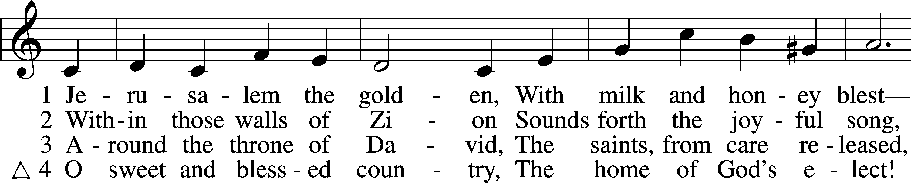
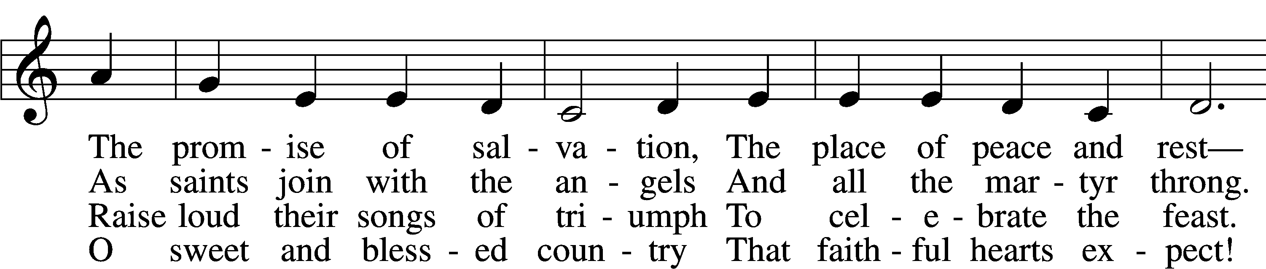
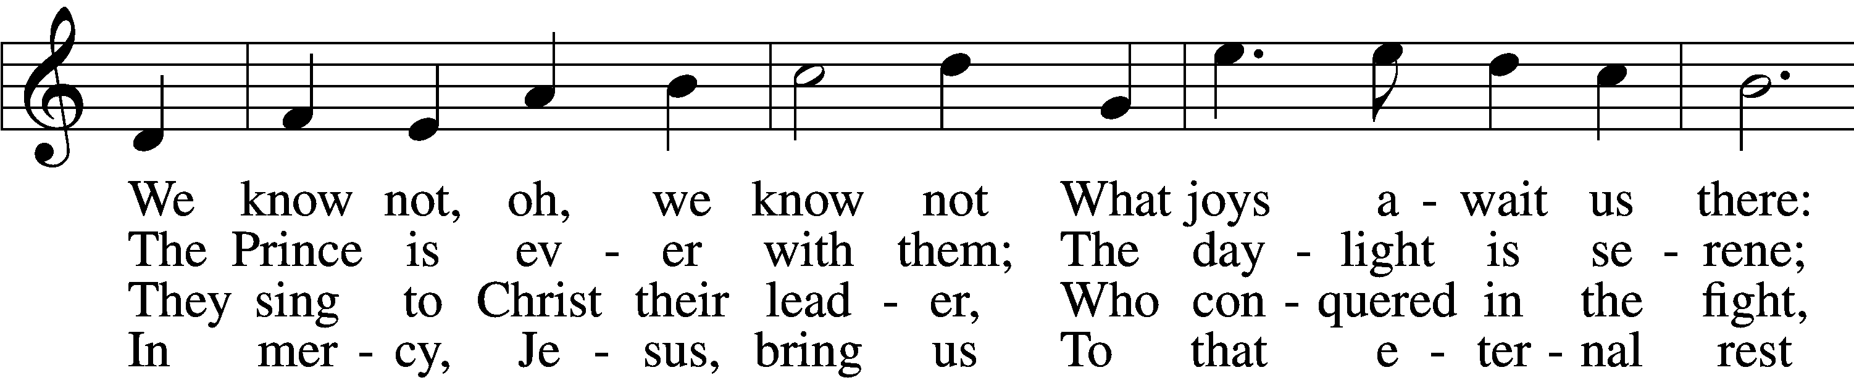
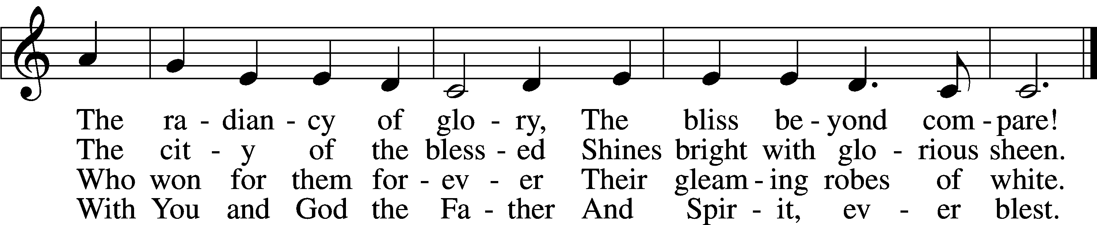
Text: Bernard of Cluny, 12th cent.; tr. John Mason Neale, 1818–66, alt.
Tune: Alexander C. Ewing, 1830–95, alt.
Text and tune: Public domain

The sign of the cross may be made by all in remembrance of their Baptism.

P In the name of the Father and of the T Son and of the Holy Spirit.
C Amen.

P Our help is in the name of the Lord,
C who made heaven and earth.

P If You, O Lord, kept a record of sins, O Lord, who could stand?
C But with You there is forgiveness; therefore You are feared.

P Since we are gathered to hear God’s Word, call upon Him in prayer and praise, and receive the body and blood of our Lord Jesus Christ in the fellowship of this altar, let us first consider our unworthiness and confess before God and one another that we have sinned in thought, word, and deed, and that we cannot free ourselves from our sinful condition. Together as His people let us take refuge in the infinite mercy of God, our heavenly Father, seeking His grace for the sake of Christ, and saying: God, be merciful to me, a sinner.

C Almighty God, have mercy upon us, forgive us our sins, and lead us to everlasting life. Amen.

P Almighty God in His mercy has given His Son to die for you and for His sake forgives you all your sins. As a called and ordained servant of Christ, and by His authority, I therefore forgive you all your sins in the name of the Father and of the Son and of the Holy Spirit.
C Amen.

Service of the Word

Introit Psalm 31:1, 3, 5; antiphon: Revelation 7:14b
These are the ones coming out of the great tribulation.
They have washed their robes and made them white in the blood of the Lamb.
In you, O Lord, do I take refuge; let me never be put to shame;
in your righteousness deliver me.
For you are my rock and my fortress;
and for your name’s sake you lead me and guide me.
Into your hand I commit my spirit;
you have redeemed me, O Lord, faithful God.
Glory be to the Father and to the Son
and to the Holy Spirit;
as it was in the beginning,
is now, and will be forever. Amen.
These are the ones coming out of the great tribulation.
They have washed their robes and made them white in the blood of the Lamb.

Kyrie LSB 204
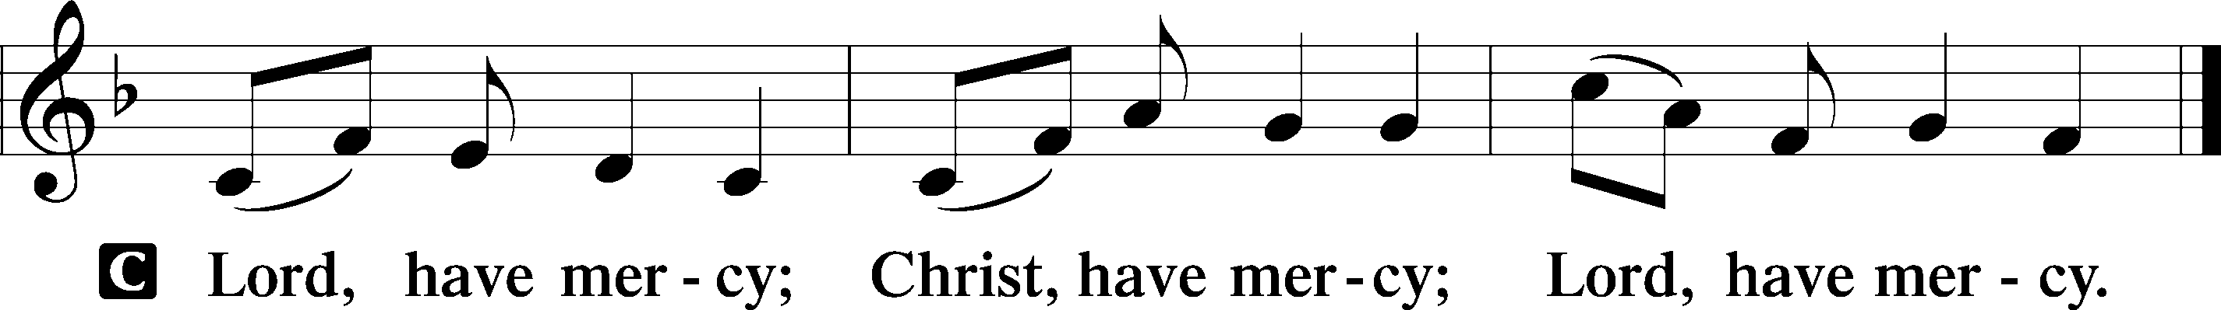

Gloria in Excelsis LSB 204
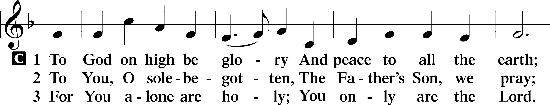
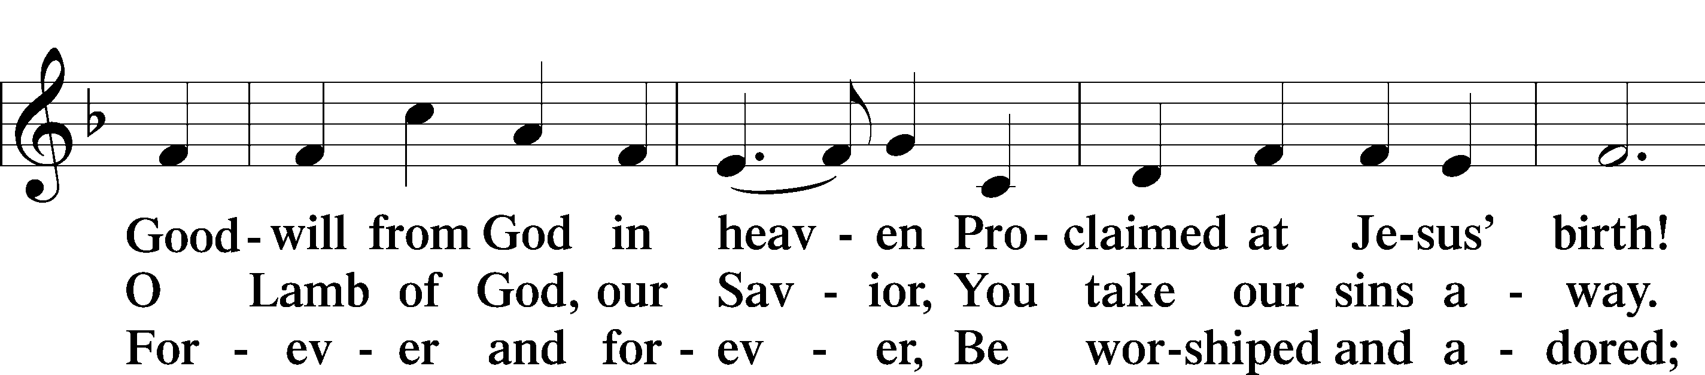
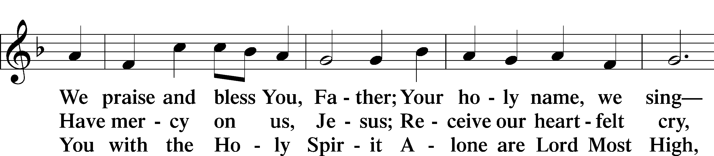
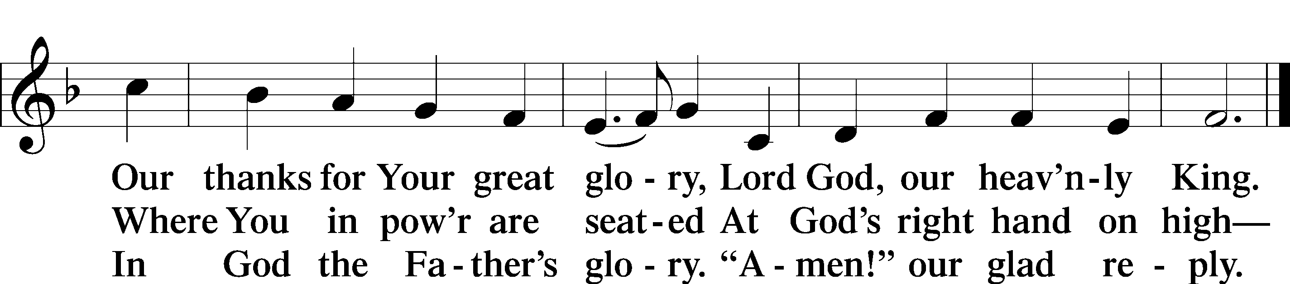
Text: Stephen P. Starke

Salutation and Collect of the Day: Proper 27 (Year C)
P The Lord be with you.
C And also with you.

P Let us pray.
Living God, Your almighty power is made known chiefly in showing mercy and pity. Grant us the fullness of Your grace to lay hold of Your promises and live forever in Your presence; through Jesus Christ, Your Son, our Lord, who lives and reigns with You and the Holy Spirit, one God, now and forever.

C Amen.

Sit

First Reading: Revelation 7:9–17
⁹After this I looked, and behold, a great multitude that no one could number, from every nation, from all tribes and peoples and languages, standing before the throne and before the Lamb, clothed in white robes, with palm branches in their hands, ¹⁰and crying out with a loud voice, “Salvation belongs to our God who sits on the throne, and to the Lamb!” ¹¹And all the angels were standing around the throne and around the elders and the four living creatures, and they fell on their faces before the throne and worshiped God, ¹²saying, “Amen! Blessing and glory and wisdom and thanksgiving and honor and power and might be to our God forever and ever! Amen.”
¹³Then one of the elders addressed me, saying, “Who are these, clothed in white robes, and from where have they come?” ¹⁴I said to him, “Sir, you know.” And he said to me, “These are the ones coming out of the great tribulation. They have washed their robes and made them white in the blood of the Lamb.
¹⁵“Therefore they are before the throne of God,
and serve him day and night in his temple;
and he who sits on the throne will shelter them with his presence.
¹⁶They shall hunger no more, neither thirst anymore;
the sun shall not strike them,
nor any scorching heat.
¹⁷For the Lamb in the midst of the throne will be their shepherd,
and he will guide them to springs of living water,
and God will wipe away every tear from their eyes.”

A This is the Word of the Lord.
C Thanks be to God.

Gradual Revelation 7:14b; Psalm 84:5
These are the ones coming out of the great tribulation.
They have washed their robes and made them white in the blood of the Lamb.
Blessèd are those whose strength is in you,
in whose heart are the highways to Zion.

Epistle: 1 John 3:1–3
¹See what kind of love the Father has given to us, that we should be called children of God; and so we are. The reason why the world does not know us is that it did not know him. ²Beloved, we are God’s children now, and what we will be has not yet appeared; but we know that when he appears we shall be like him, because we shall see him as he is. ³And everyone who thus hopes in him purifies himself as he is pure.
Stand

Alleluia and Verse
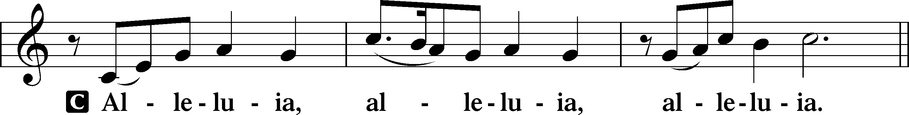

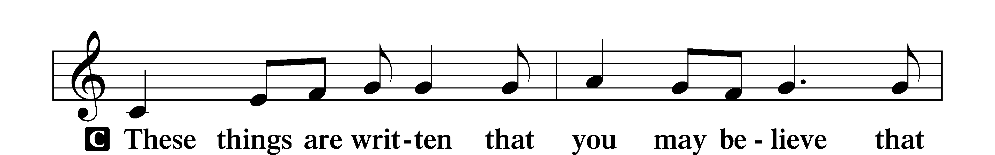
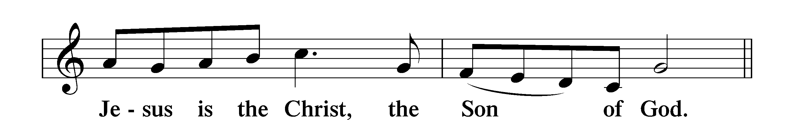

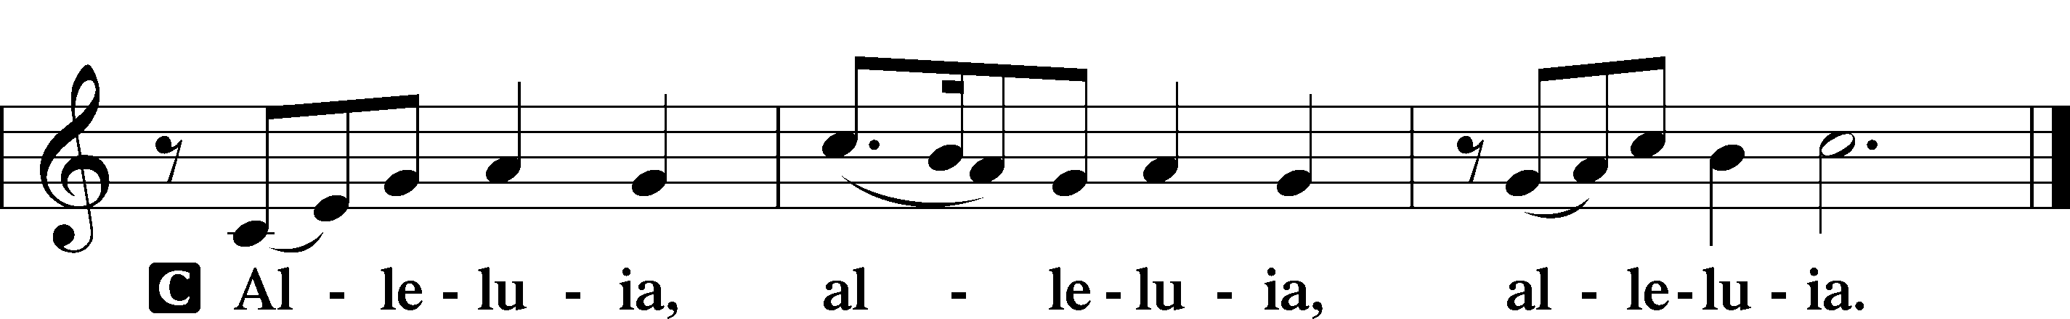
Holy Gospel: Matthew 5:1-12
P The Holy Gospel according to the fifth chapter of Matthew.
C Glory to You, O Lord.

¹Seeing the crowds, [Jesus] went up on the mountain, and when he sat down, his disciples came to him.
²And he opened his mouth and taught them, saying:
³“Blessed are the poor in spirit, for theirs is the kingdom of heaven.
⁴“Blessed are those who mourn, for they shall be comforted.
⁵“Blessed are the meek, for they shall inherit the earth.
⁶“Blessed are those who hunger and thirst for righteousness, for they shall be satisfied.
⁷“Blessed are the merciful, for they shall receive mercy.
⁸“Blessed are the pure in heart, for they shall see God.
⁹“Blessed are the peacemakers, for they shall be called sons of God.
¹⁰“Blessed are those who are persecuted for righteousness’ sake, for theirs is the kingdom of heaven.
¹¹“Blessed are you when others revile you and persecute you and utter all kinds of evil against you falsely on my account. ¹²Rejoice and be glad, for your reward is great in heaven, for so they persecuted the prophets who were before you.”

A This is the Gospel of the Lord.
C Praise to You, O Christ.

Apostles’ Creed
C I believe in God, the Father Almighty,
maker of heaven and earth.

And in Jesus Christ, His only Son, our Lord,
who was conceived by the Holy Spirit,
born of the virgin Mary,
suffered under Pontius Pilate,
was crucified, died and was buried.
He descended into hell.
The third day He rose again from the dead.
He ascended into heaven
and sits at the right hand of God the Father Almighty.
From thence He will come to judge the living and the dead.

I believe in the Holy Spirit,
the holy Christian Church,
the communion of saints,
the forgiveness of sins,
the resurrection of the body,
and the life T everlasting. Amen.

Sit

Hymn of the Day: 10,000 Reasons (Bless The Lord)

Chorus
Bless the Lord O my soul O my soul
Worship His holy name
Sing like never before O my soul
I'll worship Your holy name

Verse 1
The sun comes up it's a new day dawning
It's time to sing Your song again
Whatever may pass and whatever lies before me
Let me be singing when the evening comes

Verse 2
You're rich in love and You're slow to anger
Your name is great and Your heart is kind
For all Your goodness I will keep on singing
Ten thousand reasons for my heart to find

Verse 3
And on that day when my strength is failing
The end draws near and my time has come
Still my soul will sing Your praise unending
Ten thousand years and then forevermore

Sermon: A Vision of the Heavenly Host (Revelation 7:9-17).

Stand

Prayer of the Church
P In peace, let us pray to the Lord:
C Lord, have mercy.

P That we would acknowledge again with great joy Jesus’ resurrection from the dead, as we offer praise and thankful hearts for His victory over sin, death and the grave, let us pray to the Lord:
C Lord, have mercy.

P For pastors, that they would be faithful in the preaching of the Word and the administration of the Sacraments; and for congregations, that they would receive these gifts in thankfulness that Christ was rejected by sinners so that we may be welcomed into His kingdom, let us pray to the Lord:
C Lord, have mercy.

P For those good works that flow from faith in God’s precious Son, that everything His children do in thought, speech and action would bring glory and honor to the name of Jesus Christ, let us pray to the Lord:
C Lord, have mercy.

P For the Holy Spirit to guard and keep us, that God’s children may resist temptation and that the devil, the world and our sinful nature would not deceive us or mislead us into false belief, despair, and other great shame and vice, let us pray to the Lord:
C Lord, have mercy.

P For all in authority over us, especially those who work to bring peace and justice, that God would supply them with His blessing; that they may be inclined to His will and walk according to His commandments; and that He would grant wisdom to our citizens and competence to our leaders, let us pray to the Lord:
C Lord, have mercy.

P For all in trying circumstances: the sick, the suffering, the dying, the mourning, especially Kaden, Melva, Marcheta, Josh, Violet, Alexis, David, Bradley, Tom, Brenda, Paula, Scott, Kanbi, Bill, Jack, Bridget, Ken, Lyle, Becky, and Al, that our God would comfort them with His divine promises and grant His healing peace, until we all are gathered into His everlasting joy, let us pray to the Lord:
C Lord, have mercy.

P For the Holy Spirit, that we may eat and drink our Savior’s body and blood, firmly believing that they are given to us in this Sacrament for the forgiveness of all sin; and for strength, that neither cross nor trial may shake our confidence in the Lord’s mercy, revealed to us in the beloved Son, who gave Himself into death that we may live, let us pray to the Lord:
C Lord, have mercy.

P O Lord, You are not a God of the dead but of the living; with You live all those who have departed this life in faith. Receive our thanks for their witness, and lead us also to be found faithful and be declared worthy of eternal life with them; through Jesus Christ, Your Son, our Lord, who lives and reigns with You and the Holy Spirit, one God, now and forever.
C Amen.

Sit

Offering

Service of the Sacrament

Stand

Preface LSB 208
P The Lord be with you.
C And also with you.

P Lift up your hearts.
C We lift them to the Lord.

P Let us give thanks to the Lord our God.
C It is right to give Him thanks and praise.

P It is truly good, right, and salutary that we should at all times and in all places give thanks to You, O Lord, holy Father, almighty and everlasting God, for the countless blessings You so freely bestow on us and all creation. Above all, we give thanks for Your boundless love shown to us when You sent Your only-begotten Son, Jesus Christ, into our flesh and laid on Him our sin, giving Him into death that we might not die eternally. Because He is now risen from the dead and lives and reigns to all eternity, all who believe in Him will overcome sin and death and will rise again to new life. Therefore with angels and archangels and with all the company of heaven we laud and magnify Your glorious name, evermore praising You and saying:

Sanctus LSB 208
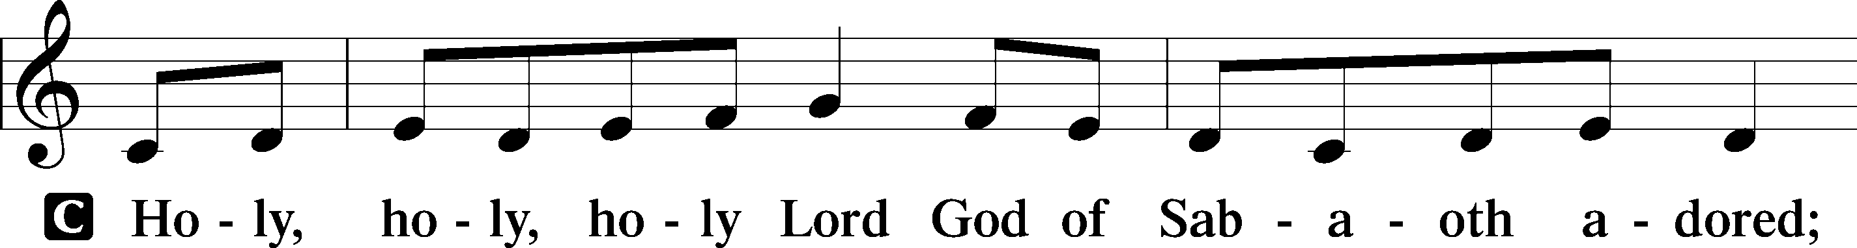
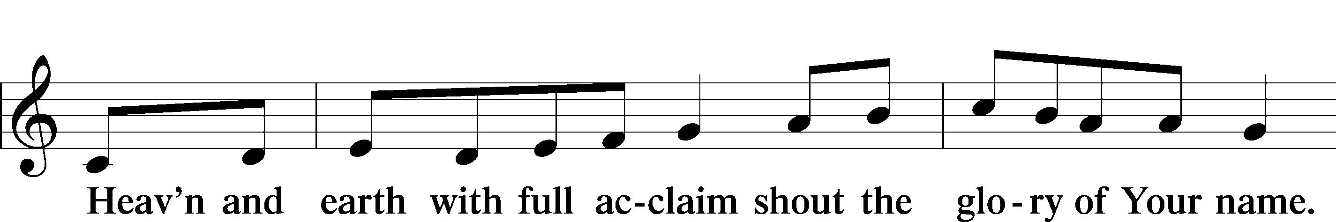
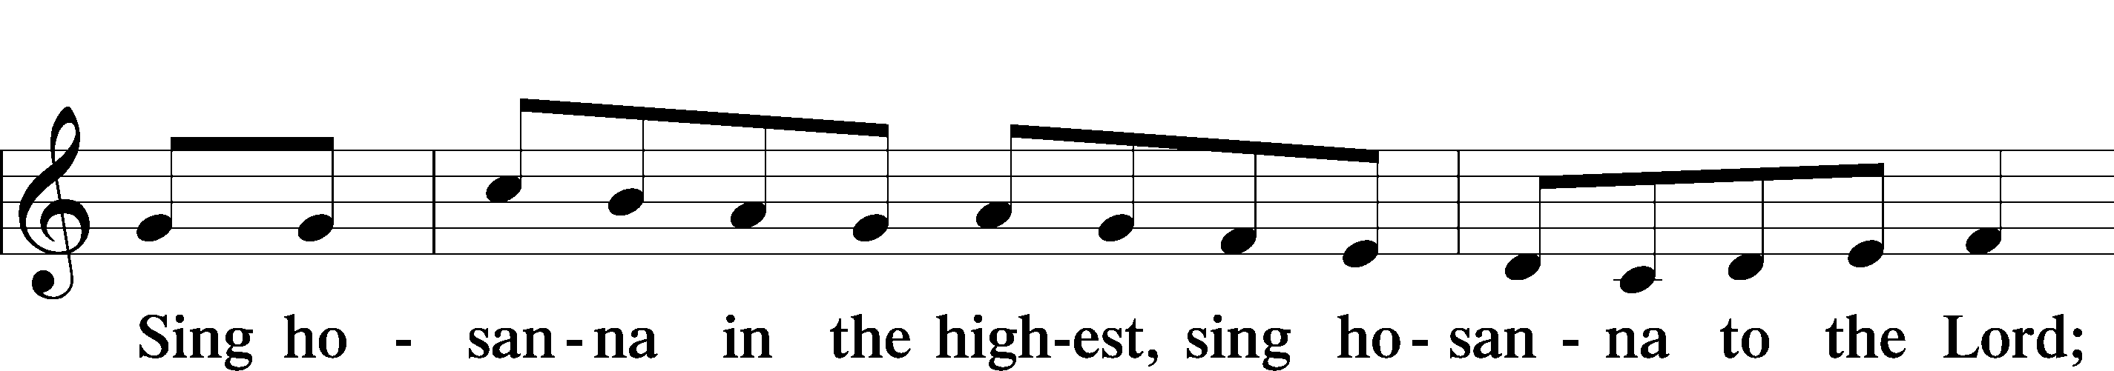
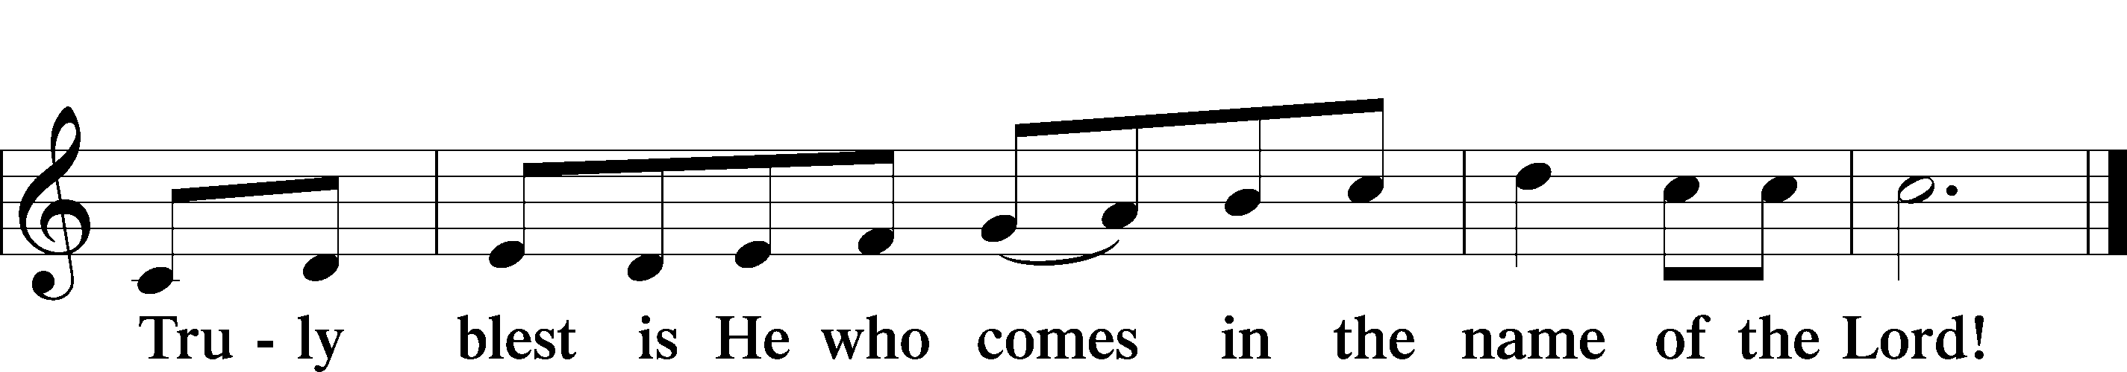
Text: Stephen P. Starke

Lord’s Prayer
C Our Father who art in heaven,
hallowed be Thy name,
Thy kingdom come,
Thy will be done on earth
as it is in heaven;
give us this day our daily bread;
and forgive us our trespasses
as we forgive those
who trespass against us;
and lead us not into temptation,
but deliver us from evil.
For Thine is the kingdom
and the power and the glory
forever and ever. Amen.

The Words of Our Lord
P Our Lord Jesus Christ, on the night when He was betrayed, took bread, and when He had given thanks, He broke it and gave it to the disciples and said: “Take, eat; this is My T body, which is given for you. This do in remembrance of Me.”

In the same way also He took the cup after supper, and when He had given thanks, He gave it to them, saying: “Drink of it, all of you; this cup is the new testament in My T blood, which is shed for you for the forgiveness of sins. This do, as often as you drink it, in remembrance of Me.”

Pax Domini
P The peace of the Lord be with you always.
C Amen.

Agnus Dei LSB 210
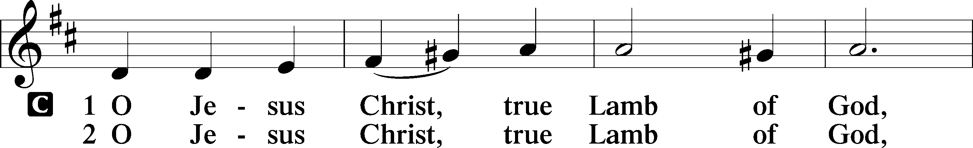
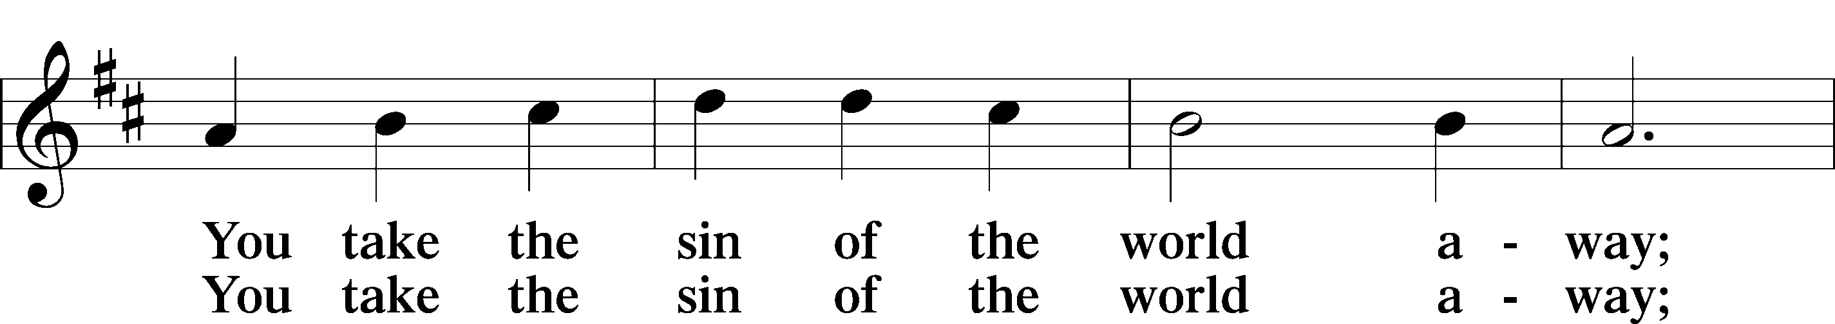
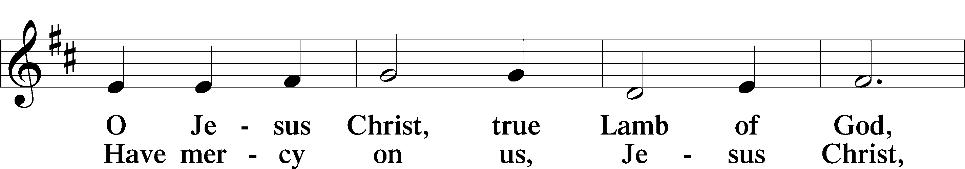
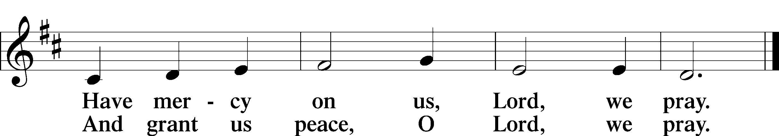
Text: Stephen P. Starke

Sit

Distribution

Distribution Hymn: 812 Come, Let Us Join Our Cheerful Songs
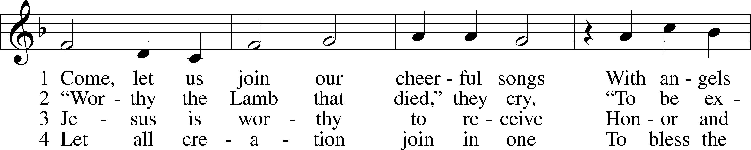
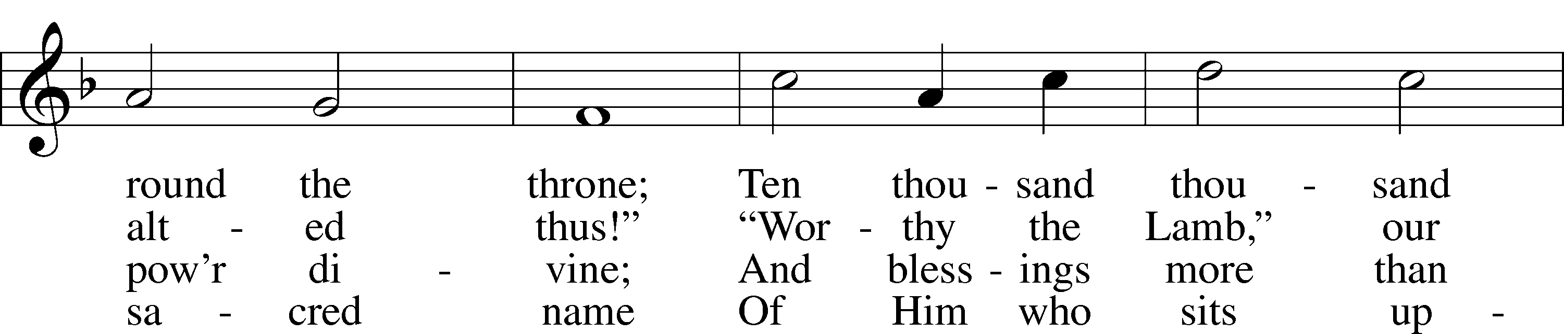
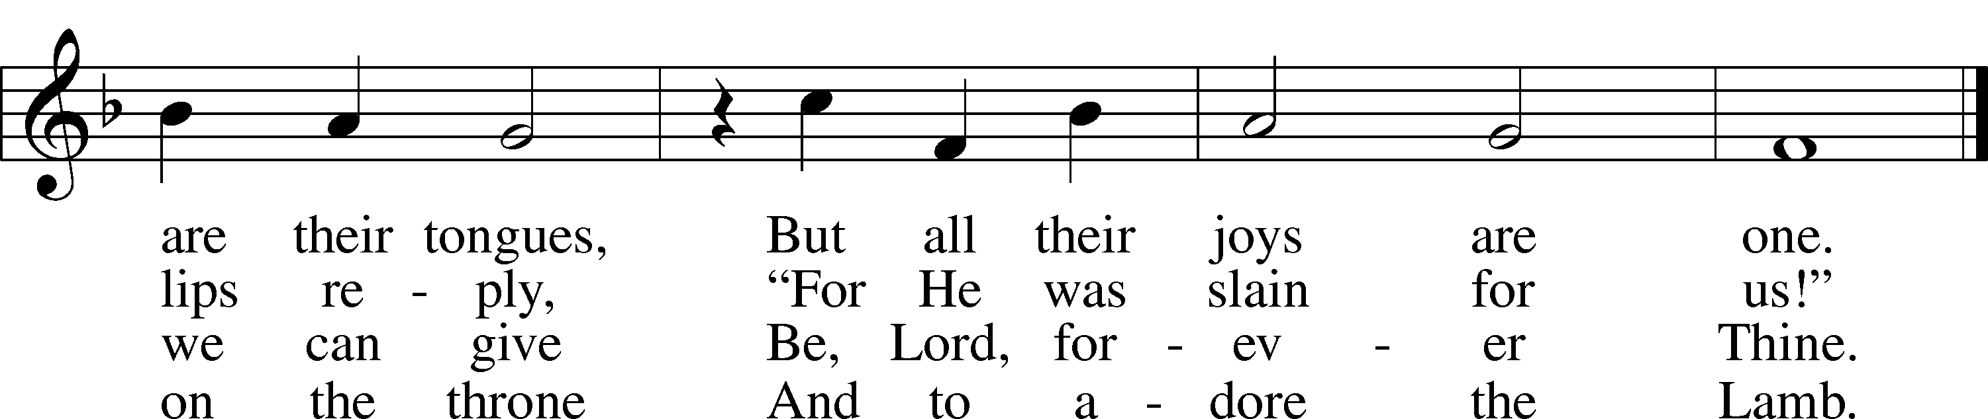
Text: Isaac Watts, 1674–1748
Tune: Johann Crüger, 1598–1662
Text and tune: Public domain

Stand

Nunc Dimittis LSB 211
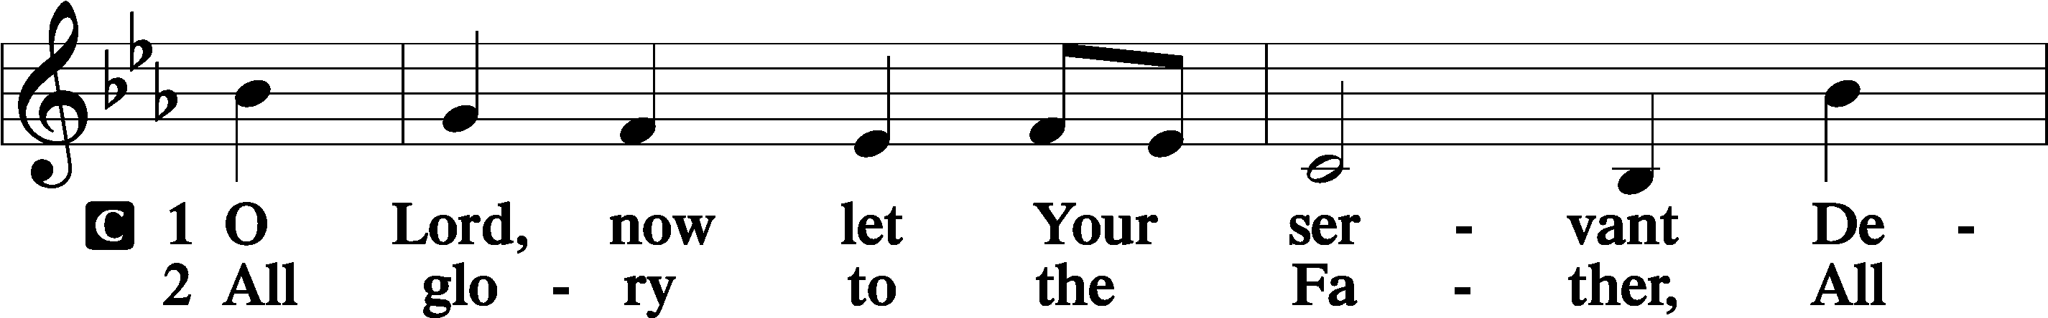
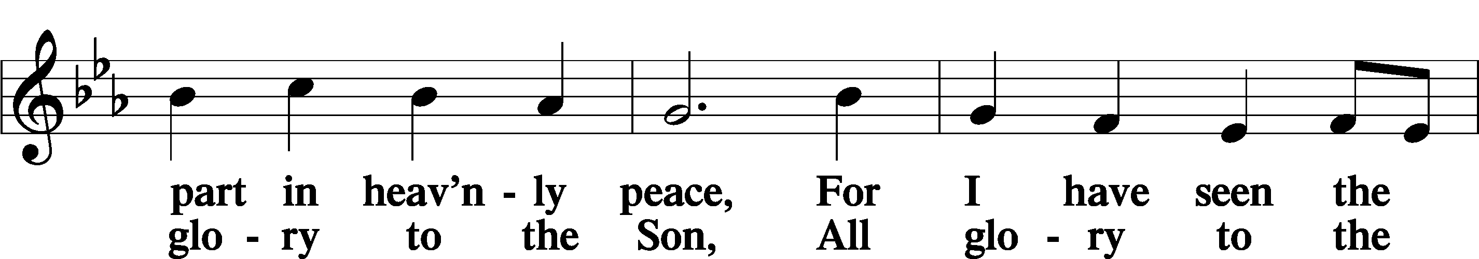
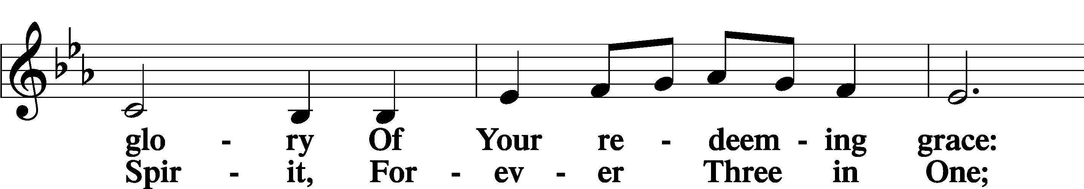
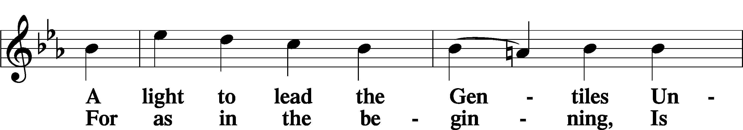
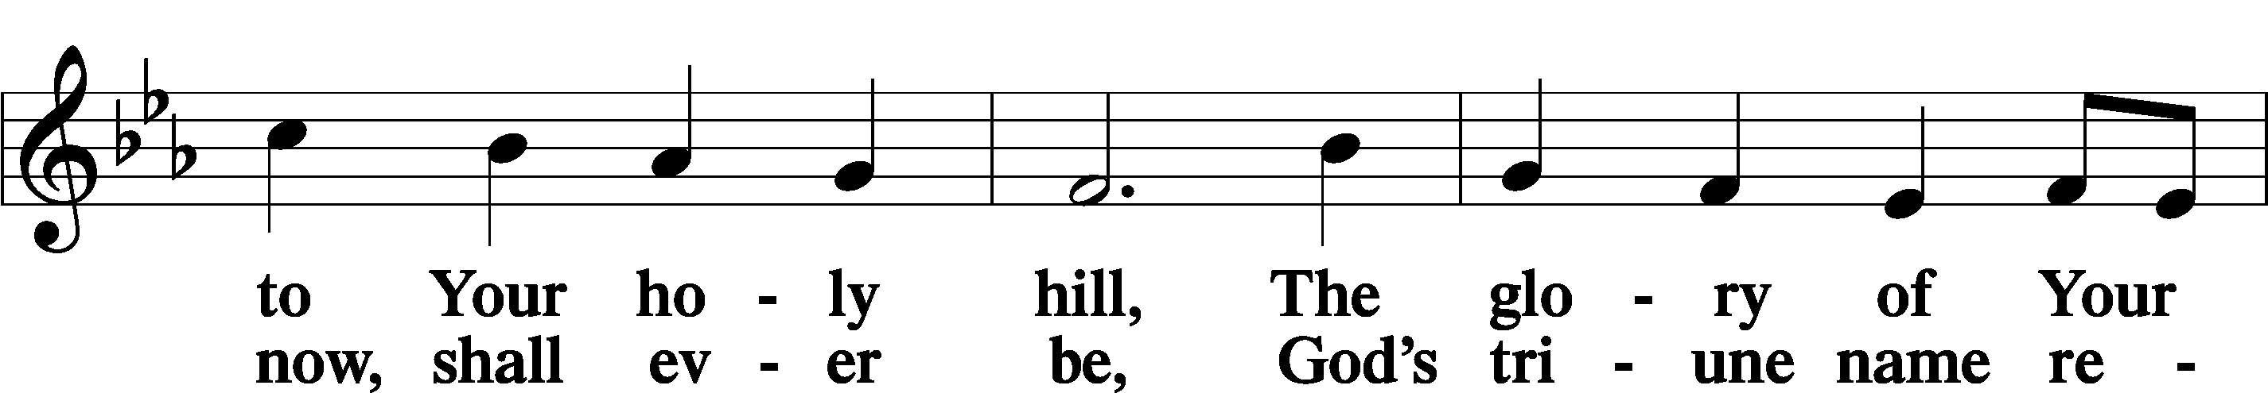
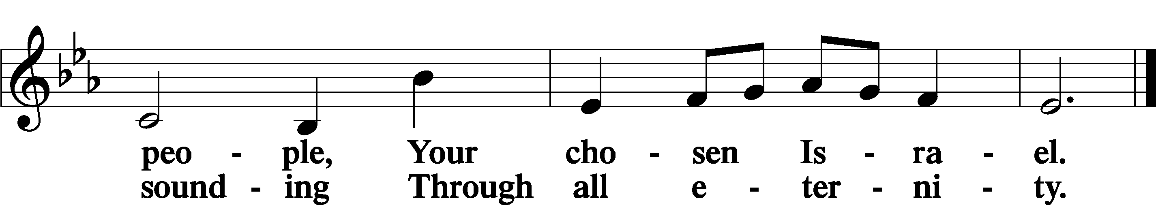

Post-Communion Collect
A Let us pray.
We give thanks to You, almighty God, that You have refreshed us through this salutary gift, and we implore You that of Your mercy You would strengthen us through the same in faith toward You and in fervent love toward one another; through Jesus Christ, Your Son, our Lord, who lives and reigns with You and the Holy Spirit, one God, now and forever.
C Amen.

Benedicamus LSB 212
A Let us bless the Lord.
C Thanks be to God.

Benediction
P The Lord bless you and keep you.
The Lord make His face shine on you and be gracious to you.
The Lord look upon you with favor and T give you peace.
C Amen.

Hymn to Depart: 941 We Praise You and Acknowledge You, O God
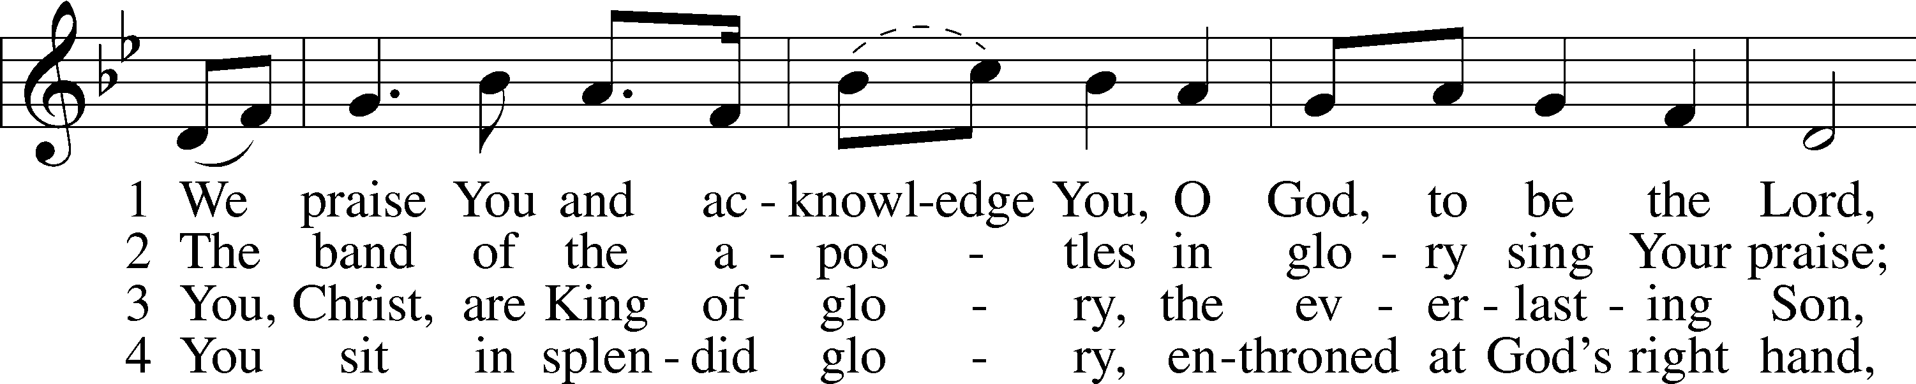
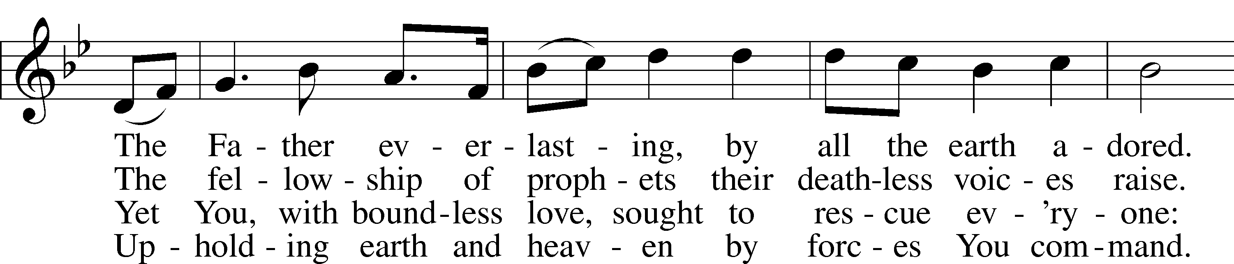
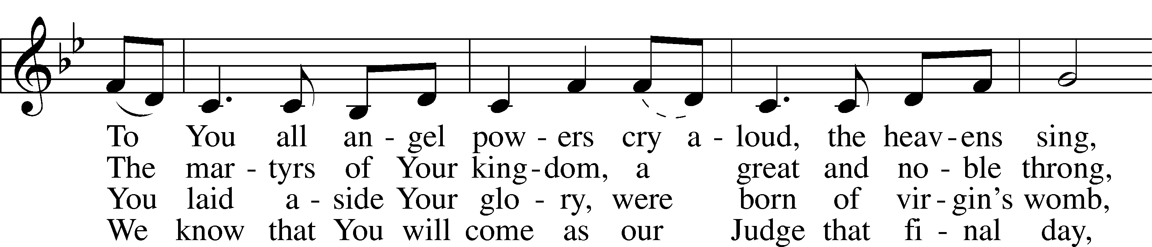
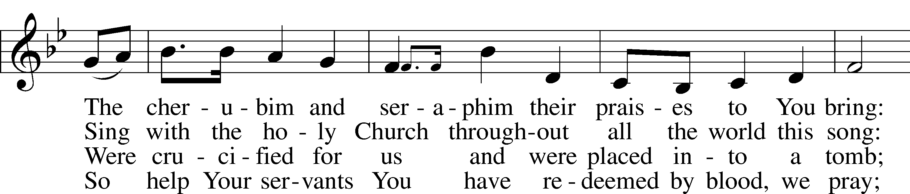
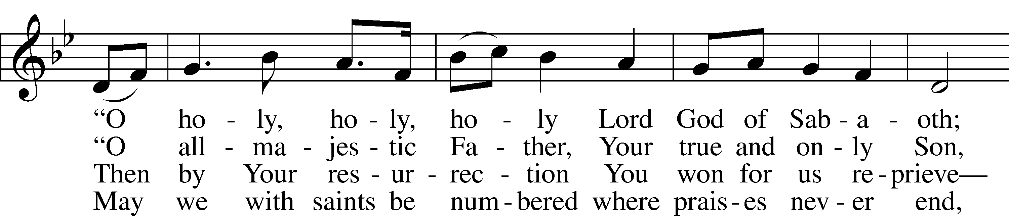
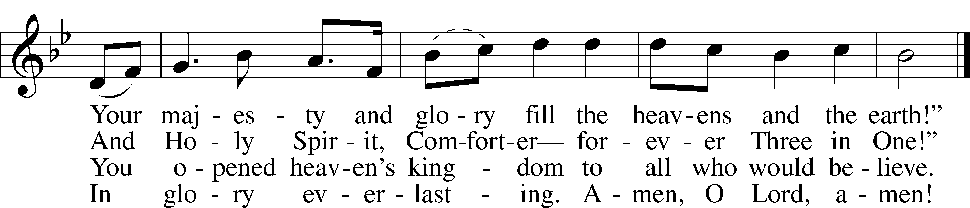
Text: Stephen P. Starke, 1955
Tune: Gustav Holst, 1874–1934, alt.
Text: © 1999 Stephen P. Starke, admin. Concordia Publishing House. Used by permission: LSB Hymn License no. 110004828
Tune: Public domain

Acknowledgments
Divine Service, Setting Four from Lutheran Service Book
Unless otherwise indicated, Scripture quotations are from the ESV® Bible (The Holy Bible, English Standard Version®), copyright © 2001 by Crossway, a publishing ministry of Good News Publishers. Used by permission. All rights reserved.
Created by Lutheran Service Builder © 2022 Concordia Publishing House.

ALL SAINTS’ DAY (OBSERVED)

Saints Are Blessed in the Eternal Presence of Christ

“A great multitude … from all tribes and peoples and languages” cry out, “Salvation belongs to our God who sits on the throne” (Rev. 7:9–10). Faith-filled saints from every place and time with unified voices eternally magnify the Lamb of God. As His beloved children, we, too, “shall see him as he is” (1 John 3:2). Joined with the throng of angels and countless saints, we shall “serve him day and night in his temple” (Rev. 7:15). In our earthly tension vacillating between saint and sinner, faith and doubt, sacred and profane, we earnestly seek Jesus to calm our fears, comfort our spirits and forgive our sins. The Holy Spirit, through faith in Christ, propels us forward, fortifying us in Word and Sacrament, to our eternal home. In the midst of our constant struggle as believers, we need to be blessed. And so we are. The poor in spirit, the meek, the hungry, the thirsty, the merciful, the pure and the persecuted are all blessed, and we will most certainly inherit the kingdom of heaven (Matt. 5:1–12).

About the Cover: Whether the sun has risen or set on labors of the saints of the Lord in this life, all in heaven and on earth exult in the glory of Christ. For the Church spreads both geographically across the world and also temporally across all time. God be praised! He has brought forgiveness through Christ Jesus, who not only has gone to the grave but also rose from the dead to never die again (Romans 6:9).

Those who have been hospitalized, homebound, in care centers or have special needs: Kaden Thompson, Melva Doerr, Marcheta Anderson, Josh Stangeland (Melanie Olson’s step-nephew), Violet Dominiack (Terry Dominiack’s wife), Lorna DeHaai, Alexis Valenzuela, (Gary and Connie Cleland’s granddaughter), David Leheska, (Jeanne Mueller’s nephew), Bradley Haynes (Linda Mason’s nephew), Tom Fenenga (Ann Powers’ father), Brenda Bultsma (Barb Powell’s sister-in-law), Paula Grussing, Scott Busack, Kanbi Knippling, Bill Dahlman, Jack Kahlman (Judy Lulf’s brother), Bridget Lake (Karen Ristau’s sister-in-law), Ken Olinger (Lila Speckel’s brother), Lyle DeHaai, Becky Rybak, Rev. Al Althoff.

“If you are sick, in need of prayer, encouragement, comfort, or basic needs and would like to be put in the weekly prayers please contact the church office or pastor!”

EVENTS FOR THE COMING WEEK

Saturday, Nov 5 Divine Service 7 p.m.
Sunday, Nov 6 Divine Service 9 a.m.
Sunday School, Confirmation Class and Youth Bible Study 10:15 a.m.
Wednesday, Nov 9 Men’s Bible Study 6:45 a.m.
Regency 11 a.m.
Sanford 1 p.m.
Elders Meeting 7 p.m.
Council Meeting 8 p.m.
Saturday, Nov 12 LWML Meals for Mission pick up 4 p.m.
Divine Service 7 p.m.
Sunday, Nov 13 Divine Service 9 a.m.
Sunday School, Confirmation Class
and Youth Bible Study 10:15 a.m.
Annual Voters Meeting 11 a.m.

ACOLYTE SCHEDULE
This week: Brylee Brennan, Saturday, Nov 5
Leo Swanson, Sunday, Nov 6
Next week: Carly Weeman, Saturday, Nov 12
Rory Peterson, Sunday, Nov 13

ANNOUNCEMENTS

Meals for Missions
Please pick up your ordered meals on Saturday evening 4-7 p.m. Thank you for supporting this fundraiser!

Men’s Bible Study
The Men’s Bible Study group is starting up once again! We will be meeting on Wednesday mornings from 6:45-7:45. New attendees welcome as we are beginning a new study.

Christmas Newsletter
This year, we would like to do a Christ-centered newsletter that will also have contributions from the congregation with their favorite Christmas recipes, stories, photos, and artwork. Children could draw a picture with the theme, “What does Christ’s birth mean to me?” We think that this would bring joy to our newsletter readers. If you have anything you would like to share, please leave on Pastor’s desk or email it to zionlutheran@midstatesd.net. We would like to have any entries by November 18th. For every entry we receive, Pastor will donate $5 to the LWML angel tree!

LAST WEEK’S ATTENDANCE AND OFFERING
Attendance
Saturday, October 29 26
Sunday, October 30 53
Offering
General Offering, October 29 & 30 $1,553.00
Simply Giving and Online Giving $ 566.30
Total $2,119.30

NEXT WEEK’S LESSONS Twenty-third Sunday after Pentecost: 1st Reading: Malachi 4:1-6 Epistle: 2 Thessalonians 3:6-13 Holy Gospel: Luke 21:5-28.
A Life Thought in the Church Year for November 6 – Pentecost XXII (Proper 27): God intends and imparts life (Luke 20:38). He wills life for every human being. He wills life even where the world witnesses only darkness, despair, and dying (Luke 20:29-32). He works life no matter how young or how old a person may be (Psalm 148:12). He works life that neither we nor anyone and anything else may end. Why would we not want to uncover, approach, and announce such a holy ground (Exodus 3:5) to everybody?

KFUO Radio, the broadcast voice of The Lutheran Church—Missouri Synod, shares Christ for you anytime, anywhere on KFUO.org via worship services, Bible and theology studies, practical talk programs, and sacred music. Find programs on demand at kfuo.org and wherever you get your podcasts! Find us on social: @KFUOradio on Facebook, Twitter, and Instagram.

CHRIST FOR YOU this week on KFUO.org: Study Joshua 21-24 on Sharper Iron's "The Promised Land Delivered" (weekdays at 8:00 a.m. CT), finish the book of James and begin the book of Exodus on Thy Strong Word (weekdays at 11:00 a.m. CT), and study the First Article of the Creed on Concord Matters (11/12 at 10:00 a.m. CT). Find your favorite programs on demand at kfuo.org or the KFUO Radio app!

Lutheran Family Service:
Soldiers, sailors, marines, airmen and women returning from deployment suffer major depression and PTSD (Post Traumatic Stress Disorder) at rates much higher than the general population. Families, as well as service members’ lives are forever changed. Who has served our country and now lives in your neighborhood or community? This week find a way to show them and their family your appreciation, respect and love! Lutheran Family Service - www.LutheranFamilyService.org.

Baptismal Anniversaries

Nov 6 Marty Dominiack, Emily Shepherd, Sasha Van Den Bosch
Nov 7 Rondell Busack, Todd Hansen
Nov 8 Carter Nelson, Sheila Thompson
Nov 11 Bryson Miller,
Elizabeth Omanson
Nov 12 Evie Olson, Dale Swanson
Nov 13 Evelyn Powell

December ust
Birthdays

Nov 6 Leslie Olesen, Sean Wagaman
Nov 7 Ophelia Chilson, Todd Engel, Roman Van Den Bosch
Nov 8 Rebecca Reimer,
Kimberly Sivertsen
Nov 9 Carol Herbst, Michael Miller, Eric Mueller, Jacob Palmer
Nov 10 Tosha Schmeidt,
Tyler Woodraska
Nov 12 Journey Richardson
Nov 13 Sarah Bode, Zane Perry, Karen Ristau

Anniversaries

Nov 10 Richard and Marsha Houska

