Zion Lutheran Church

314 S Main St, Chamberlain, SD 57325
Divine Service
Saturday Evening 7:00 p.m.
Sunday Morning 9:00 a.m.
Pastor Robert Hinckley—605-413-2671
Email: rmhjr2@gmail.com
Church Office: 605-234-9466
Email: zionlutheran@midstatesd.net
Website: zionchamberlain.com

Welcome! We are so glad you joined us this season of Pentecost when we celebrate the gift of the Holy Spirit to Christ’s holy church! May God richly bless and be with us all at this time of year. If you have any announcements or prayer requests, please let us know.
It is the mission of our church to share the love of Christ. Romans 5:5 says “God’s love has been poured into our hearts through the Holy Spirit who has been given to us.” May the Lord be with us as we hear the Gospel and receive the Sacraments for the strengthening of our faith and making disciples of all nations!
HOLY COMMUNION
"Given and Shed for You for the Remission of Sins"
"Take eat, this is My body...Drink ye all, this is My blood"

"Let a person examine themselves, and so let them eat of this bread and drink of this cup" - 1 Cor. 11:28. I have examined myself whether: 1) I truly admit and repent of my sins; 2) I believe that Christ is really present in the Sacrament and that with the Bread and the Wine I receive His true Body and Blood; 3) I believe in Jesus Christ for the forgiveness of my sins; 4) and I promise with God's help to improve my sinful life.

As a worthy guest at Holy Communion, I will receive these blessings: 1) the forgiveness of my sins; 2) strength to lead a holy life; 3) give testimony of my faith. If you have any questions about attending Holy Communion, please speak with the pastor or an elder.

Divine Service Setting 3 * Lutheran Service Book p. 184
Fourteenth Sunday After Pentecost
September 10 & 11, 2022

Confession and Absolution

Hymn of Invocation: 506 Glory Be to God the Father
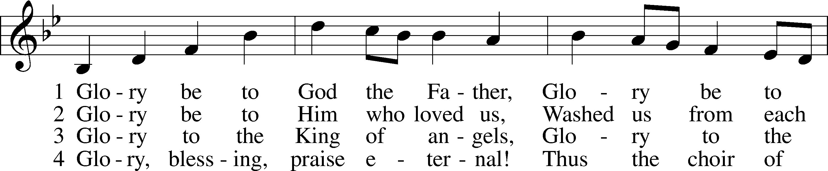
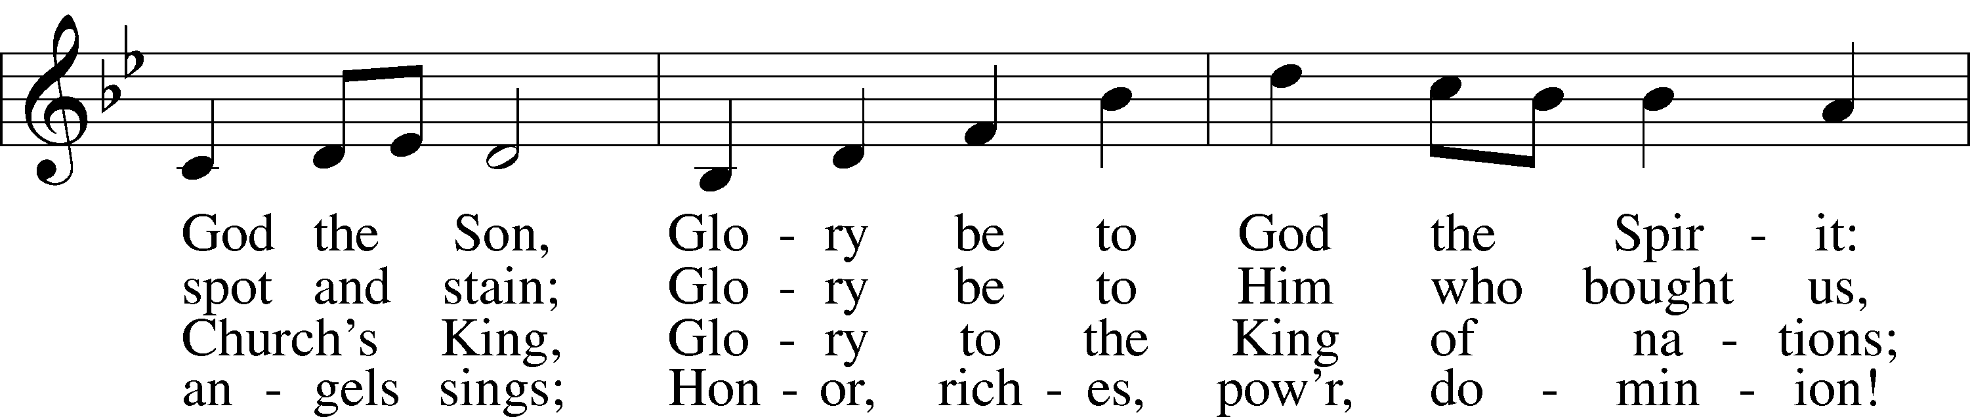
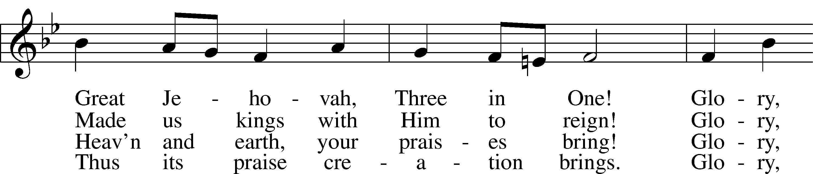
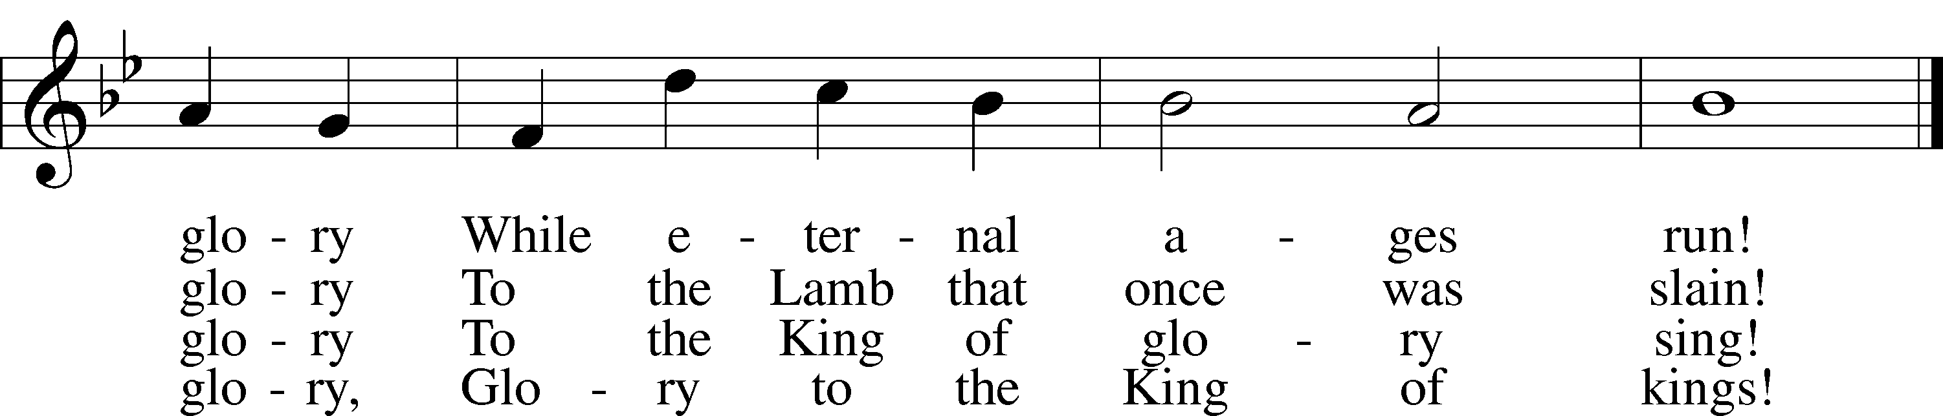
Text: Horatius Bonar, 1808–89
Tune: Walter G. Whinfield, 1865–1919
Text and tune: Public domain

The sign of the cross may be made by all in remembrance of their Baptism.

P In the name of the Father and of the T Son and of the Holy Spirit.
C Amen.

P Beloved in the Lord! Let us draw near with a true heart and confess our sins unto God our Father, beseeching Him in the name of our Lord Jesus Christ to grant us forgiveness.

P Our help is in the name of the Lord,
C who made heaven and earth.
P I said, I will confess my transgressions unto the Lord,
C and You forgave the iniquity of my sin.

Silence for reflection on God’s Word and for self-examination.

P O almighty God, merciful Father,
C I, a poor, miserable sinner, confess unto You all my sins and iniquities with which I have ever offended You and justly deserved Your temporal and eternal punishment. But I am heartily sorry for them and sincerely repent of them, and I pray You of Your boundless mercy and for the sake of the holy, innocent, bitter sufferings and death of Your beloved Son, Jesus Christ, to be gracious and merciful to me, a poor, sinful being.

P Upon this your confession, I, by virtue of my office, as a called and ordained servant of the Word, announce the grace of God unto all of you, and in the stead and by the command of my Lord Jesus Christ I forgive you all your sins in the name of the Father and of the T Son and of the Holy Spirit.
C Amen.

Service of the Word

Introit Psalm 30:2–5; antiphon: vv. 11a, 12b
You have turned for me my mourning into dancing;
O Lord my God, I will give thanks to you forever!
O Lord my God, I cried to you for help,
and you have healed me.
O Lord, you have brought up my soul from Sheol;
you restored me to life from among those who go down to the pit.
Sing praises to the Lord, O you his saints,
and give thanks to his holy name.
For his anger is but for a moment, and his favor is for a lifetime.
Weeping may tarry for the night, but joy comes with the morning.
Glory be to the Father and to the Son
and to the Holy Spirit;
as it was in the beginning,
is now, and will be forever. Amen.
You have turned for me my mourning into dancing;
O Lord my God, I will give thanks to you forever!

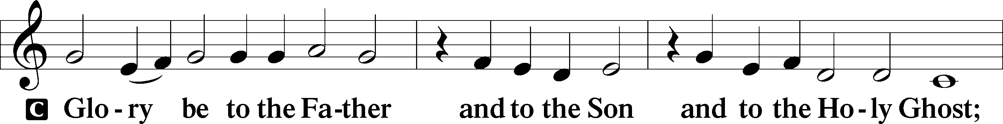
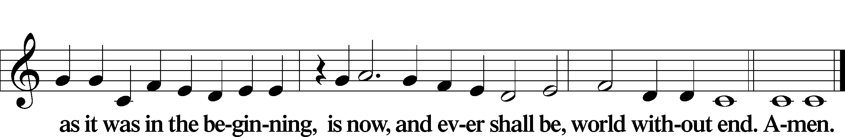

Kyrie LSB 186
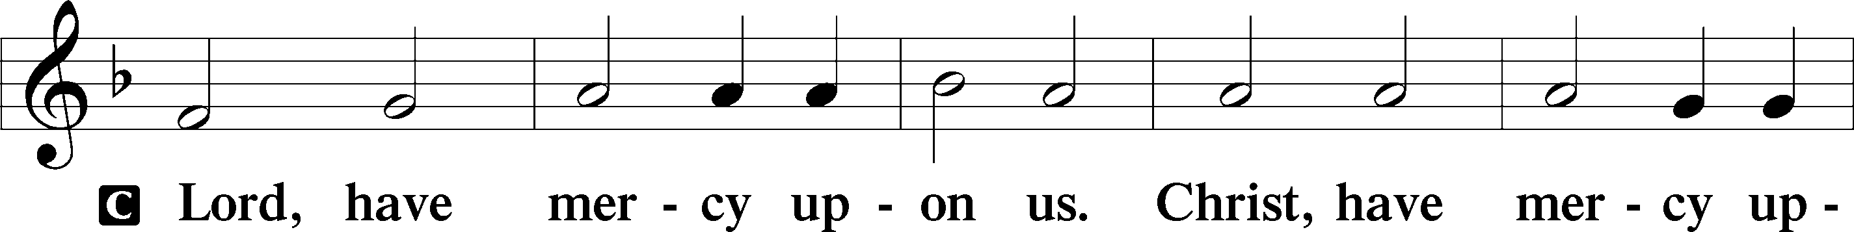
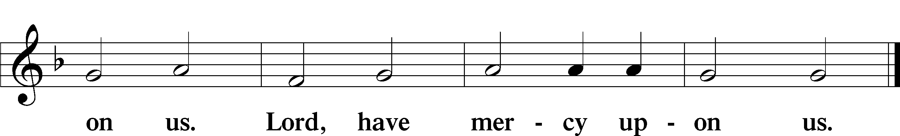

Gloria in Excelsis LSB 187
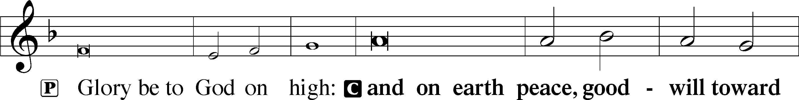
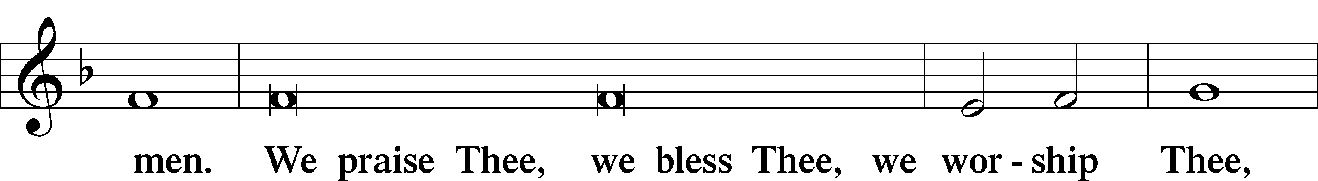
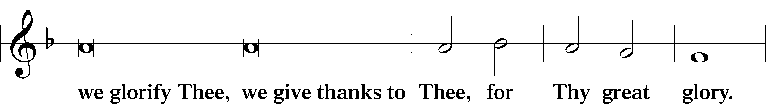
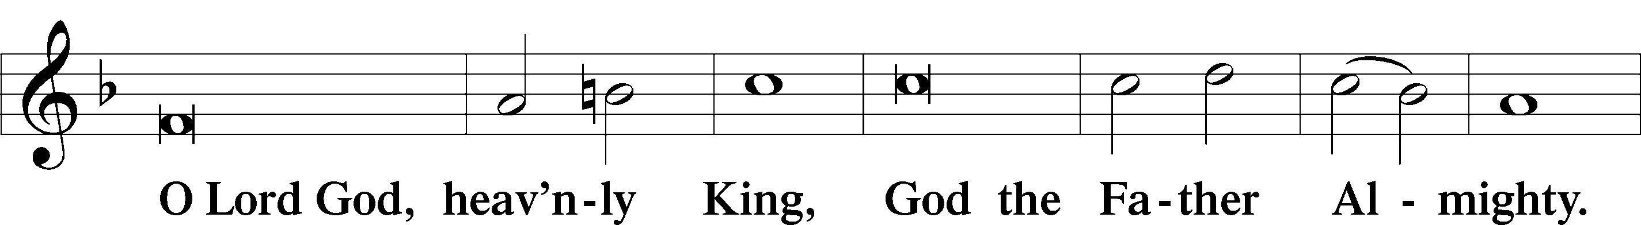
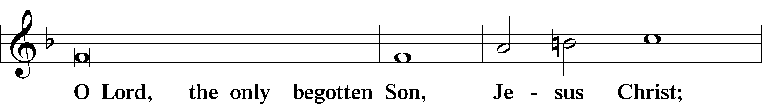
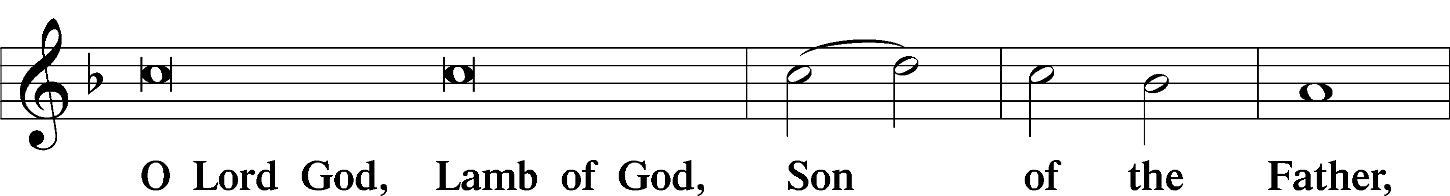
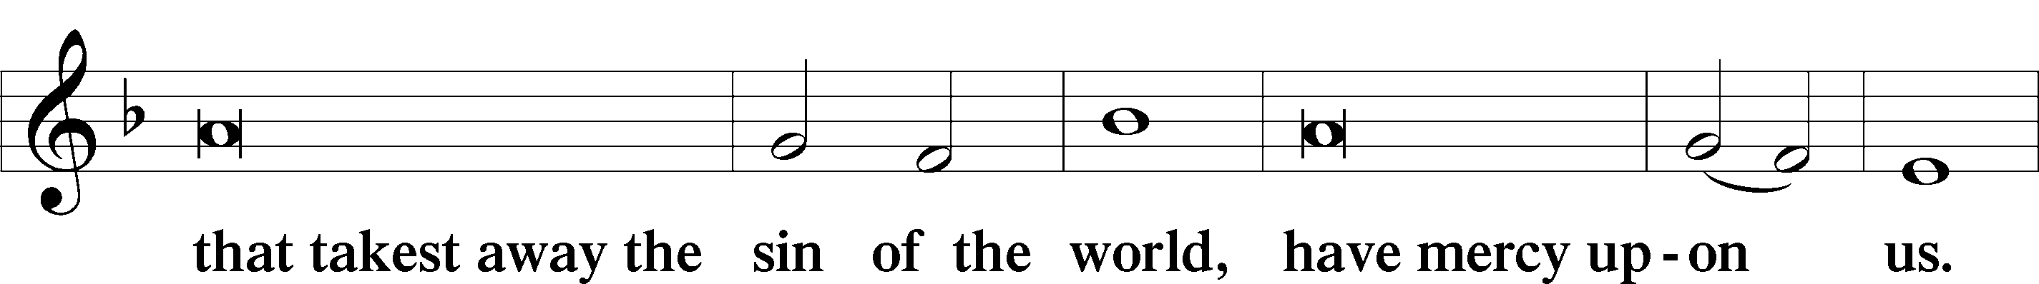
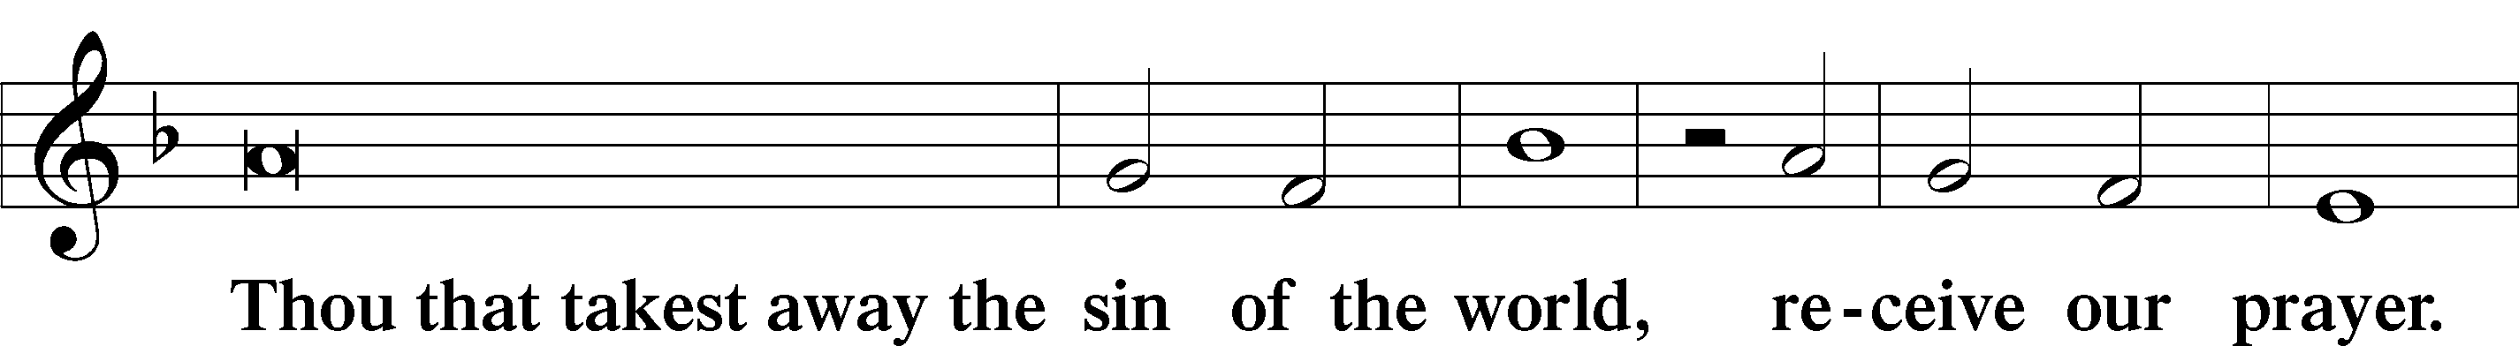
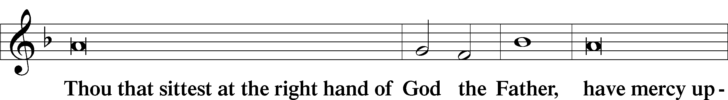
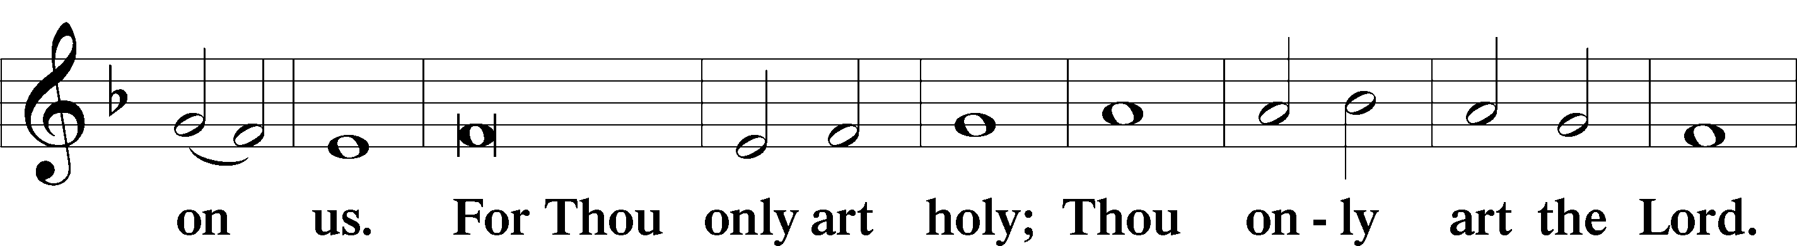
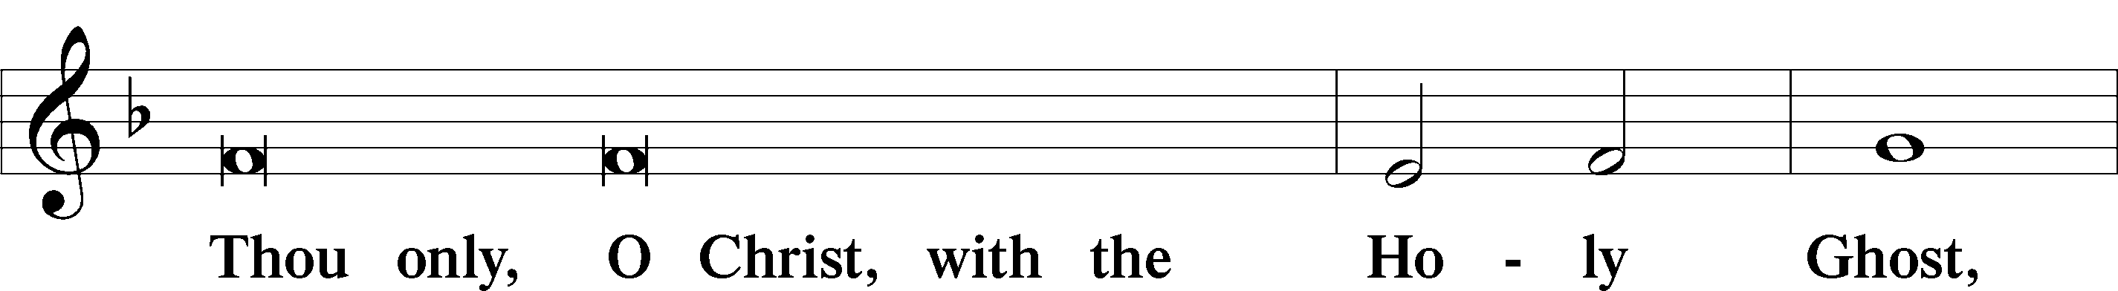
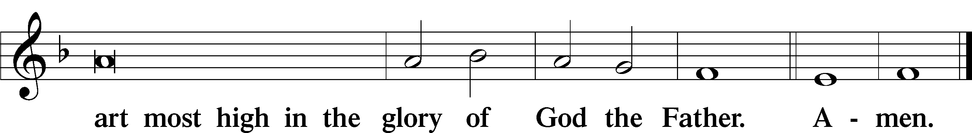
Salutation and Collect of the Day: Proper 19 (Year C)
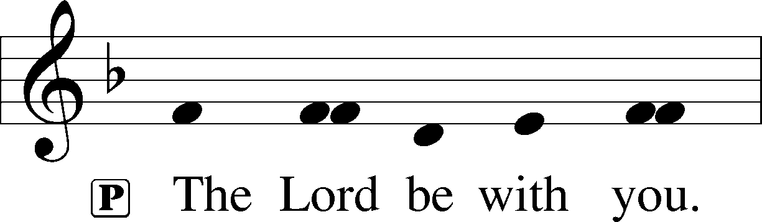
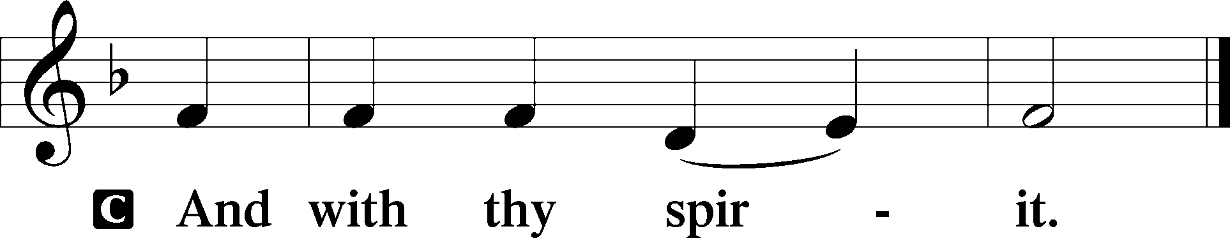

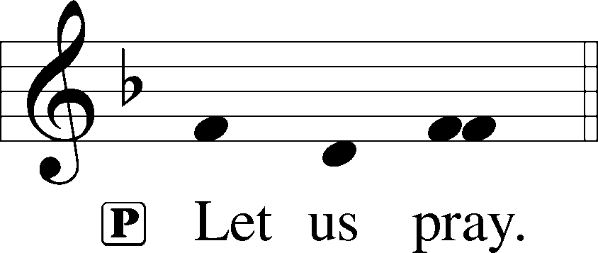

P Lord Jesus, You are the Good Shepherd, without whom nothing is secure. Rescue and preserve us that we may not be lost forever but follow You, rejoicing in the way that leads to eternal life; for You live and reign with the Father and the Holy Spirit, one God, now and forever.

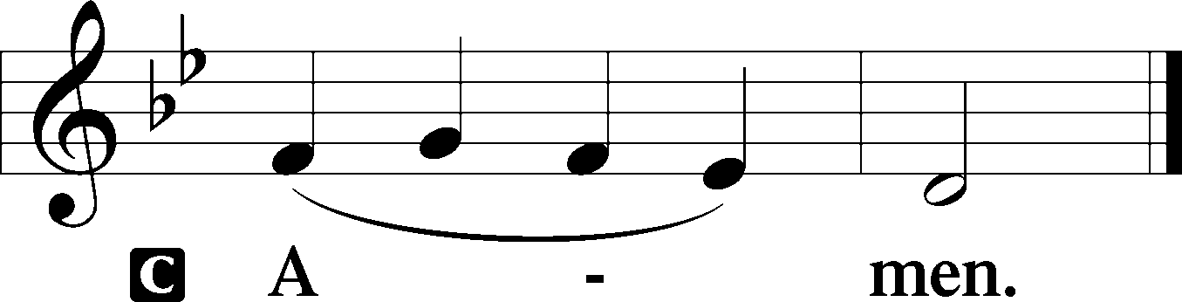

Sit

Old Testament Reading: Ezekiel 34:11–24 Ezekiel 34:11–24
“For thus says the Lord God: Behold, I, I myself will search for my sheep and will seek them out. As a shepherd seeks out his flock when he is among his sheep that have been scattered, so will I seek out my sheep, and I will rescue them from all places where they have been scattered on a day of clouds and thick darkness. And I will bring them out from the peoples and gather them from the countries, and will bring them into their own land. And I will feed them on the mountains of Israel, by the ravines, and in all the inhabited places of the country. I will feed them with good pasture, and on the mountain heights of Israel shall be their grazing land. There they shall lie down in good grazing land, and on rich pasture they shall feed on the mountains of Israel. I myself will be the shepherd of my sheep, and I myself will make them lie down, declares the Lord God. I will seek the lost, and I will bring back the strayed, and I will bind up the injured, and I will strengthen the weak, and the fat and the strong I will destroy. I will feed them in justice.
“As for you, my flock, thus says the Lord God: Behold, I judge between sheep and sheep, between rams and male goats. Is it not enough for you to feed on the good pasture, that you must tread down with your feet the rest of your pasture; and to drink of clear water, that you must muddy the rest of the water with your feet? And must my sheep eat what you have trodden with your feet, and drink what you have muddied with your feet?
“Therefore, thus says the Lord God to them: Behold, I, I myself will judge between the fat sheep and the lean sheep. Because you push with side and shoulder, and thrust at all the weak with your horns, till you have scattered them abroad, I will rescue my flock; they shall no longer be a prey. And I will judge between sheep and sheep. And I will set up over them one shepherd, my servant David, and he shall feed them: he shall feed them and be their shepherd. And I, the Lord, will be their God, and my servant David shall be prince among them. I am the Lord; I have spoken.”

A This is the Word of the Lord.
C Thanks be to God.

Gradual Psalm 34:9, 19, alt.
Fear the Lord, you his saints,
for those who fear him lack nothing!
Many are the afflictions of the righteous,
but the Lord delivers him out of them all.

Epistle: 1 Timothy 1:5–17 1 Timothy 1:5–17
The aim of our charge is love that issues from a pure heart and a good conscience and a sincere faith. Certain persons, by swerving from these, have wandered away into vain discussion, desiring to be teachers of the law, without understanding either what they are saying or the things about which they make confident assertions.
Now we know that the law is good, if one uses it lawfully, understanding this, that the law is not laid down for the just but for the lawless and disobedient, for the ungodly and sinners, for the unholy and profane, for those who strike their fathers and mothers, for murderers, the sexually immoral, men who practice homosexuality, enslavers, liars, perjurers, and whatever else is contrary to sound doctrine, in accordance with the glorious gospel of the blessed God with which I have been entrusted.
I thank him who has given me strength, Christ Jesus our Lord, because he judged me faithful, appointing me to his service, though formerly I was a blasphemer, persecutor, and insolent opponent. But I received mercy because I had acted ignorantly in unbelief, and the grace of our Lord overflowed for me with the faith and love that are in Christ Jesus. The saying is trustworthy and deserving of full acceptance, that Christ Jesus came into the world to save sinners, of whom I am the foremost. But I received mercy for this reason, that in me, as the foremost, Jesus Christ might display his perfect patience as an example to those who were to believe in him for eternal life. To the King of ages, immortal, invisible, the only God, be honor and glory forever and ever. Amen.

A This is the Word of the Lord.
C Thanks be to God.

Stand

Alleluia LSB 190
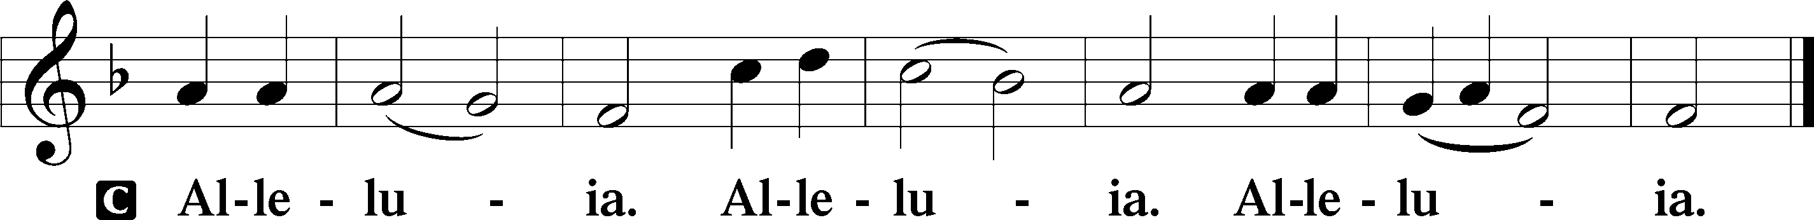

Holy Gospel: Luke 15:1–10 Luke 15:1–10
P The Holy Gospel according to St. Luke, the fifteenth chapter.

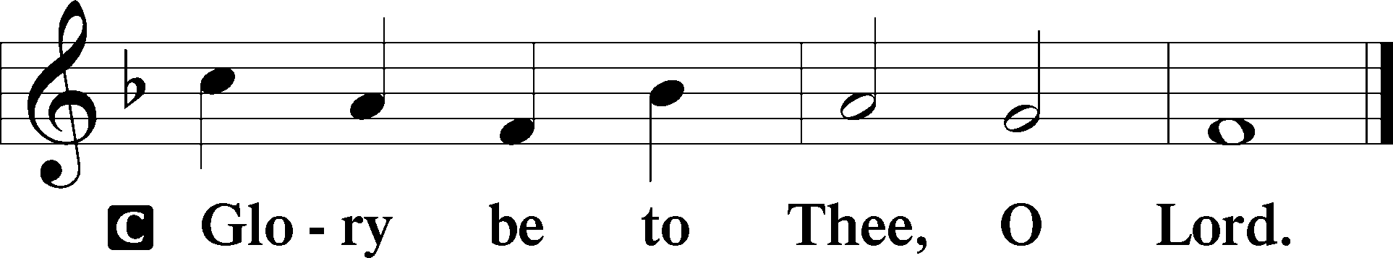

Now the tax collectors and sinners were all drawing near to hear [Jesus]. And the Pharisees and the scribes grumbled, saying, “This man receives sinners and eats with them.”
So he told them this parable: “What man of you, having a hundred sheep, if he has lost one of them, does not leave the ninety-nine in the open country, and go after the one that is lost, until he finds it? And when he has found it, he lays it on his shoulders, rejoicing. And when he comes home, he calls together his friends and his neighbors, saying to them, ‘Rejoice with me, for I have found my sheep that was lost.’ Just so, I tell you, there will be more joy in heaven over one sinner who repents than over ninety-nine righteous persons who need no repentance.
“Or what woman, having ten silver coins, if she loses one coin, does not light a lamp and sweep the house and seek diligently until she finds it? And when she has found it, she calls together her friends and neighbors, saying, ‘Rejoice with me, for I have found the coin that I had lost.’ Just so, I tell you, there is joy before the angels of God over one sinner who repents.”

P This is the Gospel of the Lord.

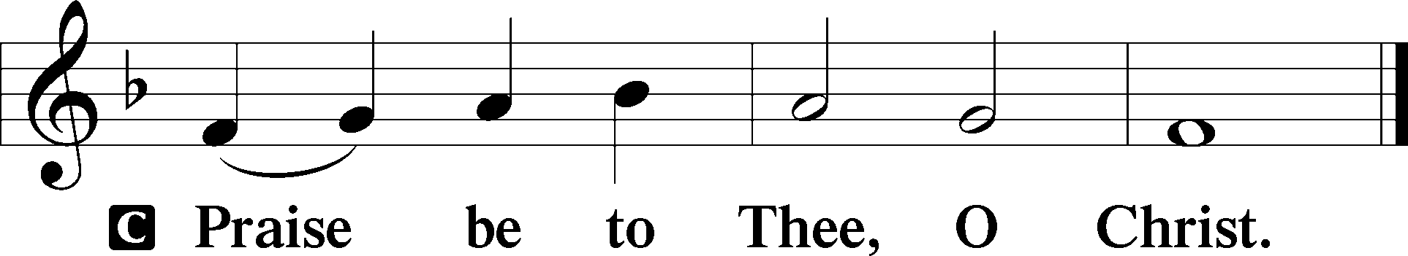
Nicene Creed
C I believe in one God,
the Father Almighty,
maker of heaven and earth
and of all things visible and invisible.

And in one Lord Jesus Christ,
the only-begotten Son of God,
begotten of His Father before all worlds,
God of God, Light of Light,
very God of very God,
begotten, not made,
being of one substance with the Father,
by whom all things were made;
who for us men and for our salvation came down from heaven
and was incarnate by the Holy Spirit of the virgin Mary
and was made man;
and was crucified also for us under Pontius Pilate.
He suffered and was buried.
And the third day He rose again according to the Scriptures
and ascended into heaven
and sits at the right hand of the Father.
And He will come again with glory to judge both the living and the dead,
whose kingdom will have no end.

And I believe in the Holy Spirit,
the Lord and giver of life,
who proceeds from the Father and the Son,
who with the Father and the Son together is worshiped and glorified,
who spoke by the prophets.
And I believe in one holy Christian and apostolic Church,
I acknowledge one Baptism for the remission of sins,
and I look for the resurrection of the dead
and the life T of the world to come. Amen.
Sit

Hymn of the Day: 588 Jesus Loves Me sts. 1, ref, 2
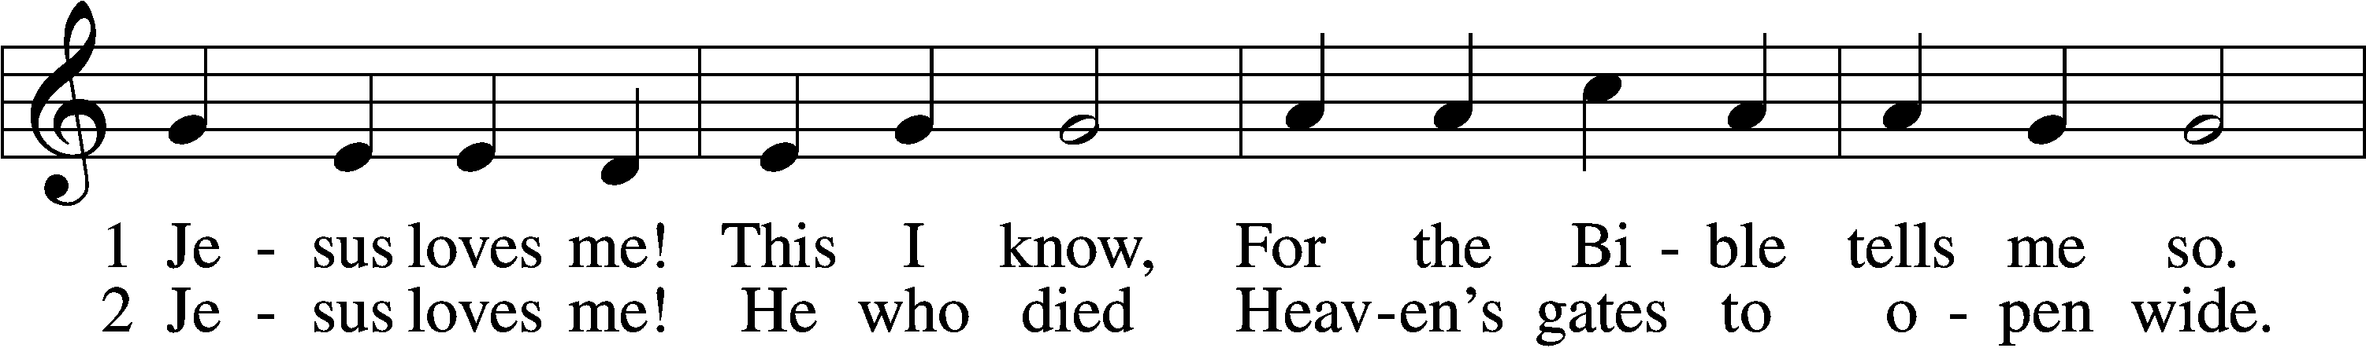
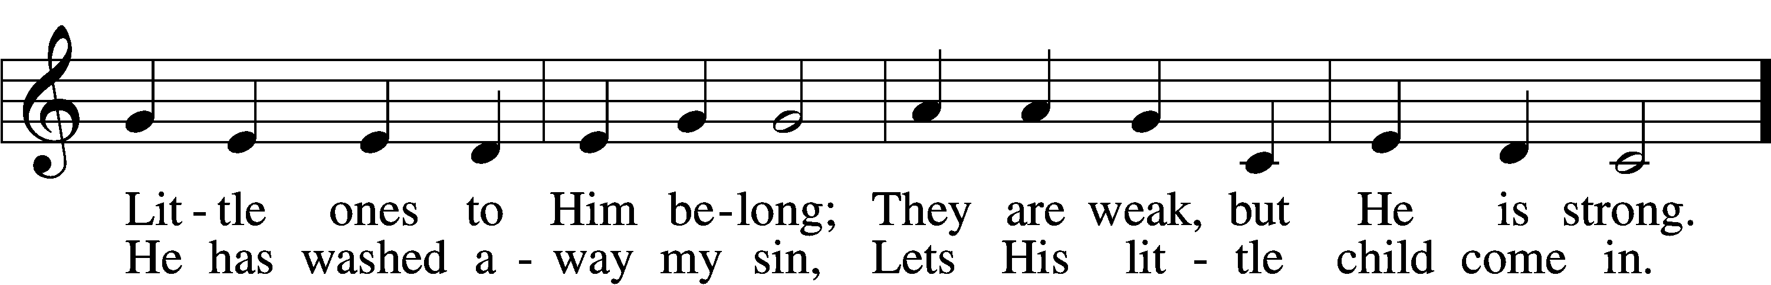
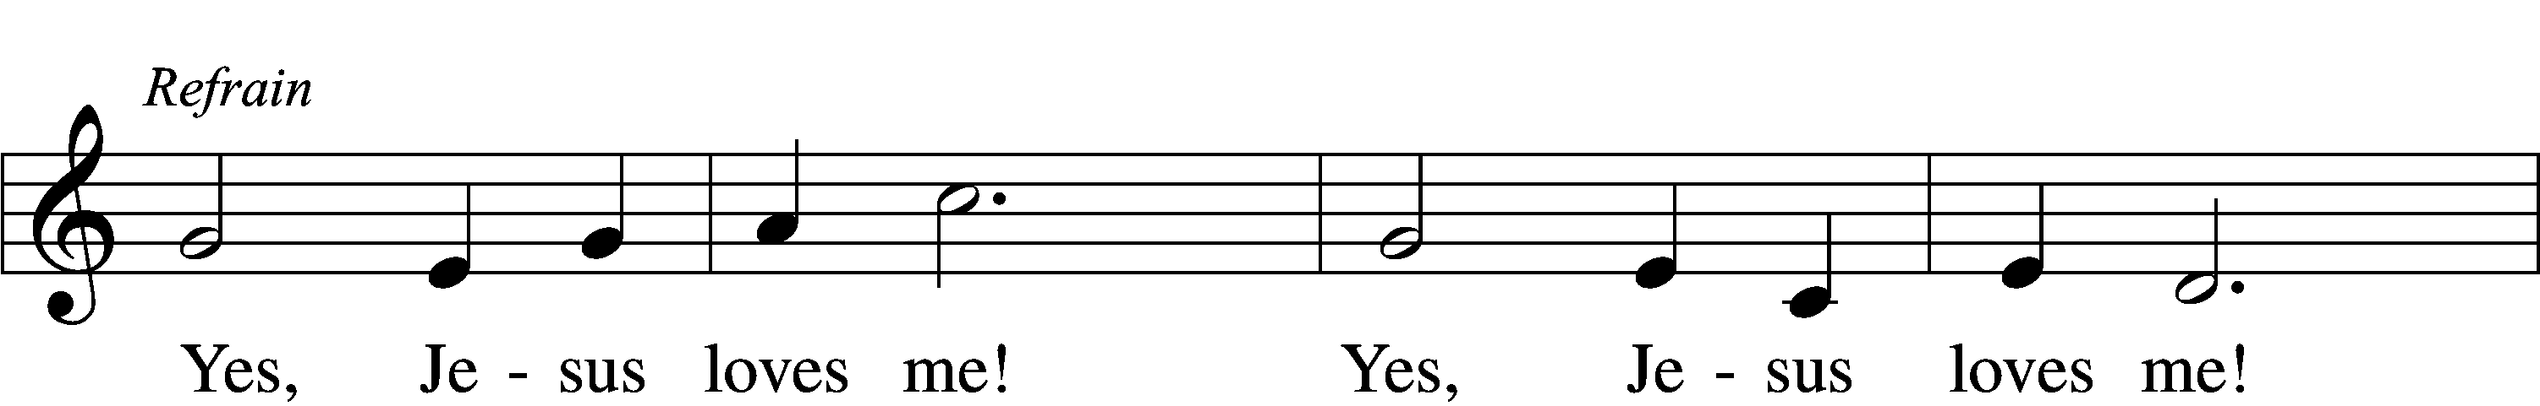
Text: Anna B. Warner, 1820–1915, alt.
Tune: William B. Bradbury, 1816–68
Text and tune: Public domain

Sermon: “The Lost Sheep” Luke 15:4

P The peace of God, which passes all understanding, keep your hearts and minds in Christ Jesus.
C Amen.

Stand

Offertory LSB 192
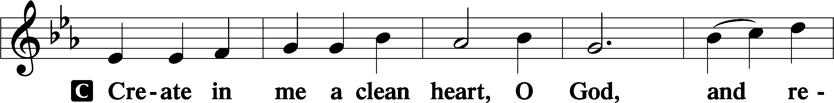
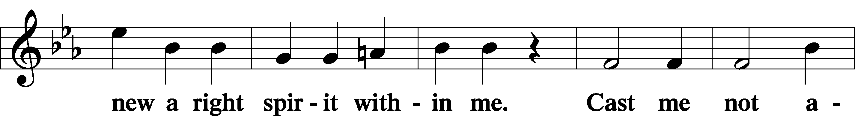
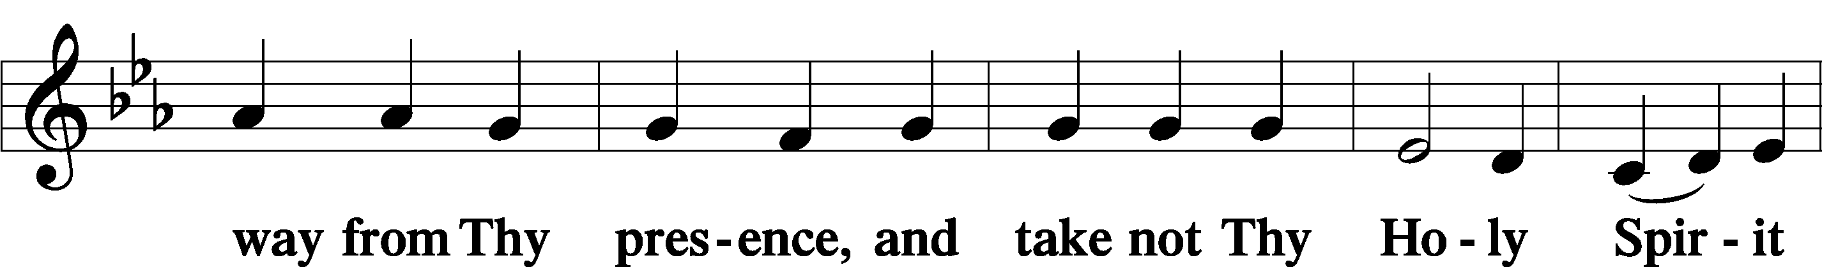
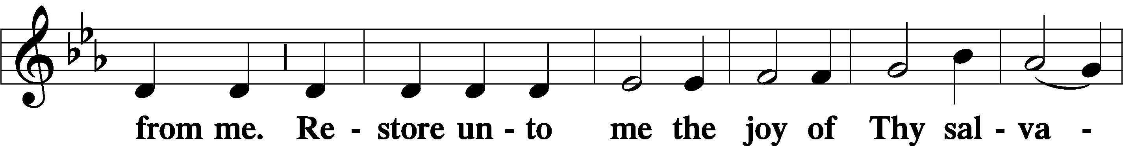
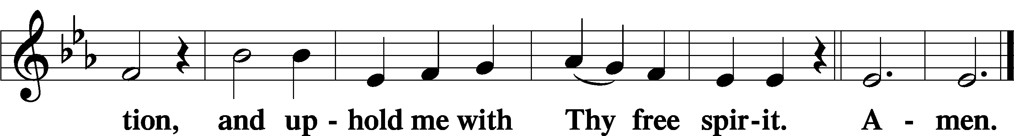

Sit

Offering

Stand

Prayer of the Church
P Our Lord, Jesus Christ, came down from heaven to seek after us lost sheep and to bring us home rejoicing. Let us call upon Him in thanksgiving and petition for ourselves and all people.
O Father in heaven, we pray to You through the Son in the Holy Spirit. Grant that we may daily recognize that You provide for our every need of body and soul. We praise and bless Your holy name for these gifts from above. Lord, in Your mercy,
C hear our prayer.

P Almighty God, You call pastors and set them to the task of shepherding Your people. Bless them in their work of providing Your gifts to those You have gathered and as they seek those who have wandered away. Lord, in Your mercy,
C hear our prayer.

P Gracious Lord, look with favor on the households of this congregation, and grant that all may live in love that issues from a pure heart, a good conscience and a sincere faith. Lord, in Your mercy,
C hear our prayer.

P O Lord, our King, You appoint princes and all governing authorities. Remember those You have placed in authority over us, and grant that they might fulfill their responsibilities according to Your Word and for the good of Your people. Lord, in Your mercy,
C hear our prayer.

P Lord of life, You heal and deliver. Hear our cries for all who are in need of strength and rescue especially the family of Iris Harmon at the passing of John Harmon, Nila Ketelhut at the passing of Merle, Josh, Violet, Alexis, David, Bradley, Tom, Brenda, Paula, Scott, Kanbi, Bill, Jack, Bridget, Ken, Lyle, Becky, and Al. Lord, in Your mercy,
C hear our prayer.

P Father in heaven, Your Son, who drew near to eat with sinners, now feeds His people with His own body and blood. Gather Your people as a shepherd gathers lost sheep. Remove from them whatever is contrary to sound doctrine and give them repentant hearts, that they might rejoice with the angels in heaven. Lord, in Your mercy,
C hear our prayer.

P Most merciful God, remember Your baptized children who have wandered from the household of faith. Pursue them as a shepherd who seeks lost sheep. Strengthen their families to persist in prayer and confidence in Your faithfulness. Lord, in Your mercy,
C hear our prayer.

P O Lord, You bring up the souls of Your people from Sheol. Receive our thanks that You restore to life Your people who go down to the pit, and preserve us in faith until we sing Your praises with them in heaven. Lord, in Your mercy,
C hear our prayer.

P Almighty God, all things are Yours, and You have promised to well supply us with all that we need. Give us courage and faith, that we may give a confident “amen” to these prayers, certain that You will give us all that is good and beneficial to our salvation and preserve us from all things harmful, for the sake of Your Son, Jesus Christ, our Lord, through whom, with whom and in whom be all honor and glory, both now and forever.
C Amen.

Service of the Sacrament

Preface LSB 194

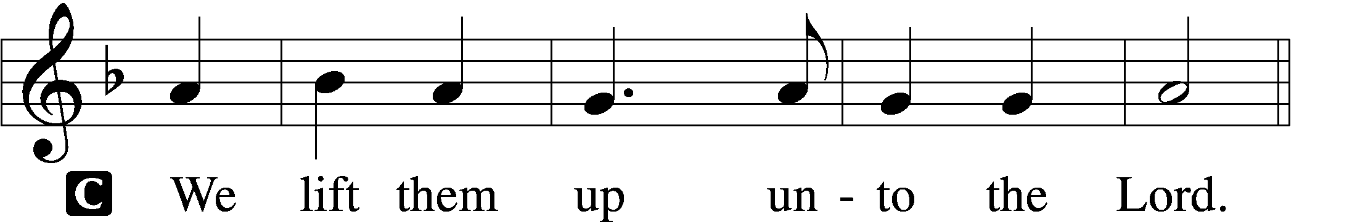

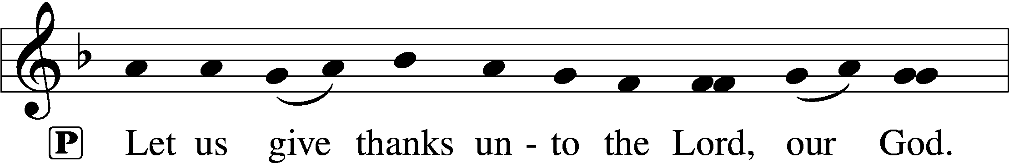
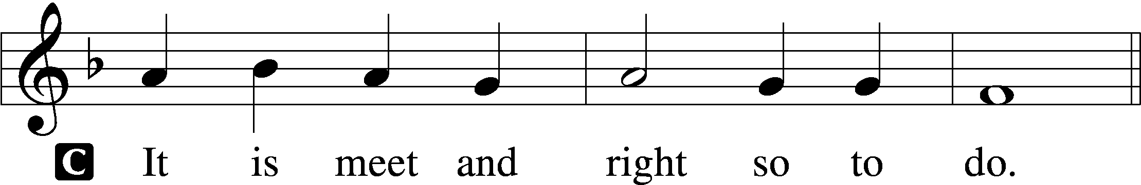

P It is truly meet, right, and salutary that we should at all times and in all places give thanks to You, holy Lord, almighty Father, everlasting God, through Jesus Christ, our Lord, who on this day overcame death and the grave and by His glorious resurrection opened to us the way of everlasting life. Therefore with angels and archangels and with all the company of heaven we laud and magnify Your glorious name, evermore praising You and saying:

Sanctus LSB 195
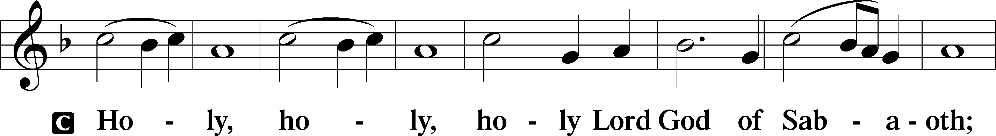
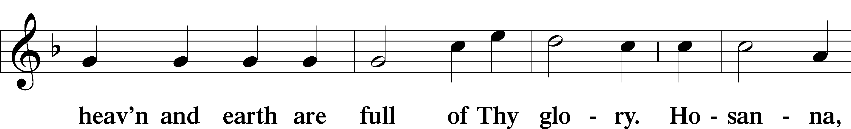
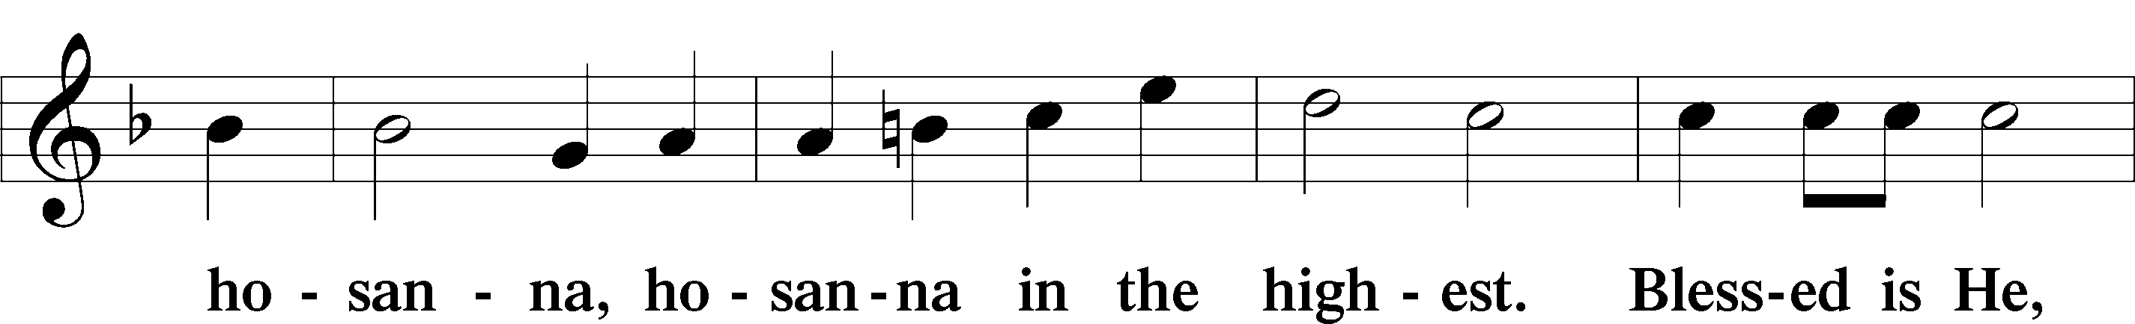
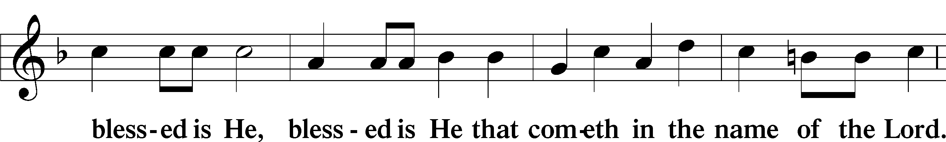
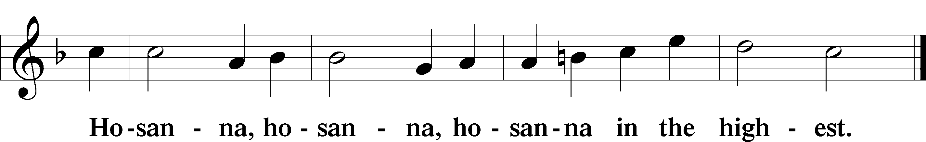

Lord’s Prayer LSB 196

Our Father who art in heaven,
hallowed be Thy name,
Thy kingdom come,
Thy will be done on earth as it is in heaven;
give us this day our daily bread;
and forgive us our trespasses as we forgive those who trespass against us;
and lead us not into temptation,
but deliver us from evil.
For Thine is the kingdom and the power and the glory forever and ever. Amen.

The Words of Our Lord LSB 197
P Our Lord Jesus Christ, on the night when He was betrayed, took bread, and when He had given thanks, He broke it and gave it to the disciples and said: “Take, eat; this is My T body, which is given for you. This do in remembrance of Me.”

In the same way also He took the cup after supper, and when He had given thanks, He gave it to them, saying: “Drink of it, all of you; this cup is the new testament in My T blood, which is shed for you for the forgiveness of sins. This do, as often as you drink it, in remembrance of Me.”

Pax Domini LSB 197
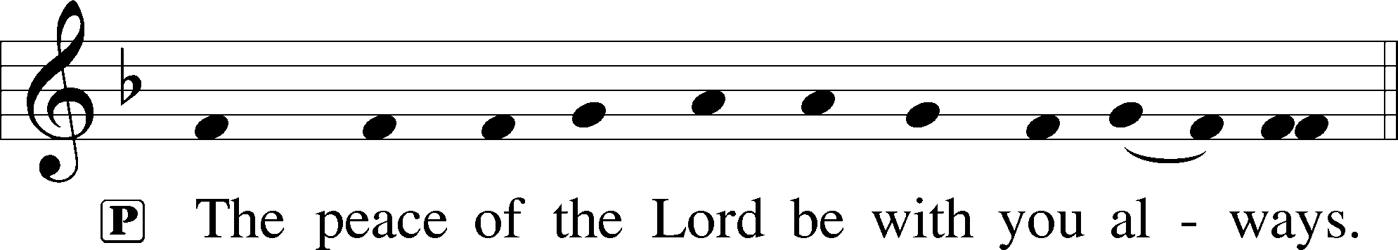

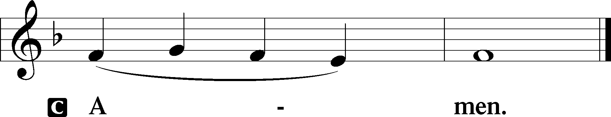

Agnus Dei LSB 198
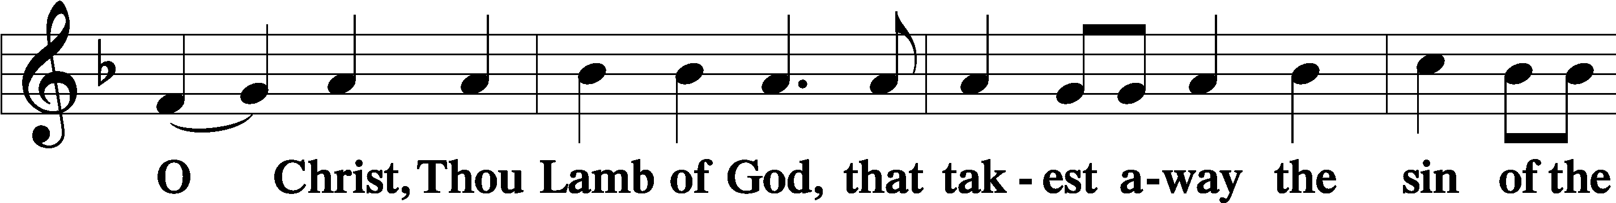
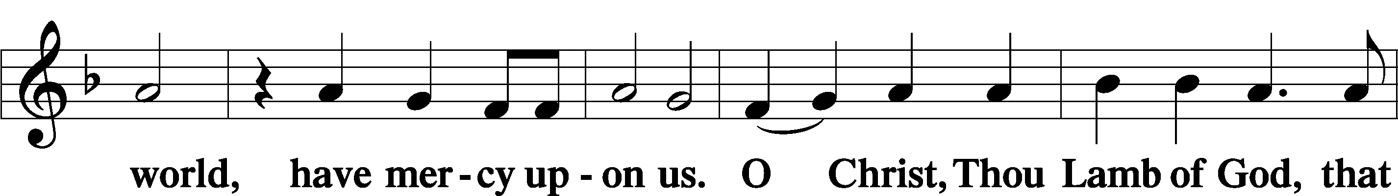
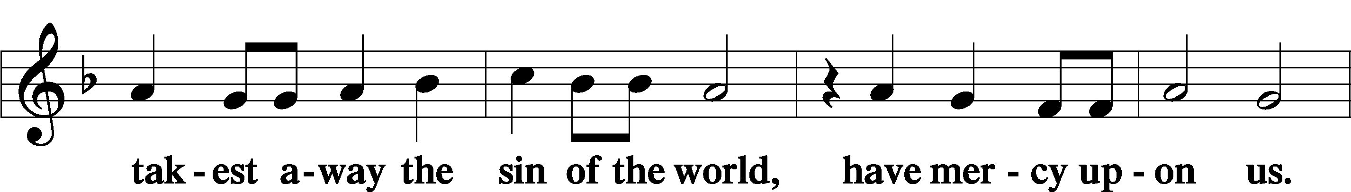
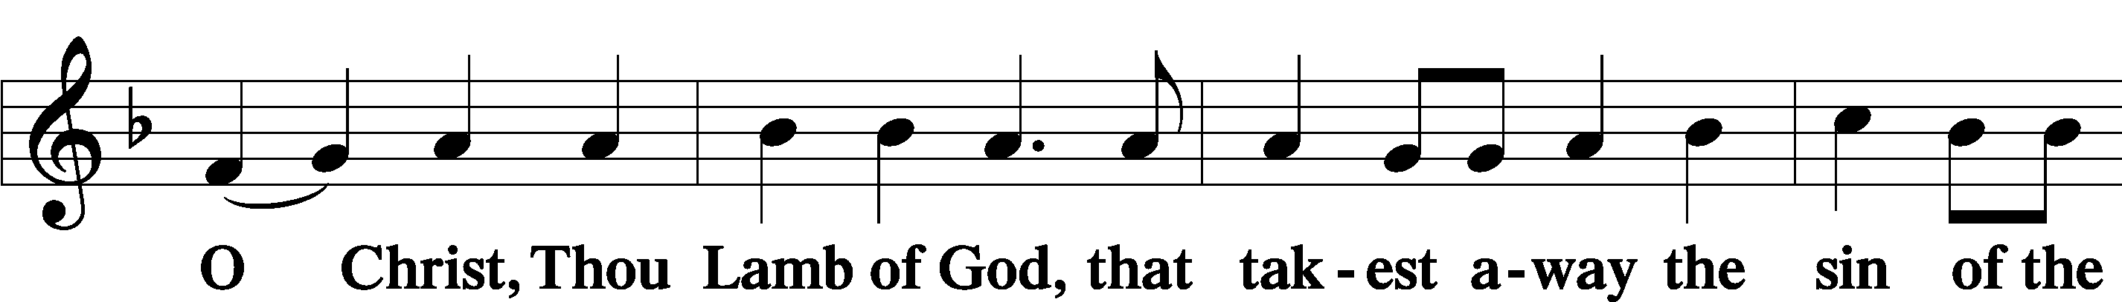

Sit

Distribution

Distribution Hymn: 618 I Come, O Savior, to Thy Table
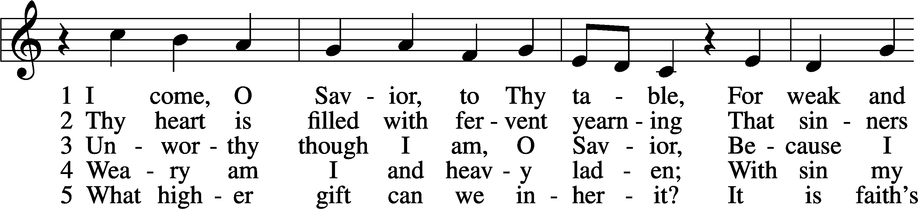
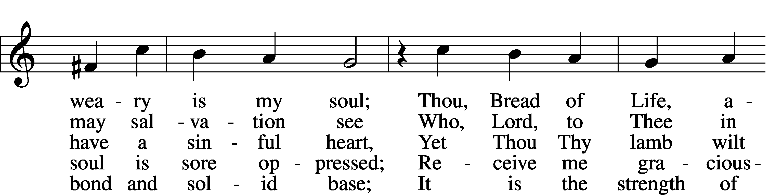
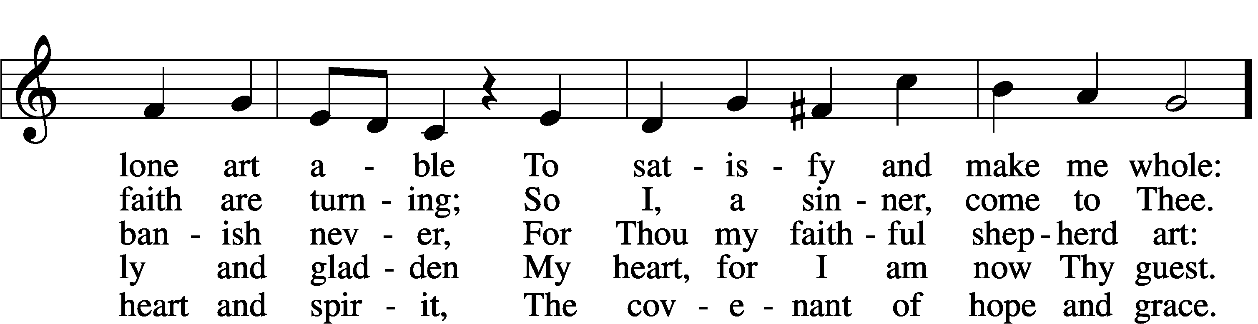
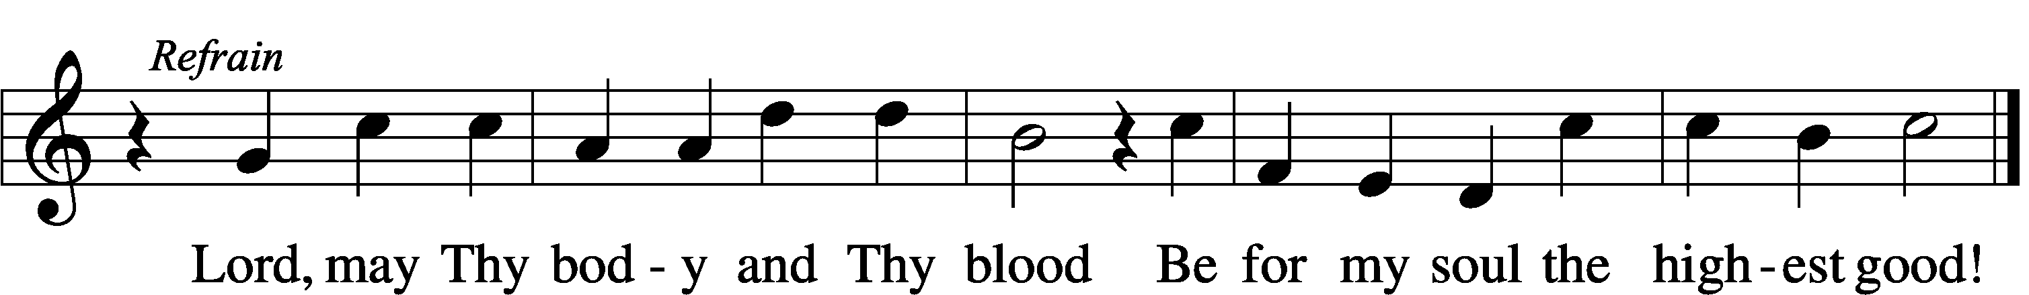
Text: Friedrich Christian Heyder, 1677–1754; tr. The Lutheran Hymnal, 1941, abr.
Tune: Emskirchner Choral-Buch, 1756, Leipzig
Text: © 1941 Concordia Publishing House. Used by permission: LSB Hymn License no. 110004828
Tune: Public domain

Stand

Nunc Dimittis LSB 199
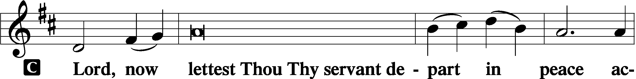

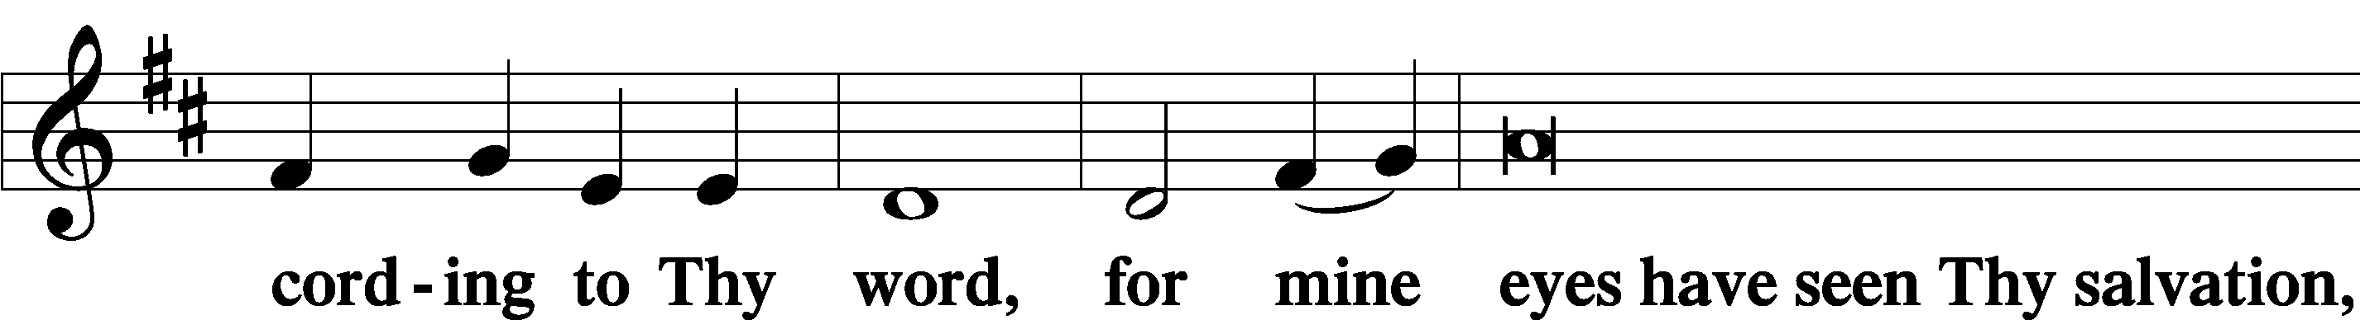

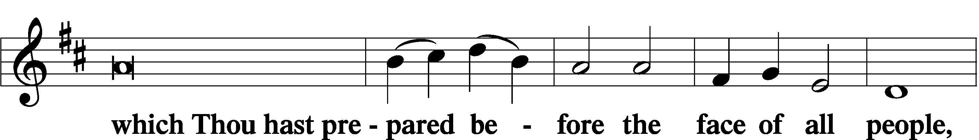

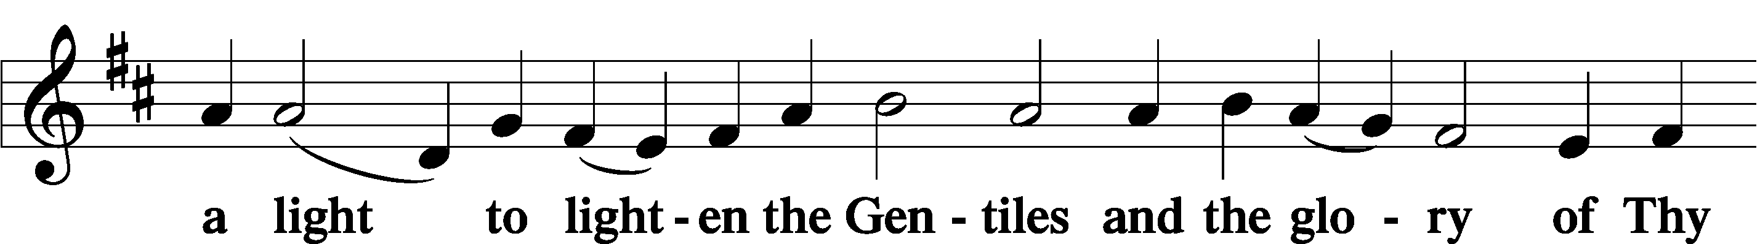

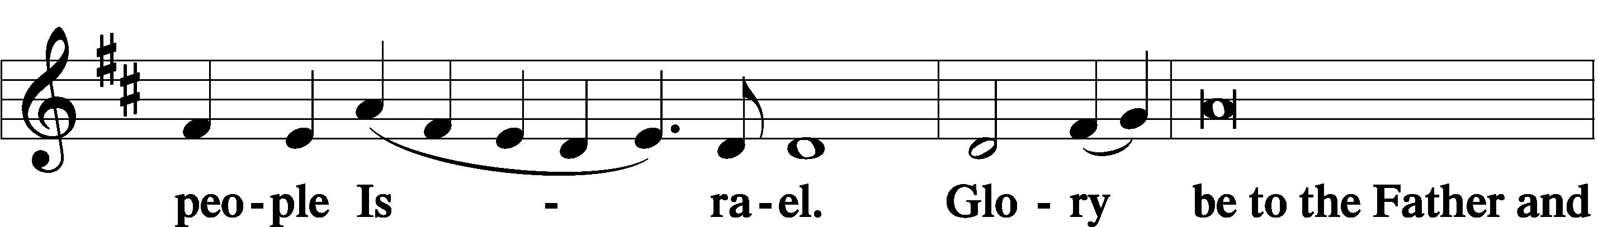

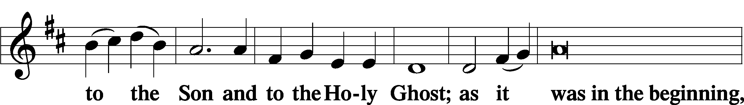

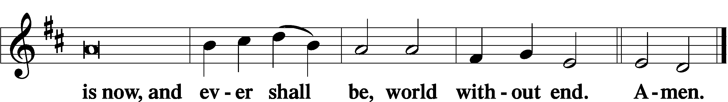

Thanksgiving LSB 200
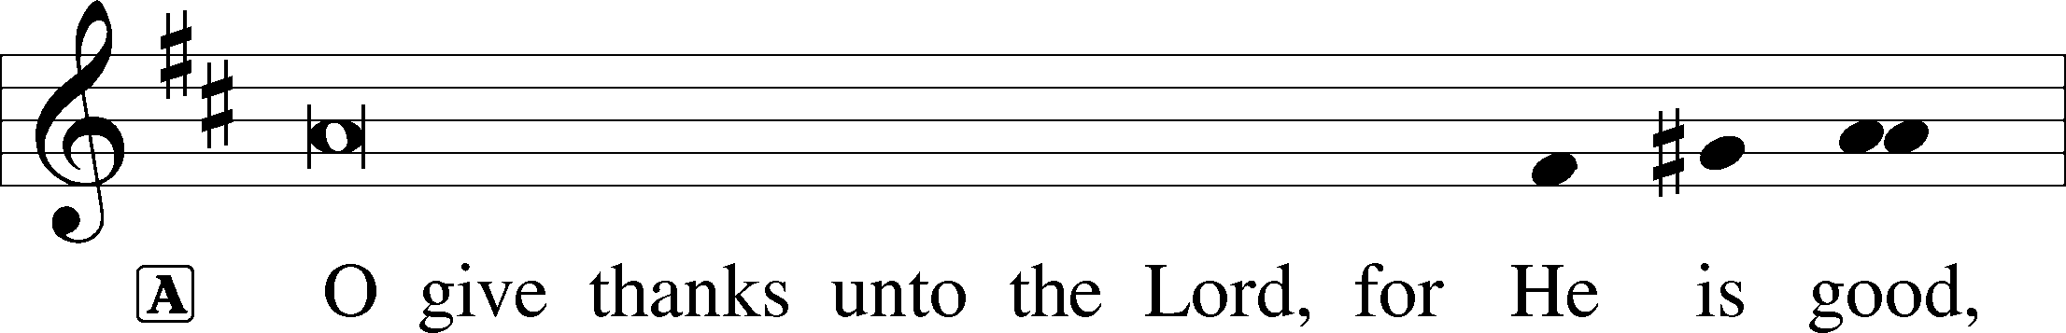

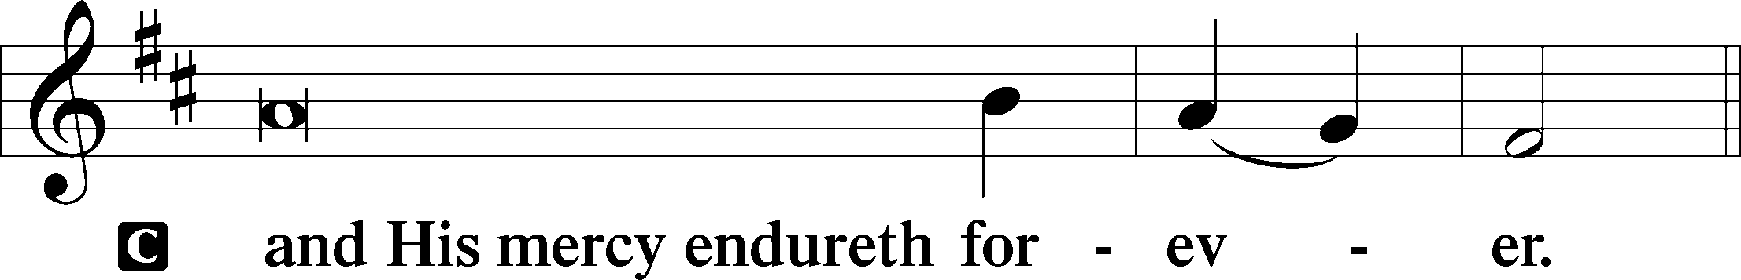

A Let us pray.
We give thanks to You, almighty God, that You have refreshed us through this salutary gift, and we implore You that of Your mercy You would strengthen us through the same in faith toward You and in fervent love toward one another; through Jesus Christ, Your Son, our Lord, who lives and reigns with You and the Holy Spirit, one God, now and forever.

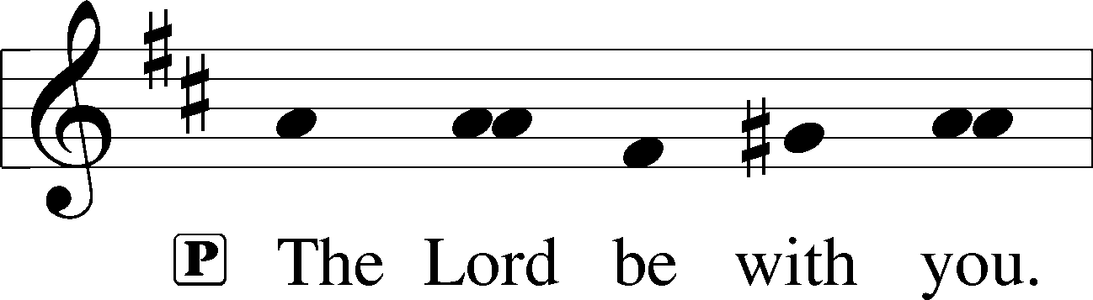

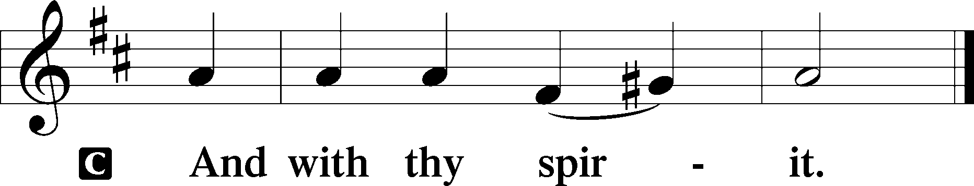

Benedicamus LSB 202
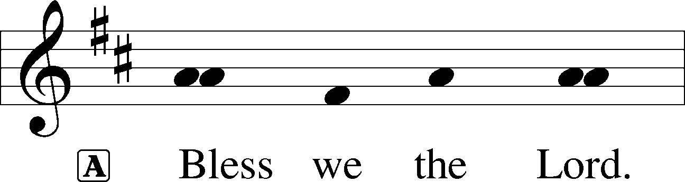

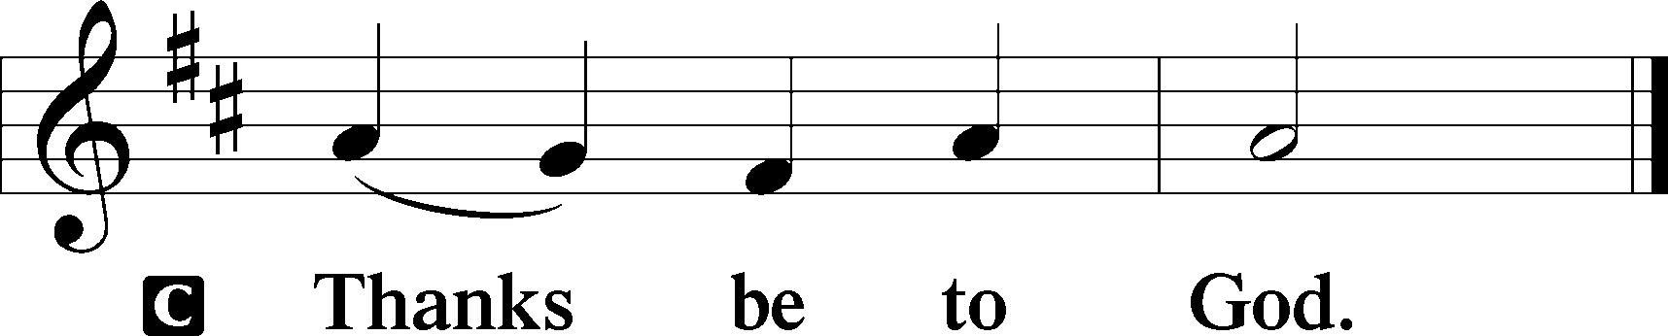

Benediction LSB 202
P The Lord bless you and keep you.
The Lord make His face shine upon you and be gracious unto you.
The Lord lift up His countenance upon you and T give you peace.
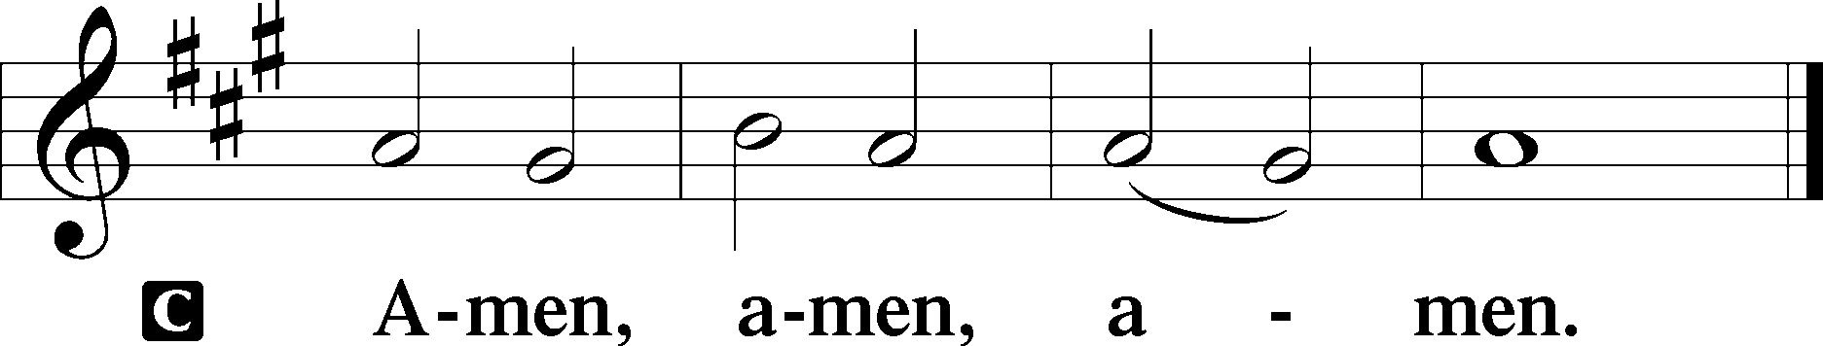

Hymn to Depart: 802 Immortal, Invisible, God Only Wise
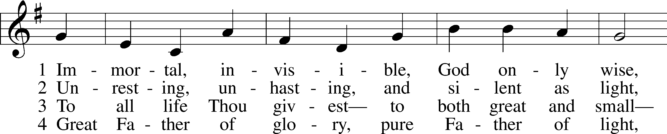
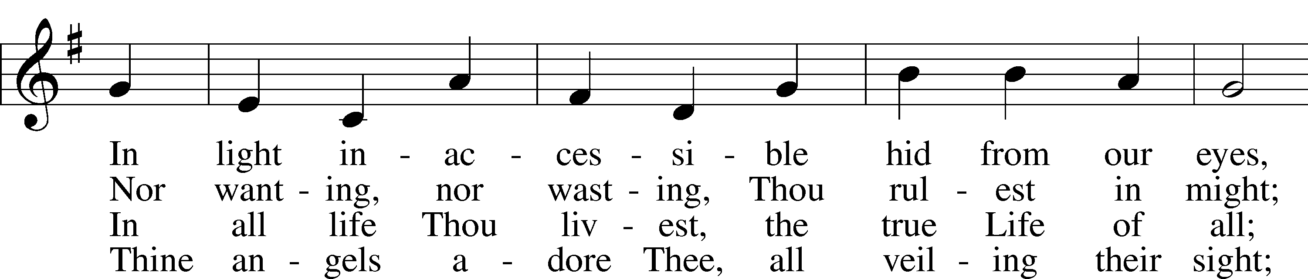
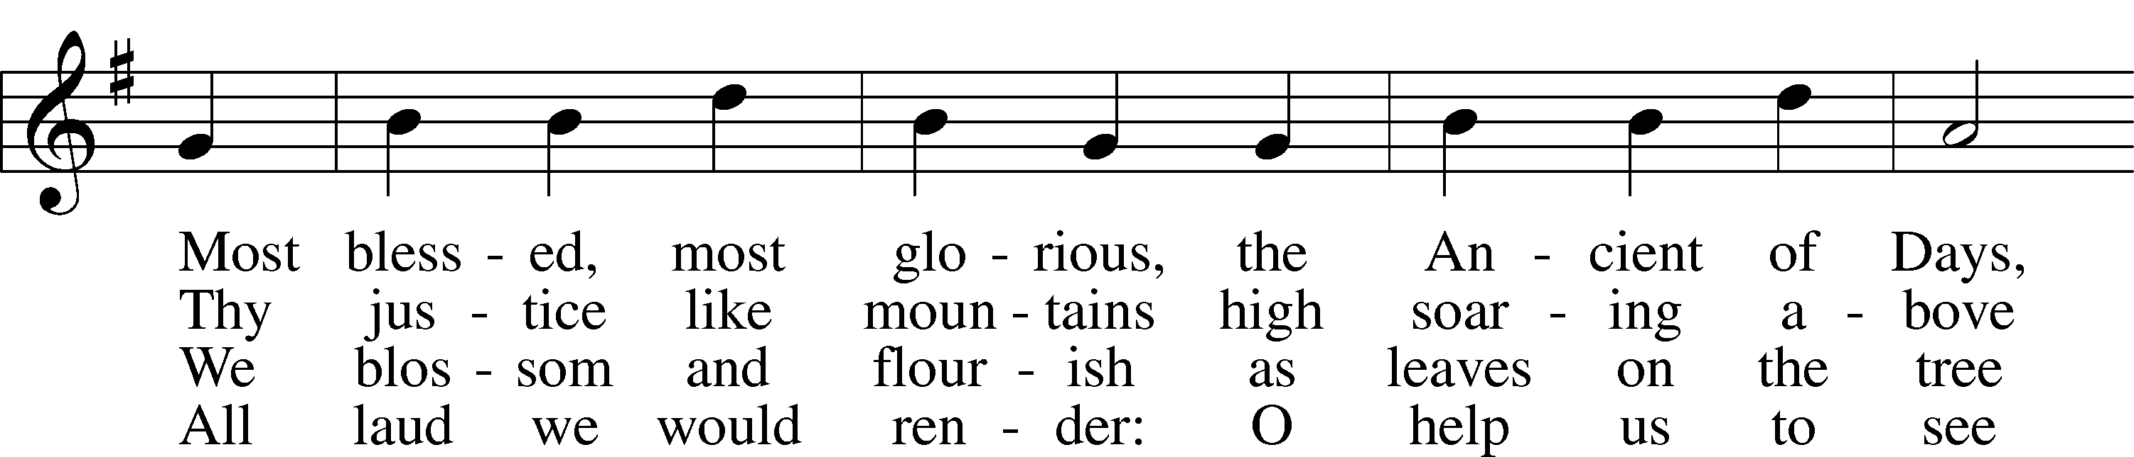
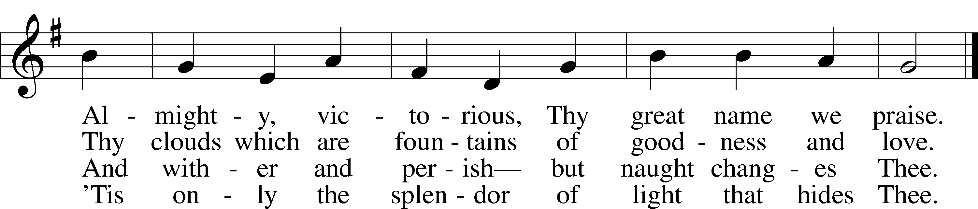
Text: W. Chalmers Smith, 1824–1908, alt.
Tune: Welsh
Text and tune: Public domain

Acknowledgments
Divine Service, Setting Three from Lutheran Service Book
Unless otherwise indicated, Scripture quotations are from the ESV® Bible (The Holy Bible, English Standard Version®), copyright © 2001 by Crossway, a publishing ministry of Good News Publishers. Used by permission. All rights reserved.
Created by Lutheran Service Builder © 2022 Concordia Publishing House.

PROPER 19C

Jesus Christ Is the Great Shepherd of His Sheep

“The saying is trustworthy and deserving of full acceptance, that Christ Jesus came into the world to save sinners” (1 Tim. 1:15). As He had mercy on Paul, in order to “display his perfect patience” (1 Tim. 1:16), so also does He seek out His sheep “from all places where they have been scattered on a day of clouds and thick darkness” (Ezek. 34:12). To deliver His flock, He “will seek the lost, … bring back the strayed, … bind up the injured, and … strengthen the weak” (Ezek. 34:16), and “they shall no longer be a prey” (Ezek. 34:22). He sets over them one great Good Shepherd, the Son of David, who “shall feed them and be their shepherd” (Ezek. 34:23). For Christ Jesus is the one man who, “having a hundred sheep, if he has lost one of them,” would “leave the ninety-nine in the open country, and go after the one that is lost, until he finds it” (Luke 15:4). When He finds the lost one and brings it home rejoicing, “the angels of God” and all the company of heaven rejoice with Him, with great joy (Luke 15:7, 10).

About the Cover: The Lord, our Shepherd, cherishes each and every one of His sheep, so much so that if one goes missing, that one sheep becomes of singular importance. He has come to seek and save the lost (Luke 19:10). Our Shepherd continues to seek out wandering and lost sheep—us and those for whom we pray—in order to bring them into the fold of His merciful forgiveness, won by His cross and eternal protection.

Those who have been hospitalized, homebound, in care centers or have special needs: the family of Iris Harmon (Mary Harmon’s sister-in-law) at the death of John Harmon, the family of Nila Ketelhut at the passing of Merle, Josh Stangeland (Melanie Olson’s step-nephew), Violet Dominiack (Terry Dominiack’s wife), Lorna DeHaai, Alexis Valenzuela, (Gary and Connie Cleland’s granddaughter), David Leheska, (Jeanne Mueller’s nephew), Bradley Haynes (Linda Mason’s nephew), Tom Fenenga (Ann Powers’ father), Brenda Bultsma (Barb Powell’s sister-in-law), Paula Grussing, Scott Busack, Kanbi Knippling, Bill Dahlman, Jack Kahlman (Judy Lulf’s brother), Bridget Lake (Karen Ristau’s sister-in-law), Ken Olinger (Lila Speckel’s brother), Lyle DeHaai, Becky Rybak, Rev. Al Althoff.

“If you are sick, in need of prayer, encouragement, comfort, or basic needs and would like to be put in the weekly prayers please contact the church office or pastor!”

EVENTS FOR THE COMING WEEK

Saturday, Sept 10 Divine Service 7 p.m.
Sunday, Sept 11 Divine Service 9 a.m.
Mite Sunday Fellowship Time 10 a.m.
Sunday School, Confirmation Class and Youth Bible Study 10:15 a.m.
Monday, Sept 12 Plarn Sleep Mat Project at Balance Studio, 5 p.m.
Tuesday, Sept 13 Circuit Pastor’s Meeting in Presho 10 a.m.
Marriage Class and Bible Study 6:30 p.m.
Wednesday, Sept 14 Marriage Class and Bible Study 5:30 p.m.
Elders Meeting 7 p.m.
Church Council Meeting 8 p.m.
Thursday, Sept 15 LWML Meeting 5:30
Saturday, Sept 17 Divine Service 7 p.m.
Sunday, Sept 18 Divine Service 9 a.m.
Sunday School, Confirmation Class
and Youth Bible Study 10:15 a.m.

ACOLYTE SCHEDULE
This week: Clara Lutter, Saturday, September 10
Jade Ristau, Sunday, September 11

Next week: Lucy Swanson, Saturday, September 17
Kaden Thompson, Sunday, September 18

ANNOUNCEMENTS

Sunday School and Confirmation Classes Begin this Sunday, September 11th:
Children will meet in the sanctuary after service at 10:15. Confirmation students will meet in the sanctuary at the same time.

Marriage Class and Bible Study:
Bible study and marriage class on Genesis will be held Tuesday from 6:30-8 p.m. and Wednesday 5:30-7 p.m. this week. Tuesday will have the most people attending. Come Wednesday for a more individual experience. Please let us know if you can help out with desserts and/or appetizers, music, couple testimonies, or any other volunteer opportunities by emailing us at rmhjr2@gmail.com. The class runs until the end of October. Come as you are able.

LWML Updates:
*Youth Encouragement Project: There is still time to turn in your forms for the Youth Encouragement Project! Please fill out a form for your teen and put in the box on the glass case in the Fellowship Hall.
* September 12th, there will be a Plarn Sleep mat (plastic bag mats) work day at Balance Studio, Stephanie Swanson’s gym, 302 Antelope Drive, at 5-7 pm. Bring your own scissors if you like. We will help her students willing to help with this service project make Plarn (plastic yarn balls). Do you crochet? Want Plarn balls to crochet into mats over the winter? We can get some of those to you with instructions for the mats.
*The next LWML group meeting will be Thursday, September 15 at 5:30 p.m. All women are invited to come sample some freezer meals and discuss the annual fundraiser and mission project. Feel free to bring one of your favorite freezer meals to share if you would like.
* Group 3 of LWML will serve September 11 (second Sunday of the month) for Mite Sunday instead of Labor Day weekend. Group 3 will serve treats and coffee and collect Mite offerings. An LWML prayer time led by Colleen will start after first helpings of coffee and treats served. We would like to pray for students, confirmands, teachers, leaders, and our pastor as they begin a new Christian education year. If there is interest, we will resume doing a prayer time on the second Sunday of the month.
*Sunday Fellowship: LWML groups will still be called upon on the first Sunday of the month for serving and providing treats for Mite Sunday for supporting mission grants. Starting in September, we will start a trial for a few months of LWML making available purchased treats (donuts or pastries) all other Sundays. Free will donations for covering the treat cost will be requested. All other Sundays except Mite Sunday will be a community style service where church members in attendance are asked to make coffee and help yourselves to coffee and provided treats and clean up after yourselves. A sign with expectations for the community kitchen clean up will be posted. If this is sustainable with free will offering and volunteer service, then we may continue. We hope to improve the consistency of fellowship time while keeping our demand on LWML service groups minimized. Please, help when you are present and able.
* Chamberlain Zone Fall Rally will be held September 24, 2022 at Messiah Lutheran Church in Murdo, SD. Registration is at 9:30 a.m. and the rally ends around 2 p.m. The Reverend Greenseth will lead the Bible Study.

LAST WEEK’S ATTENDANCE AND OFFERING
Attendance
Saturday, September 3 13
Sunday, September 4 53
Offering
General Offering, September 3 & 4 $ 2,286.00
Simply Giving and Online Giving $ 866.30
Total $ 3,152.30

NEXT WEEK’S LESSONS Fifteenth Sunday After Pentecost: 1st Reading: Amos 8:4-7 Epistle: 1 Timothy 2:1-15, Holy Gospel: Luke 16:1-15.

A Life Thought in the Church Year for September 11 – Pentecost XIV (Proper 19): Our culture discriminates based on size, skills, and circumstances in order to make abortion and assisted suicide possible. But our Lord and God has a soft spot, a definite preference for the feeble (Ezekiel 34:16), the insignificant (Luke 15:8-10), and the failures (1 Timothy 1:15). If it gladdens Him to save such as us, won’t it also enrapture us to advocate the sanctity of every life?

MAIN STREET LIVING
Starting on Sept. 11, the program will air at 8:00 a.m. due to football. It will return to 9:00 a.m. sometime in February
Sept. 11, 2022 KDLT (NBC) channels 5.1 / 46.1
10:00 AM - “A Nice Girl Like You” - A widowed pastor dates a middle aged single woman in his parish, but when she professes her love he tells her he cannot return it.
10:30 AM - Rev. Randy Sturzenbecher, pastor at Divine Shepherd Lutheran in Black Hawk, presents a message titled “Eyes That See Jesus.” This sermon is based on Luke 10:23-37.

Sept. 18, 2022 KDLT (NBC) channels 5.1 / 46.1 10:00 AM - “But Not For Lunch” - A man has difficulty adjusting to retirement until he turns his time over to the Lord. 10:30 AM - Rev. John Fries, pastor at Grace and Blessed Emmanuel Lutheran Churches in Deadwood and Sturgis, presents a message titled “God and Mammon.”

KFUO Radio, the broadcast voice of The Lutheran Church—Missouri Synod, shares Christ for you anytime, anywhere on KFUO.org via worship services, Bible and theology studies, practical talk programs, and sacred music. Find programs on demand at kfuo.org and wherever you get your podcasts! Find us on social: @KFUOradio on Facebook, Twitter, and Instagram.
CHRIST FOR YOU this week on KFUO.org: Hear Rev. Brady Finnern as the new host of Concord Matters (formerly host of Thy Strong Word) beginning 9/24 at 10:00 a.m. CT, study Deuteronomy 27-28 on Sharper Iron's "The Law of God is Good and Wise" (weekdays at 8:00 a.m. CT), and study 1 Corinthians 6-7 on Thy Strong Word (weekdays at 11:00 a.m. CT). Find these programs on demand at kfuo.org or the KFUO Radio app!

Lutheran Family Service:
Farming is Tough, Let God Lend you His Strength!
Biblical evidence that farmers are among the blessed in God’s creation and of the strength He offers you:
PSALM 46:1-3
God is our refuge and strength, an ever-present help in trouble. Therefore we will not fear, though the earth give way and the mountains fall into the heart of the sea, though its waters roar and foam and the mountains quake with their surging.
DEUTERONOMY 28:8
The LORD will send a blessing on your barns and on everything you put your hand to. The LORD your God will bless you in the land.
ISAIAH 41:10
So do not fear, for I am with you; do not be dismayed, for I am your God. I will strengthen you and help you; I will uphold you with my righteous right hand.
ISAIAH 30:23
He will also send you rain for the seed you sow in the ground, and the food that comes from the land will be rich and plentiful. In that day your cattle will graze in broad meadows.
PHILIPPIANS 4:6
Do not worry about anything, but in everything by prayer and supplication with thanksgiving let your requests be made known to God. And the peace of God, which surpasses all understanding, will guard your hearts and your minds in Christ Jesus.

Birthdays

Sept 9 Charles Swanson, Jake Swanson
Sept 14 Sally Rohrback
Sept 15 Tina DeHaai, Maxwell Kelsey, Lauren Swanson, Hollie Taber
Sept 16 Rexton Larson, Kammie Thompson
Sept 17 Julie Bode
Sept 18 Richard Hansen

Baptismal Anniversaries

Sept 10 Hope Lutter
Sept 11 Kathy Randall
Sept 13 Michael Engel
Sept 14 Lillianna McGhee
Sept 16 Ryder Bunnell
Sept 17 Belinda Holscher, Sutton Swanson, David Thompson
Sept 18 Ed Swanson, Tavi Larsen, Brady Bunker

December ust

Anniversaries

Sept 14 Russ and Renae Bunker
Sept 15 Jonathan and Courtney Tyrrell

