**Office number: (507)-427-2451**

**August 2015 Vol. 8, Issue 109**

**Newsletter**

# C:\Users\Trinity Office\Desktop\Trinity Evangelical Lutheran Church MN_files\KUFAHL-PETER-112.jpg **Pastor Kufahl …. Continue on page 3**

Another year of the Appalachian Servant Event has come and gone. In our time there, we were honored to serve four different families: One family received a new drainage field for their septic system, two families had repair work done to the interior of their home where water had rotted away a part of the flooring, and another family received a new deck as the old one was dangerously falling apart. It was a lot of work with a good share of unexpected surprises, yet by 5 pm on Tuesday evening all of the sites were completed to God’s glory.

Although the physical work of the event takes up a good share of time, and the worksites play a significant role, their importance pales in comparison to what takes place amongst the youth who attend. Every year brings in a new batch of servants from all walks of life. And once those vans pull into the parking lot of Emmanuel Lutheran, the real magic begins. Old friends are reunited with hugs and excitement. Introductions and welcomes to complete strangers take place with offers to carry luggage to their new bedroom for the next ten days. Then these amoeba type blobs of youth begin to form. Before long, the individual blobs merge into one large blob of youth, talking and laughing and enjoying one another.

In no time at all, guards are let down. It is vital that the Servant Event be a safe place, where youth can feel they can safely share anything that is going on in their lives... and do they share.

**“The heavens are telling the glory of God and the expanse (of sky) declares His handiwork.” Psalm 19:1**

For my money, this is the best time of year to do home visits. Gardens and flower beds and pots and window sills are all in bloom. Never is there a lack of things to talk about. Lesson after beautiful illustration after perfect picture demonstrates the creative work of a loving God. Our members often liken the spending of time working with their hands in the soil to being with God. To nurture His blossoming blessings and tend to every flower-full fancy is time well spent. During this time they are happy. During this time they are at peace.

**“Give thanks to the Lord, for he is good, for his steadfast love endures forever.” Psalm 136:1**

In our Lord’s magnificent creation He provides many and myriad ways for us to behold His handiwork and feel His presence. Even under the curse of sin He continuously visits earth with His glory. It cannot be hidden. It is a great blessing to experience God in this way. We give thanks unto the Lord for He is good. As the Psalmist repeats again and again, “His chesed”—His tender-lovingkindness—“endures forever”.

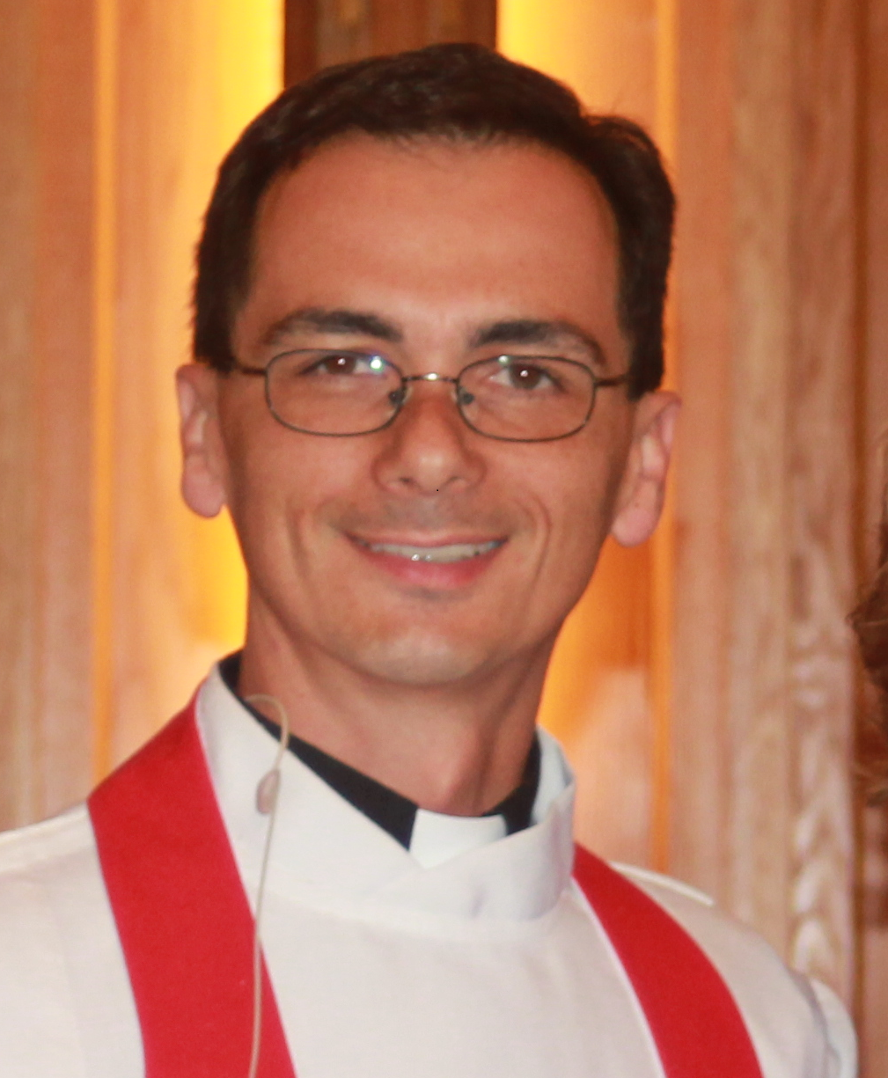 **Pastor Perkins**  “**God Visits” …Continue on page 3**

***Important Dates:***

* **August 19**

Confirmation Meeting

**• August 20**

Church Council

**• August 24**

Blessing & Donuts

**• August 26**

JrLYF

***Individual Highlights:***

**Church Council**

**Updates**

**Youth info**

**Devotions**

**Bd/Stewardship**

**Calendar**

## August Baptism

# ***Alexandra Fiala – 8/10***

# ***Keara Anacker - 8/12***

# ***Annika Brinkman – 8/13***

# ***Kelly Watkins – 8/17***

**Ryleigh Karschnik – 8/25**

**Alayna Kufahl – 8/31**

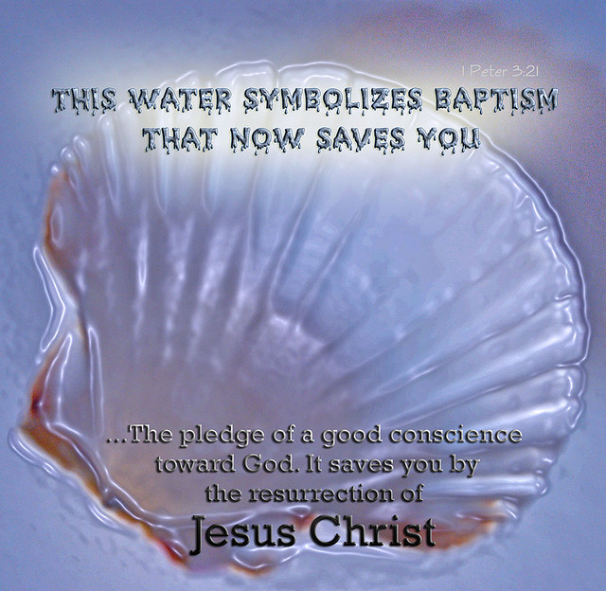

## August Anniversaries

**Mr. & Mrs. George Oltmans, 2nd**

**Mr. & Mrs. Wayne Maras, 3rd**

**Mr. & Mrs. Keith Pankratz, 3rd**

**Mr. & Mrs. Lonny Eads, 6th**

**Mr. & Mrs. Alan Coners, 7th**

**Mr. Mrs. Tim Coners, 9th**

**Mr. & Mrs. Delyle Harris, 11th**

**Mr. & Mrs. Curt Feil, 13th**

**Mr. & Mrs. Mark R. Hanson, 15th**

**Mr. & Mrs. Dick Siefkes, 15th**

**Mr. & Mrs. Wayne Bennett, 16th**

**Mr. & Mrs. Rod Hamilton, 19th**

**Mr. & Mrs. Jason Jepsen, 19th**

**Mr. & Mrs. Kevin Karschnik, 20th**

**Mr. & Mrs. Bruce Cowell, 21st**

**Mr. & Mrs. Valy Kounlabout, 21st**

**Mr. & Mrs. Steven Kremmin, 21st**

**Mr. & Mrs. Steve Penner, 21st**

**Mr. & Mrs. Lucas Karschnik, 22nd**

**Mr. & Mrs. Kent Karschnik, 23rd**

**Mr. & Mrs. Taylor Nesmoe, 25th**

**Mr. & Mrs. Jordan Brugman, 26th**

**Mr. & Mrs. Michael Quade, 28th**



## Updates

**Memorials given**:

Anna Watkins ~ $10

**Anniversaries celebrations**:

Dennis & Julie Brugman 40th Anniversary ~ $40

Earl & Arlene Karschnik 60th Anniversary ~ $60



***You should at all times remember them in your prayers, put them in mind of their baptism, and as much as in your lives, lend them your counsel and aid.***

**Twins Game???**

We are looking to see how much interest we can get to go to a Twins game on August 14 against the Indians. We need enough adults to accompany and drive for this. If you are interested, contact the church office by Friday, August 7 at noon.

**Blessings and Donuts**

Hard to believe the school year is soon upon us! Once again, this year we will be offering a time of blessings for any students/teachers prior to the start of school on Monday morning. Donuts and juice will be provided.

## …. continue Pastor Kufahl

And it is not just with their fellow youth, but with the adult leaders and the pastors who are there. It would be one thing if these issues were just talked about, but following the talking and the listening another step takes place. "Let's pray about this." Hands are held, heads are bowed, and in turn verbal petitions are carried up to the ears of the Lord.

For it is under the cross of Christ and the forgiveness that is found there, we can share with one another those sins that haunt us. Stupid mistakes, addictions, self-inflicted pain, doubts, temptations, horrible things that others have done to them... they all come out with the peace of knowing that because of Jesus, someone truly cares about them. They care enough about one another to listen, pray for, forgive, encourage, help, and do anything they can in order to be there for their fellow servant... Just as Christ is there for them.

To break apart such a community is a hard thing to do, but all servants need to go back to the life they once knew. Those lives are not always easy or pretty, but one goes knowing that there is a support group that is only a text message and a prayer away. And knowing that you are not alone makes those burdens that you have to face not so burdensome anymore.

Wouldn't it be great if Trinity could be like that? To offer our members and our community a safe place where one is welcomed and not afraid to share their stupid mistakes, addictions, self-inflicted pains, doubts, temptations, horrible things that others have done? Wouldn't it be great if we could offer a place, where servants from all walks of life just couldn't wait to walk in our doors week after week, because the people of God there really care for one another in Christ?

As a congregation, I pray that this would be our goal: that Trinity and her members would be that safe place as we share the love of Christ Jesus. At times, we do an amazing job at this, while other times... well... we could be better. Think about how many of our members we have who have not stepped foot through our doors for some time. Think of how many members (active and inactive) who are carrying burdens of pain and sin, and are too afraid to share it? What about members we may have hurt by our anti-servanthood? These are our members who need that love of Christ showed to them.

I know that I am not always perfect in expressing that patient love of Christ. I know that I can do a lot better. Yet we have a God who is perfect in showing that love through the death and resurrection of His Son. My fellow servants in Christ, by the work of the Holy Spirit within us, led by Word and Sacrament, may our Lord lead us to care for one another in the true light of Jesus. I can't WAIT to see you soon!

.

## … continue Pastor Perkins

This rightly puts us in mind of Christ leaving the throne, giving up the glories of heaven, and visiting us. This rightly reminds us that no cost was so great as to prevent our God from splitting open the skies and riding to our rescue. The Author of Life visited His creation to buy it back. Everything which was required was provided. The righteous demands of the Law were fulfilled and out way to paradise was paved. We need no longer fear the wages of our sin. Our death has been nullified.

**“Behold, I am with you always, to the end of the age.” Matthew 28:20**

And if all of these things were not enough, our God has gone even further. His promise to be with us is not empty or hollow. It’s real. He watches over us. He answers our prayers. He visits us again and again. As sinful creation takes its toll on our bodies and our faith He comes. He restores our faith. He renews our strength. He mends our wounds.

**“I was glad when they said to me, “Let us go to the house of the Lord!” Psalm 122:1**

His house stands open and ready for faithful children to come and receive—to be visited by grace. God is in this place. Come for a God visit.

**Daily Devotion...**

**August 1, Psalm 65-67; Romans 2**

**August 2, Psalm 68-69; Romans 3**

**August 3, Psalm 70-72; Romans 4**

**August 4, Psalm 73-74; Romans 5**

**August 5, Psalm 75-77; Romans 6**

**August 6, Psalm 78; Romans 7**

**August 7, Psalm 79-81;**

**Romans 8:1-18**

**August 8, Psalm 82-84;**

**Romans 8:19-39**

**August 9, Psalm 85-87; Romans 9**

**August 10, Psalm 88-89; Romans 10**

**August 11, Psalm 90-92;**

**Romans 11:1-21**

**August 12, Psalm 93-95;**

**Romans 11:22-36**

**August 13, Psalm 96-98; Romans 12**

**August 14, Psalm 99-102; Romans 13**

**August 15 Psalm 103-104; Romans 14**

**August 16, Psalm 105-106;**

**Romans 15:1-21**

**August 17, Psalm 107-108;**

**Romans 15:22-33**

**August 18, Psalm 109-111;**

**Romans 16**

**August 19, Psalm 112-115; 1 Corinthians 1**

**August 20, Psalm 116-118; Corinthians 2**

**August 21, Psalm 119:1-48; Corinthians 3**

**August 22, Psalm 119:49-104; Corinthians 4**

**August 23, Psalm 119:105-176; Corinthians 5**

**August 24, Psalm 120-123; Corinthians 6**

**August 25, Psalm 124-127; Corinthians 7:1-24**

**August 26, Psalm 128-131; Corinthians 7:25-40**

**August 27, Psalm 132-135; Corinthians 8**

**August 28, Psalm 136-138; Corinthians 9**

**August 29, Psalm 139-141; Corinthians 10:1-13**

**August 30, Psalm 142-144; Corinthians 10:14-33**

**August 31, Psalm 145-147; Corinthians 11:1-15**

BUDGET…. TREASURER needed…

**Budget Update and Thank You!**

As we are putting together the August newsletter, we are in the afterglow of the July voters meeting. It was a great time for us to get together to listen, observe, and discuss Trinity's financial situation and additional matters that pertain to our congregational life. Whenever money and finances are at stake, members of any congregation can get a bit edgy. Thankfully we had a great discussion, and a good time following with food, music, fun, fellowship, and creative ways to bring in some additional funds. Thank you!

With that being said, we are in need of individuals who would be on a committee to put together some fundraisers/gatherings a few times throughout the year. If you are interested in being a part of this committee, please contact one of the pastors or the church office.

Money raised on Sunday is not calculated yet so it will be listed in the bulletin when all is tallied.

**Treasurer Needed**

Jason Jepson has followed in the footsteps of some amazing treasurers at Trinity whom we are very thankful for. Sadly, Jason's term has come to a close, and we are in need of someone to continue on in that tradition of treasurers at Trinity. If you or someone you know is interested in serving as treasurer for a three year term, please contact Jason, one of the pastors, or the church office with any questions you may have. Thanks!

## Youth Calendar

**Sunday, August 2nd - No Sr. LYF**

**Sunday, August 9th at 6:00 – Sr. LYF at the Kufahl’s** – We will be doing some planning for the upcoming year! Don’t miss out!

**Friday, August 14th** – **Twins Game??? –** Not sure if we can make this work, but if we get a solid number of youth and adults and tickets at a good price, we’ll make it happen!

**Sunday, August 16th – Sr. LYF at Kufahl’s –** Grill out to kick off the last week of summer Vacation

**Wednesday, August 19th at 6:00** – **Confirmation Meeting at Church**

**Sunday, August 23rd – No Sr. LYF**

**Monday, August 24 at 7:00am – Blessing and Donuts –** Swing by church before going to school for a donut or two and a personalized prayer and blessing for your new school year.

**Wednesday, August 26 at 3:30 – Jr. LYF at Church –** Start the new year off right and invite a friend or two for games, food, and God’s Word!

**Sunday, August 30th at 6:00 - Sr. LYF at the Kufahl’s**

## VOTERS MEETING **…Church council will meet on August 20, 2015**

**Council Members present**: Mark Hanson, Russ Karschnik, Alisa Nickel, Lee Erickson, Jason Jepsen, Vern Peterson, Norm Kunkel, Deb Kremmin, Dave Watkins, Ron Melson, Andrew Ysker, Diane Coners, and Jessica Blom.

**Absent:**

**Excused**: The voters meeting minutes from May 3, 2015 were read, corrected, and approved.  The treasurers’ report was presented with a checkbook balance of $873.14.  Building fund balance $17,334.73;   Memorial and Special Projects savings $6463.42. Total Bank Debt and Obligations: Concordia Plan past due: $12,865.10+ Synod Missions Due Paid Monthly $2814.00+ Other Liabilities Due $2724.80+Total Liabilities Due August 1, 2015 =   $18,403.90 +Line of Credit balance: $18,000 = $36,403.90. Budget Information was given in a handout: Total Budgeted for 2015: $319,836.00; Amount Budgeted through July $186, 571.00; Actual amount expenses pain as of July 25, 2015 $163,091.61; With one week to go in July, we are under budget $23,479.33

**BOARD REPORTS:**

None at this time.

**OLD BUSINESS :** Daycare will be on hold until our finances are more stable; New storage shed will be on hold until our finances are more stable; Mark Hanson gave estimated cost of materials on various sizes of sheds for consideration: (these prices do not include base, foundation and labor costs) 12x16= $2957.00; 20x24= $5607.00; 24x24= $6027.00 After a short discussion, the position of Treasurer is still in need of filling. Jason Jepsen was praised by many for the time and efforts he has given to this position; Jason has agreed to continue fulfilling the Treasurer's duties until someone else fulfills this position.  Discussion of Financials included fundraising opportunities. A Fundraising Committee has not been formed yet. It was proposed by Pastor Kufahl that today's Church celebration/ fundraiser be a recurring event. Endowment fund will match fundraising donations, up to $15,000, made from July 25, 2015- August 1, 2015. It was discussed that some members are putting their  fundraiser donations in their church envelopes.  Those members wanted to make sure their donations were counted in the total amount raised, and, also that their donations were included on their yearly giving statements. The fact that we have 600+ members was brought up in discussion; "why aren't they contributing?"  Included in the financial discussion was a open conversation about cutting back in the budget by reducing Church Secretary hours. This was only a discovery conversation as no motion was brought to a vote. The conversation about auto pay for Offering was revisited; church members can set up an automatic payment from their bank so in the event they are not in church, the church will still receive their offering. Auto pay is encouraged and easy to set up; you can change the amount of your offering each time if you so choose and those changes can even be done with a mobile device. Offerings made by auto pay are kept private; only the financial secretary can see the name and amount of deposit. The bank does not let Laurel Leet know when someone sets up a new auto pay, so please let her know if you do make an offering by auto pay.  It was discussed that, in the past, Endowment Funds were used to supplement the salary of Pastor Bakalar and Pastor Kufahl. Each received the amount of $1500/ month from the Endowment fund to assist in paying a portion of their monthly salary. The contribution of $1500  from the endowment fund was discontinued after Pastor Bakalar left our congregation; leaving Pastor Gardner's salary to be taken solely out of the general fund. And then when Pastor Kufahl was hired as an associate Pastor with Pastor Gardner, the Endowment fund began contributing $1500/ month for Pastor Kufahls salary because he focused time on Youth Ministry. When Pastor Gardner retired, Pastor Kufahls salary was no longer supplemented by the Endowment fund, because he was the only Pastor.  At the time that Pastor Perkins was hired as the associate pastor, the congregation voted not to supplement his income from the Endowment Fund because Pastor Perkins was not going to focus on Youth Ministry. The question was raised if we can now supplement Pastor Kufahls income with the Endowment fund because he has been able to focus on Youth Ministry. Terry Karschnik reported that the balance in the Endowment fund is much lower now, than in the past, and that contributing $1500/month would be too big of a blow to the balance. The balance in that fund is roughly $173,000. There was no vote in this matter.  Kurt Janzen and Brad Herrig both emphasized that the Endowment Fund was established for the sole purpose of Youth Ministry, period. In addition, the opinion was given that if we offered Sunday school to the youth all year, even through the summer, that maybe offering and attendance would be higher.

**NEW BUSINESS:** \*Voting on the possibility of a new church service schedule is tabled until further review and discussion by the Elders. By a show of hands, it was discovered that there are people open to the idea of exploring a different church service schedule.   \*A light in the parking lot has a broken wire. In order to fix the light, the parking lot would need to be torn up. Pastor Perkins mentioned that there is a street lamp on 1st Avenue that is shaded by a tree. If that tree were to come down, then the light from that lamp would help illuminate our parking lot. Another suggestion, given by Alfred Johnson, was investing in solar lights for the parking lot.  \*Tom Meyer offered to paint parking lines in our parking lot to facilitate how the space is used. He will supply the time and sprayer if the church will supply the paint.  \*Andrew Ysker will contact the City Council and discuss how to get approval for Handicapped Signs outside of the church on 2nd Ave. We already have the signs. We just need to find out how to legally post them.   \*The next Voters meeting is scheduled for sometime in October 2015. The attendants at this meeting voted for the next meeting to be held on a Sunday, between 1st and 2nd Service.

**Our Website Has Changed!**

***P.O. Box 503,***

***1418 second Avenue, Mountain Lake, MN 56159***

**office: (507)-427-2451 fax: (507)-427-2611**

[**trinityrev2@frontiernet.net**](mailto:trinityrev2@frontiernet.net)

[**pbenmin@outlook.com**](mailto:pbenmin@outlook.com)

[**trinitysecretary@frontiernet.net**](mailto:trinitysecretary@frontiernet.net)

You can check it out at: [**www.trinitymtnlake.360unite.com**](http://www.trinitymtnlake.360unite.com). You can also learn more about what the website has to offer by going to: [www.youtube.com/watch?v=rioyOLrgQsw](http://www.youtube.com/watch?v=rioyOLrgQsw) or scan the code below with your QR Reader on your smart phone or tablet.

****

**We’re on the Web!**

***See us at:***

[**www.trinitymtnlake.360unite.com**](http://www.trinitymtnlake.360unite.com).

**NONPROFIT**

**ORGANIZATION**

**U.S. POSTAGE**

**PAID**

**MTN.LAKE, MN**

**PERMIT NO. 64**

**Trinity Evangelical lutheran church**

1418 Second Avenue

PO Box 503

Mountain Lake, MN 56159