# C:\Users\Trinity Office\Desktop\Trinity Evangelical Lutheran Church MN_files\KUFAHL-PETER-112.jpg**Pastor Kufahl …. Continue on page 3**

**Office number: (507)-427-2451**

**July 2015 Vol. 7, Issue 108**

A great deal of time and concern lately has been spent in regards to Trinity’s finances. Now, take a deep breath and please hold off any impulse to throw this article in the garbage or skip over it completely. This is something important for us as a church family to be made aware of. To review; our treasurer is having a difficult time paying the bills, our line of credit at the bank is for the most part maxed out, and we do have people calling wondering when they can expect payment. It is not a fun situation to be in.

As of our June council meeting, Trinity owed roughly $18,000 in outstanding bills. This is a hard number to swallow. A large portion of that number is owed to Concordia Plans for health insurance for our pastoral staff and their families. Now, by God’s grace and goodness through His people, we have had some very good offerings since then, but the debt is still there. We still have a lot of catching up to do.

So, how did we get into this predicament? Prior to Pastor Gardner’s retirement, we would often get very close to maxing out our line of credit at the bank. In addition, a portion of my salary each month was covered by the endowment fund. In the span of time between Pastor Gardner’s retirement and Pastor Perkins’ arrival, by God’s grace we were able to pay off our loan to the bank, take me off of funding by the endowment fund, and give money back to the endowment fund. How great was that!

But two years later, here we are. As stated earlier, a good chunk of our debt can be attributed to health insurance costs. Since my arrival, the pastoral staff has been on the lowest plan that Concordia Plans has to offer.

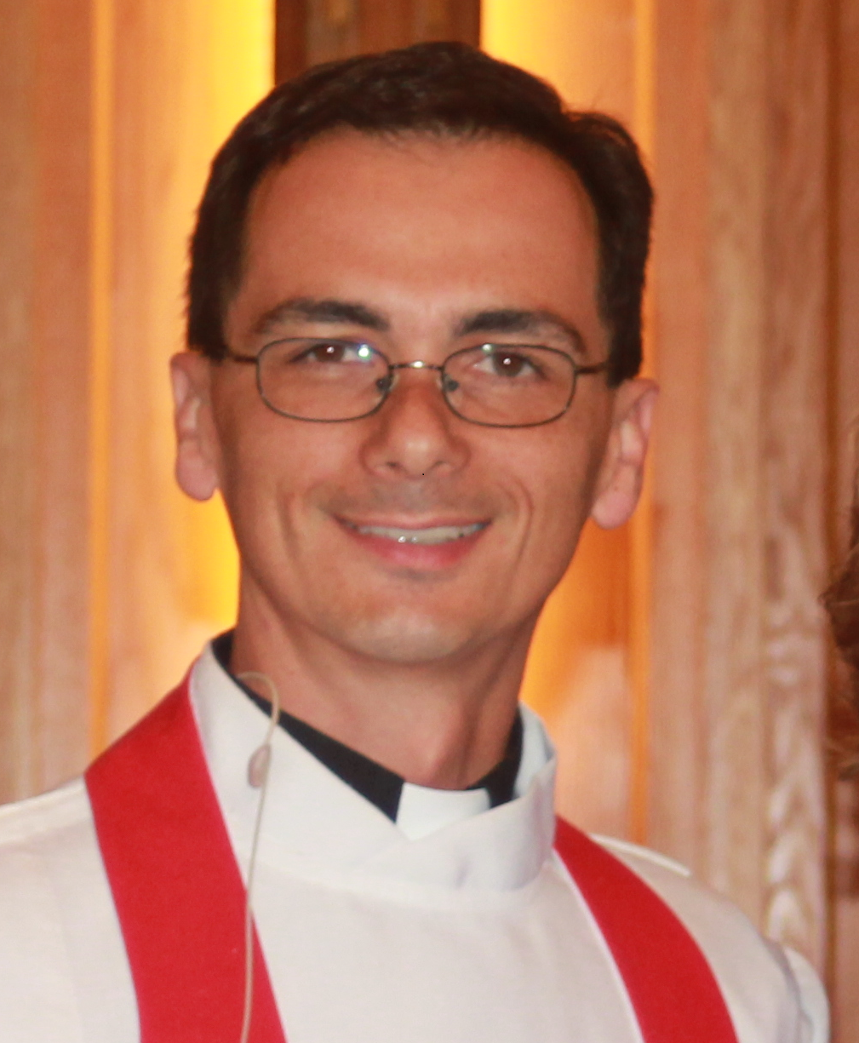**Pastor Perkins**  “**War on Two Fronts” …Continue on page 3**

World War II was one of the first conflicts to be waged by air, land, and sea. The three-pronged attack was all the rage back in the 20th century. To subdue the armies of the opponent, assaults were planned on three targets. A wicked despot named Hitler took country after country—sacked kingdom after kingdom—using bombs, tanks and infantry. Czechoslovakia, Belgium, France, Poland, and others fell like dominos before his tactic, the Blitzkrieg.

Visions of American History class run through my mind as I consider the two-pronged attack of Satan on the Church and Christ’s disciples. The Evil Foe first attacks disciples of Christ in their conscience—“You are too sinful for God’s grace”, he tells us. This can be an effective way to cut us off from the means of grace, thus separating us from the body of Christ. You’ll notice this ploy only works if we buy into it. To our shame we seek to fall into this trap, being discouraged by our own failures after we foolishly put hope in our own performance.

**\*\*\*The descendants also are impudent and stubborn: Ezekiel 2:4\*\*\***

***Important Dates:***

* **July 4**

Independence Day!

* **July 5**

Commissioning of Servant event Team

**• July 8**

Church Council

**• July 10**

Servant Team Leaves

* **July 26**

Voter’s Mtg and Picnic

***Individual Highlights:***

**Church Council**

**Updates**

**Youth info**

**Devotions**

**Bd/Stewardship**

**Calendar**



**Sabrina Hanson - 7/5**

**Mackenzie Wilson – 7/20 Kaylee Walklin – 7/23**

## June Anniversaries

**Memorials given**:

Anna Watkins ~ $130

Emil & Lydia Hildebrandt ~ $15

Gerhard & Olga Oeltjenbruns ~ $15

Zac Adrian ~ $15

Walter and Margaret Oeltjenbruns 60th Anniversary ~ $60

**Transfer In:**

Kay Gohr from Community Bible Mountain Lake, MN

Shelly Wahdan and her daughter Hope for Jackson, MN

**Wedding:**

Dexter & Karen Wermer at Trinity Lutheran, June 6, 2015

## Updates

**Mr. & Mrs. Brian Janzen, 2nd**

**Mr. & Mrs. Kevin Krahn, 3rd**

**Mr. & Mrs. Vern Peterson, 4th**

**Mr. & Mrs. Merle Boldt, 7th**

**Mr. & Mrs. Nate Brinkman, 8th**

**Mr, & Mrs. Ryan Fast, 9th**

**Mr. & Mrs. Frank Mendoza, 9th**

**Mr. & Mrs. Kory Radtke, 13th**

**Mr. & Mrs. Jesse Peters, 15th**

**Mr. & Mrs. Charles Wolle, 16th**

**Mr. & Mrs. Earl Karschnik, 17th**

**Mr. & Mrs. Jason Ella, 19th**

**Mr. & Mrs. Shawn Naas, 22nd**

**Mr. & Mrs. Nick Naxay, 23rd**

**Mr. & Mrs. Michael Stoesz, 25th**

**Mr. & Mrs. Dennis Brugman, 26th**

**Mr. &Mrs. Steven Geertsema, 27th**



***You should at all times remember them in your prayers, put them in mind of their baptism, and as much as in your lives, lend them your counsel and aid.***

## July Baptism

## …. continue Pastor Kufahl

Sadly, as we are well aware each year those plans increase little by little. Please also bear in mind that when Pastor Gardner was here, coverage was needed for himself and Diane, not a family as Pastor Perkins is blessed with. In this same span of time we have also had a transition of our custodial staff, plus additional costs for software, website, and outsourcing of our payroll due to the ever-changing federal laws. All of these additional costs have been agreed upon and approved by the voters.

Shortly after Pastor Gardner announced his retirement, you may recall we put a lot of time and effort into determining what direction Trinity needed to go: two pastors or one? Due to the numbers on our roster and the outreach that is available to us in Mountain Lake it was decided that Trinity needed two pastors. And we do. There is more than enough work for the two of us, and we still need the help of many in the congregation to see to it that such work is carried out. Would the loss of one pastor be worth losing some of our ministries? The time that you have available is also limited as you are pulled in so many directions, that it makes even worship time difficult let alone time to volunteer for the life of the church.

These were the commitments we have made as a congregation. We agreed upon a $319,836 budget which equals $6,150 per week in needed offering. At the start of the year, we really struggled with this and at times we still do,

but we have been doing much better as of late and we need to play catch-up. Through our membership, we also

confess that we intend to hear God’s Word, receive the Lord’s Supper, and support the work of this congregation faithfully. Where are you at with your commitments? Is there an issue that upsets you so much that it hinders

you from fulfilling your commitments? What can we do to help?

The church council and boards are looking at ways in which we can cut costs, raise funds, and also be

better stewards of the gifts that our God gives to us. The elders have begun looking at possible options for

health insurancefor the pastoral staff. On **Sunday, July 26** Trinity will be holding our quarterly voters

meeting right after the 9:00 service to update and discuss the issues at hand. Following the voters meeting

we encourage you to stick around for a free-will offering hot dog and eggroll lunch. Weather permitting we will be outside with Aretas providing music, games for the kids of all ages, and more. If you have any suggestions or ideas as to what we can do to help raise funds in order that we can meet budget, it will be greatly appreciated.

That which is set before us is not impossible. The devil loves to hinder the work of the Gospel, and that bugger’s traps can be so easy for us to fall into. We have a God who blesses us far beyond what we need for our daily lives. From the forgiveness that is ours in His only-begotten Son, to our families, homes, employment, finances, and all the stuff that we have; all these come from Him. The question each one of us needs to ask is; are we using these gifts to God’s glory, or our own? But praise be to God from whom all blessings flow! May our eyes be opened each day to see His goodness, and in response return thanksgiving. God grant it, amen. Thanks for listening.

.

## …continue Pastor Perkins

The other prong in Satan’s attack assaults the Word. He uses the world, popular culture, and our own doubt to undermine the veracity of Scripture. The Devil is always seeking to make the Bible appear irrelevant and ineffective by the scorn and derision of the status quo.

**\*\*\*Our soul has had more than enough of the contempt of the proud. Psalm 123:4\*\*\***

Rest assured! The word is neither irrelevant nor ineffective! On the contrary, the very assaults of that snake are what drive us back, call us back, bring us back to this same Word. Yahweh always has that snake right where He wants him. He can strengthen and encourage us best when we let go of our own control and cry out to him in our helplessness.

**\*\*\*For when I am weak, then I am strong. 2 Corinthians 12:10\*\*\***

Resist the temptation to withdraw from Him. Draw nearer to Him especially when you fail. Run to Him all the more when going through a storm. Resist the devil and the temptation to let excuses come between you and your Lord; between you and His house; between you and His Word.

My family and I took a short trip to Iowa (middle of nowhere) for a wedding last month. It took all of 45 seconds and a search engine to locate a good LCMS church within driving distance of our hotel. This is not because I am better or smarter than anyone. On the contrary, I am clumsy and obtuse with most things technology. It also is not because I am better or more spiritual than anyone else. It simply means that God has shown me danger in letting the world come between us. He has shown me my weakness as manifested when I stray.

Keep Christ with you this summer. On your phone; on your calendar; in your heart.

From Board of Stewardship “Drowning in Debt”

In my stewardship talk for today, I may cause some people to be a little uncomfortable because I want to talk about debt especially credit card debt. As the bumper sticker reads, “I owe, I owe, it’s off to work I go.” Before I share some debt statistics and causes of overspending, I will share some words from Scripture that caution us about debt. In Proverbs 22:7 we read, *“The rich rule over the poor, and the borrower is servant to the lender.”* In Luke 12:15 Jesus said*, “Watch out! Be on your guard against all kinds of greed; a man’s life does not consist in the abundance of his possessions.”* In Romans 13:8 the apostle Paul wrote, *“Let no debt remain outstanding, except the continuing debt to love one another . . .”* To live beyond one’s means is not only foolish, it is a violation of God’s will regarding the management of the money that God has given to us.

Today the average U.S. household has approximately $9,000 in credit card bills. In the last decade the indebtedness has more than doubled. To pay the compound interest on credit cards will cause many people severe financial problems. So why do people live beyond their means. The following are four temptations that cause overspending:

1. Pride: People will respect me more in the light of my increased possessions.
2. Selfishness: I deserve to accumulate things despite negative consequences.
3. Greed: I need that luxury car and bigger house even though I can’t afford them.
4. Covetousness: If my neighbors have it, I want it, too, but I want it bigger, better, and newer.

If these temptations are causing you problems, you need to ask God for strength to deal with them. With God’s strength, we can not only overcome our spending problems, and we can learn to be content. A contented person is content with less and is less likely to overspend. As Epicurus, a Greek philosopher said, “If you want to make a man happy, add not to his riches but take away from his desires.” How blessed we will be when and if we understand that our happiness is not dependent upon what we have or own.

**Daily Devotion...**

**July 1**Job 21-22; Acts 10:1-23

**July 2**   Job 23-25; Acts 10:24-48

**July 3**   Job 26-28; Acts 11

**July 4**   Job 29-30; Acts 12

**July 5**   Job 31-32; Acts 13:1-23

**July 6**   Job 33-34; Acts 13:24-52

**July 7**   Job 35-37; Acts 14

**July 8**   Job 38-39; Acts 15:1-21

**July 9**   Job 40-42; Acts 15:22-41

**July 10** Psalm 1-3; Acts 16:1-15

**July 11** Psalm 4-6; Acts 16:16-40

**July 12** Psalm 7-9; Acts 17:1-15

**July 13** Psalm 10-12; Acts 17:16-34

**July 14** Psalm 13-16; Acts 18

**July 15** Psalm 17-18; Acts 19:1-20

**July 16** Psalm 19-21; Acts 19:21-41

**July 17** Psalm 22-24; Acts 20:1-16

**July 18** Psalm 25-27; Acts 20:17-38

**July 19** Psalm 28-30; Acts 21:1-14

**July 20** Psalm 31-33; Acts 21:15-40

**July 21** Psalm 34-35; Acts 22

**July 22** Psalm 36-37; Acts 23:1-11

**July 23** Psalm 38-40; Acts 23:12-35

**July 24** Psalm 41-43; Acts 24

**July 25** Psalm 44-46; Acts 25

**July 26** Psalm 47-49; Acts 26

**July 27** Psalm 50-52; Acts 27:1-25

**July 28** Psalm 53-55; Acts 27:26-44

**July 29** Psalm 56-58; Acts 28:1-15

**July 30** Psalm 59-61; Acts 28:16-31              **July 31** Psalm 62-64; Romans 1

## Youth Calendar

**Sunday, July 5th at 9:00 – Commissioning of the Servant Event Team**

**Sunday, July 5th - Celebrate your freedom from sin and bondage to God**

**Thursday, July 9th – Servant Event Team packs the van**

**Friday, July 10th at 6 am – Servant Event Team departs.** Please keep our team members and the people they serve in your prayers.

**Sunday, July 12th at 6:00 – Sr. LYF at the Perkins’ –** Catch the change??

**Sunday, July 19th – No LYF**

**Sunday, July 26 at 9:00 –** Come for God’s Word and listen to what our team has to share

**Sunday, July 26 at 10:15 –** **Voters Meeting** – Learn what is going on in your congregation

**Sunday, July 26 at 11:15 –** **Church Picnic** – LYF will be helping to run games for the kids and other events to help raise funds for the congregation.

## Church Council **…next meeting will be July 8, 2015**

**Council Members present**: Russ & Joanne Karschnik, Laurel Leet, Ron Melson, Deb Kremmin, and Pastor Kufahl.

**Absent:** Jim Wolff, John Carrison, Lee Erickson, and Board of Finance Representative.

**Excused**: Mark Hanson, Jason Jepson, Dave Watkins, Diane Coners, and Pastor Perkins.

The May 14, 2015 council meeting minutes were read and approved.

The treasurers’ report was presented by Pastor Kufahl via a printed document from Jason Jepson.

Checking account balance: $2,276.34; Building fund balance: $17,283.45; Line of Credit: ($27,500.00); Outstanding Concordia plan bill is ($13,500) of which $4500 is due by June 24, 2015. Outstanding bill for miscellaneous items, phone, and utilities is $4,400.

**BOARD REPORTS:**

ELDERS – Ron Melson reported that the new attendance sheets are working well. A discussion was held on the future insurance plans for the pastors. Pastor Kufahl will be gone the first week of August for vacation. Pastor Perkins will be gone August 13-17. Installation of new board members and current board members will be on June 21st and Wednesday June 24th.

TRUSTEES – Pastor Kufahl reported that a discussion was held on changing the light fixtures in the sanctuary to LED lights.

FINANCE – Laurel Leet reported that she continues to help out counting the offerings on Sunday, when needed. The weekly offering for the week of June 21st was down. Deb Kremmin, on behalf of the Alter Guild, asked how monetary donations/ memorials are distributed. It was brought up at their last meeting that they have not received a memorial that was designated for them from a few months ago. This brought up a question; does donations/memorials go through the financial board before being distributed to the appropriate accounts? Some members have not seen their donations/memorials on their giving statements. Pastor Kufahl will look into this and bring to the financial board. A representative from the financial board at the monthly council meeting is needed for exactly this reason.

MEMORIALS COMMITTEE –

CHRISTIAN EDUCATION – Deb Kremmin reported that VBS went well. They are looking into Sunday school material for next year. The cost for each quarter of material will be posted in the bulletin.

YOUTH MINISTRY – Pastor Kufahl reported the LYF is planning a trip to Valleyfair, on Monday June 29th.

EVANGELISM – Pastor Kufahl reported that an ad is in the Observer encouraging people to attend Wednesday night services.

STEWARDSHIP –

CCOC -

CARE COMMITTEE –

ENDOWMENT COMMITTEE –

FISHERS OF MEN –

PASTOR KUFAHL – He officiated at two weddings, and started pre martial counseling for another. Also as a reminder when there is a wedding at church the neighbor across the street needs to be told to move his vehicle, he parks in front of church. The radio program, on KFUO A.M. he was the guest speaker on, went well. A person from SIM Sound Systems came to church to look at the issue with our sound system. The sound board needs to be repaired, so they took that and we are using a loner one until ours is repaired. He will be leaving for the North Carolina Servant Event on July 10th. Kay Gohr, Shelly Wahdan, and her daughter Hope transferred in as members. One funeral, Anna Watkins.

PASTOR PERKINS- At district convention in St. Paul.

**OLD BUSINESS :** Three quotes for the shed materials were presented:12x16- $2,957; 20x24- $5,608; 24x24- $6,027; this will be presented to the voters at the next voters meeting

**NEW BUSINESS :**

\*Financial issues/Building fund: a member donated $2,000 to the building fund a year ago and we have a $17,283.45 balance in that fund. This member is wondering if the money could be taken out and put towards the debt retirement instead. After some discussion the council decided it was best to pose the question for re-routing the funds to the voters.

\*We are still looking for someone to take over for Jason Jepson as church treasurer.

\*July voter meeting agenda: Financial issues facing the church/fundraising ideas to reduce the debt, present the quotes on building a shed, and rerouting of funds already designated but not used.

\*Voter’s meeting is July 26th following the 9 a.m. church service. Following the meeting there will be a freewill offering fundraiser with an outdoor lunch served, music provided by Aretas and games for the kids.

\*Other: We are 90 days past due on our Concordia Insurance Plan. We owe a total of $13,500, with a minimum payment or $4500 due on June 24th. Please prayerfully consider what you/we can do as a congregation to help with this situation.

**The next council meeting is July 8, 2015 at 8 p.m. (Following the Wednesday night church service)**

**Mark Your Calendars! Worship-Voters-Picnic-Music-Games. All in one morning!** On July 26, we’ve got a big morning planned. Following our worship service where we will be hearing from our Servant Event team, there will be a voters meeting to discuss and update the congregation on our current financial status. At the time of the newsletter, we are still finalizing the rest of the agenda. Immediately following the voters meeting, we will be offering a free-will picnic lunch with hot dogs, egg rolls, and crab rangoon plus other treats. Aretas will be playing with some special tricks up their sleeve. There will be games and prizes for the kids. We are looking for volunteers and ideas of what we can add to this event. Please contact the church office or one of the pastors with your ideas or offers to help. Thank you!

**Our Website Has Changed!**

***P.O. Box 503,***

***1418 second Avenue, Mountain Lake, MN 56159***

**office: (507)-427-2451 fax: (507)-427-2611**

[**trinityrev2@frontiernet.net**](mailto:trinityrev2@frontiernet.net)

[**pbenmin@outlook.com**](mailto:pbenmin@outlook.com)

[**trinitysecretary@frontiernet.net**](mailto:trinitysecretary@frontiernet.net)

Due to difficulties with our previous website, we have transitioned over to a new website that corresponds with our current church software. The new website is built for you, the members of Trinity with access to the church calendar, directory, church board members, and more. We are currently working on adding more and more to the website, so please keep in mind it is a work in progress. You can check it out at: [**www.trinitymtnlake.360unite.com**](http://www.trinitymtnlake.360unite.com). You can also learn more about what the website has to offer by going to: [www.youtube.com/watch?v=rioyOLrgQsw](http://www.youtube.com/watch?v=rioyOLrgQsw) or scan the code below with your QR Reader on your smart phone or tablet.

****

**We’re on the Web!**

***See us at:***

[**www.trinitymtnlake.360unite.com**](http://www.trinitymtnlake.360unite.com).

**NONPROFIT**

**ORGANIZATION**

**U.S. POSTAGE**

**PAID**

**MTN.LAKE, MN**

**PERMIT NO. 64**

**Trinity Evangelical lutheran church**

1418 Second Avenue

PO Box 503

Mountain Lake, MN 56159