# C:\Users\Trinity Office\Desktop\Trinity Evangelical Lutheran Church MN_files\KUFAHL-PETER-112.jpg**Pastor Kufahl …. Continue on page 3**

**Office number: (507)-427-2451**

**April 2015 Vol. 4, Issue 105**

***Important Dates:***

* **April 2**

Maundy Thursday

* **April 3**

Good Friday

* **April 5**

Easter Services

**• April 10, 17, 24**

Prayer time

**• April 12**

God Squad

* **April 15**

Women’s Bible study

**• April 16**

Church Council

* **April 19**

Confirmation Banquet

**• April 26**

Confirmation

***Individual Highlights:***

**Church Council**

**Updates**

**Youth info**

**Devotions**

**Bd/Stewardship**

**Calendar**

Is your home feeling a bit stuffy? After the long winter months of keeping everything closed up tight in order to keep the cold out, how eager and anxious are you to throw open the windows and get some fresh air in the house? There is just something about that fresh spring air that brightens our day and puts a smile on our faces. That is unless you are downwind from "the ponds."

Just as our homes can get stuffy after being closed up for the winter, so too can we. Now I know that there are probably one or two individuals with stuffy personalities coming to your mind right now, and maybe one of them is your spouse. But when it comes to being a bit 'stuffy,' I would like for you to take a moment to reflect on where you are at right now.

As we should be well aware, it doesn't take much for us to close ourselves off to other people. To open up and share our thoughts, ideas, desires, hurts, and dreams with other people, we leave ourselves vulnerably open the possibility of being belittled, ridiculed, put down, and even attacked by those with whom we share. So rather than facing the stench of pain that comes with such rejection, we close ourselves up tight.

I was too small to lift it the first time I noticed Dad’s big pry-bar. It had been with him forever, it seemed. He used it all the time. Dad usually worked by himself, so some tools had been used as an extra set of hands or to provide needed leverage. The pry-bar was one such. It could absorb, concentrate, and redirect an amazing amount of force. It had been hammered, pounded, stressed, and torqued on over and over again. The thing was indestructible. The thing about that pry-bar, my dad told me, was that the hammering and the pounding were what strengthened it and made it stronger. The strain and tension actually hardened the steel.

We human beings in our development have been accurately compared to the tempering of steel. We rely on life and other people to make us harder and sharper. Solomon knew this:

**“As iron sharpens iron so one man sharpens another.” Proverbs 27:17**

# **Pastor Perkins** **…Continue on page 3**

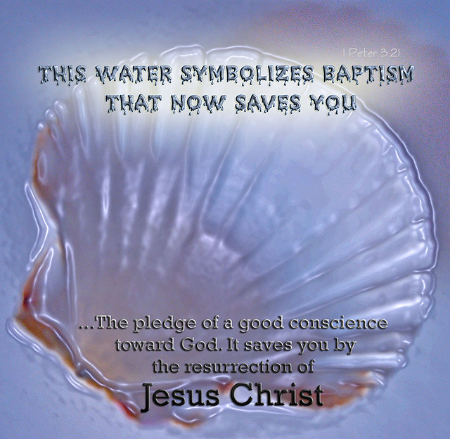

**Kaylin Nickel 4/1/2012**

**Mace Herrig 4/13/2003**

**Hana Bergling 4/17/2003**

**Claire Adrian 4/18/2010 Amilia Gullickson 4/25/2010**

## April Anniversaries

**Memorials given**:

**Jean Oeltjenbruns ~ $5**

**Deb Sneer ~ $25**

**Lorretta Hanson ~$15**

**George Coners ~ $25**

**Baptism:**

**Breckken Matthew Wolle-Boyd at Trinity Lutheran, March 8th, 2015**



## Updates

***You should at all times remember them in your prayers, put them in mind of their baptism, and as much as in your lives, lend them your counsel and aid.***

**Mr. & Mrs. Ken Klassen, 1st**

**Mr. & Mrs. Brad Herrig, 21st**

**Mr. & Mrs. Sam Prachomphonh, 21st**

**Mr. & Mrs. Ernest Ysker, 26th**

**Mr. & Mrs. Richard Schwering, 27th**

**Mr. Mrs. James Wolff, 30th**

***C:\Users\Trinity Office\AppData\Local\Microsoft\Windows\Temporary Internet Files\Content.IE5\I17EPSZQ\MC900355829[1].wmf***

## April Baptism

.

## …. continue Pastor Kufahl

On the flip side of things, how easy is it for us to shut others up? We may not have time for them, disagree with them, have grudges against them, or just plain don't like them. Therefore it becomes easy for us to give the silent treatment, verbally lash out, or do anything we can to make them leave us alone. How cold we can be to one another! The cold stench that is out there is so awful that it gags, and so it is no wonder why we close ourselves up!

We have learned to live with stale air quality, and we have learned to live closed off lives. But is this the way we are called to live and treat one another? Wouldn't it be nicer to breath in that fresh air?

When it comes to being stuffy, I couldn't imagine anything more stuffy than that of a tomb. More specifically, THE tomb where our Savior's body was laid with the stench of death hanging in the air. As Christians, we know there was more to the content of that stench than just death. For in that stale stench was mixed the aroma of all of our sins. Sins that Jesus willfully placed upon Himself.

And when the time had come and Scripture was fulfilled, the stuffiness of that tomb was expelled by the fresh air of that tomb bursting open. In Jesus' resurrection, new life had begun. And it is a new life that He shares through the forgiveness of sins.

Brothers and sisters in Christ, I write this letter to you with the reminder that in Christ's forgiveness you have the breath of fresh air. In Christ, the stench of your sins has been expelled. We should not have to fear our need for the fresh air that is found in the forgiveness of Christ. There are those among us, maybe even you dear reader, who have been closed off by fellow members of our body of Christ (maybe even by me). The suffocation is great. In Christ, may we ever be mindful of the cold stench we can convey, and instead speak and act in compassion and love as the Holy Spirit directs us.

Spring is here, but most importantly so is the fresh air of forgiveness in Jesus.

He is not here, for he has risen, as he said. Come, see the place where he lay.

**Matthew 28:6**



We come out of the womb pretty soft. Slowly we grow and develop. It is the knowledge and teaching of our parents that make us smarter. It is the little tests and strains from day to day which harden and prepare us for life in the world. As we leave home and begin our true test, the blows life strikes make us hard, malleable and sturdy. But woe to us if this is the first test we’ve seen. Like a new set of horseshoes that can break with an unlucky impact, we do well to have the benefit of some prior hardening.

Still, none of us relish the abuse of the devil, the world, and our sinful flesh. Thanks be to God that He has not left us in the world with nothing but our wits and the hardening of iron to sustain us. He has sent us an Advocate to pray on our behalf, to strengthen our faith, and to lead us to feed on His faithfulness through His Word and Sacraments. **Yahweh motivate us ever more to make the most of these gifts. God increase our faith and our faithfulness.**

Easter is upon us, my friends! The Summer is upon us! Planning for Pastor Kufahl and me has already been a fun challenge. A great many things are already filling up the calendar for what remains of 2015, particularly the summer months. Convention is coming in May, Powwow in June, and of course the Servant Event is July. August marks the end of Summer and the Threshing Bee. Everything else competes with and allows for these events. I have been invited to preach in Bridgeton, MO if a date can be secured. We are also excited about some new activities with our Lao members that are brewing, and of course, wedding bells are in the air.

Many of us have travel planned, so please remember ***worship*** if your family is going abroad so that you do not fall into temptation.

But before we cross that bridge, we have to get through April. That means Easter. That means Confirmation Sunday. That means company, meal planning, and countless arrangements to be made. Let’s get to it!

A blessed Easter to you all.

## …continue Pastor Perkins

## From Board of Stewardship “Quickly go Tell”

We have a picture of the women going to the grave that first Easter morning to anoint the body of Jesus. It is barely light, and perhaps they are speaking in soft voices. Certainly there is an air of solemnity, of sadness, for their Master is dead. Their hopes are gone.

Then we see them before the open tomb, bewildered, then fearful, as they see an angel with *“appearance like lightning and . . . clothes . . . white as snow.”* The angel’s first words are *“Do not be afraid, for I know that you are looking for Jesus, Who was crucified. He is not here; He has risen, just as He said.”*

Perhaps some of us, too, have been bewildered, afraid. Even though we have always known the whole story – even though we look back on the Resurrection – we have been bewildered and afraid. Bewildered by circumstances in our lives. Afraid of the future. The angel says to us, too, *“Do not be afraid . . . [Jesus] is risen, just as He said!”* That truth makes all the difference, for, as Paul says, *“Christ has indeed been raised from the dead, the firstfruits of those who have fallen asleep”* (1 Corinthians 15:20). Christ, the firstfruits, and then we with Him!

Hardly taking a breath, the angel gives a command to the women: *Come and see the place where He lay. Then go quickly and tell His disciples: ‘He has risen from the dead . . .’”* (Matthew 28:2-7). By faith, we, too, have seen the empty tomb; by faith in the Word of God, we know Christ is risen. The command is for us as well: **go quickly and tell.**

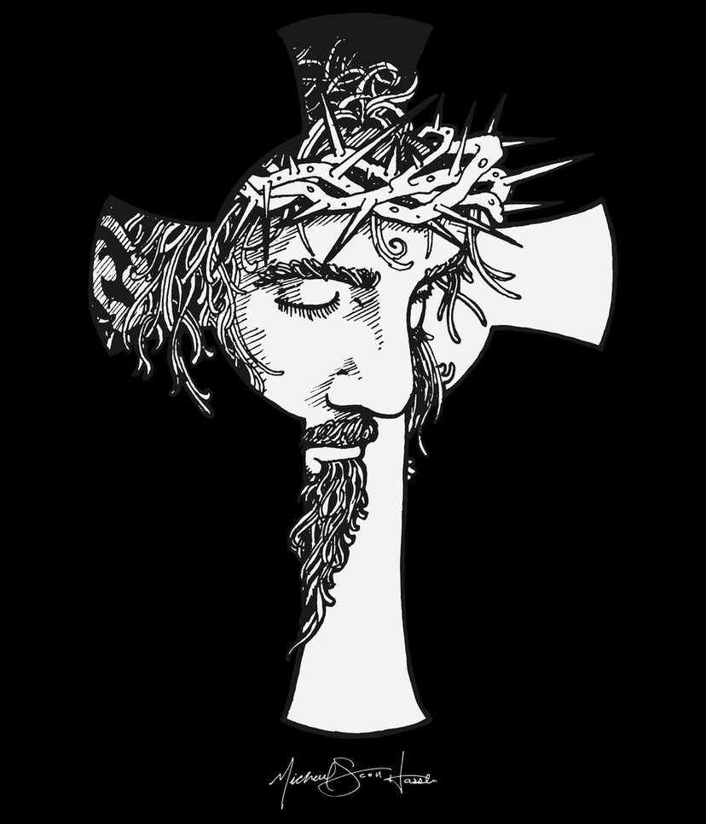

*In the evening when you go to bed, make the sign of the holy cross and say:*

In the name of the Father and of the T Son and of the Holy Spirit.

*Then, kneeling or standing, repeat the Creed and the Lord's Prayer. If you choose, you may also say this little prayer:*

I thank You, my heavenly Father, through Jesus Christ, Your dear Son, that You have graciously kept me this day; and I pray that You would forgive me all my sins where I have done wrong, and graciously keep me this night. For into Your hands I commend myself, my body and soul, and all things. Let Your holy angel be with me, that the evil foe may have no power over me. Amen.

*Then go to sleep at once and in good cheer.*

## Evening Prayer…

## Church Council **…next meeting will be May 21, 2015**

**Council Members present**: Russ and Joanne Karschnik, Mark Hanson, Joanne Karschnik, Laurel Leet, Diane Coners, Pastor Kufahl. Dave Watkins, Deb Kremmin, Lee Erickson

**Absent:** Jim Wolff and board of finance representative.

**Excused:**  Jason Jepson and John Carrison

The February 19, 2015 council meeting minutes were read and approved. The treasurers’ report was handed out as a printed document due to Jason being unable to attend meeting. The document shows the following balances: Checking: $-1,668.05; Building Fund: $16,797.23; Fishers of Men: $7,086.93; Line of Credit is maxed out at $29,000. We still have roughly $12,000 in past due bills.

**BOARD REPORTS:**

ELDERS – Dave Watkins reported that a discussion was held on possible changing service/Sunday school times because the services run long at times. The Elders and Pastors decided to leave times alone at this time. A discussion was held on changing to a different attendance/communion sheet to save on costs. To get different people to participate in the drama’s, Volunteer cards are going too passed out for members to fill out if they are interested in participating in a drama. The approved Pastor Kufahl to go the the Concordia Seminar in St. Louis, Missouri on May 4-8, 2015.

TRUSTEES – Pastor Kufahl reported that the trustees did not meet this month.

FINANCE – Laurel Leet reported the past 4 Sunday’s offerings have totaled between $4,000-$6,500.

MEMORIALS COMMITTEE – Mark Hanson reported a balance of $6,025.86 in memorial funds. Waiting for an invoice for the wedding candelabras. Possible idea was discussed at the February meeting to build a shed for the lawn/snow blower. It was decided to bring it up at the next voters meeting.

CHRISTIAN EDUCATION – Deb Kremmin reported that VBS materials are here, Captive Free are booked and housing will be needed for 2 guys and 2 girls. They discussed doing a drama for each story instead of one story teller and multiple sessions. There is still a need for teachers for VBS. The meal list for VBS is as followed: Sunday 5/17- Board of Ed serving Walking Tacos, Monday 5/18- Trustees/Elders serving Hot Dogs ad Chips, Tuesday 5/19- Board of youth/Memorial serving Pizza Hot dish, Wednesday 5/20- Board of Evangelism/ Stewardship serving Mac & Cheese, and Thursday 5/21- CCC/Finance serving Leftovers/Egg Rolls??. Senior Breakfast is May 10th at 9:15a.m. Possibly 6 graduates. The Mormon Bible Study is going well. New member classes are incorporated with adult bible class. A donation was made to purchase the Sunday School material for the spring quarter.

YOUTH MINISTRY – Pastor Kufahl reported that the board has been short a member, Steve and Heather Funk have agreed to be on the board. A motion was made by Dave Watkins to appoint Steve and Heather Funk to the Board of Youth Ministry. Deb Kremmin 2nd the motion. The motion passed without further discussion.

EVANGELISM – Lee Erickson reported that the monthly meetings will be held in the evening in Pastor Perkins office. The March baptismal cards are ready to be mailed out and they worked on some for April. It has been a good way for the board to get to know the members of our congregation. They select individual bible verses for each card. April 12th is the next fellowship coffee, with Keith Peterson from Lutheran Hour Ministries coming.

STEWARDSHIP – Diane Coners reported that April birthday cards have been completed and they got a good start on May’s. They are going to start a new Stewardship program in the fall.

CCOC – Pastor Perkins highlighted items from Cheryl Hiebert printed report. A citizenship fundraiser is scheduled for Sunday March 22. Egg Rolls /Crab Rangoon will be available between services free will offerings will be taken. The committee is responsible for the Thursday, May 21st VBS meal. Pow Wow is June 12-16 this year. We will be making the egg rolls on Friday, May 29th starting at 5pm and Saturday, May 30th starting at 9am

CARE COMMITTEE - ENDOWMENT -

FISHERS OF MEN*-* PASTOR KUFAHL – He has been helping with the Wednesday Lenten services in Okabena. He also will be preaching at Alpha/Kimble on Sunday, March 22nd. There pastor needed to go to Texas be**caus**e his father is ill. He attended the Disaster Alert Training in the Cities with Jacob Karschnik and Brenda Meyer on Saturday, March 21st. Confirmation is Sunday, April 26th. There are 5 youth in this year’s class. PASTOR PERKINS- He is asking for volunteers to help the board of Evangelism and Stewardship to write out baptismal and birthday cards. He got many new ideas from attending Best Practices in Phoenix Arizona. He hopes to implement some soon. He continues with member visits. Getting ready for Pow Wow with the CCOC. Watch for new ideas on running the egg roll stand this year. Working with possible new Lao members. They are friends of One from Windom, also a few from town.

**OLD BUSINESS :**

Budget: Since our finances are not looking very good, Pastor Kufahl has been in contact with Terry Karschnik from the Endowment Committee. The committee is looking into possibly having the endowment fund pay part of Pastor Perkins salary. A recommendation will be presented at the next voters meeting. The council also discussed other ideas on how to make the congregation aware of the churches financial issues. One is to be more specific in the bulletin, write the current check book balance and LOC balance. Also specify what is needed to pay the months bills, along with the previous weeks offering. Also Mark Hanson, as the congregations’ president, will speak at a Sunday’s service about the churches finances. This issue will also be on the agenda for the next voters meeting.Nominating Committee: It is time to nominate people for the various boards. The committee will meet on Wednesday, March 25th following the evening Lenten service. There are 3 people who have served 6 years and cannot run again, there is 5 people who have served 3years and are eligible to run again if they choose to do so.

**NEW BUSINESS :**

A request was made to have a current Membership Directory updated. Pastor Kufahl said that the last time they were printed there many extras. Anyone interested in receiving a copy of the Membership Directory may contact the church office, and one will be printed out for them. You can also access it through the church web site.The next voter meeting is scheduled for May 3rd at 7 p.m. The next council meeting is April 16, 2015.

**Our Website Has Changed!**

***P.O. Box 503,***

***1418 second Avenue, Mountain Lake, MN 56159***

**office: (507)-427-2451 fax: (507)-427-2611**

[**trinityrev2@frontiernet.net**](mailto:trinityrev2@frontiernet.net)

[**pbenmin@outlook.com**](mailto:pbenmin@outlook.com)

[**trinitysecretary@frontiernet.net**](mailto:trinitysecretary@frontiernet.net)

Due to difficulties with our previous website, we have transitioned over to a new website that corresponds with our current church software. The new website is built for you, the members of Trinity with access to the church calendar, directory, church board members, and more. We are currently working on adding more and more to the website, so please keep in mind it is a work in progress. You can check it out at: [**www.trinitymtnlake.360unite.com**](http://www.trinitymtnlake.360unite.com). You can also learn more about what the website has to offer by going to: [www.youtube.com/watch?v=rioyOLrgQsw](http://www.youtube.com/watch?v=rioyOLrgQsw) or scan the code below with your QR Reader on your smart phone or tablet.

****

**We’re on the Web!**

***See us at:***

[**www.trinitymtnlake.360unite.com**](http://www.trinitymtnlake.360unite.com).

**NONPROFIT**

**ORGANIZATION**

**U.S. POSTAGE**

**PAID**

**MTN.LAKE, MN**

**PERMIT NO. 64**

**Trinity Evangelical lutheran church**

1418 Second Avenue

PO Box 503

Mountain Lake, MN 56159