EYEWITNESS Session 6
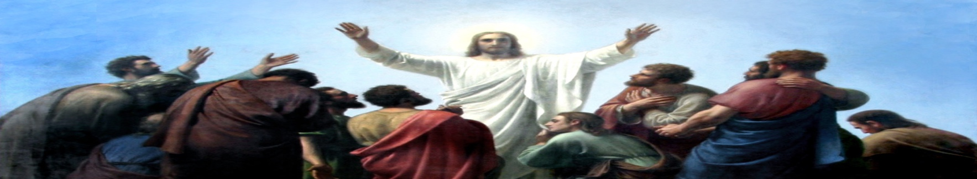

Opening Prayer

Introduction and Discussion

The eyewitness according to Acts
(See Map at end of Lesson)

Acts 17:16-21
Paul’s spirit was “provoked” because of the many false idols he saw in Athens. Where and with who did he begin to discuss these false beliefs? What do you know about these different groups?

Acts 17:22-34
Why does Paul begin with an idol to an unknown god and teach them about the Creator rather than beginning from the Old Testament?

Paul quotes two Greek poets, Epimenides (compare with Titus 1:12) of Crete and Aratus. How does Paul use the words of these pagans to draw his listeners’ attention to the true God? How can we do similar things today?

How does Paul transition from building bridges among the Athenians to talking about the sin, the law, and repentance?

How do Paul’s listeners react to this message?

Acts 20:17–38
This speech takes place at the end of Paul’s 3rd Missionary Journey (see map), and was given to the Elders of the Ephesian Churches. What are the main points Paul emphasized to them? Why did Paul emphasize these things to this audience?

Acts 22:1-29
How does Paul gain their attention? What does he tell them about himself and his experience of the risen Christ?

What does Paul say that turns his audience against him? Why do they respond in this way?

Acts 22:30-23:11
What strategy does Paul use as his defense during the trial? Why?

What plans does the risen Lord have for His apostle?

Witness (μάρτυς “martys”)
How has God given you opportunities to be a witness this past week?

Please take time to reflect on your “witness” opportunities as you go through this next week.

Closing Prayer

Christ is risen! ...

Adapted from “Eyewitness – the Eyewitness Testimony of the Risen Christ” by Carol Geisler © 2020 by Creative Communications for the parish a division of Bayard, Inc., 1564 Fencorp Dr., Fenton, MO 63026. 800-325-9414. www.creativecommunications.com
Adapted from “Books of the Bible Study Questions” by Wayne Palmer © 2019 Concordia Publishing House, 3558 S. Jefferson Ave., St. Louis, MO 63118-3968. 1-800-325-3040. CPH.org

