EYEWITNESS Session 3a – We Are Now His Witnesses
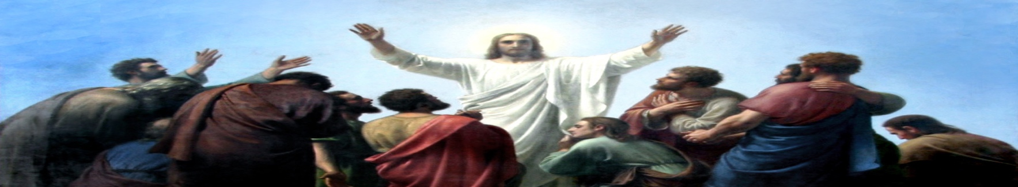

Opening Prayer

Introduction and Discussion
Consider the books and/or tools you have used throughout your life that you’ve considered authoritative. Maybe it was a book you used back in college or a tool you acquired while on the job or perhaps a trick you picked up in retirement. What was it and why did you use that book, tool, trick, etc… as authoritative instead of something else comparable?

The eyewitness according to Mark 16:

Who makes the announcement?
To whom is the gospel shared?
What is their reaction?
To whom does Jesus himself appear?
What is the reaction of those who see him?

The eyewitness according to Acts

Acts 5:12-32:
What were the almost comical results of the Jewish leaders attempt to stop the apostolic witness?

How does Peter and the Apostles response in Acts 5:29–32 reflect our situation today? How does it differ?

Acts 6:8–7:3; 7:51-60; & 8:1-3:
What false charges were brought against Stephen? How is this ironic with the content of his speech in Acts 7?

What can we learn from the first martyr of the ascended Lord?

Acts 9:1-23:
What were Saul’s plans for his trip to Damascus?

What were God’s plans for Saul’s trip to Damascus?

1 Corinthians 15:1–11 & Galatians 1:11–24:
How does Paul describe his activity as a witness?

What does he consider of first importance?

John 17:14–21:
Using this portion of Christ’s High Priestly Prayer and thinking back about what we’ve covered in this lesson, how are we witnesses without being eyewitnesses?

Witness (μάρτυς “martys”)
How has God given you opportunities to be a witness this past week?

Please take time to reflect on your “witness” opportunities as you go through this next week.

Closing Prayer

Christ is risen! ...

Adapted from “Eyewitness – the Eyewitness Testimony of the Risen Christ” by Carol Geisler © 2020 by Creative Communications for the parish a division of Bayard, Inc., 1564 Fencorp Dr., Fenton, MO 63026. 800-325-9414. www.creativecommunications.com
Adapted from “Books of the Bible Study Questions” by Wayne Palmer © 2019 Concordia Publishing House, 3558 S. Jefferson Ave., St. Louis, MO 63118-3968. 1-800-325-3040. CPH.org

