THANKSGIVING IN THE MIDST OF A PANDEMIC
NOVEMBER 2020

It has been said by some that 2020 is the year from hell. It is not hard at all to understand why some might view it that way given the COVID 19 Pandemic, the ever escalating numbers of COVID related deaths, the lockdowns, the quarantines, the high-rate of unemployment, the total disruption of normal activities, the riots, the looting, the wonton destruction of businesses and property, the decimating hurricanes on our country’s southern shores, the widespread devastation of crops in the Midwest, the consuming fires ravaging our western states and the divisive and uncivil political campaigning that has beset our nation. No question about it! This year has been pretty hellish. Who is not weighed down by anxiety, worry and perhaps even outright fear of what is yet to come?

As our National Day of Thanksgiving approaches, it’s quite conceivable then that many might question what we have to be thankful for. Anxiety by its very definition means to be without peace and contentment. It means being on the edge, fearful and uncertain. It is like having a heavy black pall of dread covering our every waking moment and smothering our nights with terrors. Given the level of our anxiety this 2020, how can we be expected to observe Thanksgiving Day or be thankful?

Listen to the Lord’s apostle Paul’s prescription for our anxiety as we read it from the fourth chapter of Philippians, “Do not be anxious about anything, but in everything by prayer and supplication with thanksgiving let your requests be made known to God. And the peace of God, which surpasses all understanding, will guard your hearts and your minds in Christ Jesus” (4:6-7).

Clearly, Paul sees being thankful as part and parcel of the solution to our anxiety not something that is unfitting our situation. However, if we look carefully, we see that the thanksgiving Paul speaks of is far and beyond any sense of partying or reveling in our pleasures. In other words, Paul is not speaking of simply being thankful for what you and I like or what is in accordance with our will or even what makes us feel good. Anyone can be thankful under those circumstances. Rather, he says be thankful “in all things.” Would not “all things” include those things we don’t like, what is contrary to our will or even what makes us feel bad? Of course, it does. All things means all things! This, then, makes thanksgiving a true condition of the heart; a condition that transcends all things, even such not very pleasant things or unhappy things.

This same apostle of the Lord says in the eighth chapter of his letter to the Romans such a condition of a thankful heart can only exist where there is faith that God works all things together for good for those who love God, who are called according to His purpose and that God has not abandoned us to our enemies but that He is for us; that He did not spare His own Son but gave him up for us all and that Jesus was raised and is even now at the right hand of God interceding for us (Romans 8).

It’s this faith; this solid trust, in God’s grace and promises that moved that ancient servant of God named Job, at the very height of his misery, to ask the rhetorical question, “Can we accept good from God and not adversity?” (Job 2:10) In total contrast to the fatalism expressed by his wife that he should, as she urged him, simply curse God and die, Job was seeing that God was allowing all of his worldly possessions and pleasures to be stripped away from him to teach him that God was still good to him despite how it all looked from a worldly perspective. Job was convinced that he hadn’t deserved all those earthly good things anyway and that God in His goodness and graciousness was using these losses in his earthly life to bring about true and lasting good for him in His eternal life. Job’s biggest problem was that he struggled to try to figure out what that good was.

Despite our present adversity, God has also not ceased to be good to us. In fact, He is being our Good and faithful Teacher. One would have to be spiritually blind not to see the good God has been working through all that has come upon us. We are daily being taught once again that there are worse things than dying and that is to lose faith and hope. We are being taught that our eternal hope of living forever in the glory of God’s presence, won and guaranteed to us in Jesus Christ crucified and resurrected, cannot be stolen away from us by a virus or anything else. After all, the nails placed in Jesus’ hands and feet have permanently nailed shut the coffin that contains sin, death and the devil.

We are being assured that Jesus’ presence with us cannot be taken from us by mandatory quarantines or civil lock down orders. God has not cast us aside and abandoned us. He is keeping His promise to be with us always, bringing us the gifts of His grace in His Word and Sacraments as we are free to regularly receive them in the worship assembly (Matt. 28:19,20; John 15: 7, Matt. 26:26-28). We are being reminded that His promises cannot be nullified by politicians and governments and that societal unrest and civil strife cannot rob us of the eternal peace God gives us in Jesus. Daily we are being reminded that our salvation is not a vaccine but it is the blood of Christ. Yes, we are being taught that nothing shall separate us from the love of God in Christ Jesus our Lord (Romans 8:39).

Thanks be to God, therefore, for this adversity. It is God’s university to educate us with the knowledge of the truth that baffles all human reason and defies all human logic but leaves in our hearts the peace that surpasses all understanding and will guide our hearts and minds in Christ Jesus. In this peace we can truly put away all anxiety and “in everything by prayer and supplication with thanksgiving let our requests be made known to God.”

Right in the midst of this pandemic and horrific year of 2020, I invite you to join me and your fellow brothers and sisters in Christ this National Day of Thanksgiving, November 26, at 10:30 am, as together we listen to our Savior’s assuring Word and with thanksgiving present our requests and concerns to God our Savior!

To Jesus be the Glory!

Pastor Schreibeis

TRINITY EVANGELICAL LUTHERAN
CHURCH & CLASSICAL SCHOOL, LCMS
Preschool - 8th Grade
221 S. Center Avenue
Miles City, MT. 59301
Phone (406) 234-4983
Fax (406) 234-8033
Email trinity@midrivers.com
www.trinitylutheranchurch.360unite.com

“GIVE THANKS”

Our Father in heaven has claimed us as His own. By the shedding of His Son’s blood, His death for our sins, and His resurrection for our justification, God the Father has received us back into His family. By water – combined with His Word, promise, and Name – the Holy Spirit has taken up residence in us. We belong to Father, Son, and Holy Spirit. He is in us, and we are in Him. And, being in Him, all things are ours. In Him, we are richly and abundantly blessed.

Our true treasure is that we belong to the most Holy Trinity, and everything that is His – righteousness, peace, eternal life – also belongs to us. Even our temporal treasures are gifts from His fatherly divine goodness and mercy.

We receive our treasures from Him, and thus, as good stewards of His varied grace, we manage them in such a way that they may be returned to Him. We bring them to Him, hallowed through prayers of thanksgiving and God’s holy Word, as a sacrifice.

Thus, all our possessions, as gifts from God, are also sacrifices to Him. We eat to nourish our bodies. We share with our family, neighbors, fellow Christians, the poor, and even our enemies as holy things given by the holy God. His temporal gifts are blessings to and for us, and they bring blessings upon us even as they are pressed into His service for His kingdom.

Thus, we place all that we have into God’s hands, and He never fails to remember us. He pours out the fullness of His promises upon us. We give thanks for all that He has done, is doing, and will continue to do. We give thanks by not taking for ourselves, but, giving to all even as our heavenly Father has given to us.

As we prepare for the celebrations of Thanksgiving, may we all give thanks continually for all that we are and all that we have because of God’s providential care. And may we be all the more diligent in bringing everything that we have received from God to Him, so that He may bless it and employ it for the good of all – even for us. For to the one who has, more will be given, and he will have an abundance.

Board of Stewardship Ministry, The Lutheran Church – Missouri Synod

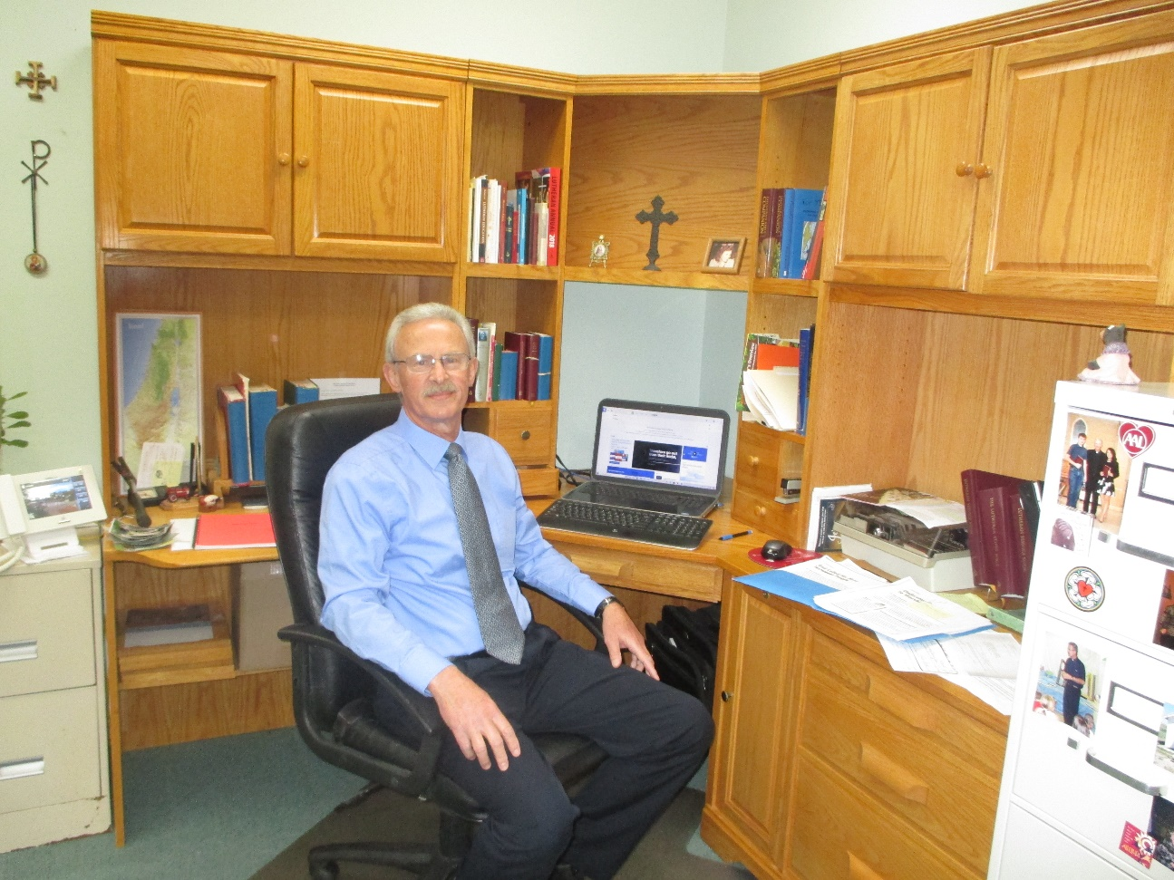

THANK YOU! Special thanks to Rebecca & Mark Ellis for the nice oak corner desk
unit that they donated this past summer to the church for the pastor’s office in memory
of her father, Rev. William “Bill” Stratman, who passed on January 21, 2016.
Your lovely gift is now in use and is greatly appreciated. --- Pastor Schreibeis

