
Every One His Witness
Equipping Individual believers to be more effective witnesses of Jesus in their everyday lives.
Our Board of Evangelism invites you to attend this special FREE Evangelism Workshop at Trinity Lutheran Church, Miles City on Saturday, October 10, 2020. Registration begins at 8:30 a.m.; the workshop will be 9:00 a.m. to 3:00 p.m. with lunch provided.
It would be helpful if you could please sign up in narthex or call the church office at 234-4983 to let us know you will be attending. This will help us be sure to have enough materials on hand for all attendees.
The “Every One His Witness” workshop draws on God’s Word and the Lutheran Confessions to build a solid foundation for bearing witness of Jesus and provides practical resources for sharing the simple Gospel in today’s complex world. Learn how to LASSIE: Listen, Ask, Seek, Share, Invite, Encourage! All are welcome to join us!

PASTOR APPRECIATION RECEPTION
will be held at Trinity, M.C. on
Sunday, October 11th,
directly following the first service.
(Board of Elders & Hospitality Committee
are handling the details; Cake will be served.)
You are welcome to bring a card.

“Let every soul be subject to the governing authorities. For there is no authority except
from God, and the authorities that exist
are appointed by God.” Romans 13:1

 HARVEST DINNER
SUNDAY, OCTOBER 18th, 2020
11:30 a.m. to 1:00 p.m.
The Board of Christian Education invites you to join us for this special dinner. This event is open to the public; please invite your friends and neighbors. We will be serving roast beef and ham, mashed potatoes & gravy, vegetables, dinner rolls, & dessert, coffee & kool-aid.
Cost of the dinner will be: Adults - 13 years & above $10.00, children 6-12 years old $5.00, children 5 years and under Free. There will be a family rate of $25.00 (Family = 2 Adults & All Minor Children). If you do not want to stay and eat, you are welcome to stop by and pick up take-out meals. Proceeds from this event will go to benefit the Trinity Lutheran Classical School, Preschool – 8th.
FALL – CHURCH WORK DAY
Volunteers are needed to meet on Saturday, October 3rd, starting at 8:00 am to work sprucing up the church inside and out. Come help us clean and repair things that need addressing. The Board of Trustees hopes to see you there!

CHURCH OFFICERS & BOARD MEMBERS
The Nominating Committee is seeking nominations for all offices whose terms will be ending this year. If you are interested in serving for another term or newly interested in serving in a position, please contact our Congregation President, Ted Schreiber or Vice President, Dennis Hirsch. All terms are for 2 years, January 1, 2020 through December 31, 2021. Terms up for Election include:
Secretary: Donna Orthman
Financial Secretary: Emma Morrison
Elders: Ken Holmlund, Clint Kelstrup,
Ted Schreiber, Shane Taylor
Trustees: Joe Ferris, Bruce Russell, Betty Toepke
Board of Stewardship: Sarah Harrington,
Florence Lodwig
Bd. of Evangelism: RaeEllen Bird, Theresa Scheid
Board of Christian Education: Teri Cox, Rebecca
Jordan, Maureen Klapmeier, Elnora Ottenbacher
2021 BUDGET
All Boards and Committees need to start working on their 2021 Church budget requests. All requests may be turned in to the Board of Stewardship chairman, Marlus Amsden or the Church office by October 11th, 2020. The Board will review and compile all requests at their October 12th meeting and will make the information available to the congregation prior to the November Voter’s Assembly meeting.

NEW ADDDRESS: Wayne & Sheri Ritter-Scott have moved to the Cornerstone, 310 N. Jordan, Apt. 205. Their mailing address remains P.O. Box 764. Congratulations on your new home.

NEW ADDDRESS: Dee Peltzer is now residing at Holy Rosary Residential Living, 2600 Wilson Street, Room #57-2, Miles City, MT. 59301.

MARRIAGE: Jarrett Lester (son of Brian & Deb) & Sadie Hostman were wed on Sept. 26, 2020.
THRIVENT ACTION GRANTS
Jack Ottenbacher received a $250 Thrivent Action Team Grant to purchase desks and fans for use by Trinity Lutheran Classical School’s K-8th.

THRIVENT CHOICE DOLLARS
Members are asked to please designate your Thrivent Choice Dollars to our church or school. This is easy to do. Just have your Thrivent member ID or contract number available, then call 1-800-847-4836 and when prompted say “Thrivent Choice”. The Member Connection Center is open M-F until 5 p.m. MST.

100th ANNIVERSARY 1916 – 2016
TRINITY FAVORITE RECIPES COOKBOOK

We still have 3 cases remaining of the special Trinity 100th Anniversary Cookbook. This wonderful keepsake book is being offered for only $10.00 each. They are available in the fellowship hall or from the church office. Please make payment to Trinity Lutheran Church; Note on the memo line: Cookbook. Give to church office or drop in the offering plate. Get one for each of your friends, neighbors, family members, co-workers, team members, graduates and newlyweds.



It is time to collect the 2021 LWML annual fees. I need to mail the fees to Barb Kohs by November 1, 2020. The fees are the same as last year:
Delegate Fund: $7.00 (Pays expenses for
Montana Zone delegate
attending LWML Convention)
Quarterly Subscription: $6.00
Please pay $13.00 to Florence by our next meeting, October 20, or bring to the meeting. If you pay your offering by check, you can include your fees in same check, just designate in memo. Thank you, Florence Lodwig
LADIES GUILD
Lutheran Women’s Missionary League
====================================
The Guild met Tuesday, September 15, 2020, at 7:00 p.m. in the Trinity fellowship hall with eleven members and Pastor Schreibeis present.
Co-Chair, Emma Morrison, opened the meeting. Pam Schreiber accompanied the group as they sang, “Chief of Sinners, Though I Be.” Maureen Klapmeier had opening devotion. Roll call response was favorite Sunday school lesson.
Pastor led a devotion from the Quarterly, “Inspired to Share His Story.” We are His, held by His Word, inspired, and in His grace.
Emma then led the business meeting. Florence Lodwig gave the treasury report. A gift was received from Mr. & Mrs. Nathan & Dawn Kraft for helping to serve their wedding reception. It was decided to send a gift to our sponsor child, Yuanne, in the Philippines. Gifts will also be made to Orphan Grain Train, to the Synod and to Little Children of the World.
Claudia Kransky requested old towels for making diaper liners.
Pam Schreiber and Debbie Helland served cake. We closed with praying the Lord’s Prayer.
October 4th is LWML Sunday. This year’s theme, “Kingdom People Produce Kingdom Fruit” is based on Jesus’ words to the chief priests and Pharisees found in Matthew 21:43.
Trinity, M.C. will have a Pastor Appreciation Reception on Sunday, October 11th, directly following the first service. The Board of Elders & Hospitality Committee are handling the details.
Guild will meet next on Tuesday, October 20th, at 7:00 p.m.
Prayerfully submitted, Jo Ann Dane, Secretary



OCTOBER GUILD DUTIES AS FOLLOWS:
Greeters: Pam Schreiber, Wava Jo Roach
Communion: Jo Ann Dane, Wava Jo Roach
Hostesses: Jo Ann Dane, Maureen Klapmeier
Devotion: Pam Schreiber
Bible Study: Pastor Schreibeis


LWML SUNDAY 2020 – October 4th
LUTHERAN WOMEN IN MISSION

Kingdom people produce
KINGDOM FRUIT

“The Kingdom of God will be… given to a people producing its fruits.” Matthew 21:43

As people of the kingdom of God, God graciously nurtures us and generously gives us everything we need to produce fruit for the kingdom during the fruit-bearing season of our lives. In response to God’s grace and empowered by the Holy Spirit through Word and Sacrament, Kingdom People (in the LWML) Produce Kingdom Fruit for the season of our whole life on this earth.

The Lutheran Women’s Missionary League (LWML) is an official auxiliary of The Lutheran Church – Missouri Synod. For over 77 years, the LWML has focused on affirming each woman’s relationship with Christ, encouraging and equipping women to live out their Christian lives in active mission ministries and to support global missions.
The LWML’s primary focus for 2020-2021 is: Nurturing Faith in Christ – By God’s grace we offer each woman opportunities to be in the Word and to use her unique gifts in God’s service.
Making Our Faith Meaningful – We equip each woman to make a significant difference in the lives of all people.
Sharing Encouragement – We value each other in Christ and we accept and encourage each woman to grow in her relationship with others.

Learn more about the mission and ministry of LWML and how you can become involved in reaching others with the life-saving message of our Lord and Savior, Jesus Christ. The LWML invites you to join us in celebrating the joy of serving the Lord with gladness.
Trinity’s LWML ladies generally meet the third Tuesday of every month at 7:00 p.m. at the church. All ladies of the congregation are welcome to join us!

Support Mite Offerings
Individual Mite boxes available on table in narthex.
Thank you for your mite gifts supporting various missions!
ATTENTION GUITAR PLAYERS
We would like to form a guitar quartet for playing during Advent & Christmas. If you are interested in playing, please contact Rick Dent at 232-1219 or church office.



Our church library features lots of great books, magazines and DVD’s. Check some out today!



You can help Orphan Grain Train to Feed 100’s or even 1000’s. Your donation of just $15 will feed 500 Mercy Meals, $150 will feed 5000 Mercy Meals. Thanks and Praise be to God for His great Mercy, Grace and Goodness.

Donations to Orphan Grain Train may be sent to:
P.O. Box 1466, Norfolk, NE. 68702-1466
(Ph. 1-877-371-7393)
Please note on memo line Mercy Meals or other specific mission you would like your gift to fulfill. Thank you for your support of the ministry of OGT.

HELP THOSE RECENTLY
DEVASTATED BY
HURRICANE LAURA
IN TEXAS & LOUISIANA

1-888-930-4438 Donate to the
LCMS World Relief & Human Care Fund
Disaster Response
1333 S. Kirkwood Road, St. Louis, MO. 63122-7226

HELP THOSE RECENTLY
DEVASTATED BY FIRES
THROUGHOUT THE
WESTERN UNITED STATES.
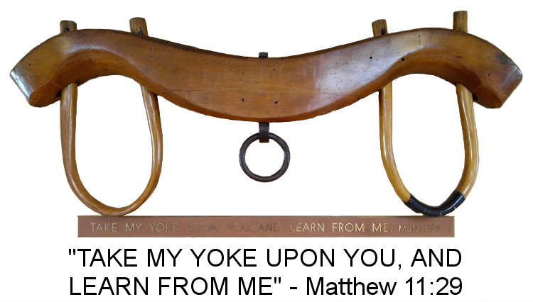

WITNESS AND OUTREACH
Matthew 11:25-30
The Lord offers quite an exchange in these Gospel verses: the overbearing burdens of this world that we carry we can exchange for the light yoke that ONLY Jesus offers to us. Only Jesus can offer the light yoke because of His tremendous strength and grace to carry our burdens through His cross. With this rest and relief of burdens, we are then free to reach out with the Gospel of God’s grace and freeing salvation to others. There is no escape from the burdens of life, but there is One who desires to exchange yokes with you, and His burden is light. Rest for the soul is knowing that you never have to face your burdens alone, even if you are living in isolation due to the Covid pandemic. God is with you always to lift you up and to lift your burdens even higher onto His shoulders. In His rest and care, reach out with the news of this exchange to someone who needs a refreshing rest today.


OLD EYE GLASSES
Trinity has a collection box for old eye glasses. The eye-glasses left here will be taken to Wal-Mart and put in their eyeglass drop box. If you have prescription eyeglasses or reading glasses you no longer use, please take them out of the drawer and donate them for mission use. You may place glasses in the eyeglass collection box in the Trinity narthex above the mailboxes or take them to the “Eye Glasses” donation box by the Optometry-Vision Center at Wal-Mart. Either way, they will be re-purposed for use by those in need.

“The Lord is my strength and my song,
and He has become my salvation;
this is my God and I will praise Him,
my father’s God, and I will exalt Him.”
Exodus 15:2
TRINITY LUTHERAN CLASSICAL SCHOOL
PRESCHOOL

"Shepherding Jesus' Lambs"
Since October 3, 1988
Another school-year is underway at our Preschool!
Our three day students learned: We learned the classroom rules, got reacquainted with old friends and met some new friends and worked on finger warm-ups (holding our pencils & crayons correctly, playing with play-dough, cutting with scissors, etc.)
Letter A – We read a book about Ants. We worked hard learning to write our Aa’s. Each week we will do a letter craft. This week we turned an A into an Alligator with sharp teeth.
Letter B - We read Bark George. We learned to write our Bb’s and turned a B into a Butterfly.
Letter C - We read The Hungry Caterpillar. We learned to write the letter Cc and turned a C into a Caterpillar.
Our two day students learned: We learned the classroom rules, met new friends and made a first day crown. We read The Kissing Hand and learned about what animals do in the daylight and at night. We found out that Chester didn’t have to be afraid of school and we do not need to be afraid as our parents and God’s love will always be with us.
Color Red - We read The Red Color Book and Llama, Llama, Red Pajama. We colored a Red crayon and painted a Red apple.
Color Pink - We read Pinkalicious. We colored Pink and painted a Pink flamingo.
Color Yellow – We colored Yellow and painted Yellow corn.
Our Five day students are Journaling in a book. We start with simple shapes and small words. I am excited to see how they grow and their book evolves.
Science – Every other week we have a new science theme. Our first unit was on Bugs & Insects - We read many books about bugs. The 3 day painted a rock Red and I turned them into a ladybug for them. We learned about the life cycle of a caterpillar. The 2 day students made caterpillars into butterflies and turned them into magnets. We sang a song about bug body parts (head, thorax, abdomen). We sorted bugs by color.
Bears - We had a teddy bear pajama party where the students brought their favorite stuffed friend. We measured them, sang songs and danced with them.
Farm – We learned how God made farm animals and what each one gives to us. The children were very interested in watching a video of sheep being sheered. We drew and colored farm animals. The students watch as I instruct them on how to make lines to draw their animals. The students draw the animal and then we outline them with a marker before they color them.
Each week we have Chapel with Pastor and myself. This month we talked about God our Creator and how He loves us; He created the world and all things in it; He made Adam, then Eve. They lived in the Garden of Eden, met a serpent, ate fruit from the forbidden tree and fell into sin.
Each week we have Show and Tell every Thursday for the 2 day students and every Friday for the 3 day students. Please follow the calendar and bring in things that correspond with what we are learning.
Picture Day’s - Individual and classroom photo days are coming up on Monday, Oct. 12 & Tuesday, Oct. 13. We will distribute preschool t-shirts for the students to wear in the group classroom photos. This years shirts are red with navy print. We hope that all students are well and in attendance for these. (Siblings also welcome – watch for details.)
Harvest Dinner - October 18th (See newsletter ad).
Pumpkin Parties - Oct. 29th & Oct. 30th, No costumes please! We will have fun games and snacks. Children are welcome to bring snacks to share or treat bags for all their classmates. No costumes please!
Cold and flu seasons are approaching; please help your children catch their coughs in their elbows. This is what we do at preschool, so if you could reinforce it at home, we might not share our germs so readily.
We are excited about our school year and getting to know all of you.

In His service, Mrs. Pam Henman

NO SCHOOL
Thursday & Friday, Oct. 15th & 16th
TEACHER & CHURCH WORKERS CONFERENCE in Kalispell, MT.



Donations toward the Cross on the Hill Fund
to help “resurrect it" are much appreciated.
Checks can be made to Trinity Lutheran Church with memo line designation for the Cross.
TRINITY LUTHERAN CLASSICAL SCHOOL
Kindergarten - 8th Grade News
K-8th Established - August 27, 2008
========================================
This school year began with Parent Orientation on Monday, August 24th; classes started Tuesday, August 25th. We are very excited to have 22 students enrolled in our K-8th this year! This is the most students we have ever had! What a blessing from God!
I am blessed to have Jolene Taylor back as my aide and kindergarten teacher, as well as Teri Cox who is teaching first grade from 9-12. Mrs. Rickman is teaching the 6th & 7th grades on-line from 9-12 daily.
I am teaching the 2nd-4th grades and have the whole group in the afternoons for history and science. Pastor is teaching the 4th-7th grade Biblical Studies, and he does Chapel with the school Wednesday mornings. Jolene and Gavin Taylor help with lunches.
Alicyn Chapman teaches art every other Wednesday, and Jessica Rosencranz will be teaching P.E. on Friday afternoons. We are so blessed to have such a wonderful and dedicated staff working to support this mission and ministry here! You are all such a blessing to our school, our students, and to me! Thank you!
I am pleased to announce that we will be starting some afterschool clubs the first full week in October. We will be doing children’s Chime Choir on Mondays (Beginners) and Tuesdays (Advanced), from 3:45-4:30 instructed by Michelle Rice, Art Club will meet on Thursdays from 3:45–5 instructed by Alicyn Chapman, and we will be adding a Chess Club on Wednesday’s from 2:15-3:15 instructed by Rebecca McKinney. I am really looking forward to these opportunities for the students to participate in!
Thanks to a Thrivent Action Team Grant applied for by Jack Ottenbacher, the school received two fans and some new desks.
A big thank you also goes out to Ryan & Jessica Rosencranz for building and painting the new backpack cubbies with hooks to help accommodate our new students.
THANK YOU to all the congregation members who once again took request slips & donated supplies! You are amazing & generous supporters of our school ministry! Your prayers and donations are appreciated!
You are welcome and encouraged to stop by at any time and check out what we are doing.
We will have individual and class pictures on Tuesday, October 13th. Students will need to wear their long sleeved oxford shirt with navy pants or skirt (no dresses please).
There will be no school on October 15th & 16th.
The Board of Christian Education will host Trinity’s annual Harvest Dinner on Sunday, October 18th. All are invited to attend. (See ad in this newsletter).
Yours in Christ, Michelle Rice
Teaching Children Chastity for Life:
TALKING POINTS FOR CHRISTIAN PARENTS

What’s better than sex ed? Mentoring your children for chastity! In this booklet, parents speak frankly to fellow parents on the basis of God’s Word, offering practical suggestions for dads and moms to provide their children with the guidance they need to navigate through puberty and into sanctified adulthood. While the world sponsors open discussions in co-ed classrooms where parents are absent, these authors call for a family-centered approach that prepares young people to form stable families of their own as they mature.
If you’ve ever thought there must be something better than sex ed, you were right: God’s answer is parent-led mentoring, and this book will teach you how to do it. To order go to www.lutheransforlife.org or www.cph.org
(Item # LFL731B / 2020 / Tract $3.00)


SUNDAY SCHOOL
REFORMATION CELEBRATION
Sunday, October 25th, 2020
During the S.S. hour 9:15 – 10:15 a.m.
Games, Crafts, Food and Fun!
Please join us for this special day!

PLEASE SAVE EMPTY SHOEBOXES FOR US
Since we did not have VBS last summer due to the Covid-19 shutdown, we hope to have VBS in the summer of 2021. We need Shoe boxes for the Vacation Bible School students to use to make a rain forest diorama craft. You may turn them into Pam Henman or Sarah Trogden. Thank You!



LIFE QUOTES
====================================
"There is Hope in Jesus, the Light of Life!"
====================================

“Laws of the State clearly matter, and the message they send affects the mindset of society. But, if our battle cry for life begins on the abortion table, then we’ve waited too long to speak. If our efforts to model life end in the courtroom, then we’ve already lost our children. God help us; it’s time to ask ourselves if we speak life or whisper death.”
Tawnia Hoehne, Frazee, Minnesota

“The Church has confessed from the beginning that each life is created by God, that human life is the supreme gift of the Creator. Human life is not given unconditionally but is given under the condition that we will be responsible for preserving it. The testimony that God respects life above all else is contained in the words of the Gospel: ‘For God so loved the world, that he gave his only begotten Son, that whosoever believeth in him should not perish, but have everlasting life’ (John 3:16).”
Abbot Tryphon, Vashon Island, Washington

“I pray that the love of Christ emboldens you to rejoice in the Word and to speak it without fear of consequence … may future generations speak of us like we do of David, Josiah, Luther, and our forefathers. May our children say of you and me, ‘Our forefathers stood their ground on Christ alone, on His Word of truth alone.’ The truth has set you free. Enjoy your own personal reformation. Then let your freedom in Christ be contagious! Let your life continue to shout: Thank Jesus Christ my Savior! I’m free at last … and so are you! Amen.”
Rev. Peter Sulzle, St. John Lutheran Church, Redwood Falls, Minnesota

“Adoption can be an enormously unselfish gift to a baby, not only as a way to give a child a secure, loving, stable family but to give that child the most precious gift of all—life.” Dr. Jean Garton,
former president of Lutherans For Life

The mission of Lutherans For Life is to witness to the sanctity of human life through education based on God's Word. www.lutheransforlife.org 1-888-364-LIFE

OCTOBER is National
Domestic Violence Awareness Month
The U.S. Department of Justice estimates that 1.3 million women and 835,000 men are victims of physical violence by a partner every year.
Every 9 seconds, a woman in the U.S. is beaten or assaulted by a current or ex-significant other.
Here is another shocking statistic: the number of U.S. troops killed in Afghanistan and Iraq between 2001 and 2012 is 6,488. The number of women who were murdered by current or ex-partners during that same time frame in 11,766, according to the Huffington Post. That’s almost double the number of people who were killed fighting in the war. People in an abusive relation-ship will stay with their partner for a number of reasons:
Their self-esteem is totally destroyed, and they are made to feel they will never be able to find another person to be with. No one could love them.
The cycle of abuse, meaning the ‘honeymoon phase’ that follows physical and mental abuse, makes them believe their partner really is sorry and does love them.
It’s dangerous to leave. Women are 70 times more likely to be killed in the weeks after leaving their abusive partner than at any other time in the relationship, according to Domestic Violence Intervention program.
Statistics suggest that 5 percent of male homicide victims each year are killed by an intimate partner.
They feel personally responsible for their partner, or their own behavior. They are made to feel like everything that goes wrong is their fault.
They share a life. Marriages, children, homes, pets, and finances are reasons victims feel they can’t leave.
Sometimes, people don’t know if they are really in an abusive relationship because they’re used to their partner calling them crazy or making them feel all the problems are their own fault. Here are a few ways to know if you’re in an abusive relationship that you need out of:
Your partner has hit you, beat you, or strangled you.
Your partner is possessive. They check up on you constantly wondering where you are; if you don’t do what they say, they get mad at you for being with friends.
Your partner is jealous. (A small amount of jealousy is normal and healthy) however, if they accuse you of being unfaithful when you are not, or they isolate you from family or friends, the jealousy has gone too far.
Your partner puts you down. They attack your intelligence, looks, mental health, or capabilities. They blame you for all of their violent outbursts and tell you nobody else will want you if you leave.
Your partner threatens you or your family.
Your partner physically and sexually abuses you. If they EVER push, shove, or hit you, or make you have sex with them when you don’t want to, they are abusing you (even if it doesn’t happen all the time.)
STEWARDSHIP MINISTRY
“God is not Mocked”

We celebrate the Reformation at the end of each October. The Reformation began on All Saints’ Eve in 1517, which was when Martin Luther posted the 95 Theses to the door of the Castle Church in Wittenberg. So, let’s hear from Luther himself on the topic of giving and stewardship.
In the Small Catechism under the Table of Duties, Martin Luther gives specific Bible passages to help Christians know their duty in their various vocations as members of their family, society at large, and in God’s family, the Church. Under the heading “What Hearers Owe Their Pastors,” Luther lists five passages from the Bible, three of which have to do with giving to your local congregation. They are these:
- “The Lord has commanded that those who preach the gospel should receive their living from the gospel.”
(1 Cor. 9:14)
- “Anyone who receives instruction in the word must share all good things with his instructor. Do not be deceived: God cannot be mocked. A man reaps what he sows.” (Gal. 6:6–7)
- “The elders [presbyters, i.e., pastors] who direct the affairs of the church well are worthy of double honor, especially whose work is preaching and teaching. For the Scripture says, ‘Do not muzzle the ox while it is treading out the grain,’ and ‘The worker deserves his wages.’ ”
(1 Tim. 5:17–18)
Luther comments on these passages in his 1535 Lectures on Galatians. He wrote:
“When Paul says ‘all good things,’ this is not to be taken to mean that everyone should share all his possessions with his preacher. No, it means that he should provide for him liberally, giving him as much as is needed to support his life in comfort. … The apostle is so serious in advocating this topic of support for preachers that he adds a threat to his denunciation and exhortation, saying: ‘God is not mocked.’ … All this pertains to the topic of support for ministers. I do not like to interpret such passages; for they seem to commend us, as in fact they do. In addition, it gives the appearance of greed if one emphasizes these things diligently to one’s hearers. Nevertheless, people should be taught also about this matter, in order that they may know that they owe both respect and support to their preachers. Christ teaches the same thing in Luke 10:7: ‘Eating and drinking what they provide, for the laborer deserves his wages’; and Paul says elsewhere (1 Cor. 9:13–14): ‘Do you not know that those who are employed in the temple service get their food from the temple, and those who serve at the altar share in the sacrificial offerings? In the same way the Lord commanded that those who proclaim the Gospel should get their living by the Gospel.’ It is important for us who are in the ministry to know this, so that we do not have a bad conscience about accepting for our work wages … it happens when those who proclaim the glory of God and faithfully instruct the youth derive their livelihood from them. It is impossible that one man should be devoted to household duties day and night for his support and at the same time pay attention to the study of Sacred Scripture, as the teaching ministry requires. Since God has commanded and instituted this, we should know that we may with a good conscience enjoy what is provided for the comfortable support of our lives from church properties to enable us to devote ourselves to our office.”
(LW 27:125–126)
Board of Stewardship Ministry, The Lutheran Church – Missouri Synod


“If we say we have no sin,
we deceive ourselves,
and the truth is not in us.
If we confess our sins,
He is faithful and just
to forgive us our sins
and to cleanse us
from all unrighteousness.”
1 John 8-9
TRINITY EVANGELICAL LUTHERAN
CHURCH & CLASSICAL SCHOOL, LCMS
Preschool - 8th Grade
221 S. Center Avenue
Miles City, MT. 59301
Phone (406) 234-4983
Fax (406) 234-8033
Email trinity@midrivers.com
www.trinitylutheranchurch.360unite.com

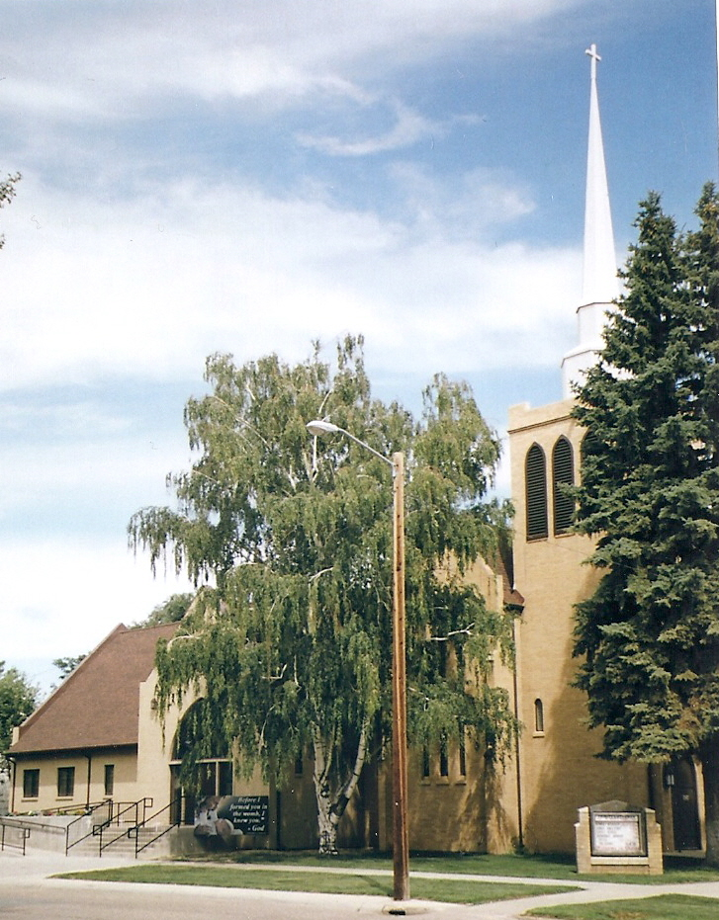

OCTOBER 2020

“Love your neighbor as yourself. Love does no harm to its neighbor. Therefore love is the fulfillment of the law.” Romans 13:9b-10

THE GREATEST COMMANDMENT
When Jesus was asked about the greatest commandment, He answered, “Love the Lord your God will all your heart and with all your soul and with all your mind and with all your strength.’ The second is this: ‘Love your neighbor as yourself.’ There is no commandment greater than these.” Luke 10:27
Jesus doesn’t separate love for God from love for neighbor. It’s one and the same command-ment.
St. Paul defines what it means to “love your neighbor as yourself.” He writes in His epistle to the Romans, “Love does no harm to its neighbor.” Our mission in life is to love God as we love our neighbor; to do our neighbor no harm. We do this as we reach out in love to those around us. Our love for God is truly reflected in our love for our neighbor.

“Each of you should look not only to your own interests, but also to the interests of others. Your attitude should be the same as that of Christ Jesus: Who, being in very nature God, did not consider equality with God something to be grasped, but made Himself nothing, taking the very nature of a servant, being made in human likeness.” Philippians 2:4-7

SERVANTS
Human nature being what it is, we resist the notion that we should be servants. Servants are lower on our social hierarchy. We would much rather be served than to serve.
St. Paul reminds us of our Lord’s example. By all rights the Son of God should have been served during His time on earth, yet He took the nature of a servant. The evidence is in His life. He performed miracles that served the needs of humankind. He submitted to the will of His father. Ultimately, He went the way of the cross – the very epitome of servanthood.
We are empowered by the Holy Spirit to look after the interests of others – to be servants and not look to be served. God grant us hearts of servanthood to glorify You and gladly serve others.

