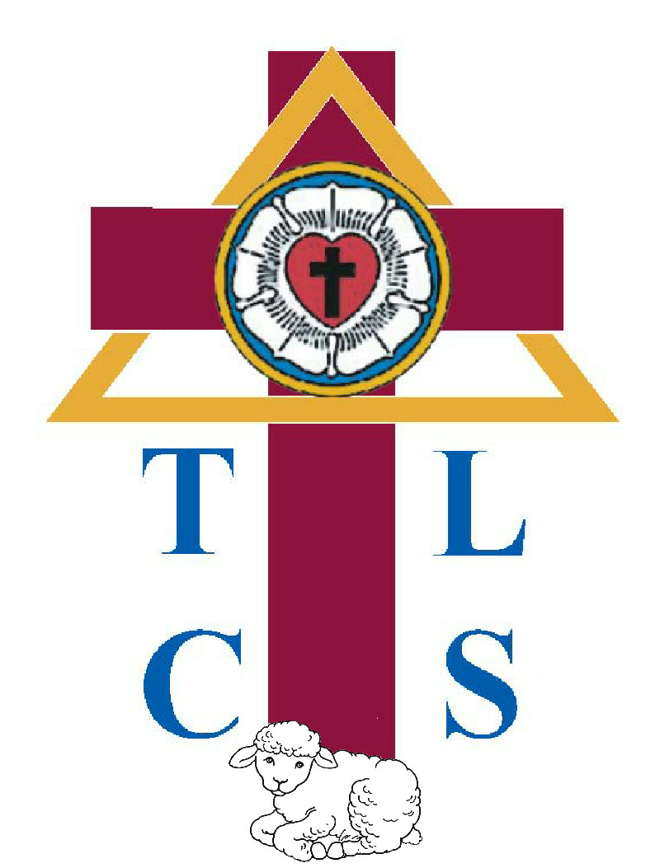
JUNE 2020

PASTOR: Howard D. Schreibeis CHURCH OFFICE: 234-4983 PARSONAGE: 234-2985

TLCS K - 8th HEAD TEACHER: Mrs. Michelle Rice PRESCHOOL TEACHER: Mrs. Pam Henman

4 - 8 TEACHER: Mrs. Roberta Rickman SUNDAY SCHOOL DIRECTOR: Sarah Trogden

ADMIN ASST: Peggy Certain PRESIDENT: Ted Schreiber VICE PRES: Dennis Hirsch

ORGANISTS: Pam Schreiber, Betty Toepke, Teri Cox

JUNE ELDERS: 8:00 - Dennis Hirsch
10:30 - Clint Kelstrup

COMMUNION: Theresa Scheid
Maureen Klapmeier

GREETERS: Maureen Klapmeier,
Jo Ann Dane

Trinity Evangelical Lutheran Church
& Classical School, Preschool – 8th
The Lutheran Church – Missouri Synod

 | Sunday | Monday | Tuesday | Wednesday | Thursday | Friday | Saturday
 |  | 1 | 2 | 3 | 4 | 5 | 6
 | 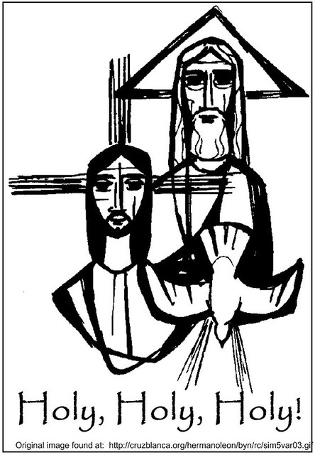 | Peggy out of office.  2:30 PM Worship  Committee  6:30 PM Board of  Evangelism | Peggy out of office.  6:30 AM Mens Bible Study  10:00 AM Bible St. @ TL |  | 6:30 AM Women’ Bible St.  1:30-4:30 Visitations  7:00 PM Elders Meeting | Pastor’s Day Off
 | 7 The Holy Trinity | 8 | 9 | 10 | 11 | 12 | 13
 | FOOD BANK & LWML MITE SUNDAY  8 AM The Lutheran Hour on KIKC 101.3 FM  8:00 AM WORSHIP Service  9:00 AM Fellowship by Sunday Bible Class  Guild Card Center / Library Open  9:15 AM Sunday School & Bible Study  10:30 AM WORSHIP Service w/Communion | 7:00 PM Board of  Stewardship | 6:30 AM Mens Bible Study  10:00 AM Bible St. @ TL  6:30 PM Board of  Christian Education |  | 6:30 AM Womens Bible St.  1:30-4:30 Visitations | Pastor’s Day Off
 | 14 Second Sunday after Pentecost | 15 | 16 | 17 | 18 | 19 | 20
 |  FLAG DAY  8 AM The Lutheran Hour on KIKC 101.3 FM  8:00 AM WORSHIP Service w/Communion  9:00 AM Fellowship by Sunday Bible Class  Guild Card Center / Library Open  9:15 AM Sunday School & Bible Study  10:30 AM WORSHIP Service |  | 6:30 AM Mens Bible Study  10:00 AM Bible St. @ TL  7:00 PM Guild Meeting |  | 6:30 AM Womens Bible St.  1:30-4:30 Visitations | Pastor’s Day Off | Summer begins  
 | 21 Third Sunday after Pentecost | 22 | 23 | 24 | 25 | 26 | 27
 | Father’s Day  8 AM The Lutheran Hour on KIKC 101.3 FM  8:00 AM WORSHIP Service  9:00 AM Fellowship by Sunday Bible Class  Guild Card Center / Library Open  9:15 AM Sunday School & Bible Study  10:30 AM WORSHIP Service w/Communion | All JULY News Articles Due Today | 6:30 AM Mens Bible Study  10:00 AM Bible St. @ TL |  | 6:30 AM Womens Bible St.  1:30-4:30 Visitations | Pastor’s Day Off
 | 28 Fourth Sunday after Pentecost  8 AM The Lutheran Hour on KIKC 101.3 FM  8:00 AM WORSHIP Service w/Communion  9:00 AM Fellowship by Sunday Bible Class  Guild Card Center / Library Open  9:15 AM Sunday School & Bible Study  10:30 AM WORSHIP Service | 29 | 30  6:30 AM Mens Bible Study  10:00 AM Bible St. @ TL  7:00 PM Trustees Mtg. | JULY 1 | JULY 2  6:30 AM Women’ Bible St.  1:30-4:30 Visitations | JULY 3  Pastor’s Day Off  Peggy out of office. | JULY 4  Independence Day  
REGISTER FOR TLCS
Preschool & K-8th

