FEBRUARY BIRTHDAYS
================================
Jensen Muri 1
Emmett Duncan (TLCS-Pre) 4
Shane Hirsch 4
Marla Malley 4
Mike Neibauer 4
Ryan Becker 5
John Bird 5
Mervin Meidinger 5
Cadence Brown 7
Ellie Helland 7
Jaxin Bentley 10
Rebecca Ellis 10
Lashonna Taylor 10
Zack Dinardi 11
Seth Lockie 11
Esther Harbaugh 12
RaeLynn Roesler 13
Shawna Wright 13

Payton Beeler 14
Charlie Swogger 14
Kayla Stewart Newton 16
Conner Bean 17
Kody Garza 17
Koy Gierke (TLCS-Pre) 18
Kadence Lockie 19
Rachael Luhr Reimanis 19
Jessica Luhr Grunst 20
Faith Taylor 22
Jay Gruba 23
Dorothy Meidinger 23
Wava Jo Roach 23
Tyler Kleinsasser 25

Alvin Beeler 26
Anna Kron 26
Cyndee Doyel 27
Bonnie Scott 27
Leanne Stewart 27
Alma Decker 28
Ernie Nelson 28
Audrey Sasse 28

FEBRUARY ANNIVERSARIES
Joe & Amber Ferris 11 yrs. 14
Mervin & Dorothy Meidinger 22 yrs. 14

Jim & Stacey Hill 19 yrs. 17
Doug & Diane Ellingson 50 yrs. 28

If your special day was not listed, please notify the church office at 234-4983.

FEBRUARY ELDERS
8:00 a.m. Dwayne Taylor, 10:30 a.m. Ted Schreiber

DEATH: Dale Grebe passed from this life on January 10, 2020 in Billings, MT. Dale was born September 27, 1927 in Melstone, MT. He graduated from Belfry High School in 1945. Dale married Betty on February 6, 1954. To this union 3 children were born: Bernie, Karla and Becky. The couple moved to Miles City in 2005 where they were active members of Trinity Lutheran Church, M.C. In 2018, they moved to Billings, MT. Condolences may be sent to Betty Grebe at 3075 Ave. C, Aspenview Apt. 105, Billings, MT. 59102.

DEATH: Our sympathy goes out to Bernice Cottom on the passing of her son, Rick Geist in Dec. 2019.

NEW ADDRESS: Ruth and Harold Bohlman are residing at TLC, 200 Vine St., Forsyth, MT. 59327.

BIBLE STUDY: On Sunday, February 2nd & 9th (and possibly the 16th), Elder, Shane Taylor will make a presentation on his trip to the Holy Land to the 9:15 a.m. Sunday morning Bible Study class.
All are welcome to attend.

 BONKO FUN NIGHT
Everyone is welcome to join us Sunday, February 9th, at 5:00 p.m. for Bonko. Attendees should bring snacks to share. Beverages provided by the Board of Stewardship. Come one, Come all for an evening of fun, food and fellowship!



Save the Date for PIE SOCIAL
TRINITY LUTHERAN CHURCH

Sunday, February 23rd, 2020

(Directly following the 10:30 a.m. service)
=================================
Purchase a slice of pie to eat while
enjoying the Auctioning of whole pies.
Proceeds will benefit: The Journey of Faith, Capital Building Fund Loan Debt Reduction Principal
Join us for fun & fellowship at this
16th Annual event.
Donations of pies for this event are being sought.
See pie donation sign up slips which will soon be available in the Sunday bulletin or church narthex.
Contact persons: Bernice Cottom and Gloria Tucker

GUILD NEWS
Lutheran Women’s Missionary League
====================================
Trinity Lutheran Guild met Tuesday, January 21, 2020 at 7:00 p.m. in the fellowship hall with 4 members and Pastor Schreibeis present. President Maureen Klapmeier opened the meeting; Pastor led an opening prayer. Jo Ann Dane had an opening devotion and Pam Schreiber led the group in singing, “Lord, Take My Hand and Lead Me.” Pastor then led a Bible study, “Beautiful Savior.”
Maureen reported that Noel Gruba, sister of the late Coleen Garza, will shop for altar flowers in memory of Coleen, using the memorial money given for that purpose.
Each LWML Society in the state is to make a quilt measuring 85 by 63 inches for the veterans home in Billings. They will be displayed at the LWML Convention in Billings, April 24-26, 2020.
Guild plans to serve the Soup Supper on Ash Wednesday, February 26th. We will make detailed plans at our next meeting regarding the menu, etc.
(Pam Schreiber has applied for & received a $250 Thrivent Action Team Grant to help with this event.)
Florence Lodwig gave the treasurer’s report and the meeting closed with the Lord’s Prayer.
Delicious refreshments were served by Florence and provided by Ginger Mueller, who was unable to attend.
Guild will meet next on Tuesday, February 18th, at 7:00 p.m. All ladies of the congregation are welcome to join us.
Respectfully submitted, Jo Ann Dane, Secretary

FEBRUARY GUILD DUTIES are as follows:
Greeters: Theresa Scheid and Pam Schreiber
Communion: Ginger Mueller and Pam Schreiber
Hostesses: Wava Jo Roach and Pam Schreiber
Devotions: Emma Morrison
Bible Study: Pastor Schreibeis

 SOUP SUPPER
The Retired Senior Volunteer Program will host the 12th Annual RSVP Soup Supper on Thursday, February 6, 2020 from 5:00 p.m. to 6:30 p.m. at Range Rider’s Hall. Adults $7, Kids 12 & under $5, Families $20. Enjoy homemade soups, breads and cookies prepared by local volunteers. All proceeds benefit your local RSVP program.
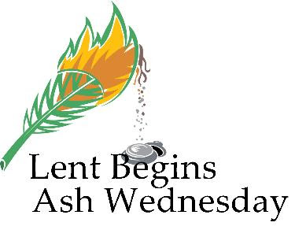
LENTEN SUPPERS & SERVICES
Beginning Ash Wednesday, February 26th, please join us each Wednesday evening throughout Lent for supper (with free will offerings) served in Trinity’s fellowship hall from 5:30 to 6:30 p.m. followed by Worship service at 7:00 p.m. featuring the CPH Lenten series “Eyes On Jesus.” Contact Peggy in church office to reserve your groups date.

Ash Wednesday, February 26th
Supper hosted Guild
Divine Service with Holy Communion at 7:00 pm

Wednesday, March 4th
Supper hosted by Board of Christian Education
Vespers Worship Service at 7:00 pm

Wednesday, March 11th
Supper hosted by Board of Evangelism
Divine Service with Holy Communion at 7:00 pm

Wednesday, March 18th
Supper hosted by: Open
Vespers Worship Service at 7:00 pm

Wednesday, March 25th
Supper hosted by: Open
Divine Service with Holy Communion at 7:00 pm

Wednesday, April 1st
Supper hosted by: Open
Vespers Worship Service at 7:00 pm

Maundy Thursday, April 9th
Supper hosted by Board of Elders
On Menu: Pancakes & Sausage
Divine Service with Holy Communion at 7:00 pm

Good Friday, April 10th
(No Lenten Supper this evening)
Tenebrae Service at 7:00 p.m.

The Resurrection of Our Lord, April 12st
Sunrise Divine Service w/Communion at 7:00 am
Easter Sunday Breakfast, 8:30 am
Hosted by Youth group & Elder’s
Resurrection Divine Service
with Holy Communion at 10:30 am

TRINITY LUTHERAN CLASSICAL SCHOOL
An Outreach of Trinity Lutheran Church
PRESCHOOL NEWS
"Shepherding Jesus' Lambs"
Since October 3, 1988
====================================
In January, the students were busy with the snack & dessert fund-raiser which ended on January 28th. Scheduled delivery date is Thursday, February 20th.
The three day students reviewed letters A-L. We studied letters M & N. Students made the letter M into a Mouse. We read “The Mitten.” Students made the letter N into a Night sky with star stickers.
The two day classes studied the shape, Heart. They finished shapes and did a review of shapes. We were busy drawing shapes to help prepare students for more pencil work as we start numbers.
Five day students worked on letters and journaling.
We had science lessons on the cold Artic. We studied penguins and polar bears. The three day students colored a penguin and placed it in a cold painted background. The two day students cut out a black penguin body then added all the parts. We are working on scissor skills. The children loved learning about penguins. They liked walking around with styro-foam balls practicing their penguin mother and father duties; it was hard keeping that egg on their feet. They thought that eating fish and regurgitating it for their young sounded really yucky and were all glad that they are not young penguins.
For polar bears, the three day students made a polar bear paw. They crinkled up, then laid flat, an eleven inch sheet of paper, then cut and glued claws & paw pads on it. We learned how polar bears stay warm & that their fur hairs are actually clear (like straws).
During Chapel, we learned about the Wise-men (Magi) visiting Jesus, Mary & Joseph flee to Egypt, and Jesus in the temple.
Classroom Valentine’s Day celebrations will be on Thursday, February 13th and Friday, February 14th. Each student should bring enough Valentines for every student in the class to receive one from them. They can be homemade or store bought. It is easier on the teacher if you just have your student sign who the card is from (not to). The children will make Valentine bags at preschool which will be hung along the counter for students to put a Valentine in Each one. (Parents can help their child distribute their Valentines if they would like to.) If you want to, you are welcome to bring in goodie bags for each student or snacks to share.
There will be no preschool on Friday, Feb. 28th.
Sharing in the love of Christ. Mrs. Pam Henman

T.L.C.S. K – 8th Grade
Established August 25, 2008

Third quarter began on January 20. We have made it halfway through the year already!
Our two houses, Michael and Gabriel, have been earning (and losing) points throughout the quarter. Michael’s House ended the quarter with 147 points, while Gabriel had 118. The students in the house of Michael earned a pizza party at Seabeck’s for their hard work. Thank you to Seabeck’s for your wonderful donation! The students in both houses have been working hard to help out their house. Thank you to our outgoing 2nd quarter Captains: Erowyn and Talon and Co-Captains: Sophia and McKenna. You were great leaders and examples for your houses. We welcome our 3rd quarter Captains: Jayden and Isaac and Co-Captains: Aaron and Daniella! I know you will do your best to lead your houses through your hard work and encouragement!
This year we will be learning about Mongolia through Lutheran Hour Ministry’s Gospel Adventure Online Mission Trip. We will get to see what work the missionaries are doing in Mongolia as we learn about the area as well. We will be collecting chapel offerings to send to the missionaries there to help with the work they are doing in Mongolia.
We celebrated our 100th day of school on Friday, January 31. We had a small party to mark this special occasion.
We will have a Valentine’s Day Party during the afternoon of Friday, February 14. We will focus on how we can share God’s love to those around us, just as God shows His love for us through Jesus.
All of our fundraising goodies will come in in the middle of February. The school children will bring you your orders as soon as they can.
There will be no school for TLCS K-8th students on Thursday, February 27 and Friday, February 28 for Parent/Teacher Conferences. Parents should be on the lookout for a sign-up sheet to go up outside the classroom.
The Peace of the Lord be with each and every one of you! Michelle Rice
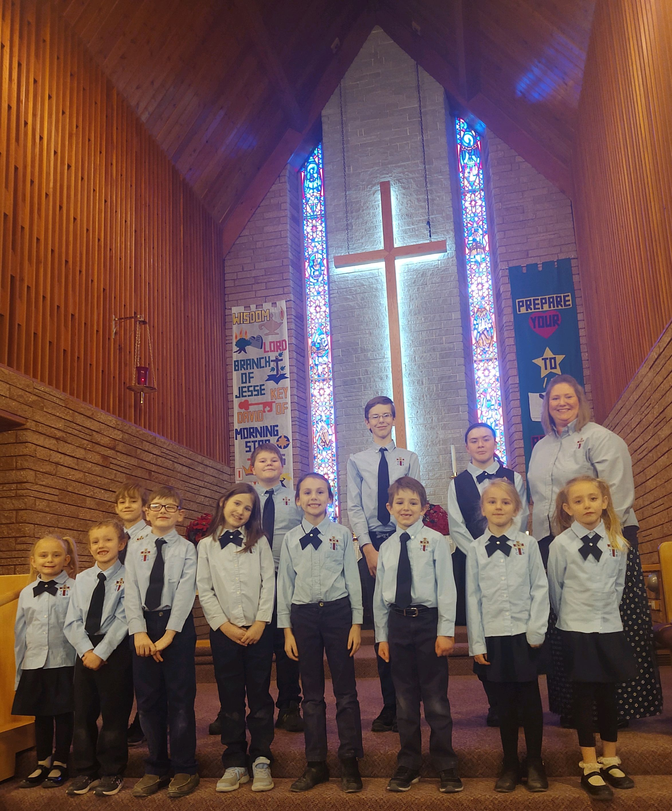
Trinity Lutheran Classical School K-8th

REYNOLD’S In January, Trinity Lutheran Classical School received a quarterly rebate check from Friends of Reynold’s rebate program for $174.29. Thank you to all who utilize their cards at Reynold’s when buying groceries! If you do not have a card, you may pick one up from the counter of the walk-up window in the church office and present it at Reynold’s each time you buy groceries. The card MUST be given to the cashier BEFORE they start to ring up your order. Each quarter (at no cost to you) our school will receive a check for a percentage of total sales designated under our number.
You Shop – Amazon Gives AMAZON donates 0.5% of the price of your eligible Amazon Smile purchases to the charitable organization of your choice. Amazon Smile is the same Amazon you know, same products, same prices, same service. If you order stuff from Amazon, customers can go to smile.amazon.com then select an organization to donate to. Trinity Lutheran Church, Miles City is a registered Amazon Smile non-profit recipient organization with all proceeds earned going to benefit Trinity Lutheran Classical School.
ACE SCHOLARSHIPS

Trinity Lutheran Classical School is a proud ACE Scholarships Partner School. ACE believes every child deserves a great education and makes that a reality by providing children from low-income families with K-12 scholarships to quality private schools. Since 2012, ACE has awarded over $7 million in scholarships to scholars at 60+ partner schools in Montana alone. T.L.C.S., Miles City is blessed to have students who are ACE scholarship recipients. ACE Scholarships need to be applied for by April 20th of each year for the following school-year. To learn more, text ACE to 52886.

WHERE WILL YOUR CHILD BE ATTENDING IN THE FALL? LET US KNOW YOUR INTENTIONS.



Celebrate Lutheran Education
at TLCS March 2020

“Joy:Fully Lutheran”
“Rejoice always, pray without ceasing,
give thanks in all circumstances; for this
is the will of God in Christ Jesus for you.”
1 Thessalonians 5:16-24 ESV

Celebrate Lutheran education with us and our network of nearly 2,000 LCMS preschools, elementary schools and high schools. We take the opportunity to proclaim and celebrate God’s work among us in our Lutheran schools. We thank God for the opportunity to provide excellent academic preparation for the children we serve. We are most grateful for the opportunity to share Jesus’ amazing love with children and their families. Let us proclaim these great blessings within the communities we serve. Our schools are amazing incubators for faithful witness of God’s love for us through Christ by teachers and students alike. Grow in the faith!



“For the Lord gives wisdom;
from His mouth come knowledge and understanding; He stores up sound wisdom for the upright; He is a shield for those who walk in integrity.” Proverbs 2:6-7
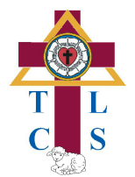
Trinity Lutheran Classical School, Pre - 8th
S.O.S. (Support Our School)
11th Annual Dinner & Auction
Hosted by the Board of Christian Education
ALL are welcome to attend!

Trinity Lutheran Church fellowship hall
Saturday, MARCH 21st, 2020
Children sing at 5:00 p.m.
Dinner & Silent Auction at 5:30 p.m.
Live Auction begins at 6:30 p.m.

SILENT and LIVE AUCTION of

Theme Gift Baskets, Desserts & More

We are currently seeking donations of themed gift baskets, gift certificates, specialty items and homemade desserts for the silent and live auctions. No alcohol donations please.
Any help from the church congregation, our school families, former alumni and local business community would be appreciated! Donors are asked to put a tag on their basket (or item), listing donor’s name and actual or estimated value. If you would like a receipt for your donation, speak with Elnora Ottenbacher @ 234-6211.
Plan now to attend this special event! We hope to see you there! Watch for more details in March newsletter.


VACATION BIBLE SCHOOL 2020 DATES ARE SET

VBS - JUNE 15-20, 2020
Rainforest Explorers by CPH
Jesus Leads the Way
VBS Co-Directors: Sarah Trogden, Pam Henman
PLEASE SAVE EMPTY SHOEBOXES FOR US
We need them for this summer’s Vacation Bible School to make a rain forest diorama craft. ALSO NEEDED: Fake vines or ferns
for décor, green tissue paper & blue glass beads for crafts.
Thank You! Pam and Sarah



JOF – CF Loan Debt Reduction Update
On October 15, 2004 the congregation of Trinity Lutheran Church, Miles City took a big step on our “Journey of Faith” by originating a loan with the Lutheran Church Extension Fund for $853,000 to finance the balance of costs for building the new addition which was dedicated on November 23, 2003. This loan was taken out for 20 years (240 regular monthly payments); it is scheduled to mature on October 15, 2024. Our monthly loan payments are $5,688.49 due on the 15th of each month and considered late on the 25th. A late fee of $113.77 is added to any payment received on or after the 25th. (Our last late payment fee was paid in January 2012.) All payments have been made on time since then.
As of December 31st, 2019, 183 regular monthly loan payments had been made. In addition, in 2019, $4,428 in extra principal payments were made from Thrivent Choice Dollars designated for CF, from Memorials, the Pie Social, and other Designated CF Gifts.
The outstanding balance on this loan as of Dec. 31, 2018 was $108,222.80. The remaining outstanding balance on this loan as of December 31, 2019 is $38,470.68. The total 2019 reduction in loan was $69,752.12. The total interest paid in 2019 was $2,937.76 as compared to $5,284.82 in 2018, $7,037.65 in 2017, $10,144.73 in 2016, and $14,433.03 in 2015. The current interest rate is 4.0% (as compared to 3.875% in 2018, 3.625% in 2017, 3.50% in 2016, and 3.75% in 2015). In Jan. 2019 we paid $349.11 in interest; In Dec. 2019 we paid $146.90 in interest, a decrease of $202.21.
In 2019, we issued 130 envelopes. Of those, 16 were not used, 114 gave offerings to the church general and/or special funds; 53 gave offerings to the Capital-Building Fund (2 less than in 2018, 3 less than in 2017 & 5 less then in 2016).
In 2020, any gifts that you can give to the “Journey of Faith” Capital-Building Fund loan debt reduction in addition to your general fund offerings would be greatly appreciated so we can continue to make our monthly loan payments in a timely manner. Only donations designated as Capital – Building funds are used to make the loan payment. No general fund offerings are used for this purpose. Pink “Journey of Faith” (capital-building fund) envelopes are available in the narthex to all members and visitors as well as additional JOF/CF envelopes in your 2020 offering envelope box. Please use them diligently as we strive to maintain prompt loan payments. For those who do not give to CF at this time, please consider making a small monthly contribution to this effort. Remember, our loan payment is $5,688.49 each month.
With the help of past principal payments made, we will pay the loan off earlier than our loans maturity date of Oct. 2024. Provided we continue to make our regular payments, our current projected estimated payoff date is July of 2020. That is 4 years and 3 months early! Thanks for your past donations and future consideration.

“We Are Stewards”
Of the three things a person is not to talk about in polite company – religion, politics, and money – the church is called, in one way or another, to talk about all three. Perhaps this is the reason why teaching about stewardship often seems to be an afterthought. It’s something that happens only out of necessity when financial constraints are already nipping at the heels.
There is a more excellent way. Stewardship shouldn’t be the kind of teaching that comes up only when there is a financial crunch. It should be part and parcel of the ongoing instruction of Christians as they live out their faith in their vocations – members of their family, their society, and their church. This teaching touches upon every facet of our lives; it stakes a claim upon our time, our presence, our prayers, and our possessions.
Stewardship begins with the acknowledgment that we are stewards. A steward is a manager of someone else’s possessions. In Christian stewardship, we recognize, according to the Apostles’ Creed, that God is the owner of all things as the Creator, Redeemer, and Sanctifier. And in His fatherly divine goodness and mercy, He gives us what is His to manage here below.
The principal virtue for stewards is faithfulness. As St. Paul wrote to the Christians in Corinth: “Moreover, it is required of stewards that they be found faithful.” (1 Corinthians 4:2)
Stewards must manage that which belongs to the owner according to the owner’s wishes. That is what it means to be faithful in stewardship.
That raises a question: How are Christian stewards to be faithful in their managing of what God has entrusted to them to manage? In other words, what are the specific duties of a Christian steward?
This depends upon what God has revealed in His Word for each of our vocations in life as those in a family (fathers, mothers, husbands, wives, children), society (governors or citizens), and the church (pastors or laity). The Table of Duties from Luther’s Small Catechism lays this out in a helpful and orderly way.
Let’s look just at what the laity (hearers as it is labeled in the catechism) owe their pastors:

“In the same way, the Lord has commanded that those who preach the gospel should receive their living from the gospel.” (1 Corin. 9:14)
“Let the one who is taught the word share all good things with the one who teaches. Do not be deceived: God cannot be mocked. A man reaps what he sows.” (Galatians 6:6–7)
“Let the elders who rule well be considered worthy of double honor, especially those who labor in preaching and teaching. For the Scripture says, ‘You shall not muzzle an ox when it treads out the grain,’ and, ‘The laborer deserves his wages.’ ” (1 Timothy 5:17–18)
“We ask you, brothers, to respect those who labor among you and are over you in the Lord and admonish you, and to esteem them very highly in love because of their work. Be at peace among yourselves.” (1 Thess. 5:12–13)
“Obey your leaders and submit to them, for they are keeping watch over your souls, as those who will have to give an account. Let them do this with joy and not with groaning, for that would be of no advantage to you.”
(Hebrews 13:17)

We can see that the Lord commands hearers to support the work of the ministry with the gifts God endowed them – their time, their presence, their prayers, and their possessions. This is the means by which God blesses His people with His gifts: the ministry with the support of those whom they serve, and the hearers with the work of the ministry.
St. Paul expounds upon this further in his letters to the church at Corinth. He instructs them to give regularly (1 Cor. 16:1–2), proportionally (1 Cor. 16:1–2; 2 Cor. 8:12), and generously (2 Cor. 8:20) of our first-fruits (1 Cor. 16:2) with a spirit of eagerness (2 Cor. 9:2), earnestness (2 Cor. 8:7), cheerfulness (2 Cor. 9:7), and love (2 Cor. 8:23).
All of this teaching is set forth squarely within the context of stations to which God calls us. This is always appropriate for the church to speak because it instructs God’s people in how they are to live out their faith as His stewards under those who are created, redeemed, and sanctified by Him. Board of Stewardship Ministry, LC-MS

PUBLICATION SUBSCRIPTIONS The church orders bulk subscriptions of “The Lutheran Witness” ($16.00), “Portals of Prayer” ($5.00), & offering envelopes ($4.00) for its members and prints the MT. District Newsletter – The Montana Reflections ($5.00) for our congregation. To help offset these costs (Total $30.00) please use the All Subscriptions envelope found in the front of your 2020 offering envelope box. Thanks!

LIFE QUOTE
“The key to a Christian family living out His love—the mutual love we can only know because God first loved us—is Jesus. In the Christian household where friends, extended family members, and neighbors come together, we love one another and forgive one another. We do this because God loves and forgives us through the life, death, and resurrection of His beloved Son Jesus.”
Ron Schlegel, The Lutheran Laymen

