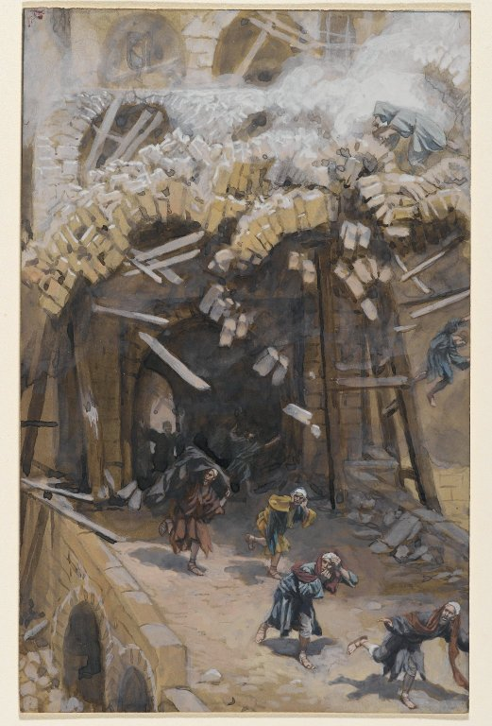
+ The Third Sunday in Lent +
24 March A.D. 2019

James Tissot, “The Tower of Siloam”
As We Gather

Lighting of the Candles

Ringing of the Carillon

Announcements

Prelude
Sermon title

James Tissot, “The Tower of Siloam”
“Worse Sinners”

As We Gather
Responding to a tragedy from His day, in today's Gospel (Luke 13.1-9) Jesus asks whether those who suffered were "worse sinners." We are faced with similar questions in our time, as we look out on a world racked with violence, disasters, and death. Are those who suffer "worse sinners"?

Lighting of the Candles
Ringing of the Carillon
Announcements
Prelude
+ THE SERVICE OF PREPARATION +

Entering the presence of a holy God, we begin by acknowledging our unworthiness and receiving the Lord’s forgiving word of absolution.

Please stand

“Christ Be My Leader”
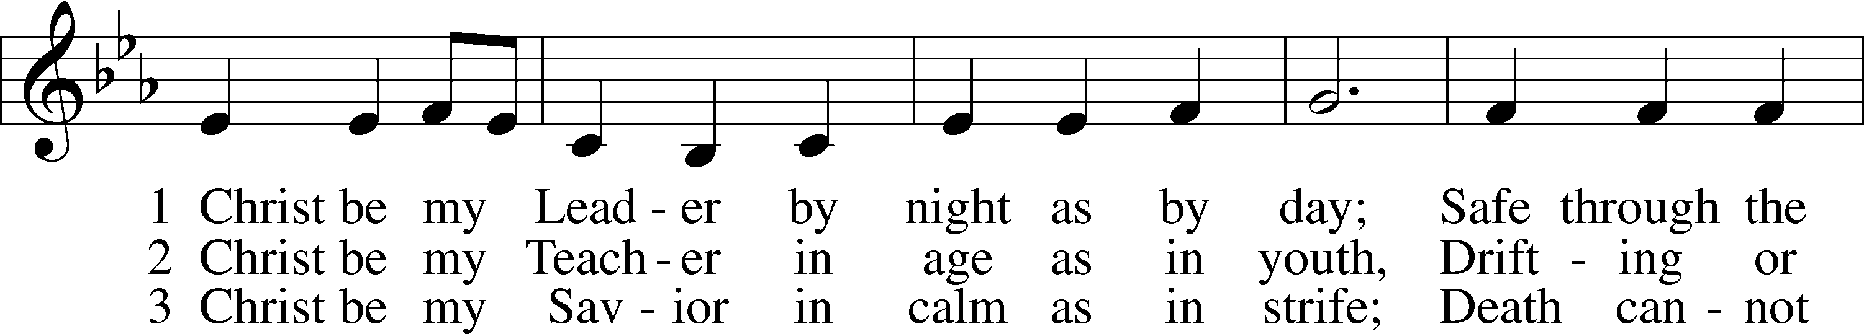
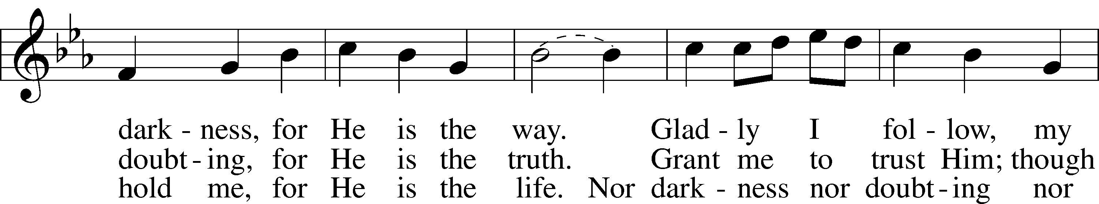
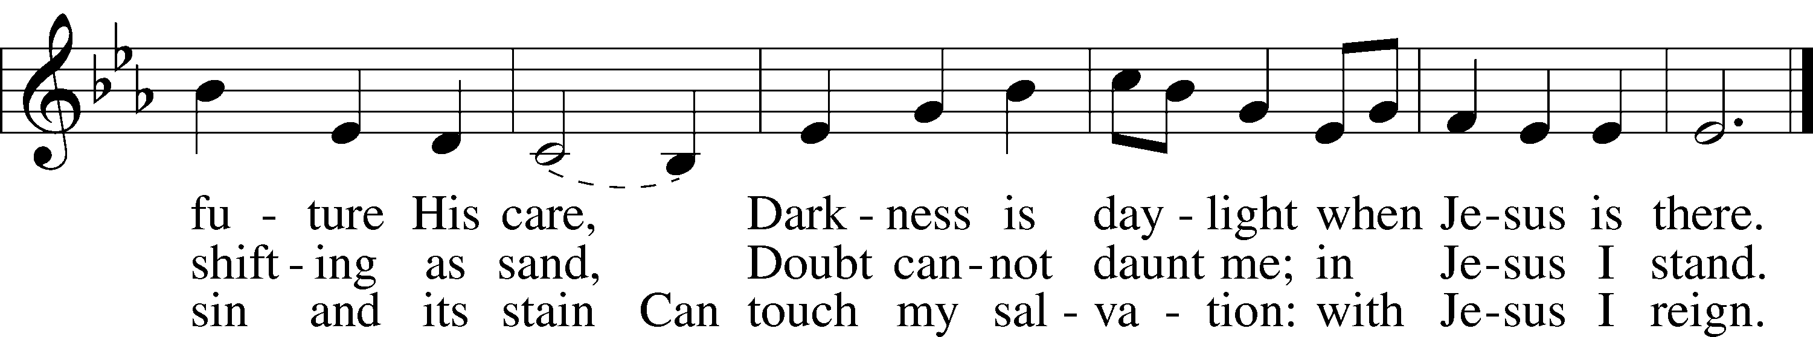
Text: © 1964, renewed 1992 Hope Publishing Co. Used by permission: LSB Hymn License no. 110002406
Tune: Public domain

The sign of the cross may be made by all in remembrance of their Baptism.

Pastor: In the name of the Father and of the Son and of the Holy Spirit.
People: Amen.

Pastor: Beloved in the Lord! Let us draw near with a true heart and confess our sins unto God our Father, beseeching Him in the name of our Lord Jesus Christ to grant us forgiveness.

Our help is in the name of the Lord,
People: who made heaven and earth.

Pastor: I said, I will confess my transgressions unto the Lord,
People: and You forgave the iniquity of my sin.

Silence for reflection on God’s Word and for self-examination.

Pastor: O almighty God, merciful Father,
People: I, a poor, miserable sinner, confess unto You all my sins and iniquities with which I have ever offended You and justly deserved Your temporal and eternal punishment. But I am heartily sorry for them and sincerely repent of them, and I pray You of Your boundless mercy and for the sake of the holy, innocent, bitter sufferings and death of Your beloved Son, Jesus Christ, to be gracious and merciful to me, a poor, sinful being.

Absolution

+ SERVICE OF THE WORD +

In the Service of the Word, Christ is presented to us in the Scriptures, as we prepare to meet Him in the Lord’s Supper.

Introit Psalm 5:4–8; antiphon: Psalm 1:6

Pastor: For the Lord knows the way of the righteous, but
the way of the wicked will perish.
People: For you are not a God who delights in wickedness; evil may not dwell with you.

Pastor: The boastful shall not stand before your eyes; you hate all evildoers.
People: You destroy those who speak lies; the Lord abhors the bloodthirsty and deceitful man.

Pastor: But I, through the abundance of your steadfast love, will enter your house. I will bow down toward your holy temple in the fear of you.
People: Lead me, O Lord, in your righteousness because of my enemies; make your way straight before me. Glory be to the Father and to the Son and to the Holy Spirit; as it was in the beginning, is now, and will be forever. Amen. For the Lord knows the way of the righteous, but the way of the wicked will perish.

Kyrie Mark 10:47

Greek for “Lord [have mercy],” the Kyrie (KIH-ree-ay) is our first prayer and the Christian’s perpetual cry of faith.

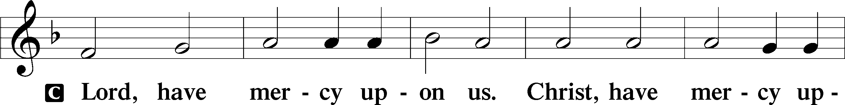
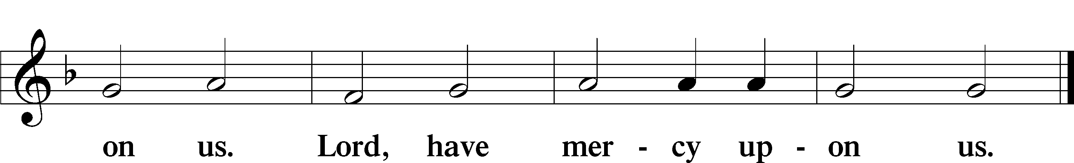

Salutation and Collect of the Day 2 Timothy 4:22

The Lord’s presence is announced and a brief prayer “collects” the theme of the day’s Scriptures.

Pastor: The Lord be with you.
People: And also with you.

Pastor: Let us pray.
O God, whose glory it is always to have mercy, be gracious to all who have gone astray from Your ways and bring them again with penitent hearts and steadfast faith to embrace and hold fast the unchangeable truth of Your Word; through Jesus Christ, Your Son, our Lord, who lives and reigns with You and the Holy Spirit, one God, now and forever.
People: Amen.

Please be seated

Children’s Message: Pastor Tinetti
Old Testament Reading Ezekiel 33:7–20
Reader: Tom Jass
“So you, son of man, I have made a watchman for the house of Israel. Whenever you hear a word from my mouth, you shall give them warning from me. If I say to the wicked, O wicked one, you shall surely die, and you do not speak to warn the wicked to turn from his way, that wicked person shall die in his iniquity, but his blood I will require at your hand. But if you warn the wicked to turn from his way, and he does not turn from his way, that person shall die in his iniquity, but you will have delivered your soul.

“And you, son of man, say to the house of Israel, Thus have you said: ‘Surely our transgressions and our sins are upon us, and we rot away because of them. How then can we live?’ Say to them, As I live, declares the Lord God, I have no pleasure in the death of the wicked, but that the wicked turn from his way and live; turn back, turn back from your evil ways, for why will you die, O house of Israel?

“And you, son of man, say to your people, The righteousness of the righteous shall not deliver him when he transgresses, and as for the wickedness of the wicked, he shall not fall by it when he turns from his wickedness, and the righteous shall not be able to live by his righteousness when he sins. Though I say to the righteous that he shall surely live, yet if he trusts in his righteousness and does injustice, none of his righteous deeds shall be remembered, but in his injustice that he has done he shall die. Again, though I say to the wicked, ‘You shall surely die,’ yet if he turns from his sin and does what is just and right, if the wicked restores the pledge, gives back what he has taken by robbery, and walks in the statutes of life, not doing injustice, he shall surely live; he shall not die. None of the sins that he has committed shall be remembered against him. He has done what is just and right; he shall surely live.

“Yet your people say, ‘The way of the Lord is not just,’ when it is their own way that is not just. When the righteous turns from his righteousness and does injustice, he shall die for it. And when the wicked turns from his wickedness and does what is just and right, he shall live by them. Yet you say, ‘The way of the Lord is not just.’ O house of Israel, I will judge each of you according to his ways.”

Reader: This is the Word of the Lord.
People: Thanks be to God.

Epistle 1 Corinthians 10:1–13
Reader: Tom Jass
I want you to know, brothers, that our fathers were all under the cloud, and all passed through the sea, and all were baptized into Moses in the cloud and in the sea, and all ate the same spiritual food, and all drank the same spiritual drink. For they drank from the spiritual Rock that followed them, and the Rock was Christ. Nevertheless, with most of them God was not pleased, for they were overthrown in the wilderness.

Now these things took place as examples for us, that we might not desire evil as they did. Do not be idolaters as some of them were; as it is written, “The people sat down to eat and drink and rose up to play.” We must not indulge in sexual immorality as some of them did, and twenty-three thousand fell in a single day. We must not put Christ to the test, as some of them did and were destroyed by serpents, nor grumble, as some of them did and were destroyed by the Destroyer. Now these things happened to them as an example, but they were written down for our instruction, on whom the end of the ages has come. Therefore let anyone who thinks that he stands take heed lest he fall. No temptation has overtaken you that is not common to man. God is faithful, and he will not let you be tempted beyond your ability, but with the temptation he will also provide the way of escape, that you may be able to endure it.

Reader: This is the Word of the Lord.
People: Thanks be to God.

Please stand

Lenten Verse Joel 2:13
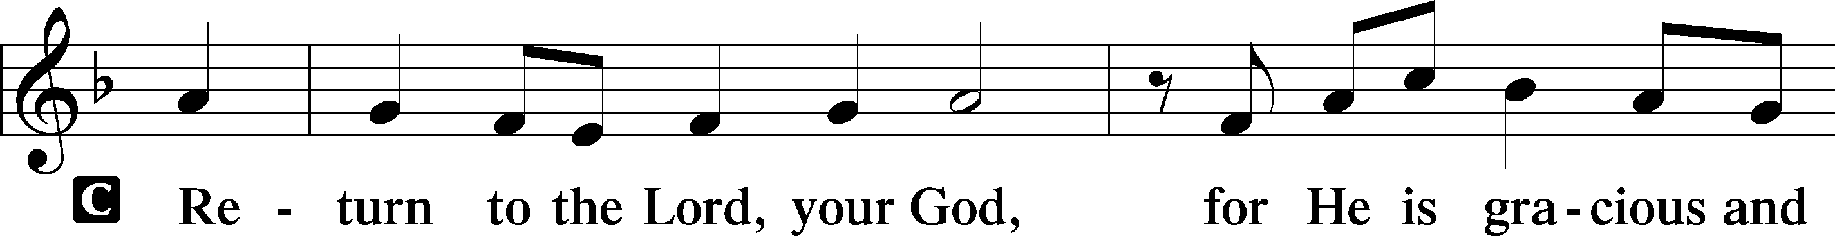
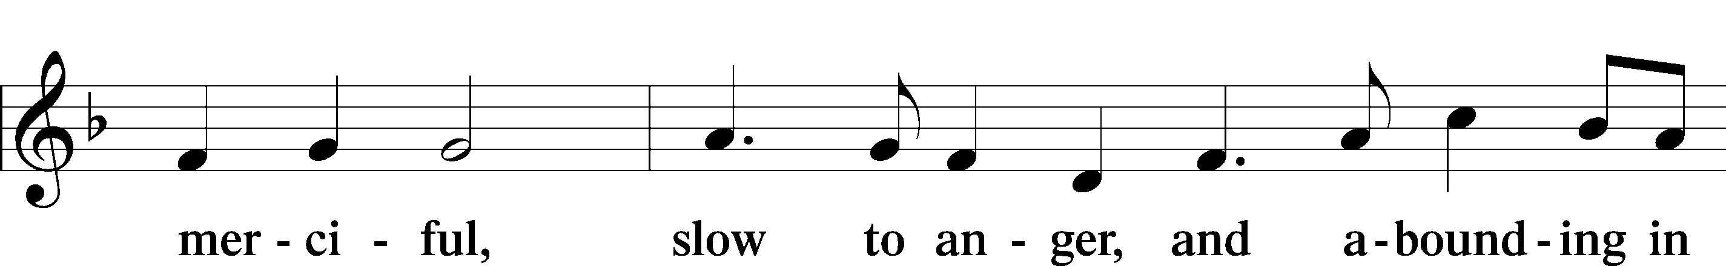
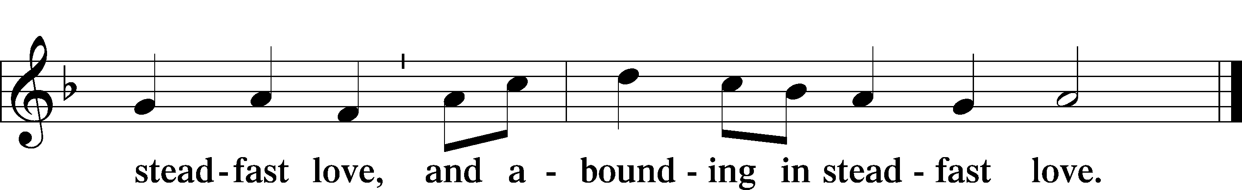

Holy Gospel Luke 13:1–9
Pastor Tinetti
Pastor: The Holy Gospel according to St. Luke, the thirteenth chapter.
People: Glory to You, O Lord.

There were some present at that very time who told [Jesus] about the Galileans whose blood Pilate had mingled with their sacrifices. And he answered them, “Do you think that these Galileans were worse sinners than all the other Galileans, because they suffered in this way? No, I tell you; but unless you repent, you will all likewise perish. Or those eighteen on whom the tower in Siloam fell and killed them: do you think that they were worse offenders than all the others who lived in Jerusalem? No, I tell you; but unless you repent, you will all likewise perish.”

And he told this parable: “A man had a fig tree planted in his vineyard, and he came seeking fruit on it and found none. And he said to the vinedresser, ‘Look, for three years now I have come seeking fruit on this fig tree, and I find none. Cut it down. Why should it use up the ground?’ And he answered him, ‘Sir, let it alone this year also, until I dig around it and put on manure. Then if it should bear fruit next year, well and good; but if not, you can cut it down.’”

Pastor: This is the Gospel of the Lord.
People: Praise to You, O Christ.

“When I Survey the Wondrous Cross”

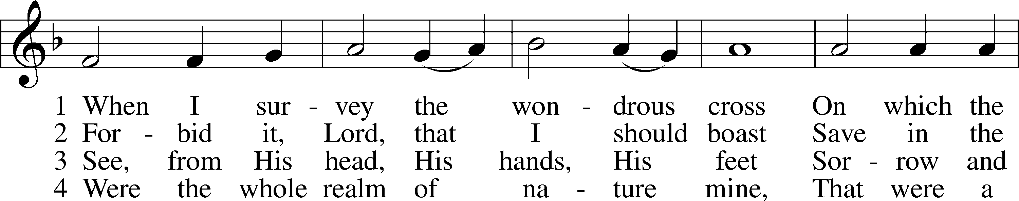
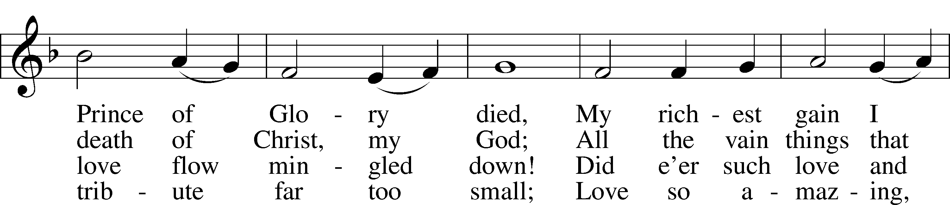
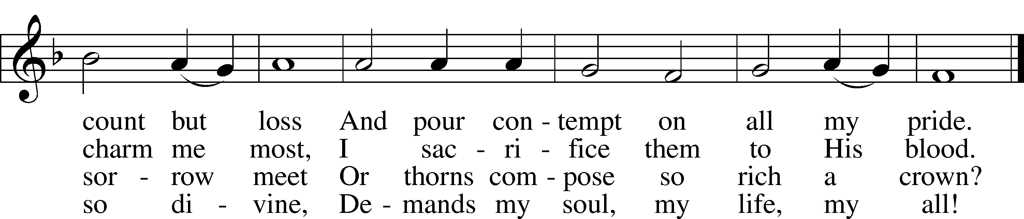
Text and tune: Public domain

Please be seated

Sermon: “Worse Sinners” Pastor Tinetti

Please stand

“We All Believe in One True God”
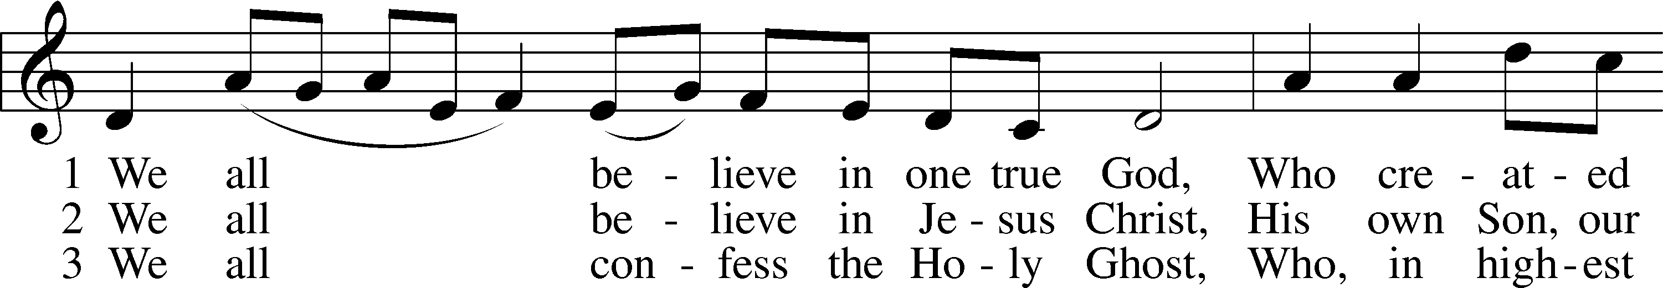
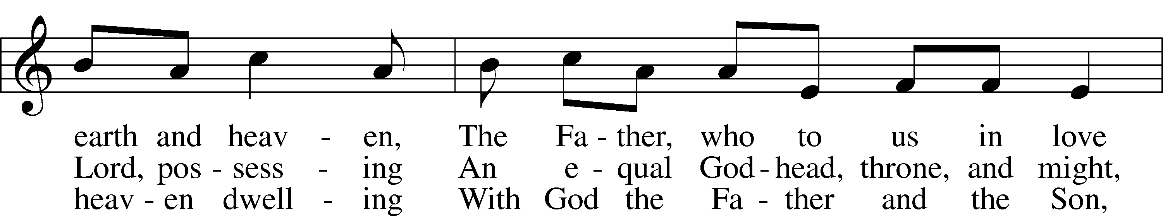
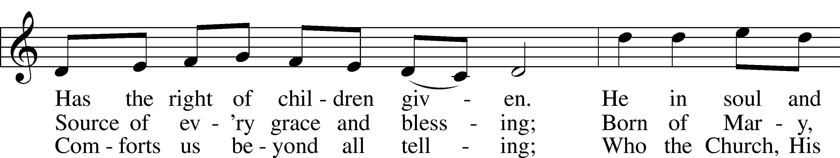
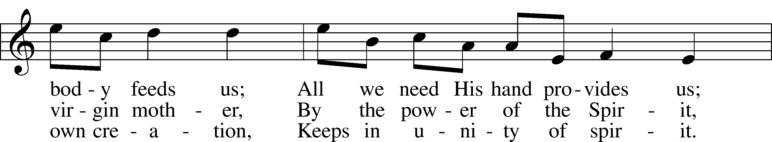
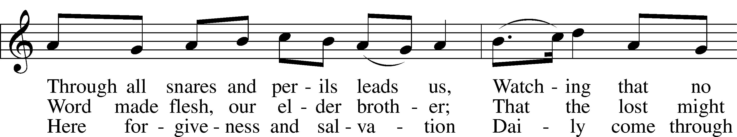
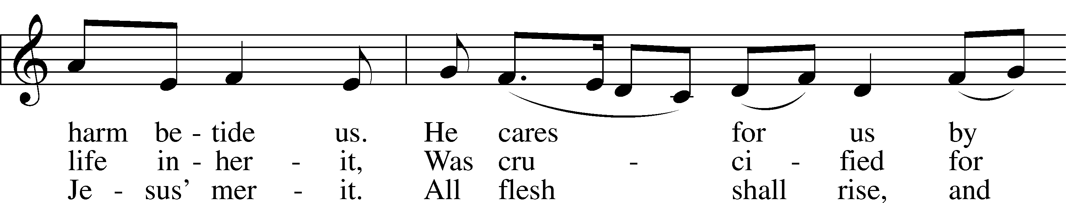
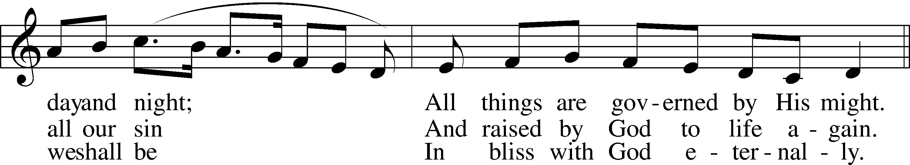
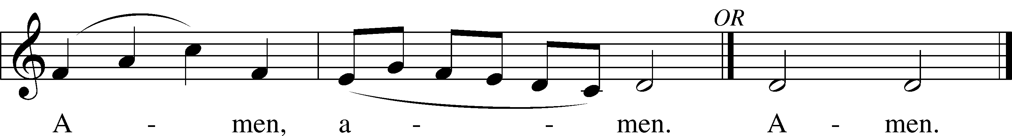
Tune and text: Public domain
Prayer of the Church

Pastor: Friends in Christ, I urge you all to lift up your hearts to God and pray with me as Christ our Lord has taught us and freely promised to hear us.

God, our Father in heaven, look with mercy on us, Your needy children on earth, and grant us grace that Your holy name be hallowed by us and all the world through the pure and true teaching of Your Word and the fervent love shown forth in our lives. Graciously turn from us all false doctrine and evil living whereby Your precious name is blasphemed and profaned. Lord, in Your mercy,
People: hear our prayer.

Pastor: May Your kingdom come to us and expand. Bring all transgressors and those who are blinded and bound in the devil’s kingdom to know Jesus Christ, Your Son, by faith that the number of Christians may be increased. Lord, in Your mercy,
People: hear our prayer.

Pastor: Strengthen us by Your Spirit according to Your will, both in life and in death, in the midst of both good and evil things, that our own wills may be crucified daily and sacrificed to Your good and gracious will. Into Your merciful hands we commend [name(s)] and all who are in need, praying for them at all times: Thy will be done. Lord, in Your mercy,
People: hear our prayer.

Pastor: Grant us our daily bread, preserve us from greed and selfish cares, and help us trust in You to provide for all our needs. Lord, in Your mercy,
People: hear our prayer.

Pastor: Forgive us our sins as we also forgive those who sin against us so that our hearts may be at peace and may rejoice in a good conscience before You, and that no sin may ever frighten or alarm us. Lord, in Your mercy,
People: hear our prayer.

Pastor: Lead us not into temptation, O Lord, but help us by Your Spirit to subdue our flesh, to turn from the world and its ways, and to overcome the devil with all his wiles. Lord, in Your mercy,
People: hear our prayer.

Pastor: And lastly, O heavenly Father, deliver us from all evil of both body and soul, now and forever. Lord, in Your mercy,
People: hear our prayer.

Pastor: We trust, O Lord, in Your great mercy to hear and answer us; through Jesus Christ, our Lord.
People: Amen.

Please be seated

Offering 2 Corinthians 9; Psalm 116:12-19

We respond to God’s gifts by returning to Him of His own. If you are visiting with us today, please do not feel compelled to give.

“We Give Thee But Thine Own”

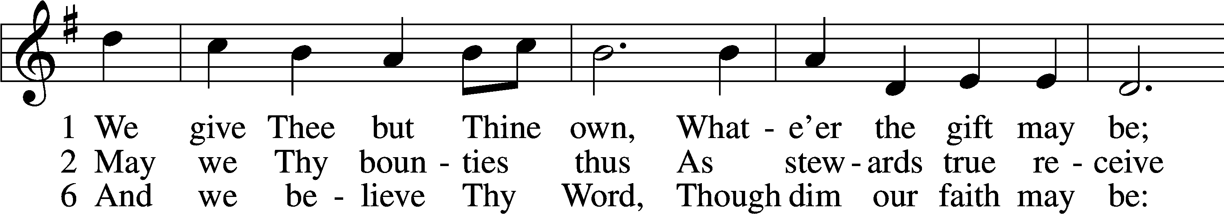
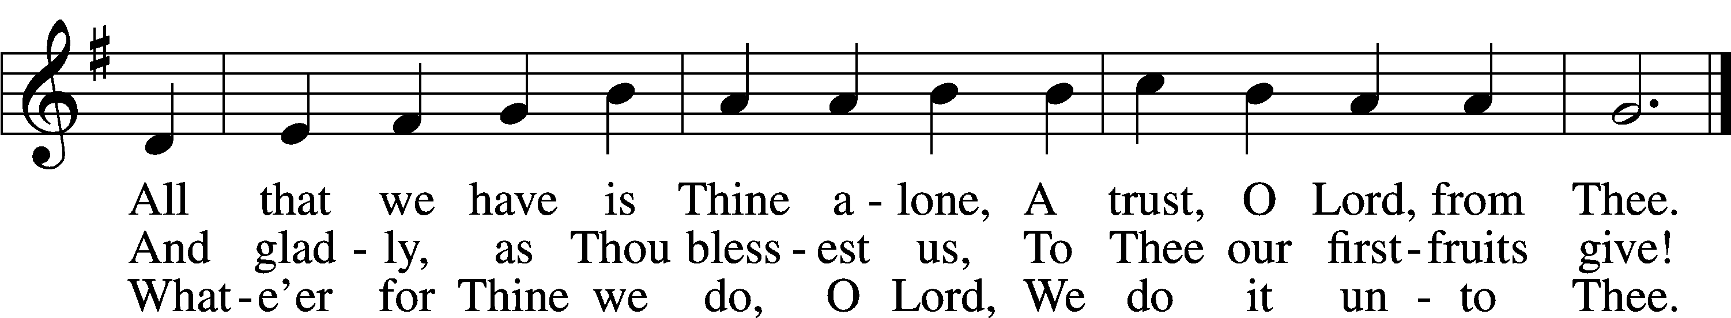
Tune and text: Public domain

+ SERVICE OF THE SACRAMENT +

In the Service of the Sacrament, we receive Jesus’ very body and blood into our mouths, which delivers the forgiveness of sins, life, and salvation.

Please stand

Preface Psalm 136; Colossians 3:1; 2 Timothy 4:22

Pastor: The Lord be with you.
People: And also with you.

Pastor: Lift up your hearts.
People: We lift them to the Lord.

Pastor: Let us give thanks to the Lord our God.
People: It is right to give Him thanks and praise.

Pastor: It is truly good, right, and salutary that we should at all times and in all places give thanks to You, O Lord our God, king of all creation, for You have had mercy on us and given Your only-begotten Son that whoever believes in Him should not perish but have eternal life. Grant us Your Spirit, gracious Father, that we may give heed to the testament of Your Son in true faith and, above all, firmly take to heart the words with which Christ gives to us His body and blood for our forgiveness. By Your grace, lead us to remember and give thanks for the boundless love which He manifested to us when, by pouring out His precious blood, He saved us from Your righteous wrath and from sin, death, and hell. Grant that we may receive the bread and wine, that is, His body and blood, as a gift, guarantee, and pledge of His salvation. Graciously receive our prayers; deliver and preserve us. To You alone, O Father, be all glory, honor, and worship, with the Son and the Holy Spirit, one God, now and forever.
People: Amen.
Lord’s Prayer Matthew 6:9–13

People: Our Father who art in heaven, hallowed be Thy name, Thy kingdom come, Thy will be done on earth as it is in heaven; give us this day our daily bread; and forgive us our trespasses as we forgive those who trespass against us; and lead us not into temptation, but deliver us from evil. For Thine is the kingdom and the power and the glory forever and ever. Amen.

Pastor: In the name of our Lord and Savior Jesus Christ, at His command, and with His own words, we receive His testament:

The Words of Our Lord Matthew 26:26–28; 1 Corinthians 11:23–25

The bread and wine are consecrated (or ‘set apart’) by Jesus’ very words.

Pastor: Our Lord Jesus Christ, on the night when He was betrayed, took bread, and when He had given thanks, He broke it and gave it to the disciples and said: “Take, eat; this is My body, which is given for you. This do in remembrance of Me.”

In the same way also He took the cup after supper, and when He had given thanks, He gave it to them, saying: “Drink of it, all of you; this cup is the new testament in My blood, which is shed for you for the forgiveness of sins. This do, as often as you drink it, in remembrance of Me.”

Sanctus Isaiah 6:3; Matthew 21:9

Latin for “holy,” in the Sanctus (SAHNK-toose) we join the heavenly chorus in hailing our King’s presence in our midst.

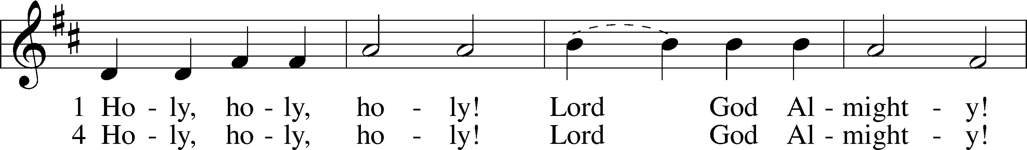
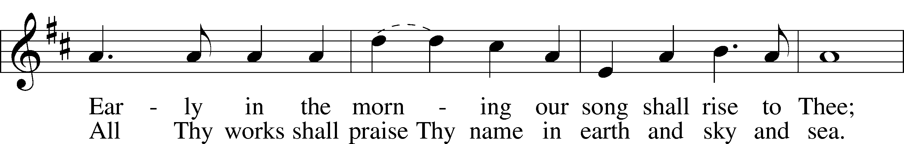
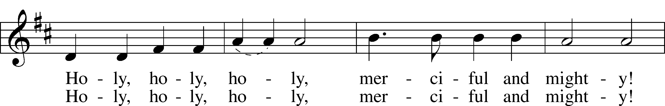
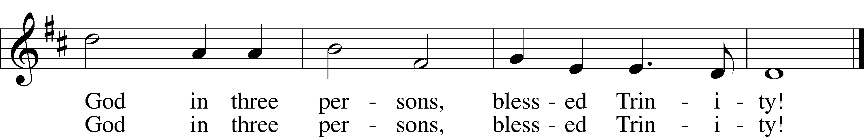
Text and tune: Public domain

Pax Domini John 20:19

Latin for “the peace of the Lord,” in the Pax Domini (PAHKS DOH-mee-nee) the voice of the Gospel proclaims our peace with God.

Pastor: The peace of the Lord be with you always.
People: Amen!

Sharing of the Peace Matthew 5:22-24; Ephesians 4:1-3

Having peace with God through Jesus’ body and blood, we share His peace with one another.

Agnus Dei John 1:29

Latin for “Lamb of God,” in the Agnus Dei (AHG-noose DAY-ee) we join John in announcing Jesus’ presence for our forgiveness.
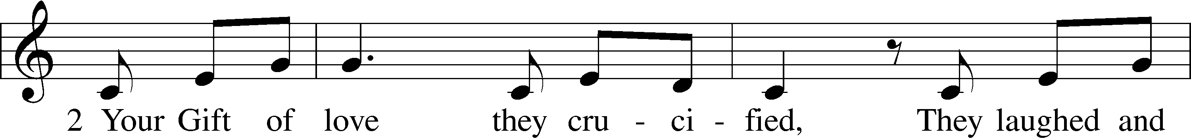
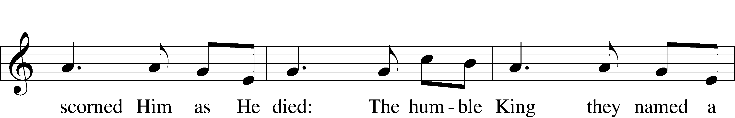
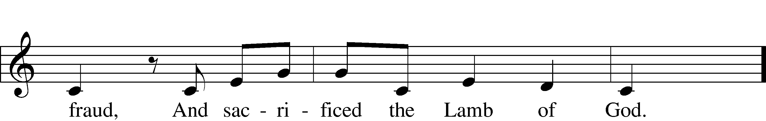
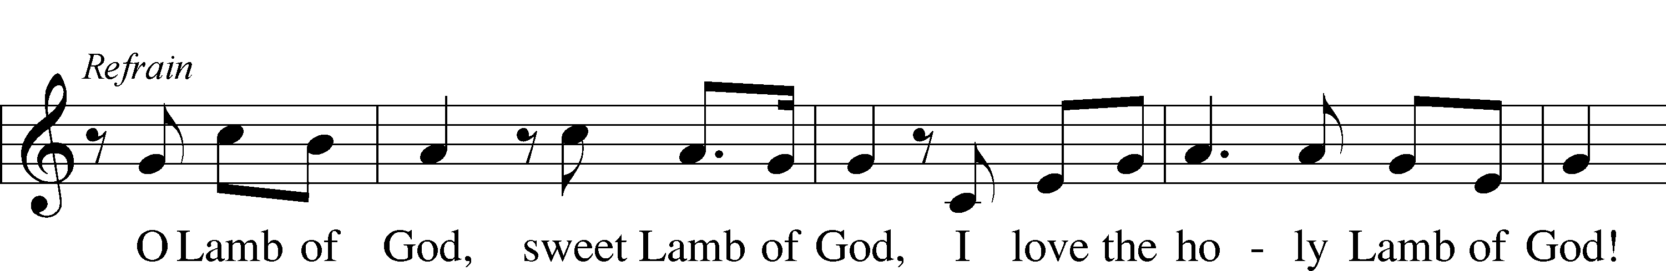
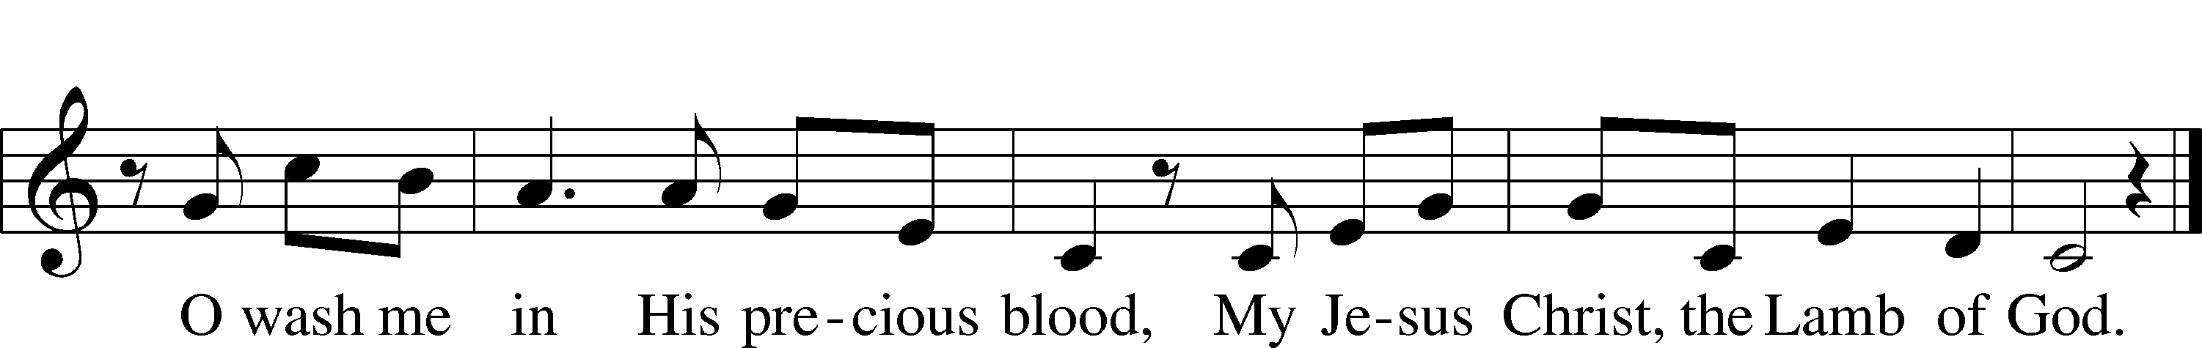
Tune and text: © 1985 Straightway Music, admin. EMI. Used by permission: LSB Hymn License no. 110002406

Please be seated

Preparing For Holy Communion

Our Lord Jesus expects the baptized who are instructed in the basics of the Christian faith to come to His Table saying, “Do this in remembrance of Me.” There at His Table he offers us His body with the bread (saying, “This is my body”) and His blood with the wine (saying, “This is my blood”). Lutherans consider this to be a mystery – the word “sacrament” means mystery, and so we do not try to understand or explain this but simply to believe that because He says so, His body and blood are “in, with and under” the bread and wine which are also truly there. He offers these precious gifts for our forgiveness, to nourish our lives in Him.

Distribution of Holy Communion

Please tell either an Elder or usher if you cannot come to the Lord’s Table so Holy Communion can be brought to you. After the individual communions, the rest of the congregation is welcomed to the Table. It is the tradition of Trinity Arcadia to offer both the chalice and individual glasses. Please help us know your preference by opening your hands at the appropriate time. Individual glasses in the center of each tray contain white, unfermented grape juice. You may also ask for gluten-free bread.

“Great Is Thy Faithfulness”

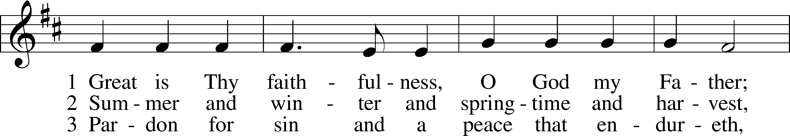
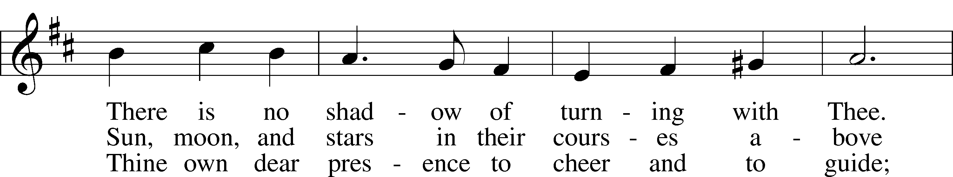
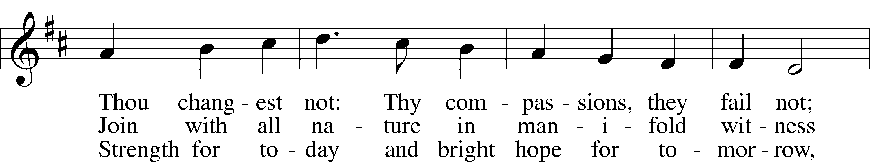
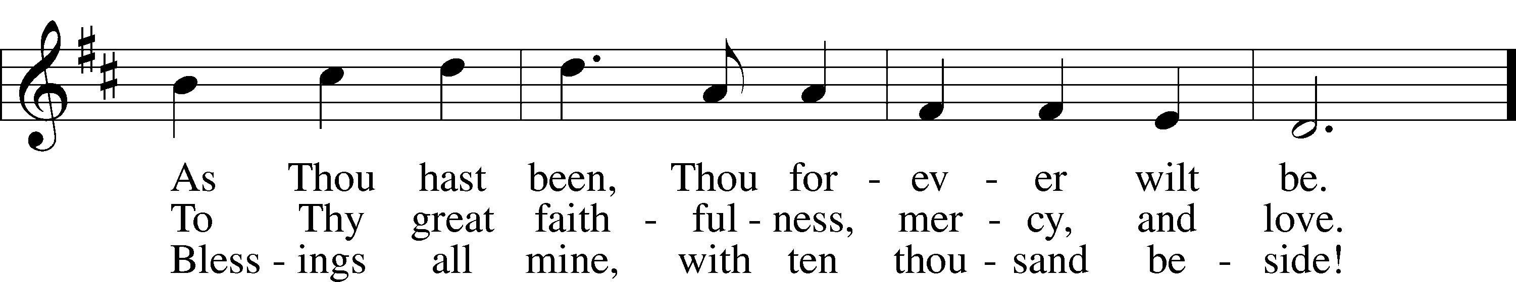
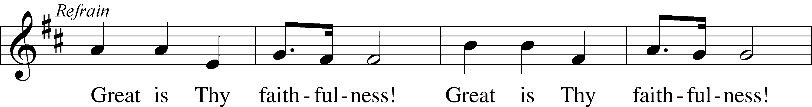
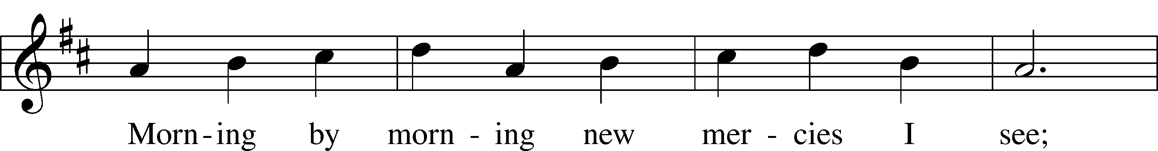
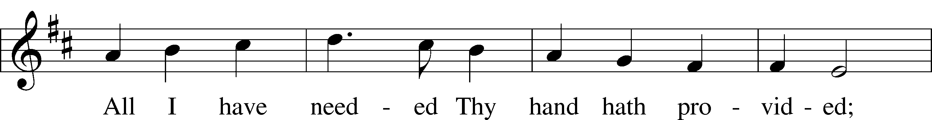
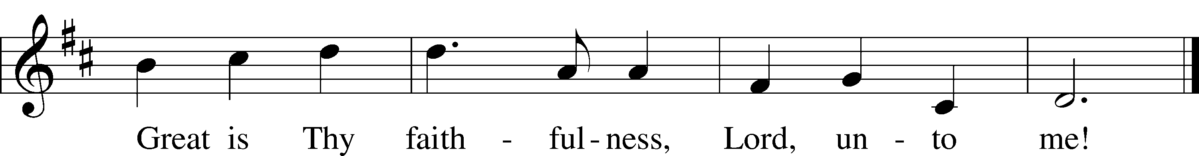
Text and tune: © 1923, renewed 1951 Hope Publishing Co. Used by permission: LSB Hymn License no. 110002406
“Christ, the Life of All the Living”

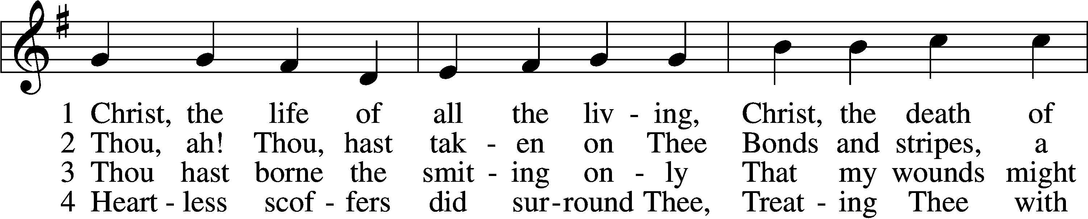
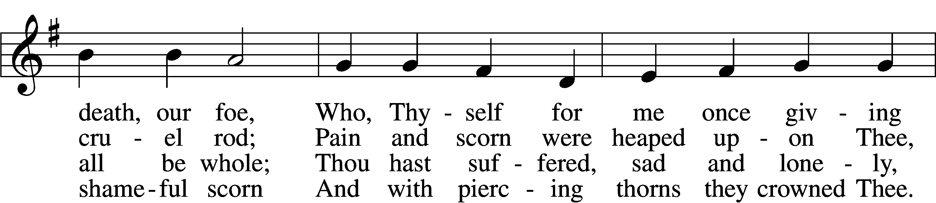
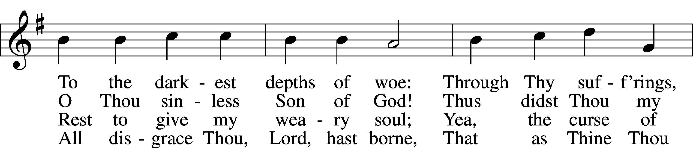
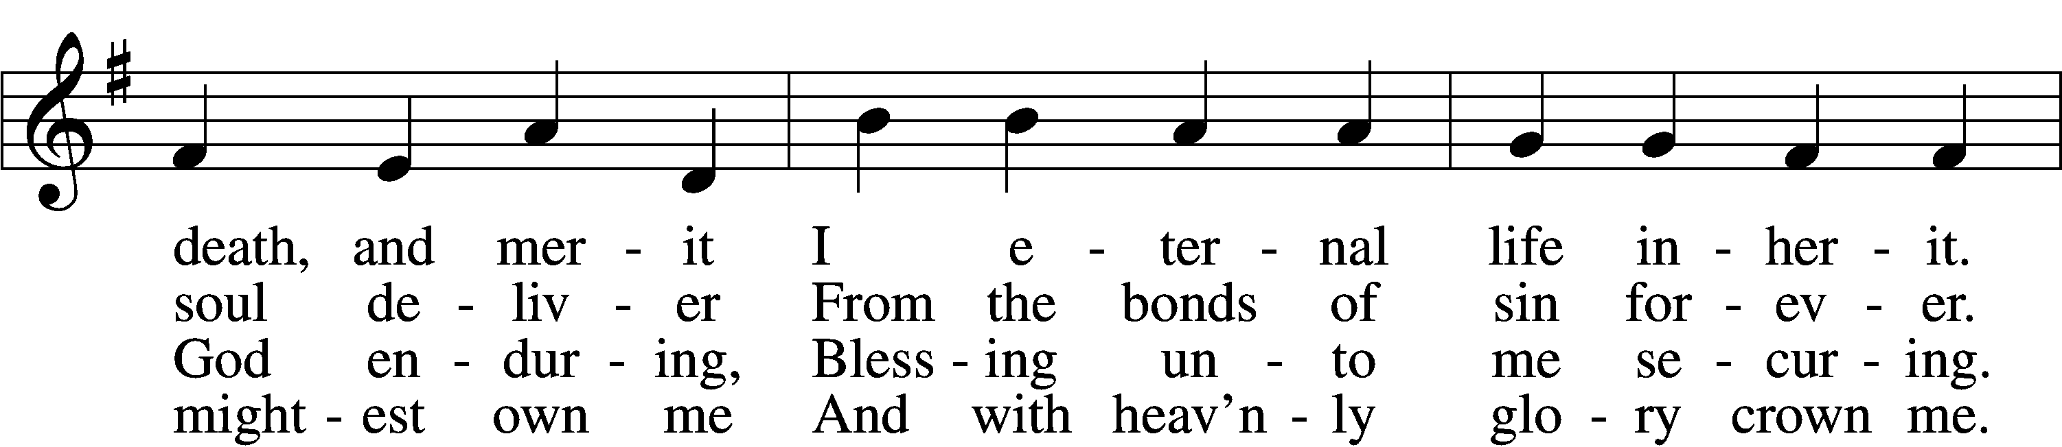
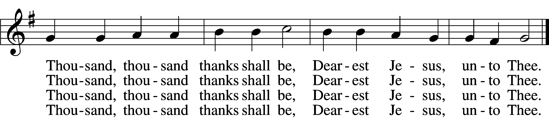

“God Moves in a Mysterious Way”

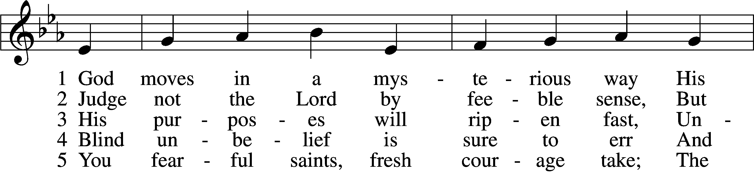
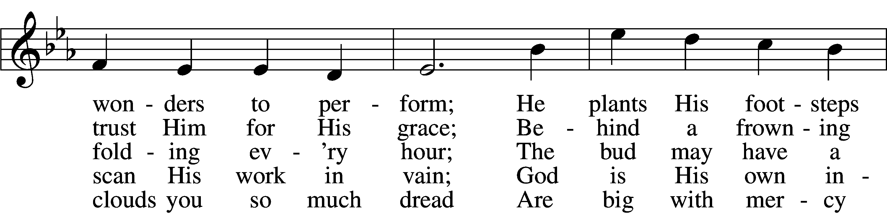
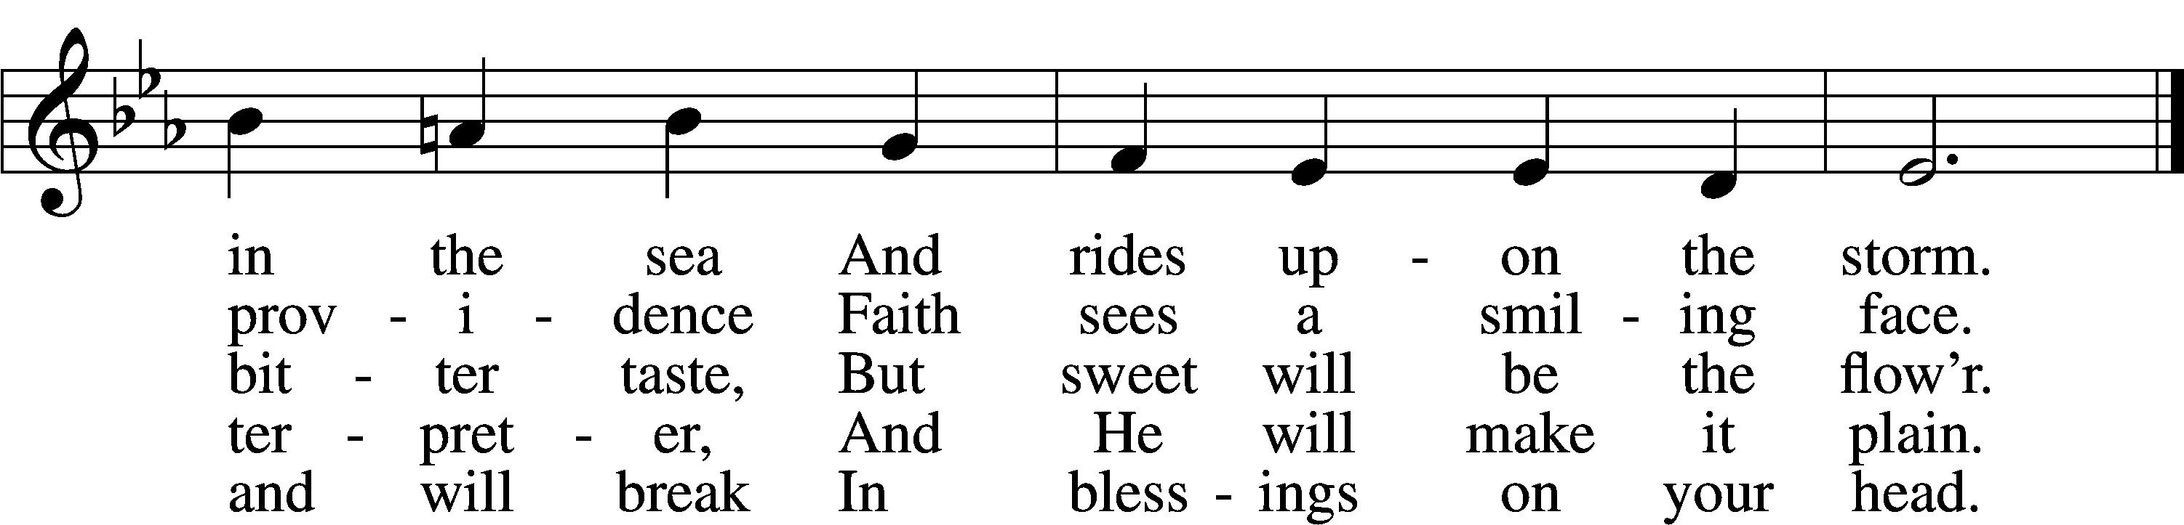
Tune and text: Public domain

Please stand

“O Lord, We Praise Thee”

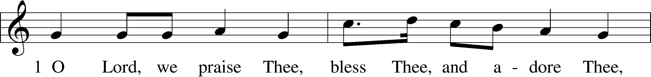
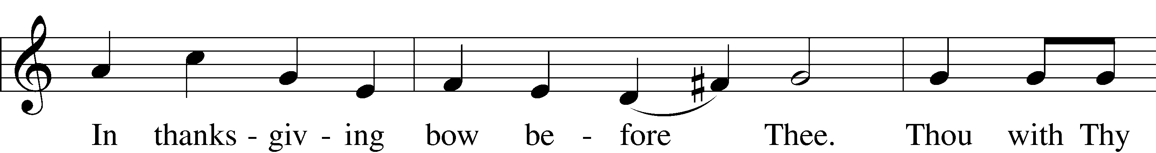
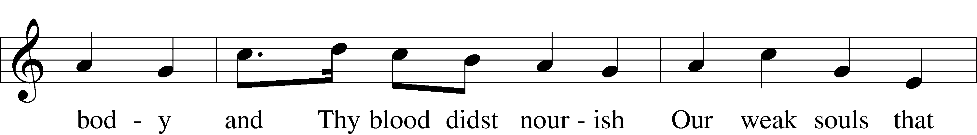
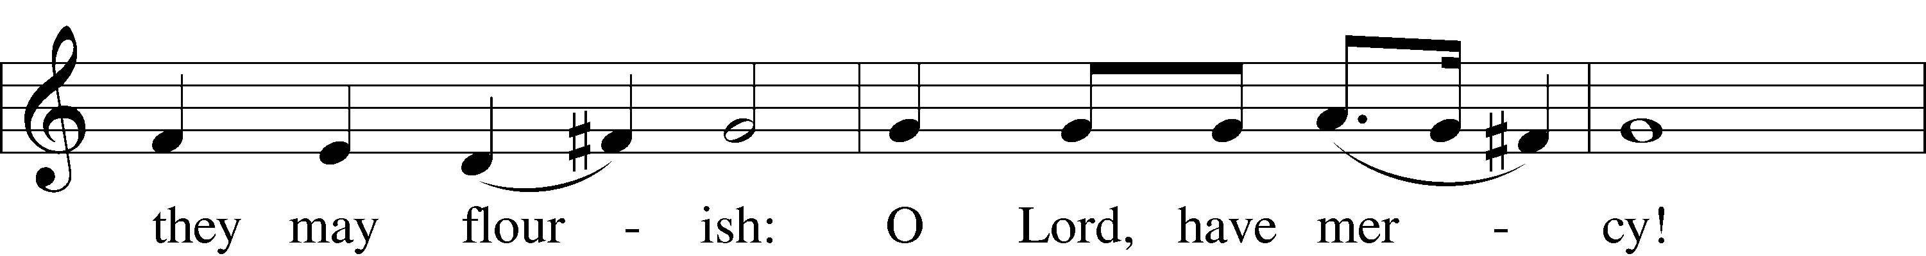
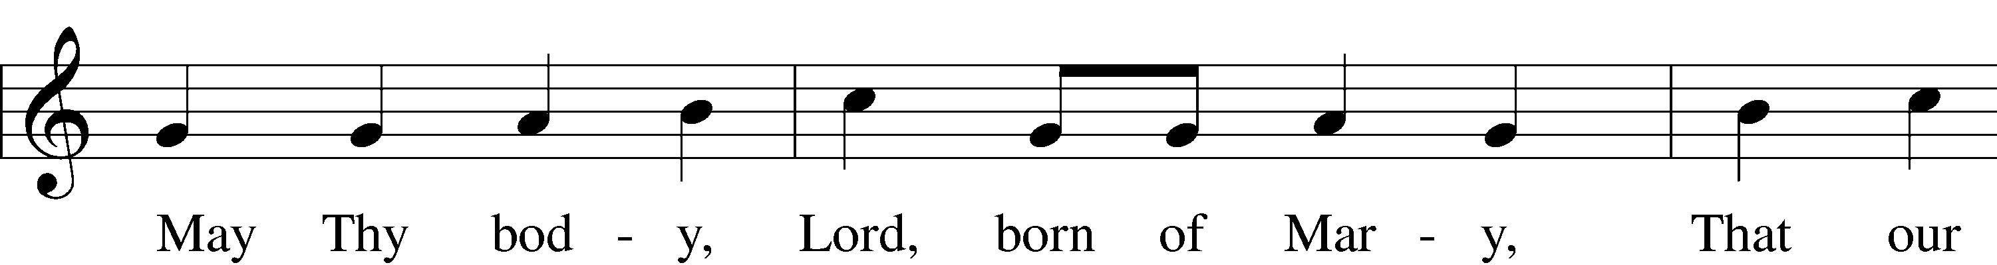
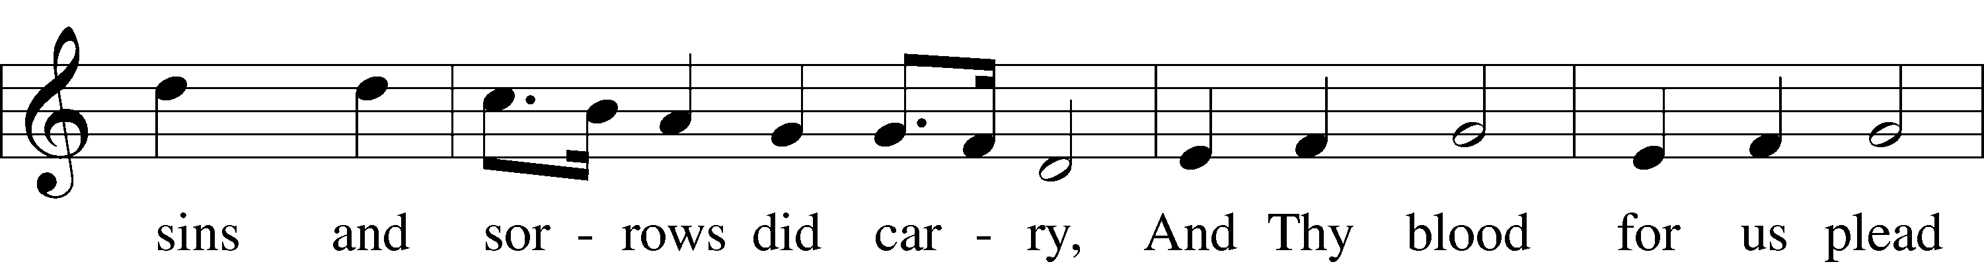
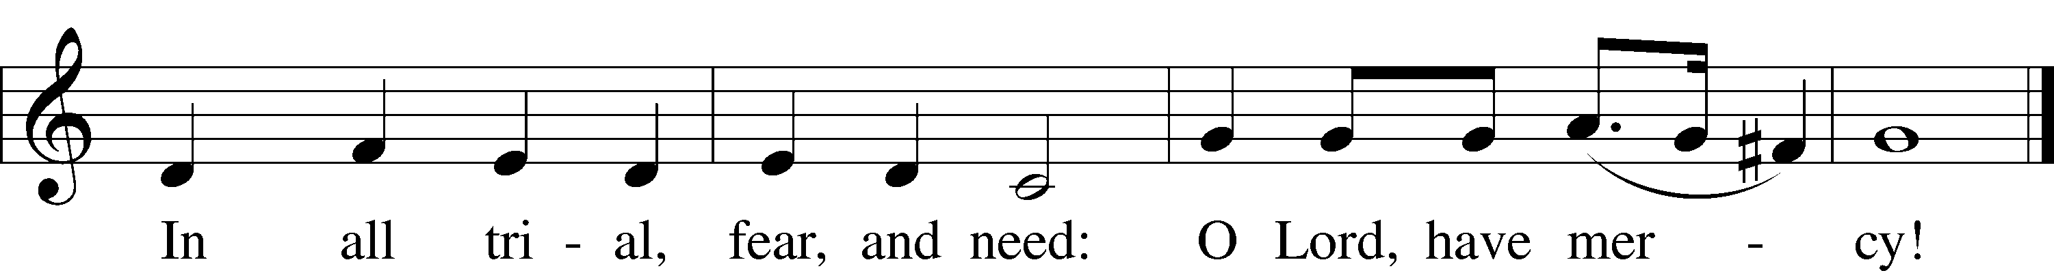
Tune: Public domain
Text: © 1941 Concordia Publishing House. Used by permission: LSB Hymn License no. 110002406

Post-Communion Collect

Pastor: Let us pray.
We give thanks to You, almighty God, that You have refreshed us through this salutary gift, and we implore You that of Your mercy You would strengthen us through the same in faith toward You and in fervent love toward one another; through Jesus Christ, Your Son, our Lord, who lives and reigns with You and the Holy Spirit, one God, now and forever.
People: Amen.

Benediction Numbers 6:24–26

Ending where we began—with God’s Name—in the Benediction we are Sent forth by His blessing.

Pastor: Let us bless the Lord.
People: Thanks be to God.

Pastor: The Lord bless you and keep you. The Lord make His face shine on you and be gracious to you. The Lord look upon you with favor and give you peace.
People: Amen.

“Guide Me, O Thou Great Redeemer”

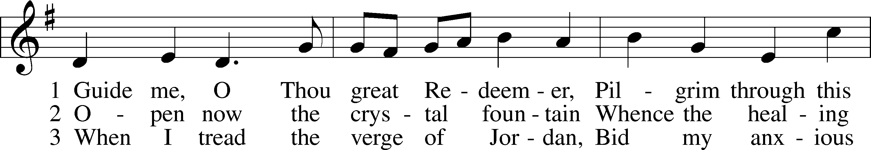
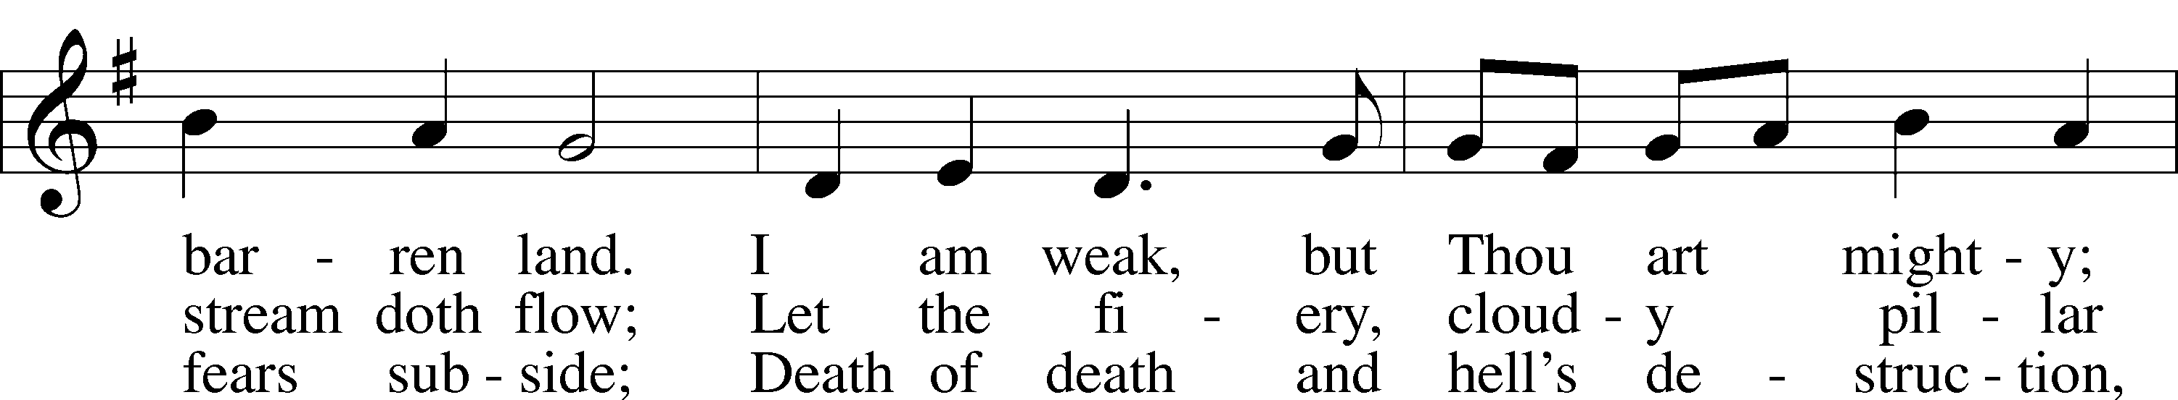
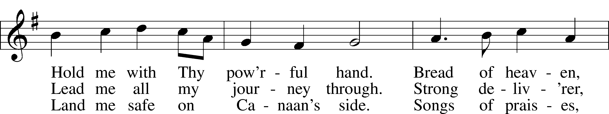
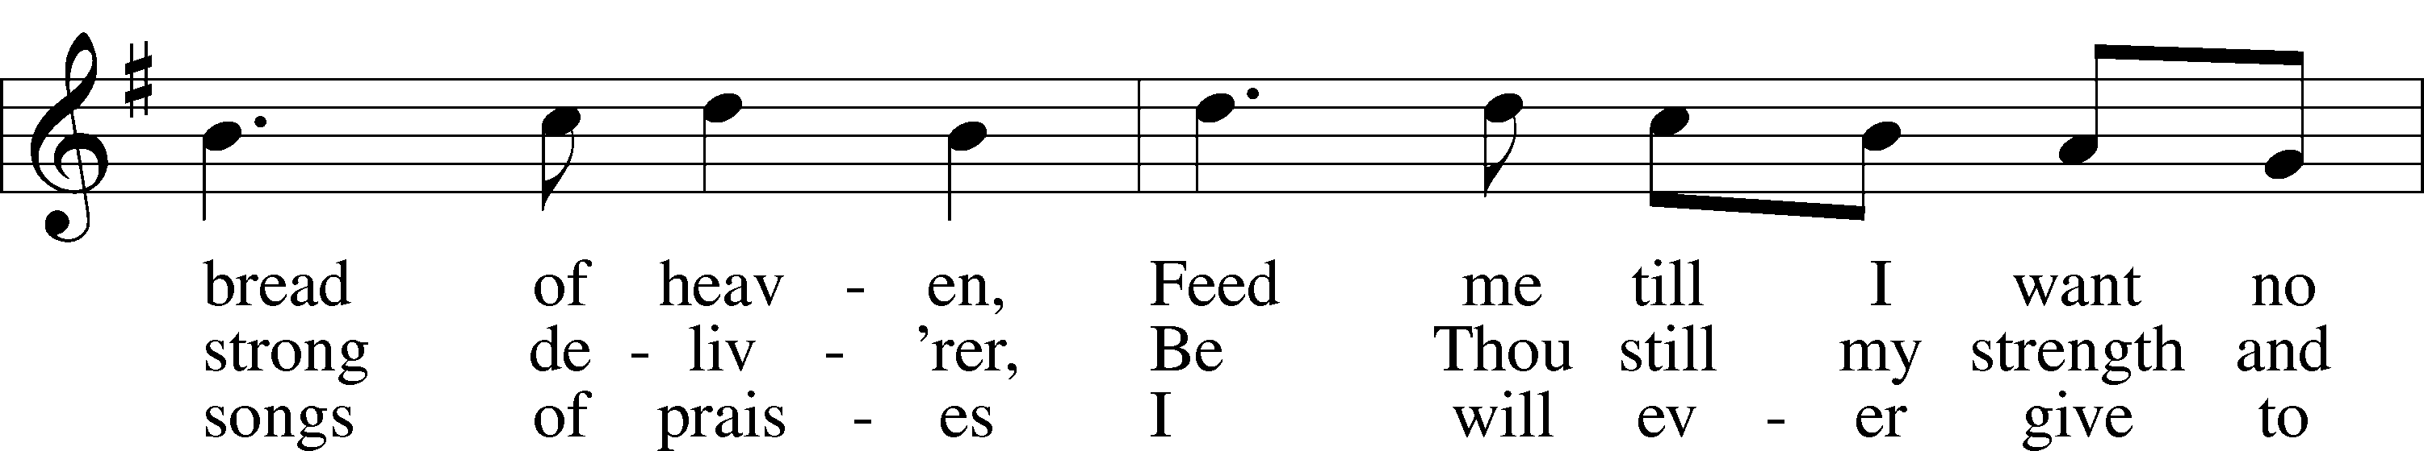
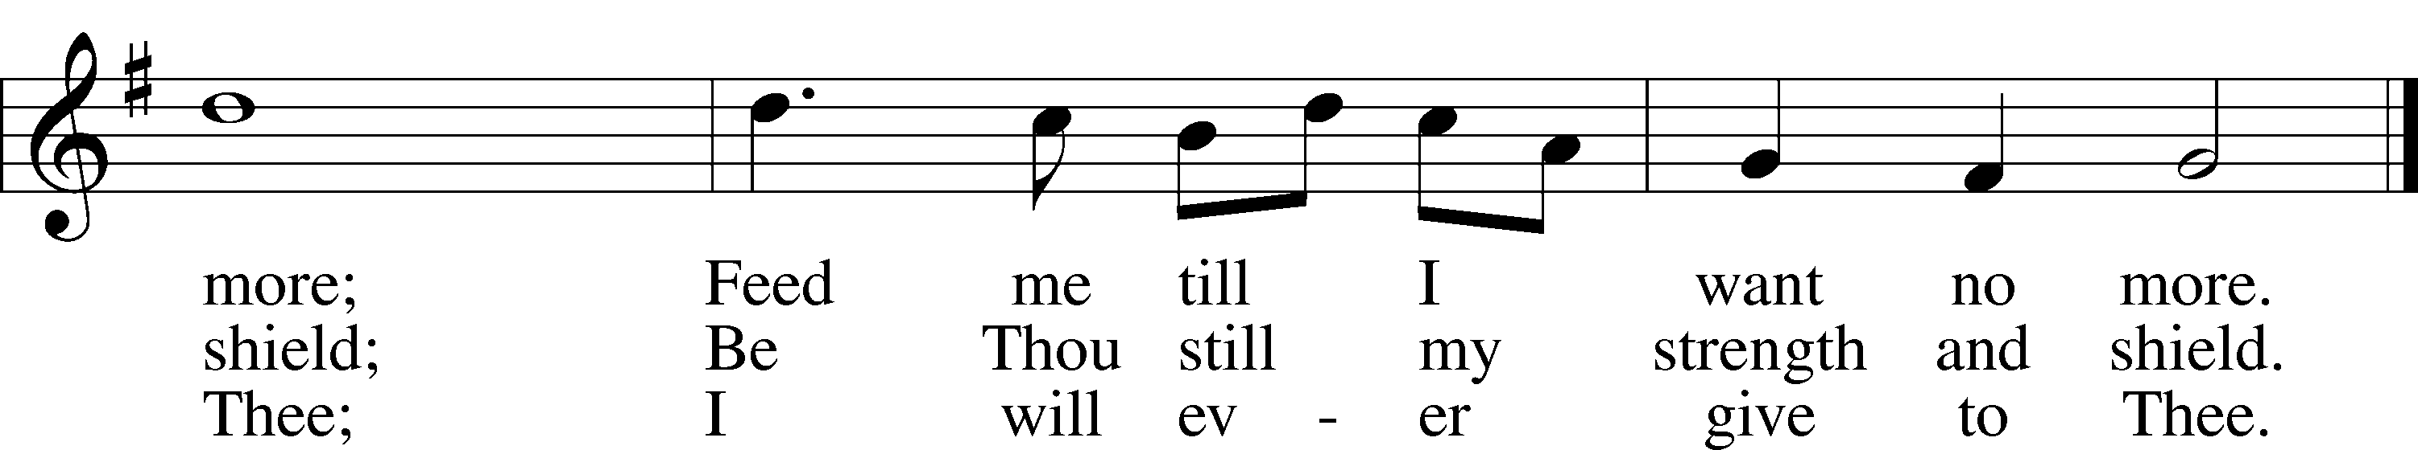
Text and tune: Public domain

Pastor: Go in peace, serve the Lord.
People: Thanks be to God!

Acknowledgments
Divine Service, Setting Five from Lutheran Service Book Unless otherwise indicated, Scripture quotations are from the ESV® Bible (The Holy Bible, English Standard Version®), copyright © 2001 by Crossway, a publishing ministry of Good News Publishers. Used by pe mission. All rights reserved. Created by Lutheran Service Builder © 2018 Concordia Publishing House.

Trinity Lutheran Church
Established 1881
Church built 1888

Pastor: Pastor Ryan Tinetti
Musical Accompanist: Gabriella Haiderer
President: Jack McKenna
Elders: Chip May, Jack McKenna, Richard Nelson
Mark Kuhlmann, Paul Scheppelman
Beverly Gay- Photiades

Head Usher: Larry Wendt
Church phone: 231-889-3620
Pastor Tinetti’s phone: 509-329-8339

Church’s WIFI code: 17191Third
Church e-mail address: Trinityarcadiami@gmail.com
Church website: Trinityarcadiami.org

Church’s mailing address:
Trinity Lutheran Church
P. O. Box 139
Arcadia, MI 49613
