+ The 7th Sunday after Epiphany +
24 February A.D. 2019
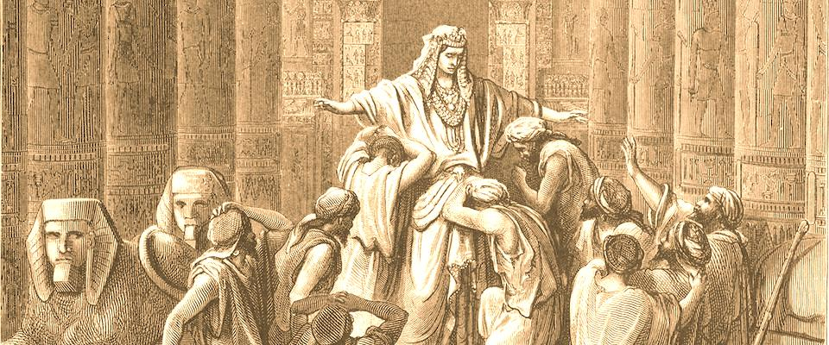
Senseless Mercy

As We Gather
As humans who are still mired in sin, grudges come naturally and revenge seems sensible. Today's readings, however, point us toward something that, apart from God, seems utterly senseless: mercy.

Lighting of the Candles
Ringing of the Carillon
Announcements
Prelude

+ SERVICE OF PREPARATION +

Please stand

“Today Your Mercy Calls Us”
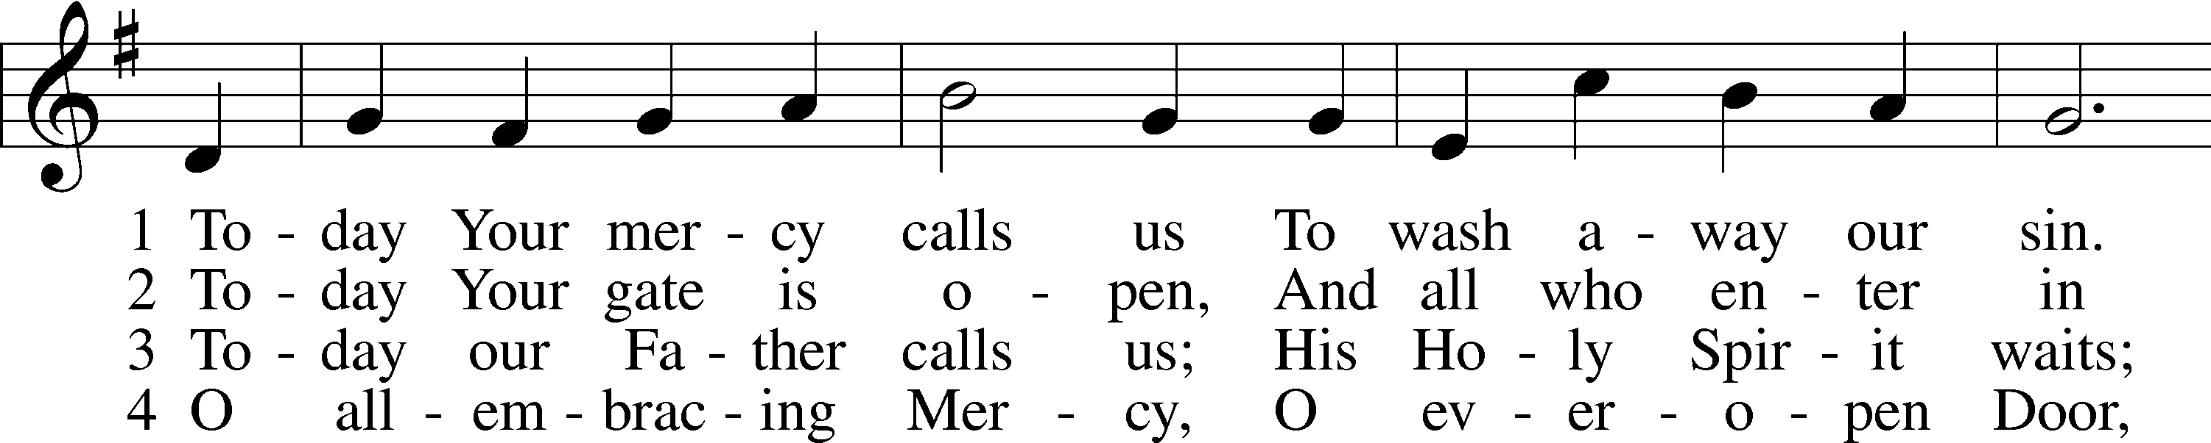
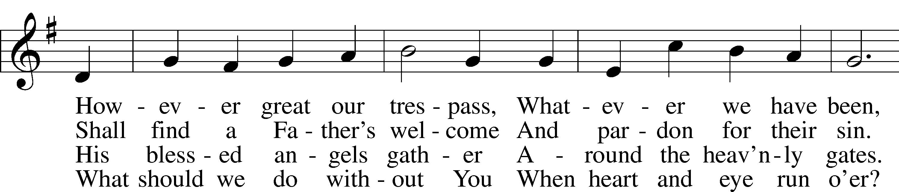
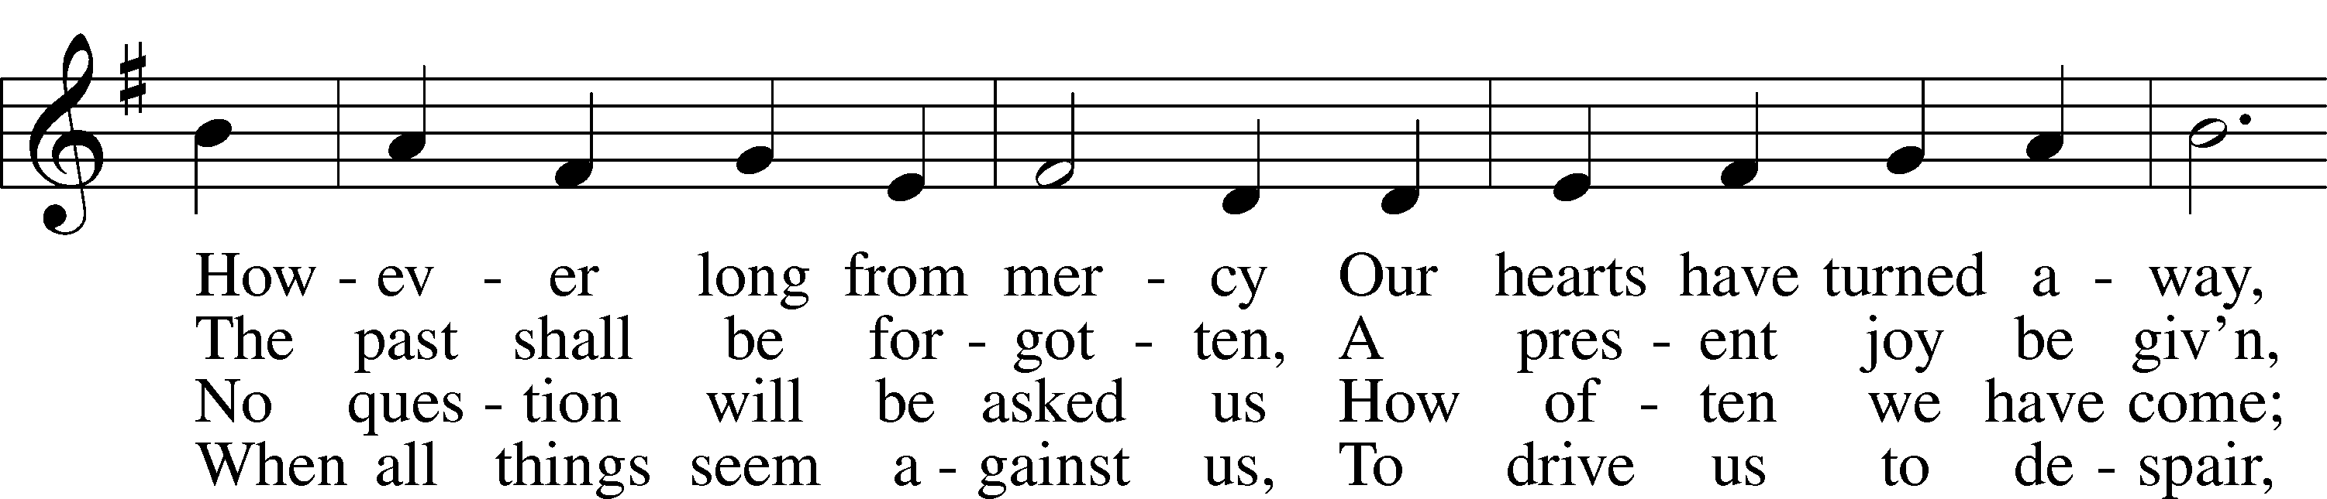
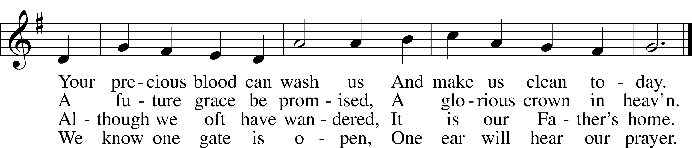
Text and tune: Public domain

The sign of the cross may be made by all in remembrance of their Baptism.

Pastor: In the name of the Father and of the Son and of the Holy Spirit.
People: Amen.

Pastor: If we say we have no sin, we deceive ourselves, and the truth is not in us.
People: But if we confess our sins, God, who is faithful and just, will forgive our sins and cleanse us from all unrighteousness.

Silence for reflection on God’s Word and for self-examination.
Pastor: Let us then confess our sins to God our Father.
People: Most merciful God, we confess that we are by nature sinful and unclean. We have sinned against You in thought, word, and deed, by what we have done and by what we have left undone. We have not loved You with our whole heart; we have not loved our neighbors as ourselves. We justly deserve Your present and eternal punishment. For the sake of Your Son, Jesus Christ, have mercy on us. Forgive us, renew us, and lead us, so that we may delight in Your will and walk in Your ways to the glory of Your holy name. Amen.

Absolution

+ SERVICE OF THE WORD +

Introit Psalm 37:1–5; antiphon: vv. 7a, b

Pastor: Be still before the Lord and wait patiently for him; fret not yourself over the one who prospers in his way.
People: Fret not yourself because of evildoers; be not envious of wrongdoers!

Pastor: For they will soon fade like the grass
and wither like the green herb.
People: Trust in the Lord, and do good; dwell in the land and befriend faithfulness.

Pastor: He will give you the desires of your heart.
People: Commit your way to the Lord; trust in him, and he will act. Glory be to the Father and to the Son
and to the Holy Spirit; as it was in the beginning, is now, and will be forever. Amen. Be still before the Lord and wait patiently for him; fret not yourself over the one who prospers in his way.

Kyrie

Pastor: In peace let us pray to the Lord.
People: Lord, have mercy.

Pastor: For the peace from above and for our salvation let us pray to the Lord.
People: Lord, have mercy.

Pastor: For the peace of the whole world, for the well-being of the Church of God, and for the unity of all let us pray to the Lord.
People: Lord, have mercy.

Pastor: For this holy house and for all who offer here their worship and praise let us pray to the Lord.
People: Lord, have mercy.

Pastor: Help, save, comfort, and defend us, gracious Lord.
People: Amen.

“This Is the Feast”

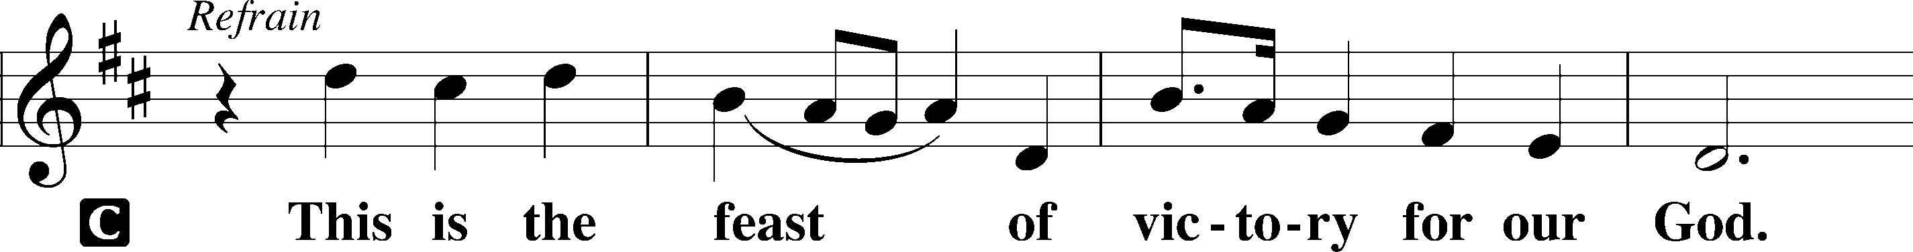
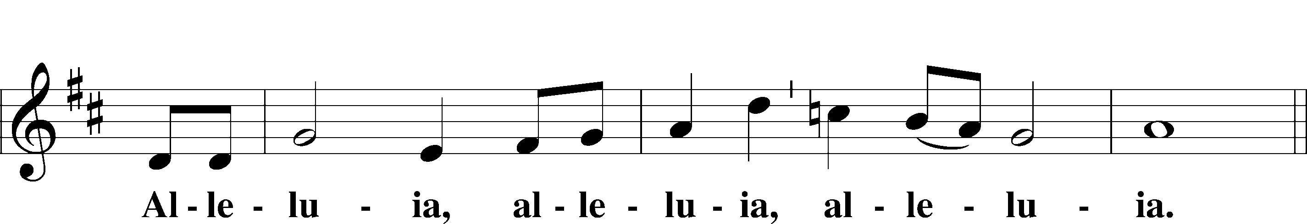
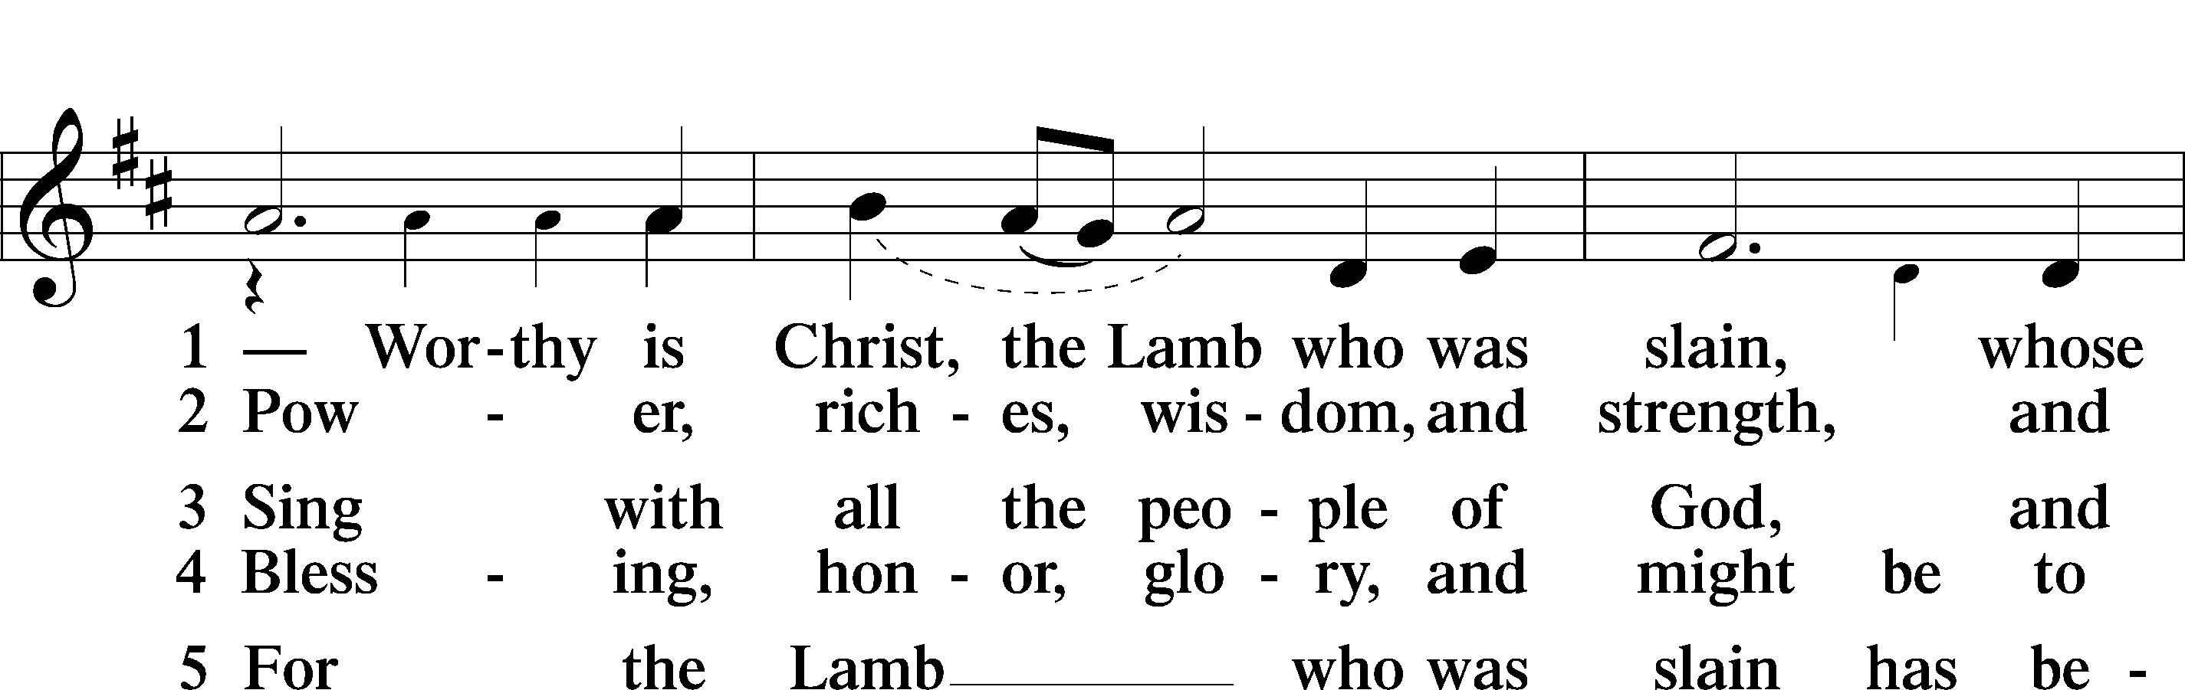
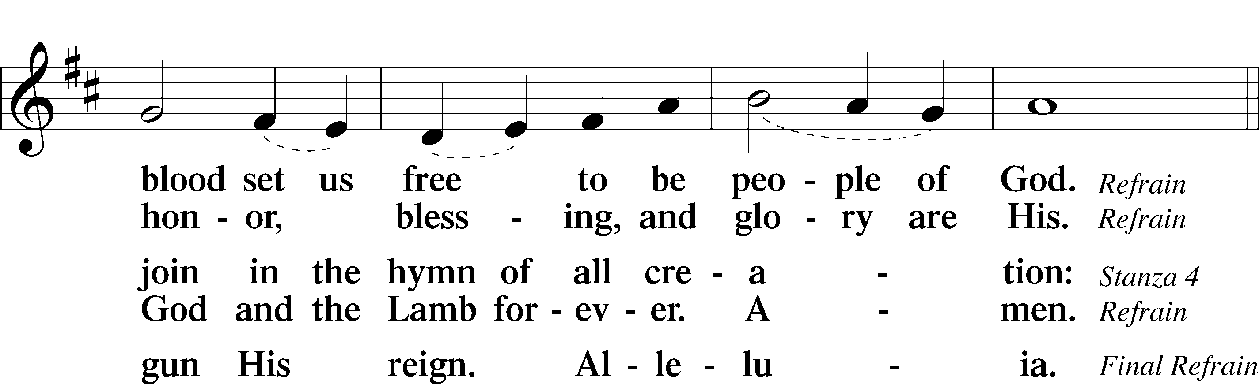
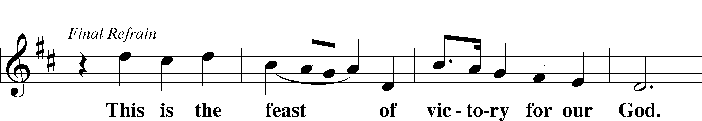
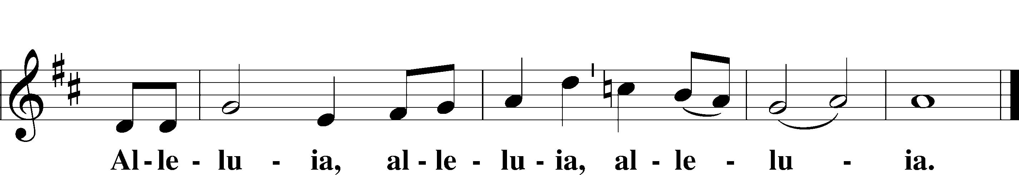

Prayer of the Day

Pastor: The Lord be with you.
People: And also with you.

Pastor: Let us pray.
O God, the strength of all who put their trust in You, mercifully grant that by Your power we may be defended against all adversity; through Jesus Christ, Your Son, our Lord, who lives and reigns with You and the Holy Spirit, one God, now and forever.
People: Amen.

Please be seated

Children's Message Pastor Tinetti

Old Testament Reading Genesis 50:15-21
Reader: Paul Scheppelman
When Joseph's brothers saw that their father was dead, they said, “It may be that Joseph will hate us and pay us back for all the evil that we did to him.” So they sent a message to Joseph, saying, “Your father gave this command before he died: ‘Say to Joseph, “Please forgive the transgression of your brothers and their sin, because they did evil to you.”’ And now, please forgive the transgression of the servants of the God of your father.” Joseph wept when they spoke to him. His brothers also came and fell down before him and said, “Behold, we are your servants.” But Joseph said to them, “Do not fear, for am I in the place of God? As for you, you meant evil against me, but God meant it for good, to bring it about that many people should be kept alive, as they are today. So do not fear; I will provide for you and your little ones.” Thus he comforted them and spoke kindly to them.

Reader: This is the Word of the Lord.
People: Thanks be to God.

Epistle 1 Corinthians 15:21–26, 30–42
Reader: Paul Scheppelman

For as by a man came death, by a man has come also the resurrection of the dead. For as in Adam all die, so also in Christ shall all be made alive. But each in his own order: Christ the first fruits, then at his coming those who belong to Christ. Then comes the end, when he delivers the kingdom to God the Father after destroying every rule and every authority and power. For he must reign until he has put all his enemies under his feet. The last enemy to be destroyed is death. . . .

But someone will ask, “How are the dead raised? With what kind of body do they come?” You foolish person! What you sow does not come to life unless it dies. And what you sow is not the body that is to be, but a bare kernel, perhaps of wheat or of some other grain. But God gives it a body as he has chosen, and to each kind of seed its own body. For not all flesh is the same, but there is one kind for humans, another for animals, another for birds, and another for fish. There are heavenly bodies and earthly bodies, but the glory of the heavenly is of one kind, and the glory of the earthly is of another. There is one glory of the sun, and another glory of the moon, and another glory of the stars; for star differs from star in glory.

So is it with the resurrection of the dead. What is sown is perishable; what is raised is imperishable.

Reader: This is the Word of the Lord.
People: Thanks be to God.

Please stand

Alleluia and Verse

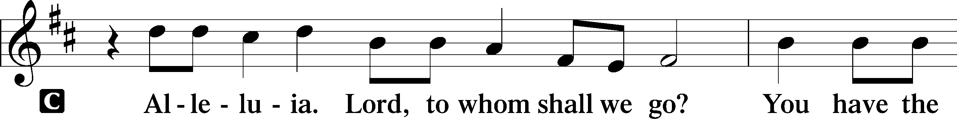
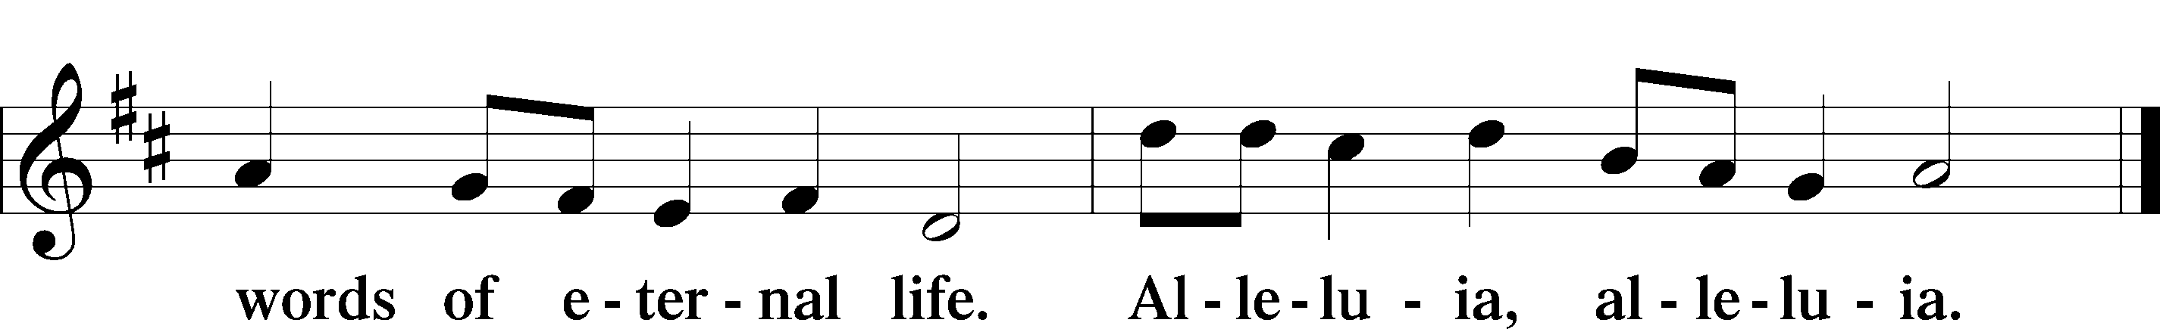

Holy Gospel Luke 6:27–38
Pastor Tinetti

Pastor: The Holy Gospel according to St. Luke, the sixth chapter.
People: Glory to You, O Lord.

Jesus said: “But I say to you who hear, Love your enemies, do good to those who hate you, bless those who curse you, pray for those who abuse you. To one who strikes you on the cheek, offer the other also, and from one who takes away your cloak do not withhold your tunic either. Give to everyone who begs from you, and from one who takes away your goods do not demand them back. And as you wish that others would do to you, do so to them.

“If you love those who love you, what benefit is that to you? For even sinners love those who love them. And if you do good to those who do good to you, what benefit is that to you? For even sinners do the same. And if you lend to those from whom you expect to receive, what credit is that to you? Even sinners lend to sinners, to get back the same amount. But love your enemies, and do good, and lend, expecting nothing in return, and your reward will be great, and you will be sons of the Most High, for he is kind to the ungrateful and the evil. Be merciful, even as your Father is merciful.

“Judge not, and you will not be judged; condemn not, and you will not be condemned; forgive, and you will be forgiven; give, and it will be given to you. Good measure, pressed down, shaken together, running over, will be put into your lap. For with the measure you use it will be measured back to you.”

Pastor: This is the Gospel of the Lord.
People: Praise to You, O Christ.

Please be seated

“Lord of Glory, You Have Bought Us”

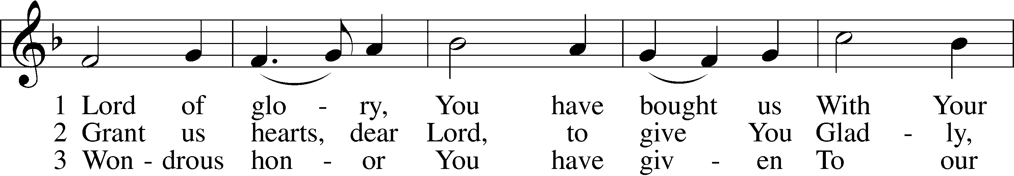
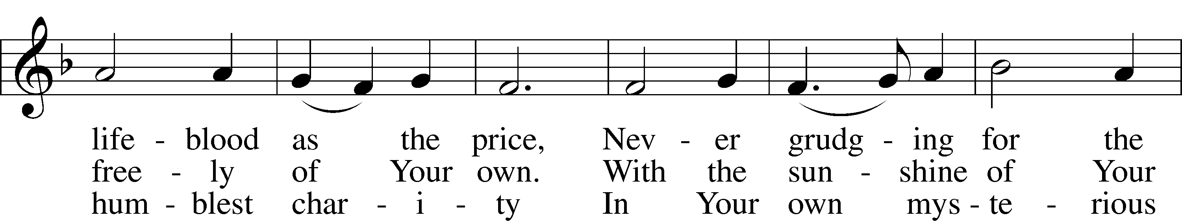
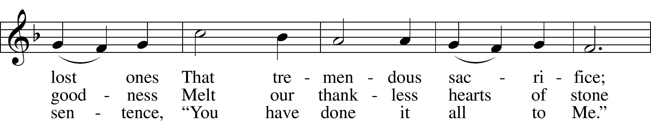
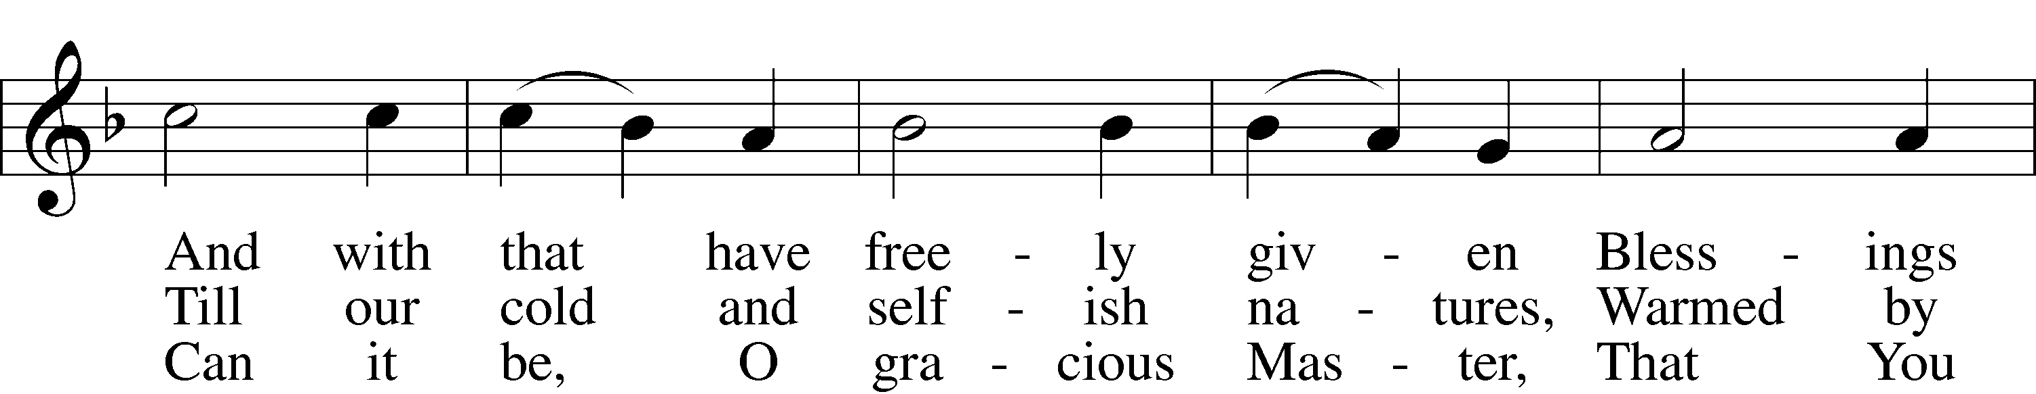
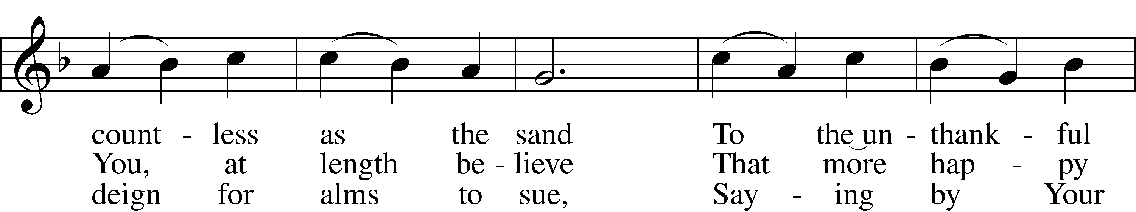
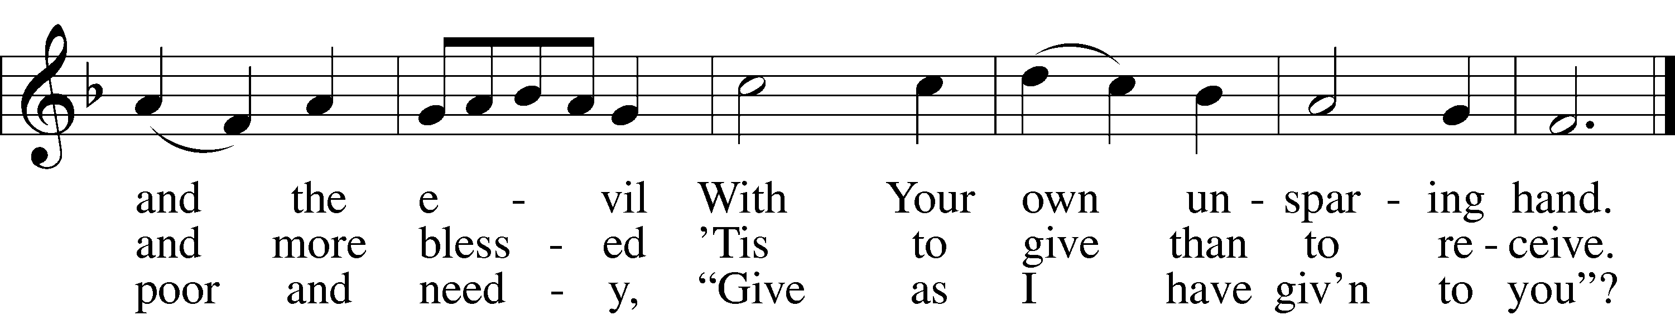
Text and tune: Public domain

Sermon “Senseless Mercy” Pastor Tinetti

Please stand

“Lord of Glory, You Have Bought Us”

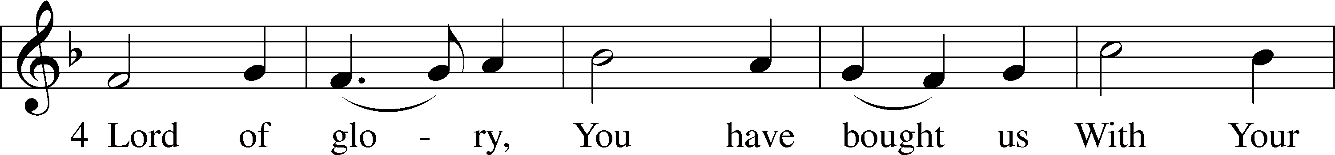
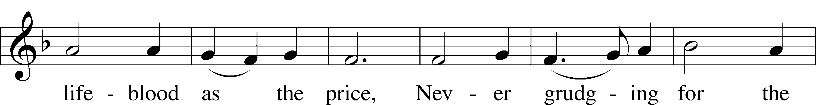
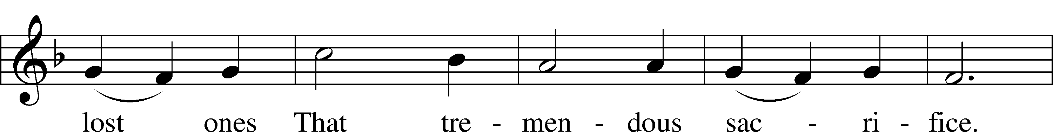
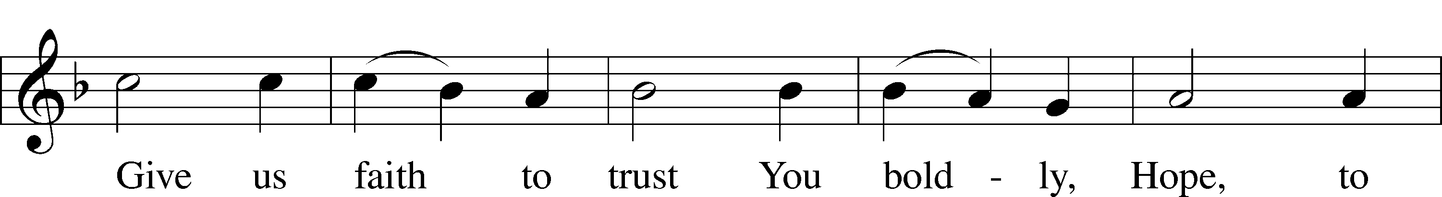
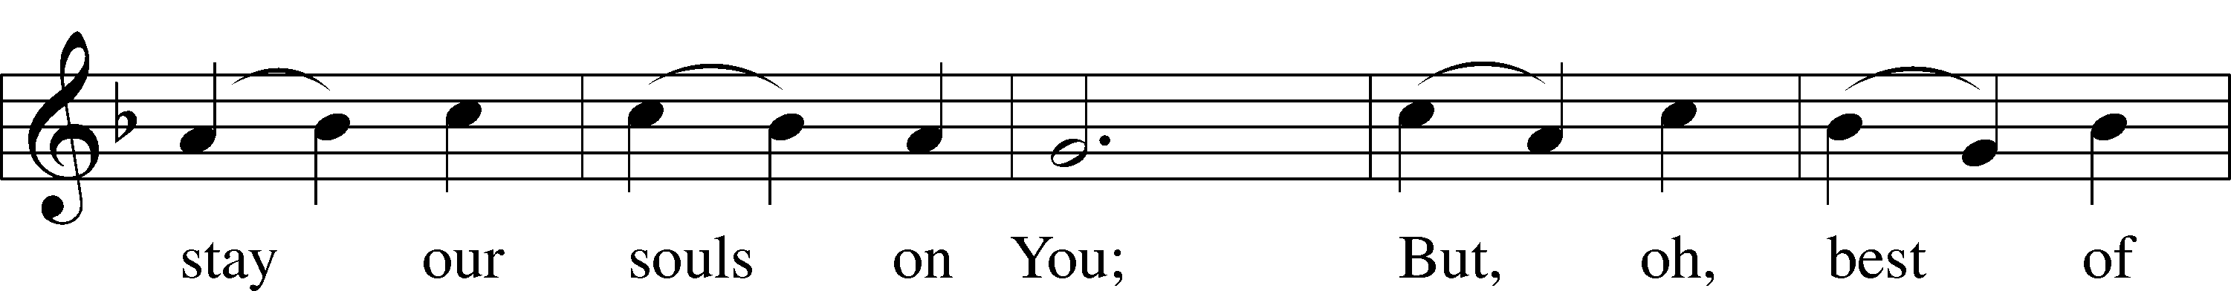
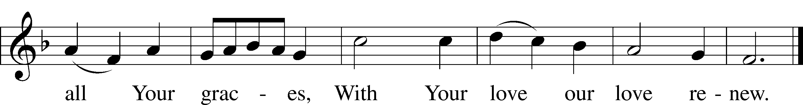
Text and tune: Public domain

Nicene Creed

People: I believe in one God, the Father Almighty, maker of heaven and earth and of all things visible and invisible.

And in one Lord Jesus Christ, the only-begotten Son of God, begotten of His Father before all worlds, God of God, Light of Light, very God of very God, begotten, not made, being of one substance with the Father, by whom all things were made; who for us men and for our salvation came down from heaven and was incarnate by the Holy Spirit of the virgin Mary and was made man; and was crucified also for us under Pontius Pilate. He suffered and was buried. And the third day He rose again according to the Scriptures and ascended into heaven and sits at the right hand of the Father. And He will come again with glory to judge both the living and the dead, whose kingdom will have no end.

And I believe in the Holy Spirit, the Lord and giver of life, who proceeds from the Father and the Son, who with the Father and the Son together is worshiped and glorified, who spoke by the prophets.

And I believe in one holy Christian and apostolic Church, I acknowledge one Baptism for the remission of sins, and I look for the resurrection of the dead and the life of the world to come. Amen.

Prayer of the Church

Pastor: Let us pray for the whole people of God in Christ Jesus and for all people according to their needs.

Brief silence

Pastor: We pray, Lord, with Joseph of old, who endured hardship and struggle and yet believed it would come to good. Bring all things to completion according to Your wisdom and purpose in Him who as the new Adam has brought hope to a world in sin and death, even Jesus Christ, our Lord. Lord, in Your mercy,
People: hear our prayer.

Pastor: We pray, Lord, for guidance amid the changes and chances of this mortal life. Deliver us from the pangs of doubt and from the paralysis of fear. Help us to know with joy our Lord Jesus Christ and the power of His resurrection, that we may not surrender to anxiety or despair. Lord, in Your mercy,
People: hear our prayer.

Pastor: We pray, Lord, for Your Church; for an end to the earthly divisions that grieve You; for the true unity of doctrine and faith in Your Word; and for those who lead us in the Synod, the district, the circuit and this congregation. Lord, in Your mercy,
People: hear our prayer.

Pastor: We pray, Lord, for Your comfort upon all who suffer. Deliver the sick according to Your will, and sustain those troubled in body or soul by Your grace. Especially do we pray for _____________ and those we name in our hearts. Be with the dying and grant them peace at the last, and give Your comfort to those who grieve. Give to all patience and courage, that they may endure these times of trial with hope in their hearts. Lord, in Your mercy,
People: hear our prayer.

Pastor: We pray, Lord, for Your love to have its way with us. Lead us to expect no reward, and teach us from Your own example not to act from self-interest but to love even our enemies and to serve those in need. End all bitterness and strife, and let Your forgiveness cover us in our lives together as You cover us with the blood of Christ before Your heavenly throne. Lord, in Your mercy,
People: hear our prayer.

Pastor: We pray, Lord, to grant us these and all things good and wholesome and profitable to our salvation, through the merits and mercies of Jesus Christ, our Savior, in union with You and the Holy Spirit, the one eternal God, now and forever.
People: Amen.

Please be seated

Offering

As the Offering is brought forward, please stand and sing:

Offertory
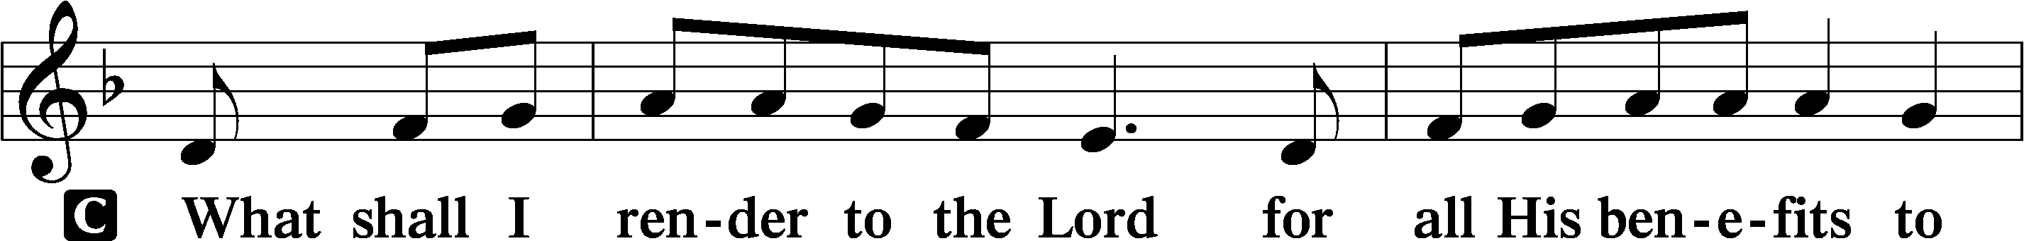
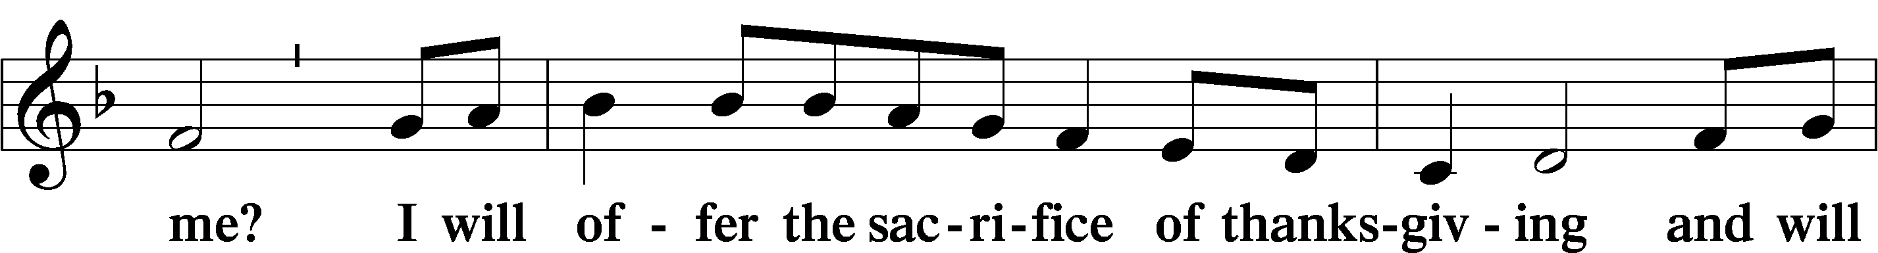
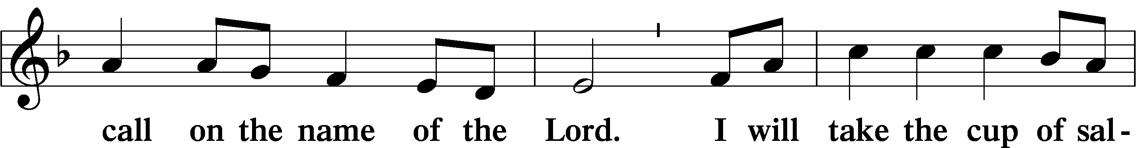
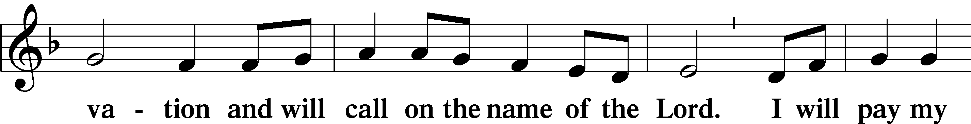
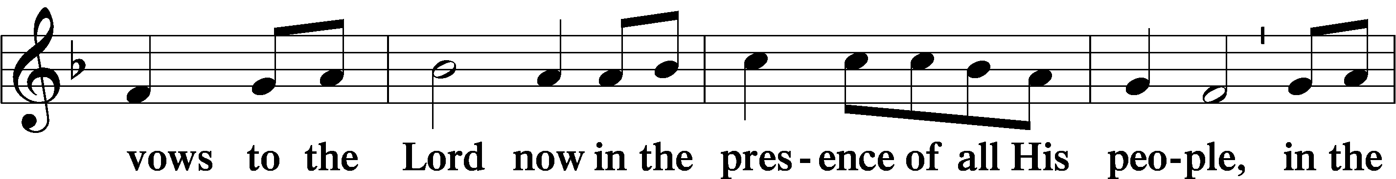
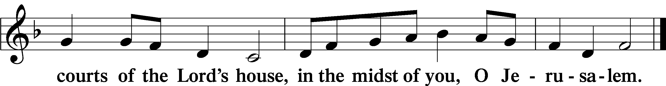

+ SERVICE OF THE SACRAMENT +

Preface

Pastor: The Lord be with you.
People: And also with you.

Pastor: Lift up your hearts.
People: We lift them to the Lord.

Pastor: Let us give thanks to the Lord our God.
People: It is right to give Him thanks and praise.

Pastor: It is truly good, right, and salutary that we should at all times and in all places give thanks to You, holy Lord, almighty Father, everlasting God, through Jesus Christ, our Lord; for what had been hidden from before the foundation of the world You have made known to the nations in Your Son. In Him, being found in the substance of our mortal nature, You have manifested the fullness of Your glory. Therefore with angels and archangels and with all the company of heaven we laud and magnify Your glorious name, evermore praising You and singing:

Sanctus

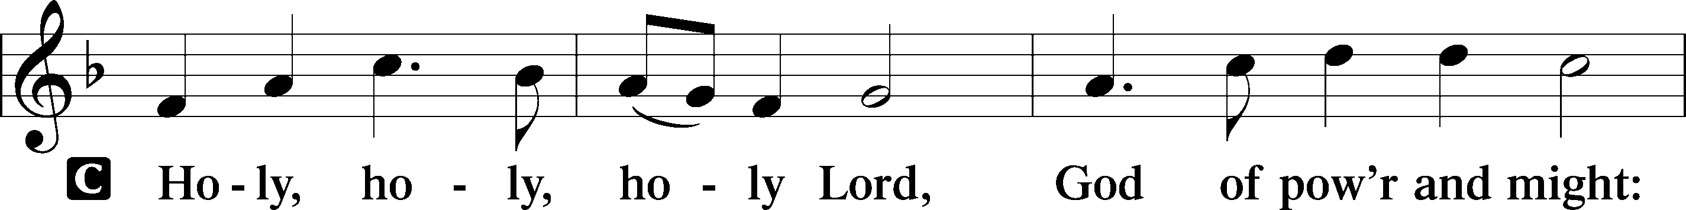
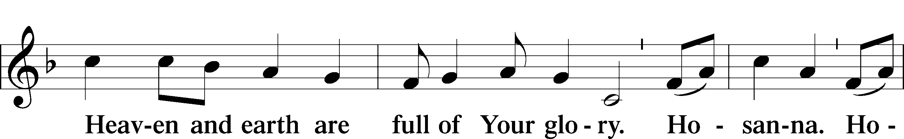
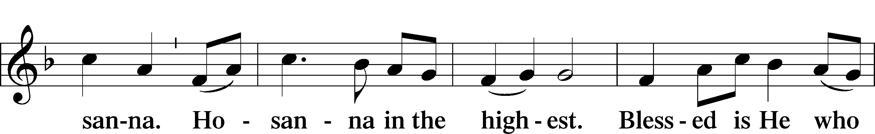
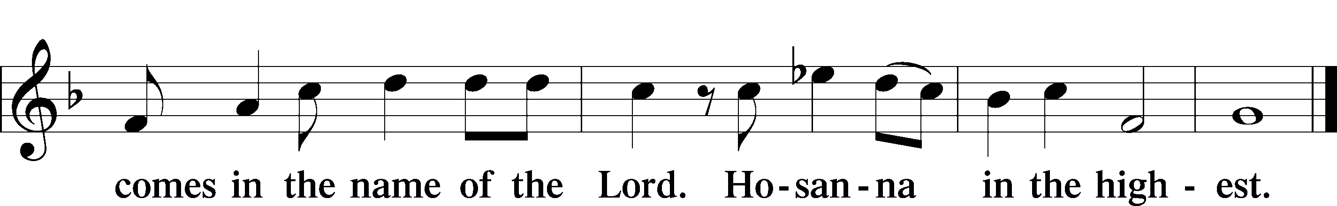

Lord’s Prayer

Pastor: Lord, remember us in Your kingdom and teach us to pray:
People: Our Father who art in heaven, hallowed be Thy name, Thy kingdom come, Thy will be done on earth as it is in heaven; give us this day our daily bread; and forgive us our trespasses as we forgive those who trespass against us; and lead us not into temptation, but deliver us from evil. For Thine is the kingdom and the power and the glory forever and ever. Amen.

The Words of Our Lord

Pastor: Our Lord Jesus Christ, on the night when He was betrayed, took bread, and when He had given thanks, He broke it and gave it to the disciples and said: “Take, eat; this is My body, which is given for you. This do in remembrance of Me.”

In the same way also He took the cup after supper, and when He had given thanks, He gave it to them, saying: “Drink of it, all of you; this cup is the new testament in My blood, which is shed for you for the forgiveness of sins. This do, as often as you drink it, in remembrance of Me.”

Pax Domini

Pastor: The peace of the Lord be with you always.
People: Amen!

Sharing of the Peace

Following the prayers, the people may greet one another in the name of the Lord, saying, “Peace be with you,” as a sign of reconciliation and of the unity of the Spirit in the bond of peace (Matt. 5:22–24; Eph. 4:1–3).

Agnus Dei

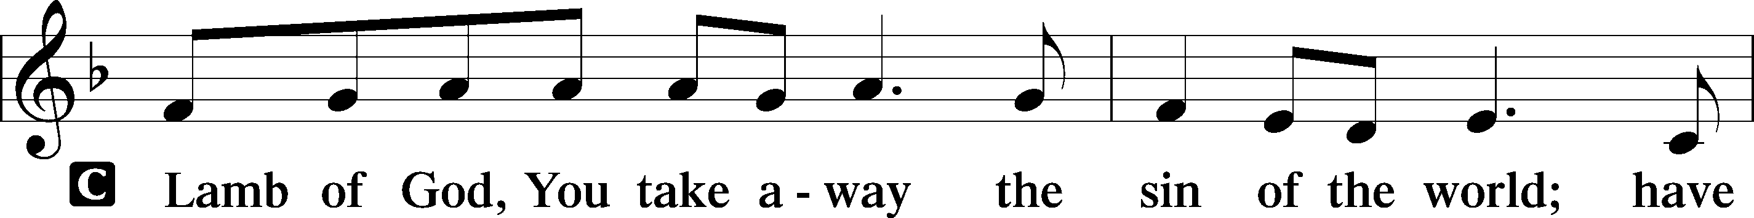
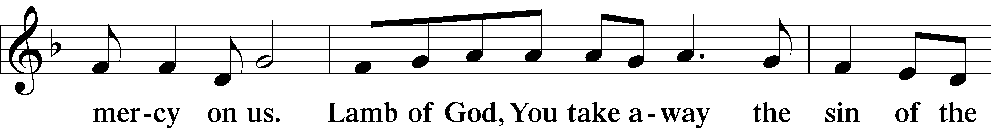
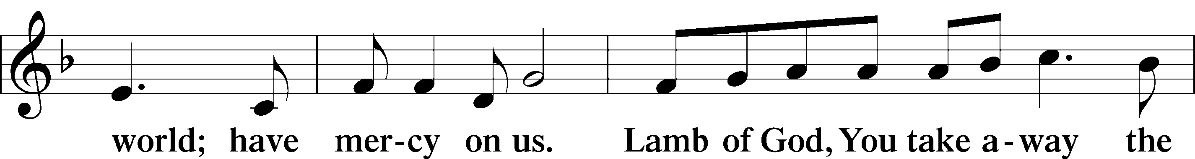
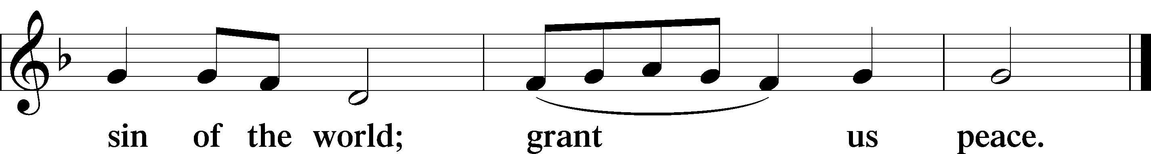

Please be seated

Distribution of Holy Communion

Please tell either an Elder or usher if you cannot come to the Lord’s Table so Holy Communion can be brought to you. After the individual communions, the rest of the congregation is welcomed to the Table.

It is the tradition of Trinity Arcadia to offer both the chalice and individual glasses. Please help us know your preference by opening your hands at the appropriate time. Individual glasses in the center of each tray contain white, unfermented grape juice. You may also ask for gluten-free bread.

“Praise to the Lord, the Almighty”
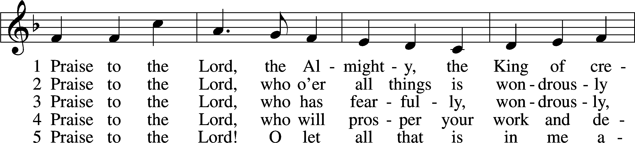
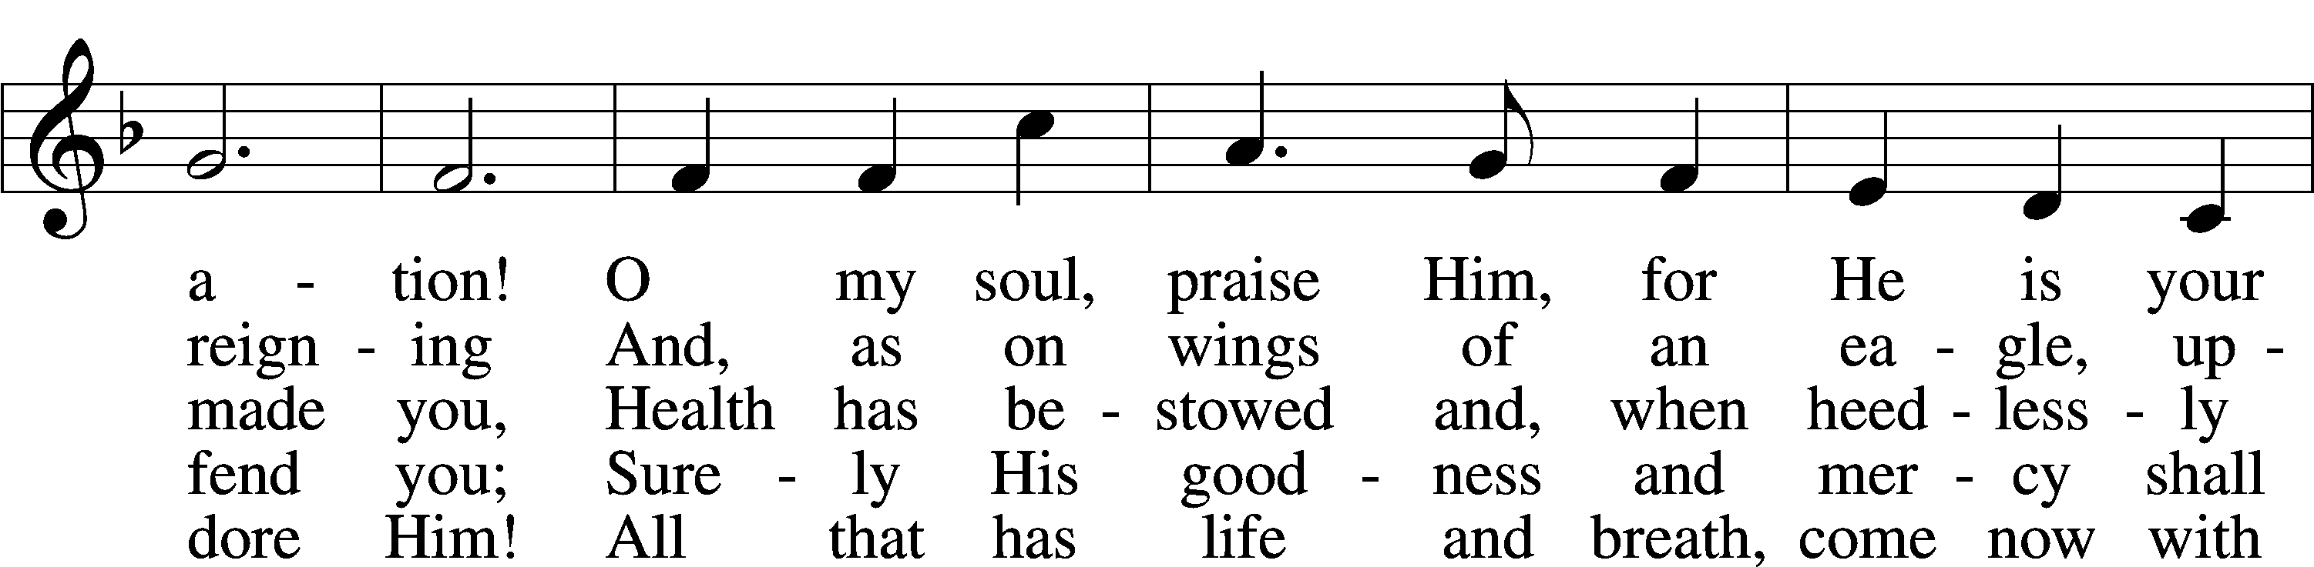
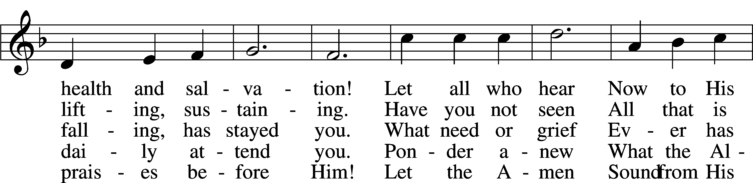
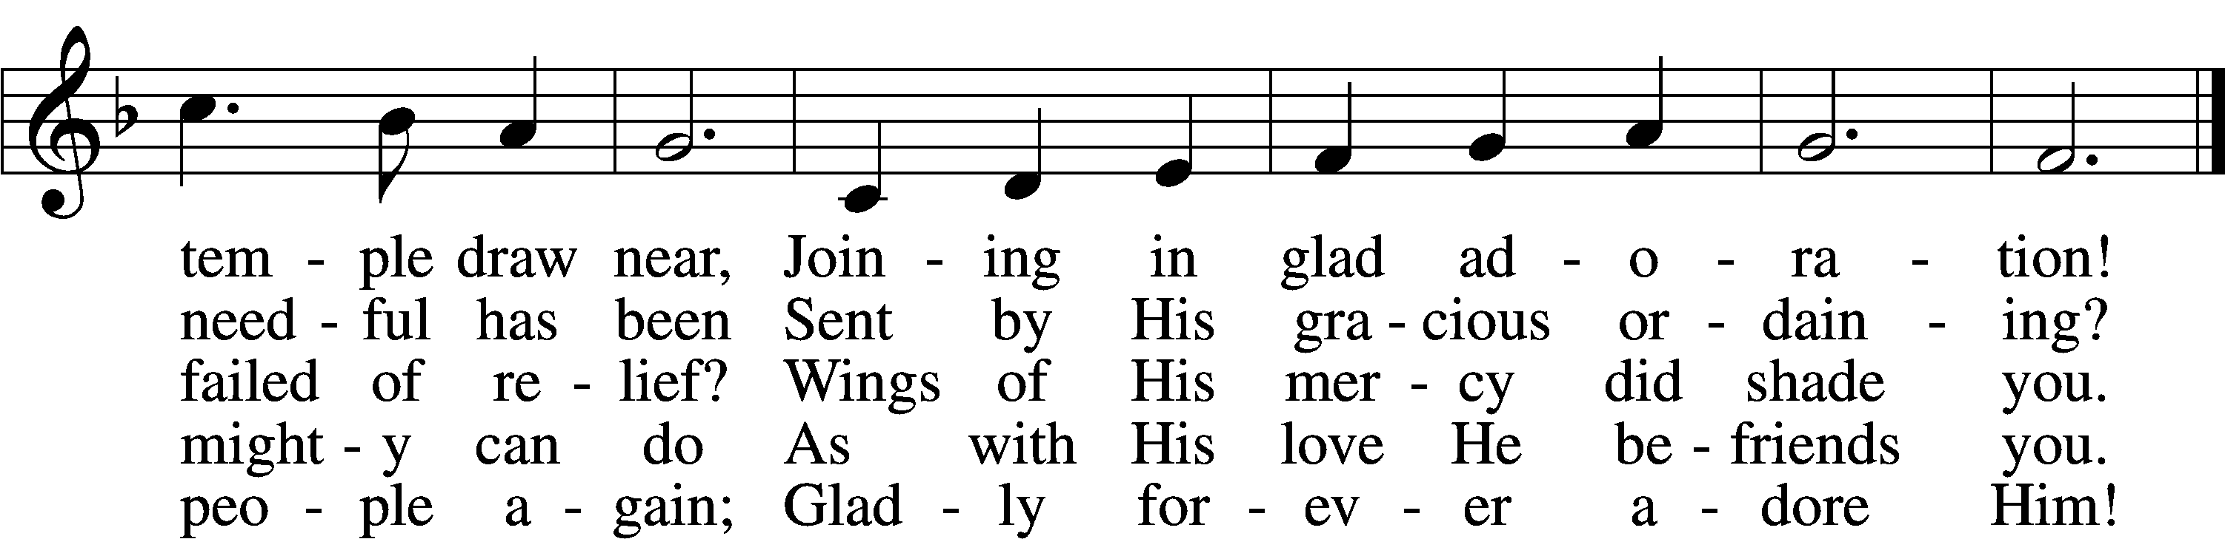
Tune and text: Public domain
“Jesus, Thy Blood and Righteousness”

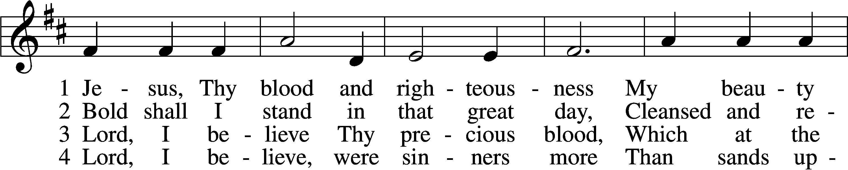
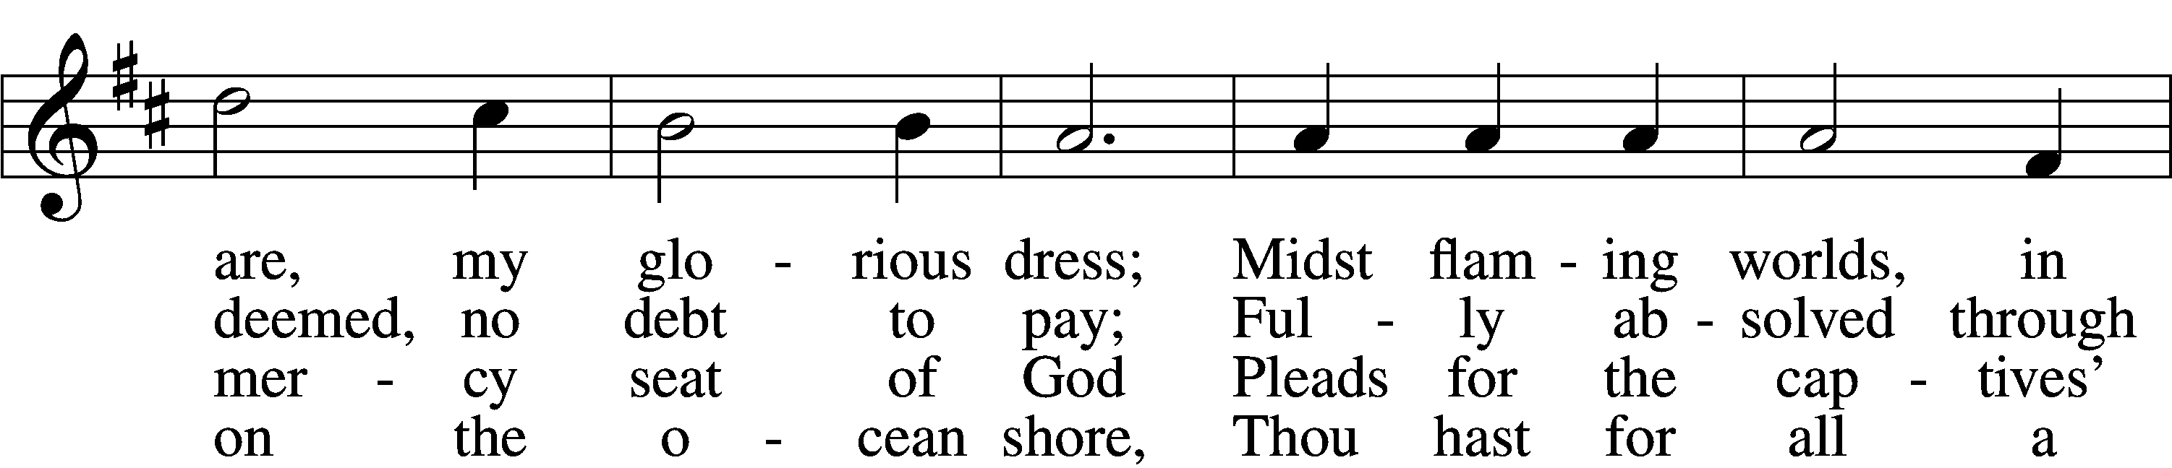
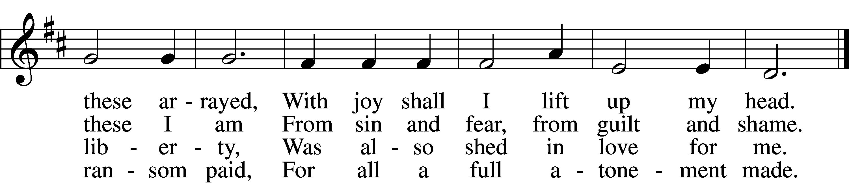
Text and tune: Public domain

“Draw Near and Take the Body of the Lord
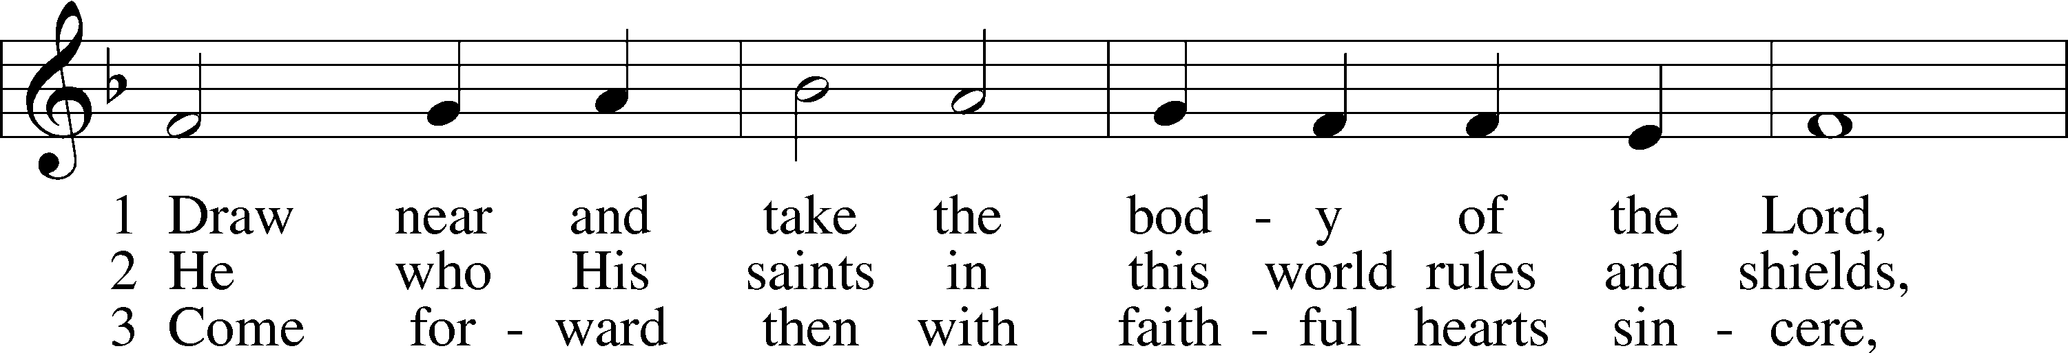
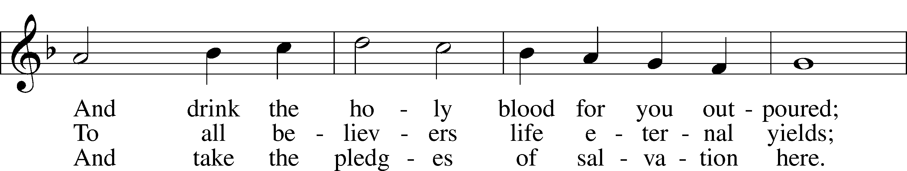
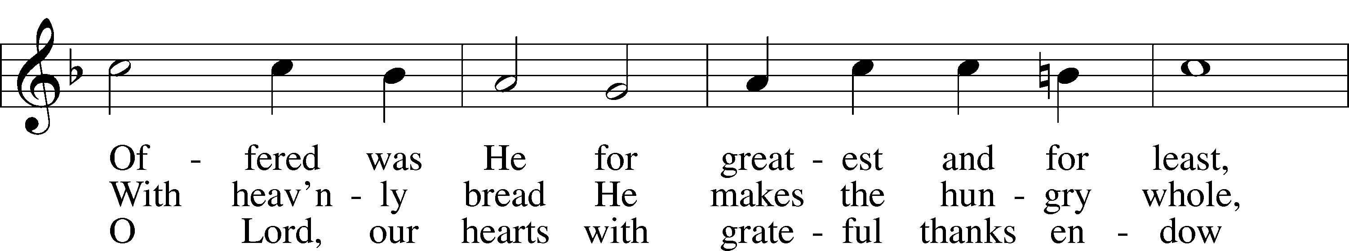
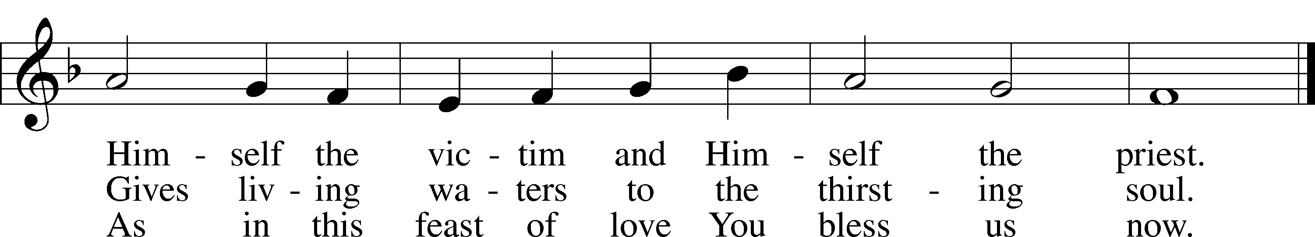
Text and tune: Public domain

Please stand
“Thank the Lord”

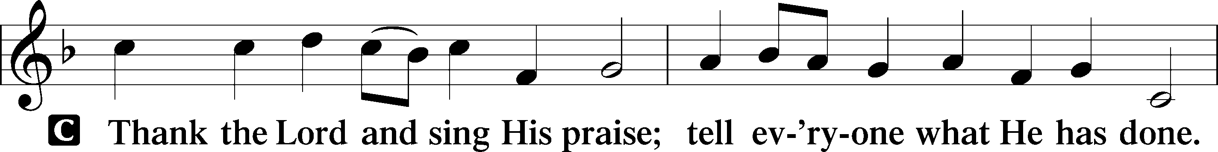
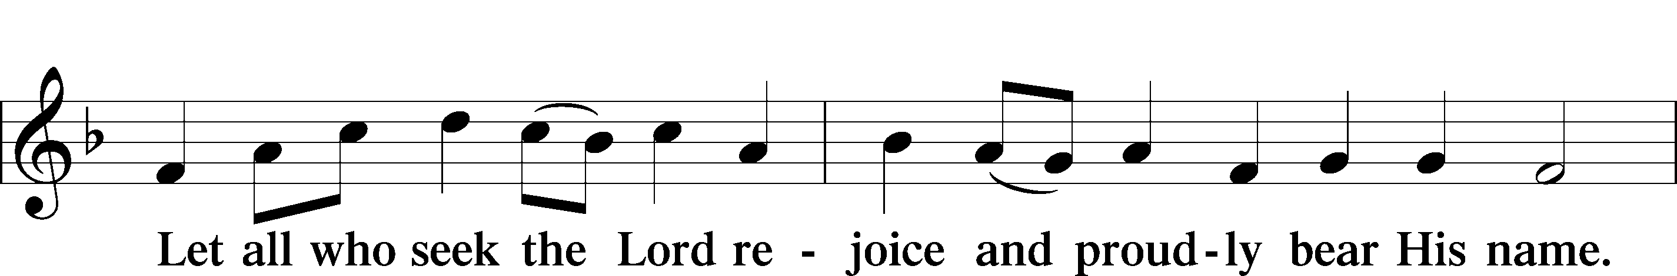
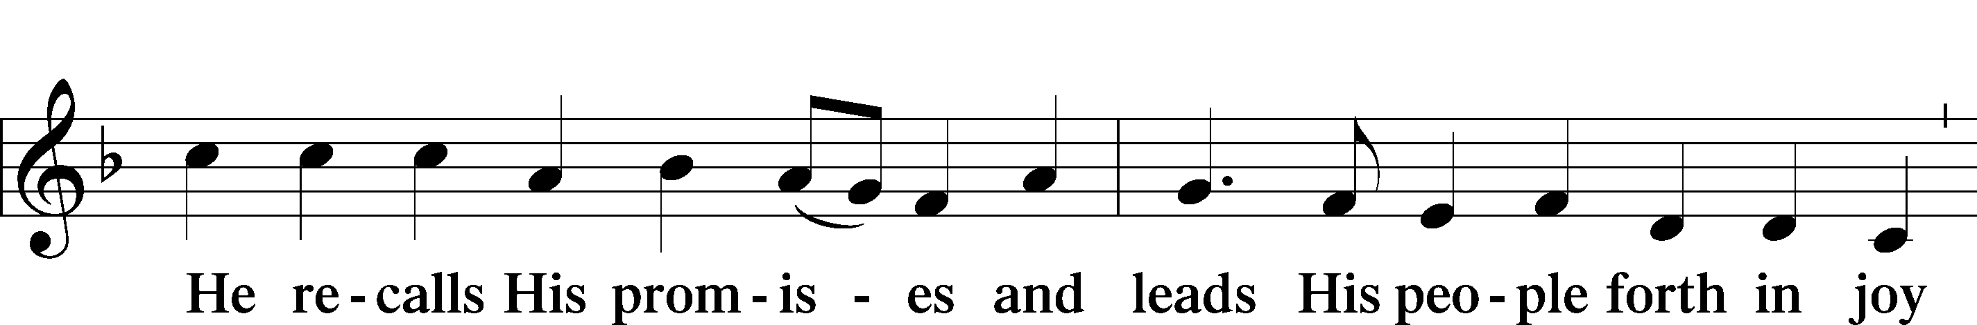
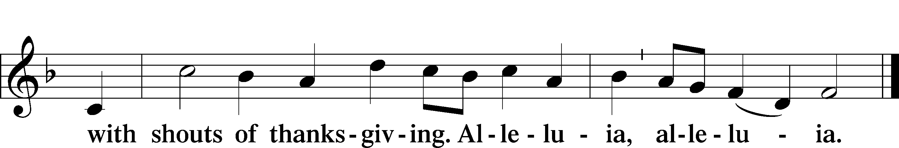

Post-Communion Collect

Pastor: Let us pray.
We give thanks to You, almighty God, that You have refreshed us through this salutary gift, and we implore You that of Your mercy You would strengthen us through the same in faith toward You and in fervent love toward one another; through Jesus Christ, Your Son, our Lord, who lives and reigns with You and the Holy Spirit, one God, now and forever.
People: Amen.

Benediction

Pastor: The Lord bless you and keep you. The Lord make His face shine on you and be gracious to you. The Lord look upon you with favor and give you peace.
People: Amen.

“Savior, Again to Thy Dear Name We Raise

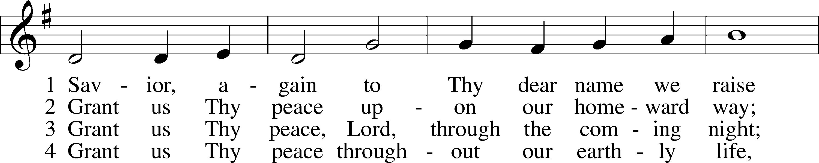
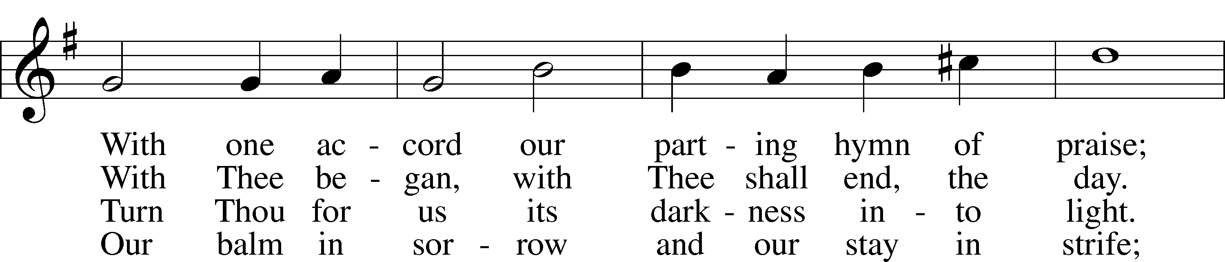
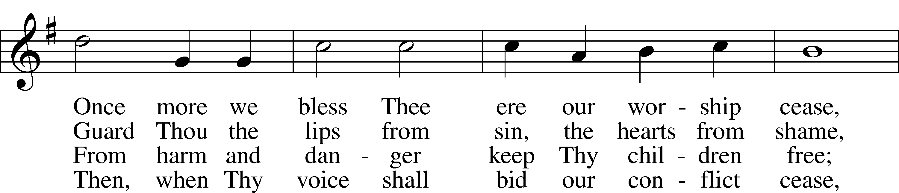
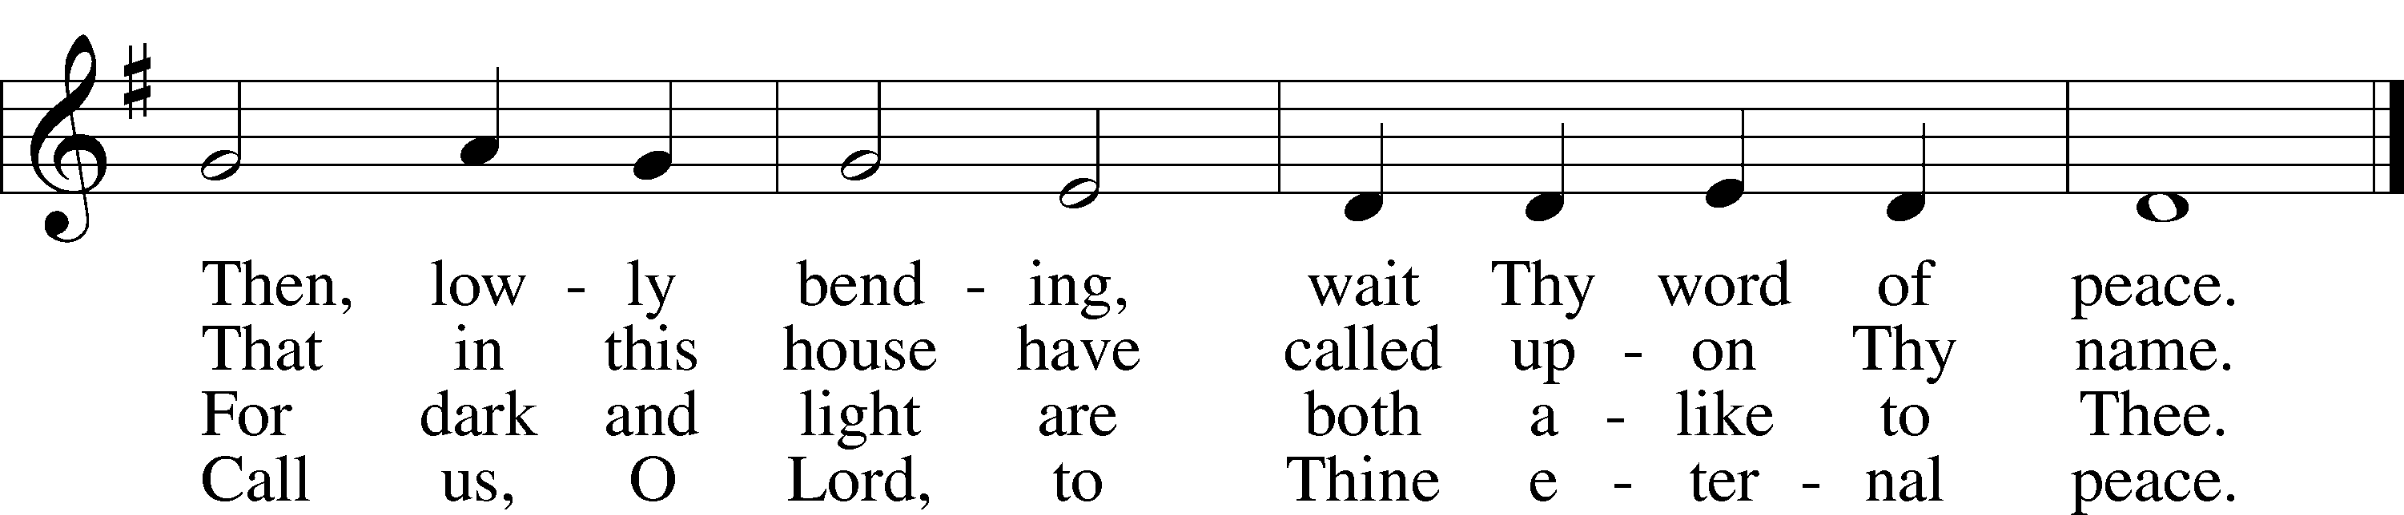

Pastor: Go in peace, serve the Lord.
People: Thanks be to God!

Acknowledgments
Divine Service, Setting One from Lutheran Service Book
Unless otherwise indicated, Scripture quotations are from the ESV® Bible (The Holy Bible, English Standard Version®), copyright © 2001 by Crossway, a publishing ministry of Good News Publishers. Used by permission. All rights reserved.
Created by Lutheran Service Builder © 2018 Concordia Publishing House.

Trinity Lutheran Church
Established 1881
Church built 1888

Pastor: Pastor Ryan Tinetti
Musical Accompanist: Gabriella Haiderer
President: Jack McKenna
Elders: Chip May, Jack McKenna, Richard Nelson
Mark Kuhlmann, Paul Scheppelman
Beverly Gay- Photiades

Head Usher: Larry Wendt
Church phone: 231-889-3620
Pastor Tinetti’s phone: 509-329-8339

Church’s WIFI code: 17191Third
Church e-mail address: Trinityarcadiami@gmail.com
Church website: Trinityarcadiami.org

Church’s mailing address:
Trinity Lutheran Church
P. O. Box 139
Arcadia, MI 49613

