+++TLC COUNCIL REPORT 11-20-19

LWML (Lutheran Women’s Missionary League)

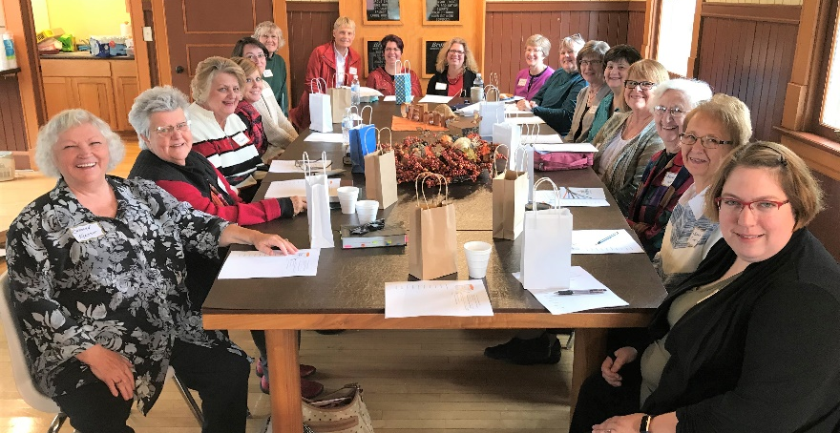
- August 25: Backpack Blessing for students and teachers. Gave each student and teacher a gift.
- September 21: LWML Retreat at Mission Central
- October 27: TLC Women’s Retreat at Jefferson Depot. Theme: One Purpose-
- LWML Sunday: Served during service and power point to share what LWML does.
- Adopting a Seminarian: Alex Sloter from Boone
- Quilting Group: Quilts for ARC

Upcoming Events:
- December 4: Serve meal before Advent service
- December 14 - 5:00: Twilight Christmas
- Hosting a kitchen shower for TLC: Need plates, cups, paper towels, silverware, coffee etc.
- December 24, after service: delivery of plates of goodies to businesses that are open Christmas Eve.

MOP (Mission/Outreach/Parish Fellowship)
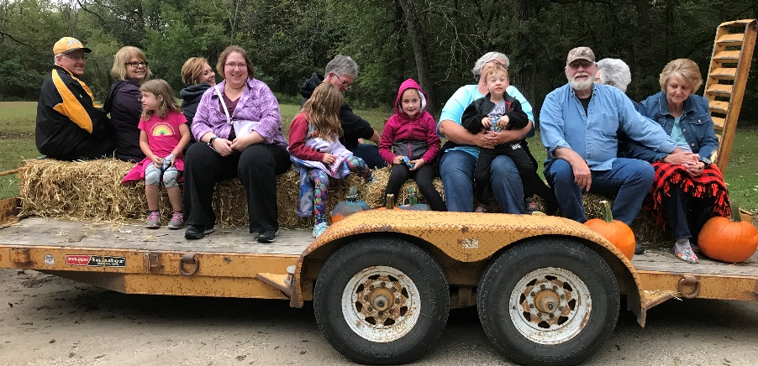
- Hosted Pastor Appreciation @ Lutheran Half Hour
- Outreach to members of Trinity and visitors to TLC by offering free Christian materials on a table in the hall.
- September 28: Family Fall Festival at Seven Hills Park—Hot dogs, crafts and hayride.
- Operation Christmas Shoeboxes -- Approximately 70
- November 24: Gary Thies (Mission Central) speaking at church/ Bible class
- November 24: Mission Offering for Denny and Mary Merritt going to Africa soon.
- Date to be determined: Fireman Appreciation Meal

