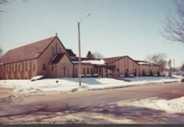
TRINITY TIDINGS
February 2018
Monthly Publication of Trinity Lutheran Church 801 West Lincoln way
Jefferson, Iowa 50129
http://tlcjeffia.360unite.com/home
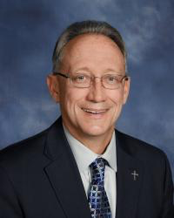
A Message from Pastor Dennis

“Be Prepared”
“You have been taught the Holy Scriptures from childhood, and they have given you the wisdom to receive the salvation that comes by trusting in Christ Jesus. ¹⁶ All Scripture is inspired by God and is useful to teach us what is true and to make us realize what is wrong in our lives. It straightens us out and teaches us to do what is right. ¹⁷ It is God's way of preparing us in every way, fully equipped for every good thing God wants us to do.”
(2 Timothy 3:15-17)

“Be Prepared.” That's the motto of the Boy Scouts of America. And when I was a Boy Scout back in the day, that motto of be prepared was reinforced with each activity and teambuilding training event we ever did. This motto meant that a Scout was always to be in a state of readiness—in mind and body—to do one's duty to God and country and to always obey the scout law.

So, are you prepared for the season of Lent to begin? If you're not, what can you and I do about it? Thanks be to God that the Lenten season, which is about to begin with our February 14th Ash Wednesday celebration, is really all about God getting you and me prepared to meet His Son. That is if we will but take the time to listen and learn.

On the first Sunday in Lent, Jesus begins His ministry of the Cross by being baptized in the Jordan River by His cousin John the Baptist. On the day of Jesus’ baptism, God the Father ordained His Son for the ministry of the Cross with His Holy Spirit, giving Jesus the vision, strength, and faith to save all mankind from their deadly sins. And when Jesus came up out of the water, the Spirit of God rested on Him, and God the Father then said that this is His Son with whom He is well pleased, listen to Him. And all hearers of God’s Word from that day forward, to you and me right now, every child of God who believes in Jesus and is baptized would be saved.

No one on their own, without faith in Jesus, can truly be prepared for anything life gives them. Yet God the Father prepared His Son from the very beginning, from heaven to the earth, from the cross through the grave, to do for us what we could never do on our own. Jesus removes our sins and anything else that would try to keep us from being made children of God.

The result of Jesus's death and resurrection is how God continues to prepare you and me to live one day at a time, trusting in the mercy and forgiveness of God to live by faith in His Son. Living by faith, waiting for that Glorious Day that is coming when Jesus takes us Home to be with Him and all the saints in heaven for all eternity!

So, are you prepared? Are there any issues or concerns you have right now that seem to be holding you back from letting our God—in this Lenten season—continue to prepare you to live by faith in Him? Let us take all our fears and frustrations and inadequacies to the Lord in prayer, trusting in His mercy and in His Son, so the Word of God can continue to teach us to do what is right, equipping us to be His living witnesses in the here and now! Thank You Lord Jesus, Amen.
Pastor Dennis
ANNIVERSARIES BIRTHDAYS
2/16 Jim & Jeanne Daubendiek 2/14 Stephen Fagg
2/14 Emily Finch
BIRTHDAYS 2/15 Bradon Hirsch
2/1 Ethan Frederick 2/15 Abby McConnell
2/1 Brenda Warnke 2/16 Cameron Greenough
2/3 Dylan Boude 2/16 Mary Pedersen
2/3 Randal Freeman 2/16 Charles Hane
2/4 Frederick Woodley 2/17 Gary Higgins
2/5 Ryanne Connell 2/17 Luke Larson
2/6 Sherry Graven 2/18 David Pedersen
2/7 Chastity Derry 2/21 Martin Higgins
2/9 Nicholas Dinkel 2/21 Carolyn Kienast
2/9 Amalia Easton 2/23 Mark McHugh
2/11 William Cloninger Jr. 2/25 Charlie Hane
2/11 Jill Wanninger 2/26 Carolyn Berry
2/11 Travis Warnke 2/26 Jacob Day
2/12 Terry Day 2/26 Jonathan Fagg
2/12 Nora Nasheim 2/29 Roger Nielson
2/13 Marilyn Peterson

CHURCH COUNCIL MEMBERS FOR 2018 (Officers & chairpersons are in bold)
Chairman – Scott Graham Vice Chairman – Dick Fairclough Secretary – Linda Thede

Board of Elders – Lynn Menz, Al Robson, Pat Griffin, Trent Gierstorf, Dave Pedersen, Kyle Kinne

Board of Trustees – Mike Compton, Dennis Thede, Jack Fredrickson, Gary Higgins

Board of Education – Cheryl Robson, Valerie Gierstorf, Jodi Frederick, Melissa Barrett

Board of Missions – Ellie Menz, Ruth Consier, Mary Merritt, Janie Hertel

Board of Community Outreach – Nina McDonald, Kathy Milligan, Jane Finch, Anne Carstens

Board of Talents, Gifts & Stewardship – Lois, Brant, Mark Erickson

Board of Parish Fellowship – Connie Carstens, Sarah Erickson, Caryn Hane, Tammy Brophy

Installation of officers and board members was Sunday, January 14th. After Lutheran Half Hour a special event was held in the fellowship hall for the boards and officers. Each board met and elected a chairperson and talked about tentative goals for the year. Listed below are the goals each board hopes to pursue for 2018.

BOARD OF ELDERS – Chairman Lynn Menz
- One elder will accompany and assist pastor as he visits shut-ins.
- The elders will begin to connect with inactive members by phone or other means.
- If no organist is available, we may have a contemporary service with guitar or other music.

BOARD OF TRUSTEES – Chairman Mike Compton
- We will reevaluate floor coverings.
- We will repair or replace the fabric above the altar.
- We will repair or replace the fabric over the speakers behind the organ and choir area.

BOARD OF EDUCATION – Chairperson Melissa Barrett
- We plan to transition from worship to Sunday School by 11:00, singing for 10 – 15 minutes with lessons from 11:15 – 11:45.
- We will have Sunday School children sing during worship and post pictures and lessons to demonstrate what they are learning.

BOARD OF MISSIONS – Chairperson Ellie Menz
- We plan to do a monthly mission update at the end of the church service to keep the congregation informed about the missionaries we support.
- When a month has five Sundays, a special mission focus will be planned.
- We plan to work together with the outreach and parish fellowship boards to organize events.
BOARD OF COMMUNITY OUTREACH – Chairperson Nina McDonald

BOARD OF PARISH FELLOWSHIP – Chairperson Connie Carstens

Outreach/Parish Fellowship/Mission Board Report
The three boards are planning to work together in an effort to accomplish more in our outreach to Trinity Lutheran Church, our community, state, country and internationally.
We met on January 17 and laid out our basic goals for the year. Things will change but the following are some of our current plans.

One of our main goals is to increase awareness for the amazing opportunities God has given us to reach out and make a difference in our community and world. One way is to have a ‘Mission Minute’ the first Sunday of each month. We will be introducing by DVD, three missionaries who we will be sponsoring. We will be supporting Pastor and Mrs. Rickman and their four children serving in Asia, Pastor Gaugert serving in Togo, West Africa and Deaconess Duke and husband in Lima, Peru with offerings that we receive each ‘Mission Sunday’ (first Sunday of the month).

You will hear more about that later, but first let’s focus on our TLC missionary, Adam Pedersen. Adam will be serving in Hong Kong in February! On February 4, Adam will be commissioned to serve and at the end of the service, he will be sharing what he will be doing in Hong Kong. There will be a ‘door offering’ to help with his expenses.

April: Lynn and Ellie Menz will be sharing about their trip to the two LCMS churches in Puerto Rico.

May: Take cookies and/or bars to the hospital and schools for Hospital Appreciation Week and/or
Teacher’s Appreciation Week.
June: Church service at Spring Lake, potluck meal and fun family games at the lake.

July 29: Gary Thies, Mission Central, Mapleton, IA will be speaking at TLC service and Bible Class. We will begin the day by serving an 8:30 AM breakfast.

August 5: Missionary Gaugert will speak at TLC in evening. We will have a delicious meal.

August: Possible road trip to Mission Central

September 30: Family Fun Festival at Seven Hills Park

October: Firemen and Police Appreciation Meal

November 17: Possible road trip to Sioux City to pack meals for the hungry.
We are praying for God’s guidance and direction as we make plans to serve Him by serving others.

God’s Blessings, Ellie Menz

BOARD OF TALENTS, GIFTS, & STEWARDSHIP - Chairperson Lois Brant

Board of Elders Meeting Minutes
January 9, 2018 - Present: Pastor Dennis, Lynn Menz, Al Robson, Pat Griffin, David Pederson, and Kyle Kinne Absent: Trent Gierstorf

I. Pastor opened with a prayer. He then gave an update on Lois Brant’s hospital stay.

II. On January 28th there will be an affirmation of faith during the service for new members. Pastor is working on a new directory that will be printed and shared with the congregation. Elders discussed and determined they did not want Pastor filling any current or near future vacancies at the present time. Elders and Pastor discuss having Gary Thies speak to the congregation.

III. Communion servers: Feb 4: Al Robson, Pat Griffin Feb. 14: Dave Peterson, Kyle Kinne
Feb 18: Trent Gierstorf, Pat Griffin

IV. Elders discussed Jan. 14th council event. (It was held immediately after Lutheran Half Hour because there will be no Bible class.)

V. Elders talked about Elder’s manuals. Everyone will bring the copies they have for the next meeting.

VI. An Office Assistant position update was given. There have been 6 people who have inquired about it. The church is still looking and an ad will be in the newspaper soon.

VII. Elders discussed who to ask for a fill-in organist when others cannot make it.

VIII. Lynn shared a Church history of 2017 that he put together. All felt this would be valuable to the church to do every year. They discussed possibly updating the information on the wall in the hallway.

CHURCH COUNCIL MINUTES - Trinity Lutheran Church Council 1/17/2018
The meeting was called to order at 7:10 pm by Scott Graham. Pastor Dennis led the council with a daily devotion for today called Jesus Calling.

Those in attendance were: Scott Graham, Mark Erickson, Dick Fairclough, Lynn Menz, David Pedersen, Pastor Dennis, Cheryl Robson, Melissa Barrett, Sarah Erickson, Pat Griffin, Al Robson, Nina Mc Donald, Ruth Consier, Anne Carstens, Kathy Milligan, Ellie Menz, Jodi Frederick, Caryn Hane and Linda Thede

The board minutes from the November meeting were approved with a motion from Al Robson and seconded by Dick Fairclough. All were in favor.

Reporting Boards as follows:
Elders: Affirmation of Faith Sunday, January 28, 2018; Office position received two applicants and will be discussed next week. Pastor Dennis discussed creating a black/white directory he will start in the summer. When Pastor is ready to receive photos he will let the congregation know. Lynn Menz has prepared the history of the church and would like people to look it over. If he has omitted something, please let him know and submit the information to Lynn Menz . Lynn also needs February newsletter information by 1/20/2018. Pastor Dennis talked about ARC Food Bank and at this time they need monetary donations.

Christian Education: Will meet next week and decide who the chair will be. 2017 Christmas Program was a lot of fun and was last done in 2005. Bible Bowl will be February 4, 2018. There will be a sign-up sheet for snacks on the rolling board. This is a great way for youth to share what they have learned. Discussion of the fish bowl for children donations in church was all positive and the children enjoyed giving their donations.

Trustees: Not reporting at this time

Member & Community Outreach: Chair, Nina Mc Donald. Ellie discussed that email needs to be updated so everyone is receiving church information. Pat shared that information sheets will be placed in mailboxes Sunday, January 21st for members to update their personal information. This information will be shared, so hopefully email lists are updated. Pastor Dennis gave the Lenten Luncheon date as Wednesday, February 28, 2018 from 12:15-12:45. Other save the dates are: 6/2018 Spring Lake, 7/29/2018 Gary Thies , 8/5/2018 Missionary Gaugert, 9/30/2018 Fall Festival.

Missions: Chair, Ellie Menz. Ellie discussed that Outreach, Missions and Fellowship often overlap. Working together they have a large group of 12 people and can get more done. Adam Pedersen, will be speaking about his trip to Hong Kong on 2/4/2018. There was discussion on having a Mission Sunday monthly and donations would be given to the 3 missionaries.

Parish Fellowship: Chair, Connie Carstens. Ash Wednesday, February 14, 2018 the committee will be hosting a meal of chili, chicken soup and bars for approximately 50 people.

Stewardship, Talents & Gifts: Chair, Lois Brant. No report

Other Board, Committees and Auxiliaries
Trost Music: Mark, Ruth, Rita and Melissa reported at this time there are no needs in children’s music. David shared that the donor had three desires: garden, history of the church and music.

Historic Cabinet: Dan Benitz will build the cabinet, but he was concerned about having a glass door on the front. The council voted to have a glass door, so at this time no construction has begun.

Old Business:
Suggestion Box: Many people put suggestions into the box. BINGO was from the suggestion box. Ruth reported that another suggestion was baking and it was disappointing when preparation was made to have baking, but no one attended. Scott suggested that having events at different times makes it difficult for people to attend, but having a consecutive date might help events be successful. The goal of the box was to find out what interest people have. It was discussed that forms need to be more detailed for suggestions to be successful. Lois is planning something with gardening.

New Business: District convention will be at Camp Okoboji June 24-26, 2018. Pastor Dennis will be attending along with lay delegate, Dick Fairclough. Lynn Menz is the alternate delegate. Pat reported that he thought the Christmas tree was out of place and blocked the bells, choir and altar. Pastor Dennis discussed when the Power Point fabric screens are purchased and installed, they will go back further. When this is complete a decision can be made what type of Christmas tree would be appropriate for the church.

Financial Reports:
Budget Committee: Dick Fairclough, nothing to report at this time.
Financial Report: Pat Griffin reviewed the yearly financials and currently Trinity has had a good year. The church is sound financially. It was moved by Melissa Barrett and seconded by Nina McDonald to approve the report. All were in favor.

The meeting adjourned at 8:50 pm with all attendees closing with the Lord’s Prayer.

LWML MEETING MINUTES -- January 21, 2018
- Opening Prayer
- Thank you, Pat Benitz, for the goodies.
- Devotional on “Who are you like?” (Is it true that you are the average of the five people you spend the most time with?) Is Jesus one of the five on your list?
- Treasury Report: Balance is $503.29. Alana sent $100 to Ft Wayne for seminarian Trae Fister, $50 to the Good Samaritan Fund and $45.81 to Zone for mites.
- Signed and addressed 17 Valentine cards for our shut in/home bound members. Cards are available for two weeks for Trinity members to sign.

- Next week there will be Valentine cards for Trinity members to sign for eight college students
- Congregational members are being asked to bring goodies for the college boxes that will be assembled on February 4 by LWML.
- LWML’s Group 2 will be in charge of organizing and serving the Lenten Luncheon at noon on February 28.
- Margaret Martens and Cheryl Robson will be in charge of the organizing of the evening Lenten supper on February 28. Other LWML members are invited to help with the serving and clean up.
- The topic of new counters in the kitchen was discussed. LWML is willing to do a fundraiser to pay for the counters.

- Our TLC Women’s Retreats have been a success and we plan to continue them. It was decided that we have a Spring Retreat with a focus on “Caring for Ourselves” Bible Study. The Fall Retreat focus will be “Caring for Others” and we will be involved with service projects. Dates and locations to be announced.
- We have exciting ideas for a Mother/Daughter Banquet. Date will depend on the speaker’s availability.
- To brighten up our Fellowship Hall, LWML is going to have seasonal decorations on the tables.
Melissa Barrett is doing a Valentine theme.
Rina Walker volunteered to create an Easter theme.
Kathy Milligan volunteered to create a summer theme. Mark your calendars for our next meeting---February 18 at 8:15 AM.

Submitted by Ellie Menz

FEBRUARY CHURCH CALENDAR – In past newsletters, the month’s calendar was printed. The calendar is now on the website so please to go there to find it. www.tlcjeffia.360unite.com
It is under ‘news’ in the drop down menu.

VOLUNTEERS CALENDAR – Go to the website above to see this calendar as well and check the schedule of servers for the month.

PASTOR’S SERMONS – Very soon, pastor plans to have his sermons on the church website and possibly on Facebook. This will be a great opportunity to spread God’s Word.

ANNOUNCEMENTS: (Also read announcements on the website under the ‘news’ menu.)
Sunday School Fish Bowl Offering: Going forward, the children of the church will be invited by Pastor to give their offerings to the Lord prior to the ushers being invited up. The Children’s offering will go to the Sunday School so they can give to a mission project of their choosing.

2017 Contribution Records: The 2017 contribution records have been mailed. Contact Pat Griffin at the church office if you have any questions.

Handbell Practice: The next practice is Wednesday, January 31st following confirmation. Watch for announcements about practice times during the Lenten season.

Church Mailboxes: An information sheet has been placed into your church mailbox. Please fill out the sheet so we can update our church records. Return then to church by February 5 if possible.

Lutheran Witness: It’s time to renew, or begin, your subscription for 11 issues. June and July are combined as one. The cost is $20.70. Drop off your payment at the church office.

Office Assistant: The church will be hiring a new part time office assistant. There is a list of responsibilities and applications in the office. See Pat Griffin if you are interested in applying. Interviews of applicants by pastor and two elders is in progress.

Ash Wednesday: On February 14, Ash Wednesday, the missions, outreach and parish fellowship boards will be serving a delicious meal of chicken and chili soup, cheese and crackers and yummy Valentine bars. The meal begins at 5:30 p.m. What a great way to celebrate Valentine’s Day as we focus on the love Jesus shares with us.

Adam Pedersen Leading a Mission Trip to Hong Kong
Adam Pedersen is co-leading a mission group to Hong Kong in February to teach Vacation Bible School during the Chinese New Year. This will be his third trip to Hong Kong in the past three years. The team will pair up with local congregation, Amazing Grace Lutheran Church of the Hong Kong Synod, to run the VBS. Over 150 local children, ages 4 to14, will attend VBS. Trinity will have a sending ceremony for Adam on Sunday, February 4th and he will share information about his upcoming mission trip after the service. A freewill donation (door offering) will be collected to support Adam’s mission trip.

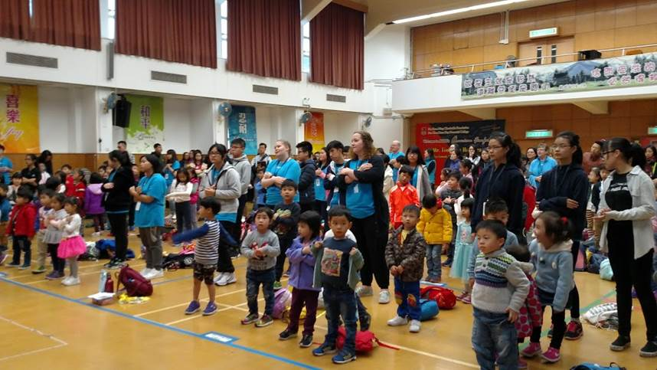
This photo from Adam’s last trip to Hong Kong shows a VBS session in action.

THANK YOU very much for all your prayers and for your concern while I was in the hospital. Thank you for the many cards and well wishes. I was overwhelmed.
God bless you, Lois Brant

THANKS to those who served as editors for my “History/Happenings of Trinity 2017. Copies of my ‘photo essay’ of 2017 were made available on Sunday, January 21st. If you didn’t get a copy, let me know and I will get one to you. I will laminate a final copy and insert it into a three ring binder for the church library. I hope it will serve as a history of Trinity as each year’s copy is added.
Lynn Menz

VOLUNTEER OPPORTUNITIES
College Student Valentine Boxes!
It’s that time again for our Trinity Lutheran members to let the college students know that we are thinking of them. This tradition was started at Trinity in 1994!
You are invited to bring yummy treats to send to the college students. It will make their day!
Bring microwave popcorn, candy, gum, snack mixes and anything that a college student’s tummy would enjoy. Bring by February 4 so they can receive a box of goodies before Valentine’s Day.
Please send me the name and address of Trinity college students. This is very important as we don’t want to miss anyone. Thank you for your help. The boxes will be assembled after church on
February 4. Sponsored this year by LWML.
Ellie Menz ellie@iowadistrictwest.org 515-370-1159

Blast from the past….
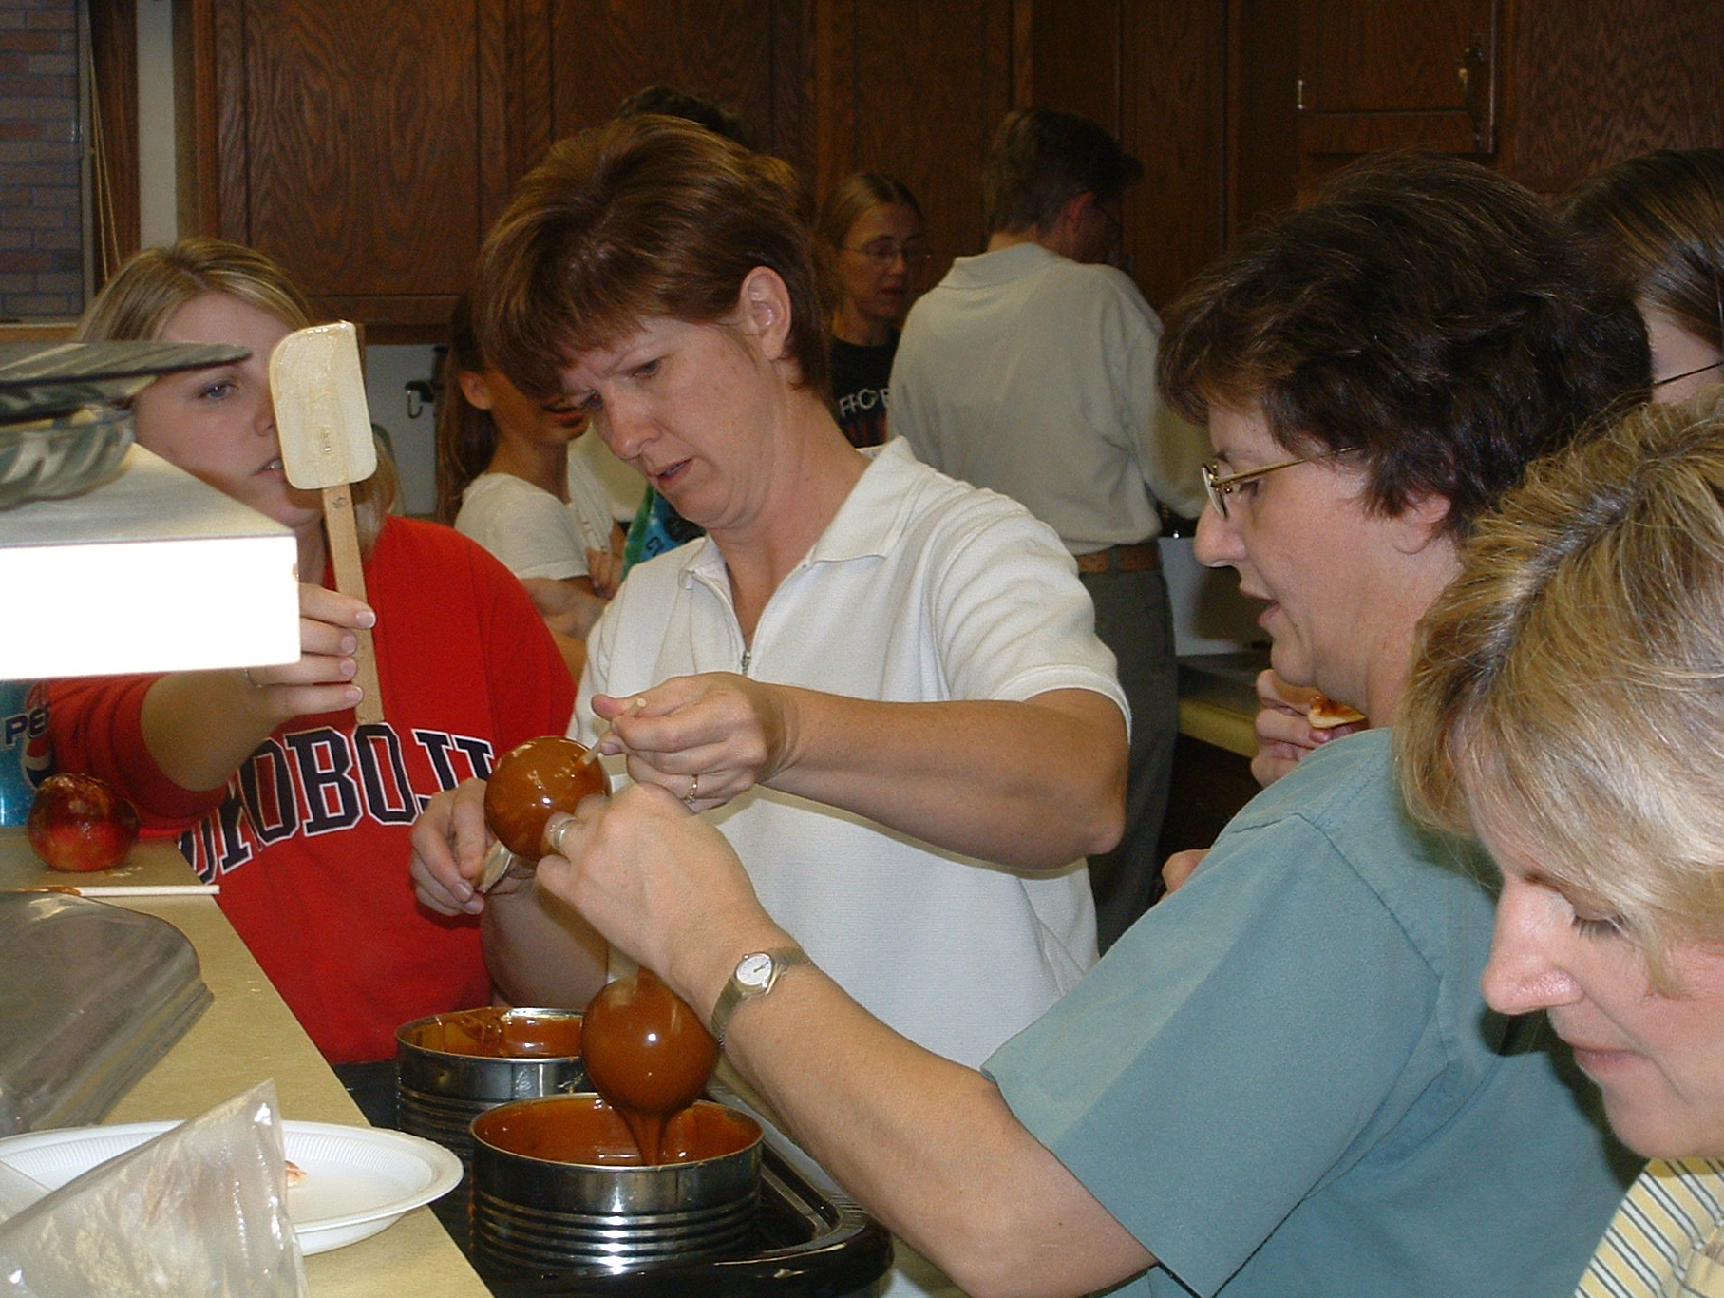

Who do you know in this 1953 Trinity confirmation class? Playing in the caramel!

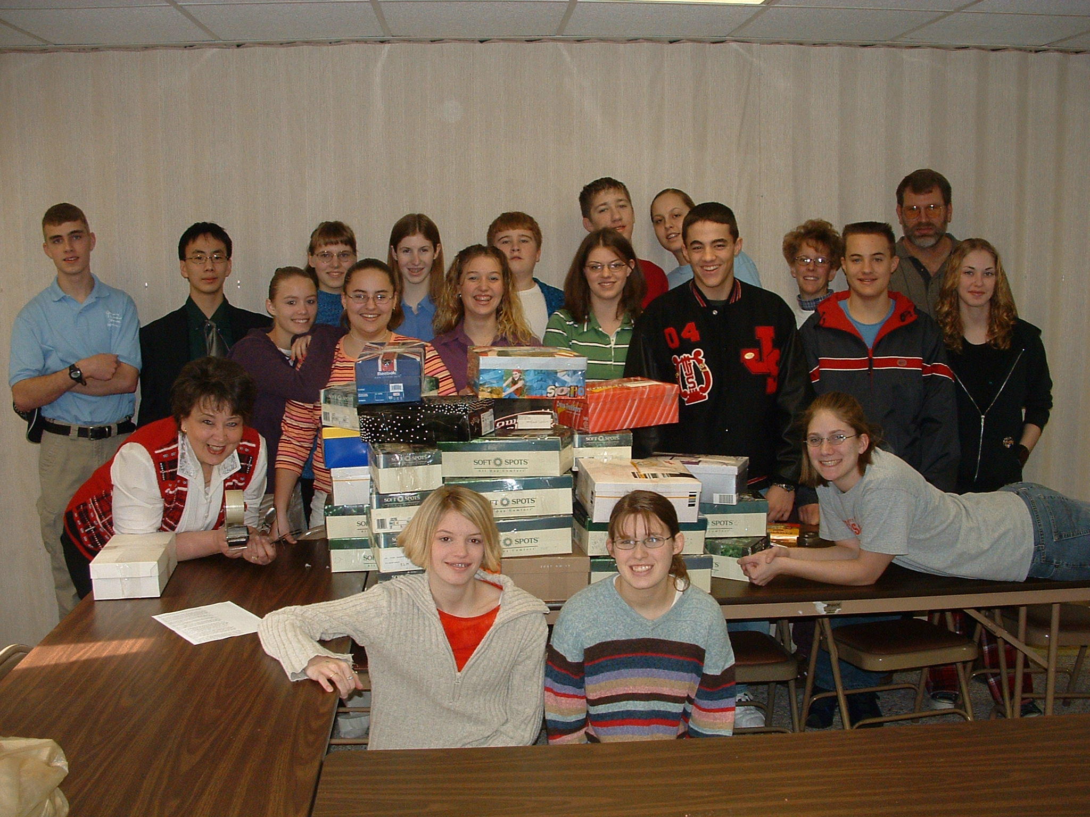
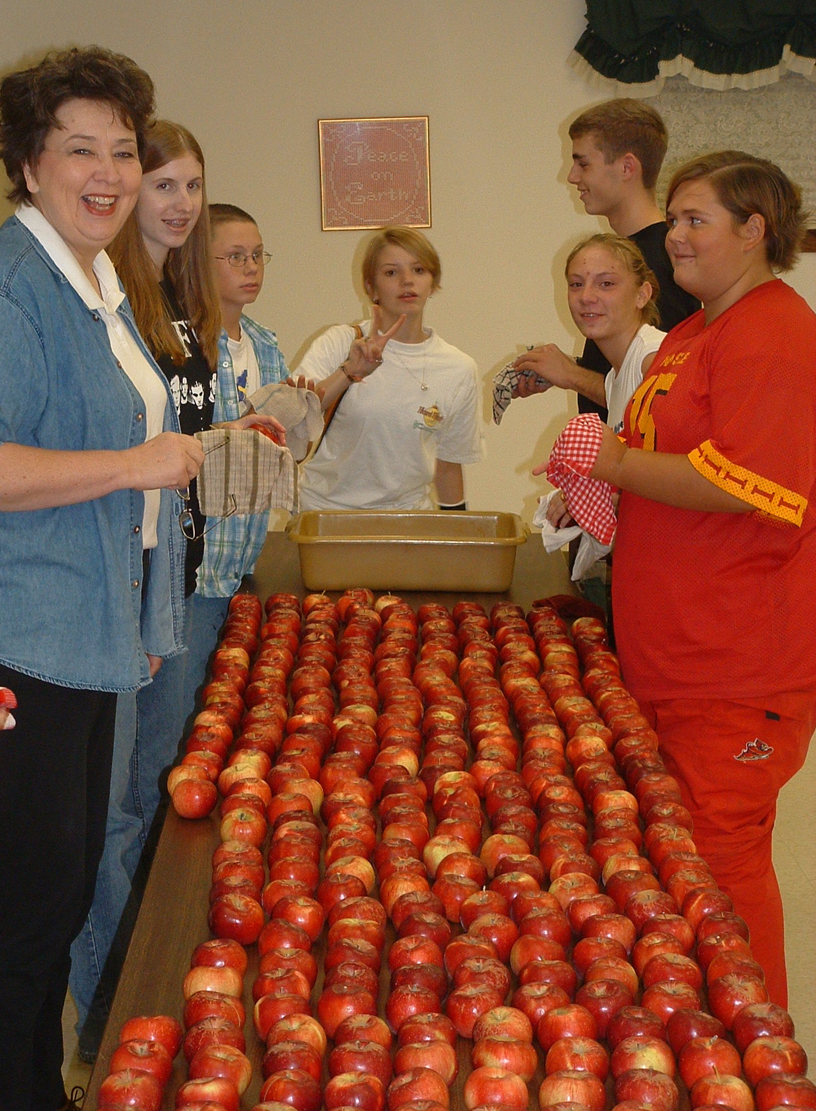
Remember when….

Who are these
Youngsters and
their young
leader??

