St. Peter Lutheran Church Faith Lutheran Church

Deshler, Nebraska Hebron, Nebraska

**Printed Order of Service**

**May 31, 2020**

Day of Pentecost

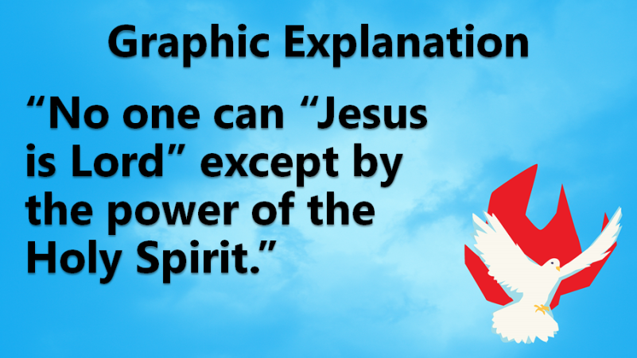 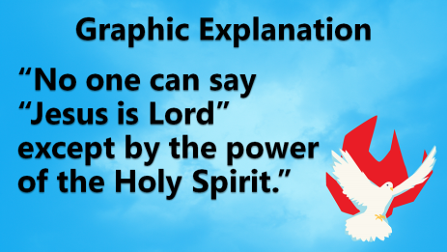 GRAPHIC EXPLANATION

WELCOME

OPENING PRAYER

OPENING HYMN "O Holy Spirit, Enter In” LSB 913

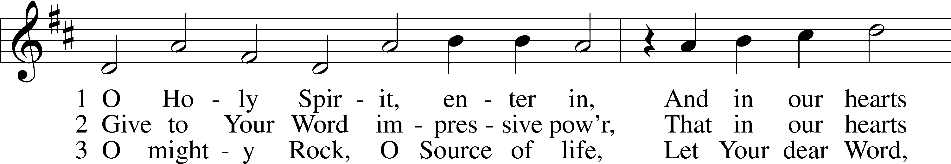

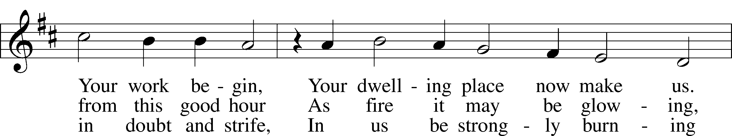

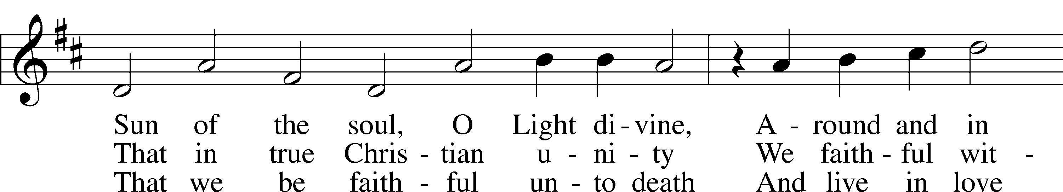

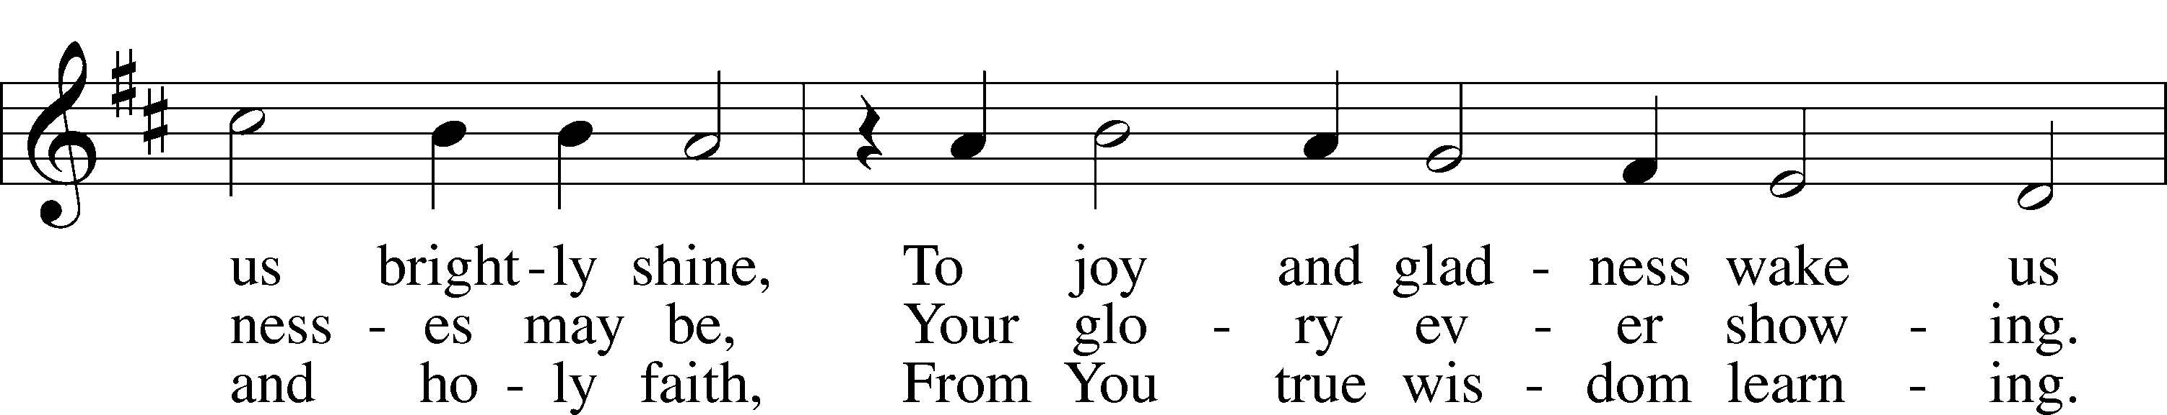

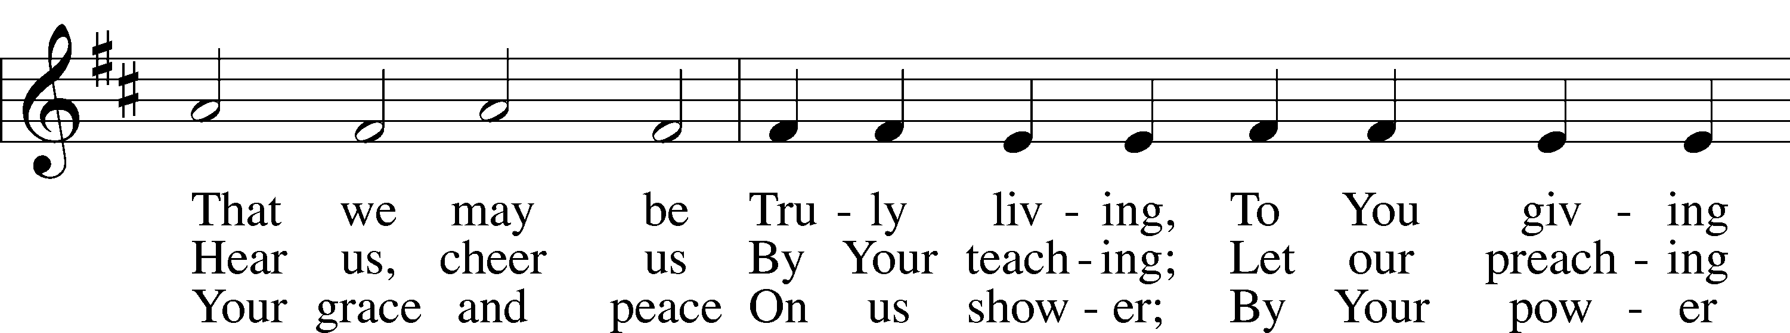

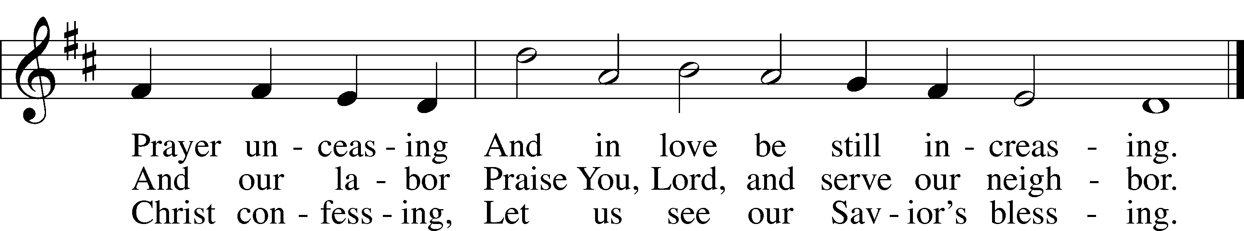

INVOCATION

P In the name of the Father and of the T Son and of the Holy Spirit.

C **Amen.**

CONFESSION AND ABSOLUTION

HYMN “Holy Spirit, Light Divine" LSB 496

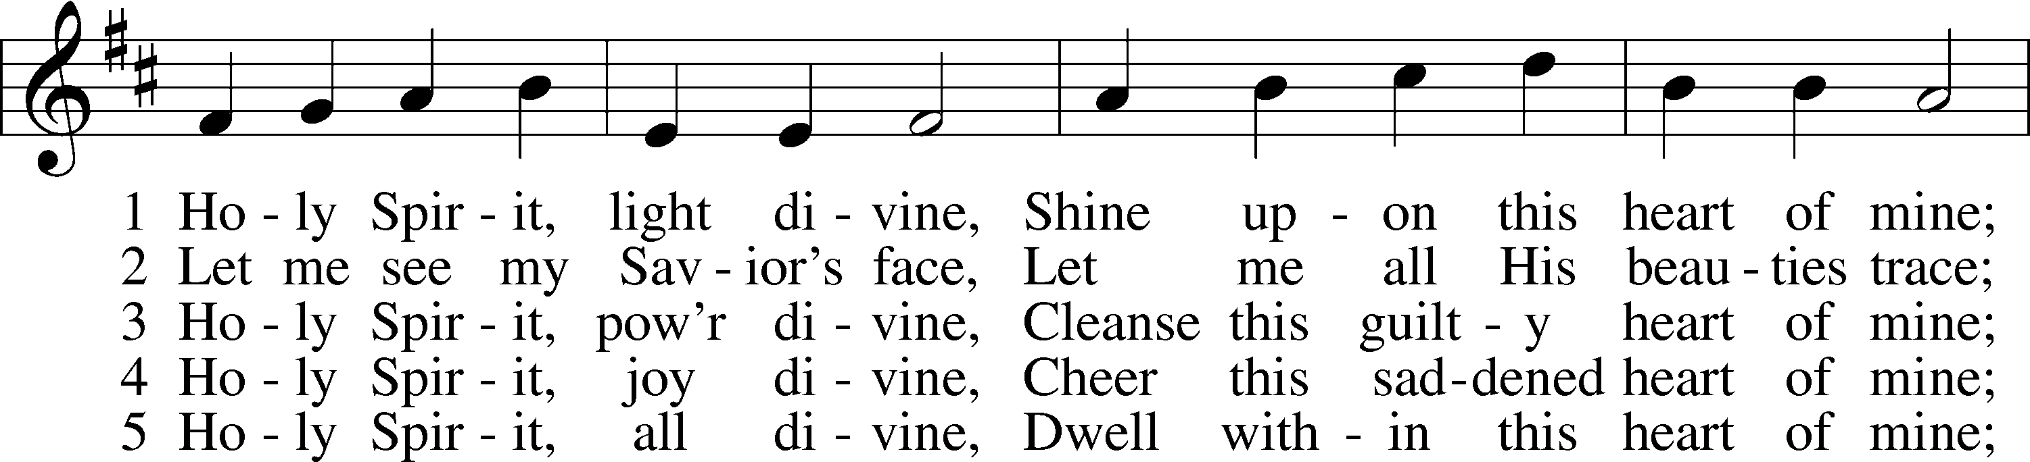

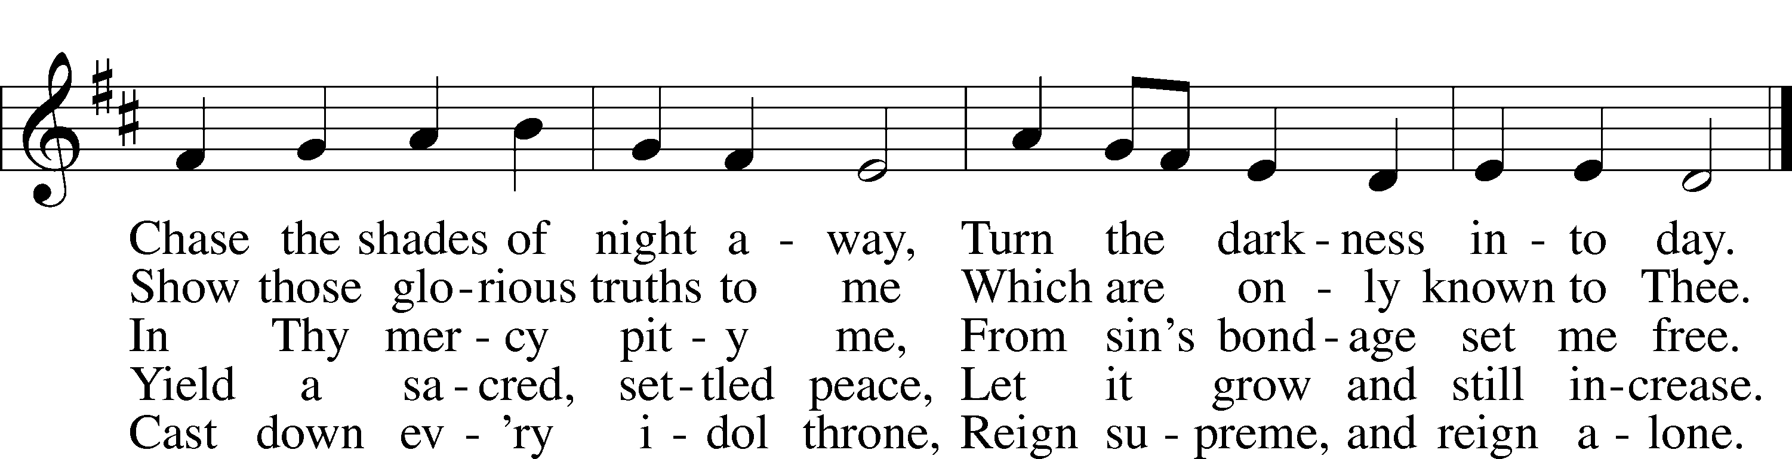

OLD TESTAMENT: Numbers 11:24-30

24Moses went out and told the people the words of the Lord. And he gathered seventy men of the elders of the people and placed them around the tent. 25Then the Lord came down in the cloud and spoke to him, and took some of the Spirit that was on him and put it on the seventy elders. And as soon as the Spirit rested on them, they prophesied. But they did not continue doing it.

26Now two men remained in the camp, one named Eldad, and the other named Medad, and the Spirit rested on them. They were among those registered, but they had not gone out to the tent, and so they prophesied in the camp. 27And a young man ran and told Moses, “Eldad and Medad are prophesying in the camp.” 28And Joshua the son of Nun, the assistant of Moses from his youth, said, “My lord Moses, stop them.” 29But Moses said to him, “Are you jealous for my sake? Would that all the Lord’s people were prophets, that the Lord would put his Spirit on them!” 30And Moses and the elders of Israel returned to the camp.

P This is the Word of the Lord.

C **Thanks be to God.**

EPISTLE: ACTS 2:1-21

1When the day of Pentecost arrived, they were all together in one place. 2And suddenly there came from heaven a sound like a mighty rushing wind, and it filled the entire house where they were sitting. 3And divided tongues as of fire appeared to them and rested on each one of them. 4And they were all filled with the Holy Spirit and began to speak in other tongues as the Spirit gave them utterance.

5Now there were dwelling in Jerusalem Jews, devout men from every nation under heaven. 6And at this sound the multitude came together, and they were bewildered, because each one was hearing them speak in his own language. 7And they were amazed and astonished, saying, “Are not all these who are speaking Galileans? 8And how is it that we hear, each of us in his own native language? 9Parthians and Medes and Elamites and residents of Mesopotamia, Judea and Cappadocia, Pontus and Asia, 10Phrygia and Pamphylia, Egypt and the parts of Libya belonging to Cyrene, and visitors from Rome, 11both Jews and proselytes, Cretans and Arabians—we hear them telling in our own tongues the mighty works of God.” 12And all were amazed and perplexed, saying to one another, “What does this mean?” 13But others mocking said, “They are filled with new wine.”

14But Peter, standing with the eleven, lifted up his voice and addressed them, “Men of Judea and all who dwell in Jerusalem, let this be known to you, and give ear to my words. 15For these men are not drunk, as you suppose, since it is only the third hour of the day. 16But this is what was uttered through the prophet Joel:

17“‘And in the last days it shall be, God declares,  
that I will pour out my Spirit on all flesh,  
 and your sons and your daughters shall prophesy,  
and your young men shall see visions,  
 and your old men shall dream dreams;  
18even on my male servants and female servants  
 in those days I will pour out my Spirit, and they shall prophesy.  
19And I will show wonders in the heavens above  
 and signs on the earth below,  
 blood, and fire, and vapor of smoke;  
20the sun shall be turned to darkness  
 and the moon to blood,  
 before the day of the Lord comes, the great and magnificent day.  
21And it shall come to pass that everyone who calls upon the name of the Lord shall be saved.’”

P This is the Word of the Lord.

C **Thanks be to God.**

HOLY GOSPEL: JOHN 7:37-39

P The Holy Gospel according to St. John, the seventh chapter.

C **Glory to You, O Lord.**

37On the last day of the feast, the great day, Jesus stood up and cried out, “If anyone thirsts, let him come to me and drink. 38Whoever believes in me, as the Scripture has said, ‘Out of his heart will flow rivers of living water.’” 39Now this he said about the Spirit, whom those who believed in him were to receive, for as yet the Spirit had not been given, because Jesus was not yet glorified.

P This is the Gospel of the Lord.

C **Praise to You, O Christ.**

APOSTLES’ CREED

**I believe in God, the Father Almighty, maker of heaven and earth.**  
  
**And in Jesus Christ, His only Son, our Lord, who was conceived by the Holy Spirit, born of the virgin Mary, suffered under Pontius Pilate, was crucified, died and was buried. He descended into hell. The third day He rose again from the dead. He ascended into heaven and sits at the right hand of God the Father Almighty. From thence He will come to judge the living and the dead.**  
  
**I believe in the Holy Spirit, the holy Christian Church, the communion of saints, the forgiveness of sins,**  
**the resurrection of the body, and the life** T**everlasting. Amen.**

HYMN OF THE DAY “Spread the Reign of God the Lord" LSB 830

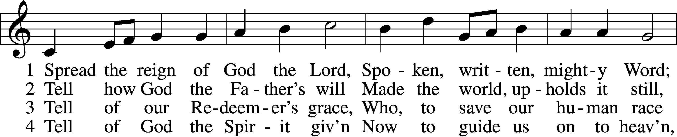

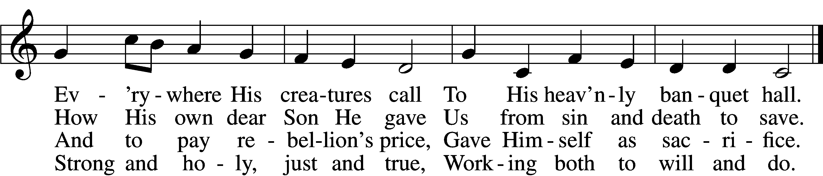

5. Enter, mighty Word, the field; Ripe the promise of its yield.  
 But the reapers, oh, how few For the work there is to do!

6. Lord of harvest, great and kind, Rouse to action heart and mind;  
 Let the gath’ring nations all See Your light and heed Your call.

SERMON **“Complete in Christ — Laboring for Christ”**

Colossians 1:24-29

Prayer of the Church

LORD'S PRAYER

**Our Father who art in heaven,  
 hallowed be Thy name,  
 Thy kingdom come,  
 Thy will be done on earth as it is in heaven;  
 give us this day our daily bread;  
 and forgive us our trespasses as we forgive those who trespass against us;  
 and lead us not into temptation,  
 but deliver us from evil.  
 For Thine is the kingdom and the power and the glory forever and ever. Amen.**

BENEDICTION

P The Lord bless you and keep you.

The Lord make His face shine on you and be gracious to you.

The Lord look upon you with favor and T give you peace.

C **Amen.**

CLOSING HYMN “Creator Spirit, by Whose Aid” LSB 500

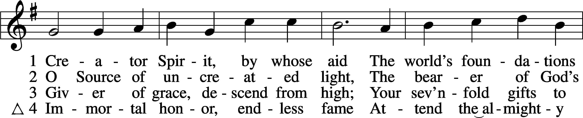

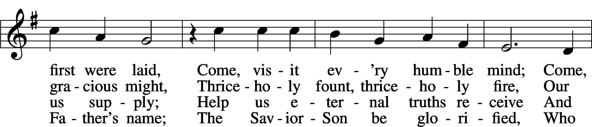

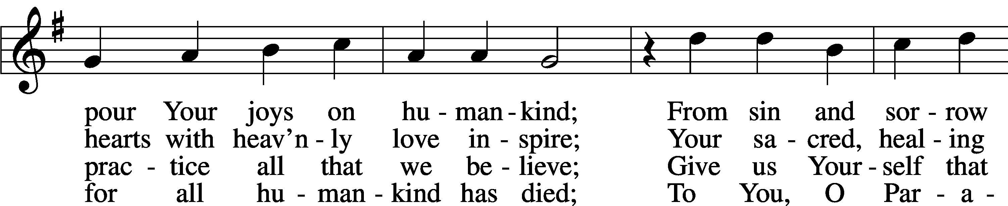

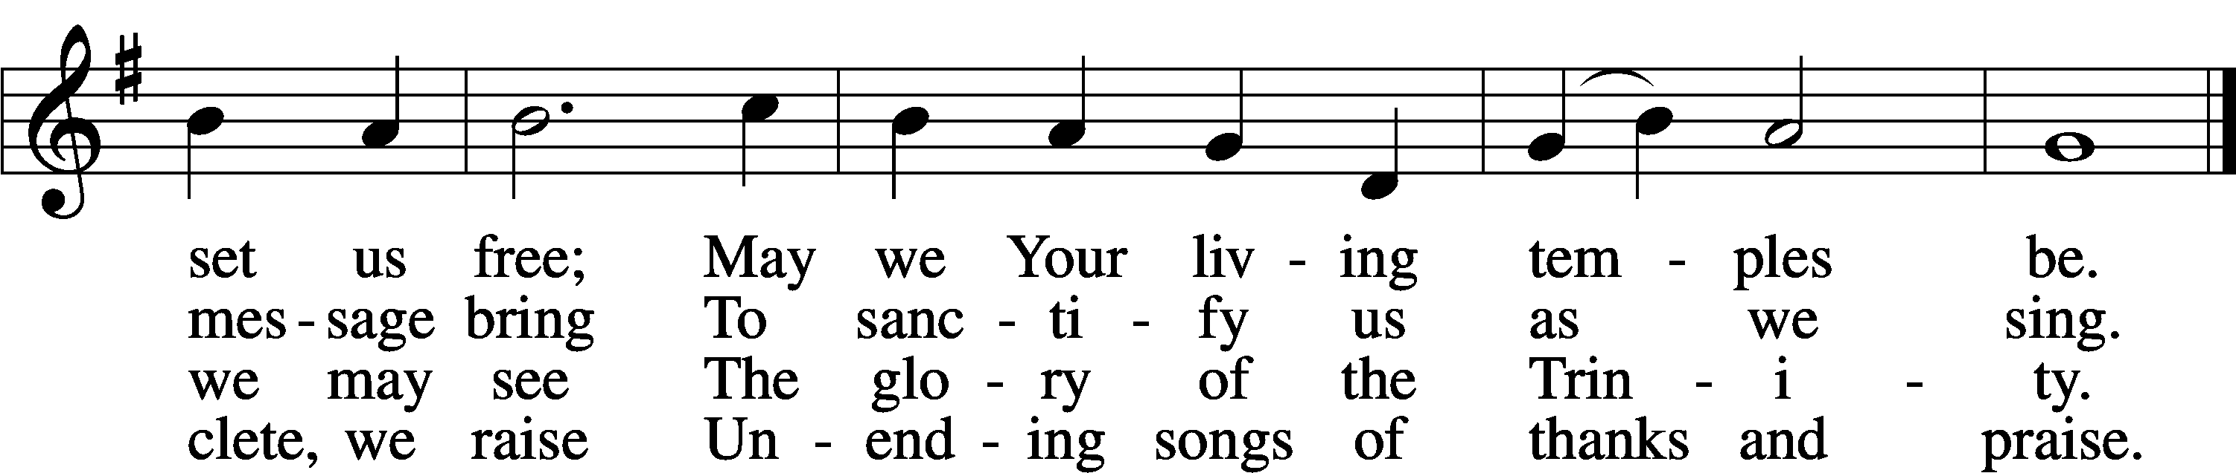

ACKNOWLEDGMENTS: Scripture quotations are from the ESV® Bible (The Holy Bible, English Standard Version®), copyright © 2001 by Crossway, a publishing ministry of Good News Publishers. Used by permission. All rights reserved. Created by Lutheran Service Builder © 2018 Concordia Publishing House.

**Sermon Outline - May 31, 2020**

“Complete in Christ – Laboring for Jesus”

Colossians 1:24-29

1. Jesus’ ________________________

Paul’s & ours

2. _______________ the ________________

Christ in you

3. ________________ _______________________

Paul’s goal

**Prayer Page - May 31, 2020**



*Our Mission: Worship - Community - Mission*

**Thanksgiving:**

Grant Joseph Mueller (new grandson for Gene & Patty Mueller)

**Hospitalized:**

Rose Plock

Patti Mueller…

**For peace, patience & protection as they wait to get their adopted daughter, Ruby, from China:**

Brett & Jessica (Betten) Brown and their family…

**Ongoing health concerns:**

Chase Laaker (battling seizures)

Cammie (Cahill) Freitag

Allen Schardt

Doug Grupe

Kylie Noojin (daughter-in-law of John & Tammy)

Lynnis Eitzman (battling cancer)

Rose Plock (physical therapy)

Whitney Watson (breast cancer - Rod & Cindy’s daughter-in-law)

Aaron Fiet (Dale Endorf’s brother-in-law)

Robin Sedlachek

Marlene Weideman

Donna Genung

Bridget Schnuelle (daughter of Brenda Betten)…

**Birthdays this week:**

Grant Hansen, Maddyn Harms, Virgin Ralston, Ivy Harms, Eugene Mueller…

**Baptismal birthdays this week:**

Payton Bauer, Duncan Finke, Shamlynn Francik, Lacey Schmidt…

**Wedding anniversaries this week:**

Rod & Cindy Watson (47 years on June 1)

Harvey & Marlene Weideman (64 years on June 2)

Robert & Lorna Ludwig (60 years on June 5)…

▪ **Prayer requests from our missionaries, Rev. Dale and Suzanne Kaster:**  Pray that the Holy Spirit would open up hearts to the Gospel in the Czech Republic…

▪ **That God would use** **each of us** at St. Peter to encourage one another and to love those we come into contact with...

▪ **For Deshler Lutheran School:** That our staff, families, and congregation would focus on ”JOY:FULLY SHARING JESUS!”…

▪ **For our missionaries:** The hundreds of men and women serving overseas bearing witness, showing mercy and living life together in and by our Lord, Jesus Christ, with others around the world…

▪ **For our country; President Donald Trump;** all leaders; our service men and women; Chaplains; for peace, guidance & safety in our land…

▪ ***Our members in service****:*Joseph Dunlap…

▪ ***Relatives/friends in service or active service:***Jacob Noojin; Mark & Suzanne Baden (children of Marvin & Sharon); Eric Carbo; Peter Magnus (nephew of John & Tammy Noojin); Brent McCoy; Brandon Lee (nephew of Galen & Melissa Sasse); Isaac Ralston (grandson of Virgil & Lola); Brian Loontjer; TJ & Emily Wiebe, (brother & sister-in-law of Jocelyn Berggren)...

▪ **For Hope Pregnancy Center:** That God would bless this ministry as it reaches out to families in our local area and defends life...

▪ **For our members in assisted living, nursing home & care centers:**

Mary Loontjer, Meadowlark Heights, Deshler

Larry Schardt, Blue Valley Care Home, Hebron

Sandra Meyer, Region 5 Group Homes, Hebron

Roger Finke, Lakeview Assisted Living, Firth

Nick Bartling, Life Care Center of Elkhorn, Omaha…

PRAYER PAGE

WEEK OF MAY 31, 2020

**Hospitalized:**

Mary Ehlers

**Health Issues:**

Phil Harders (Nicholas Elting’s father-in-law) recently discovered cancer, having surgery soon

Marla Braithwait

Cammie Frietag

Pastor Richard Gudgel

**Announcements - May 31, 2020**

**WELCOME!** We pray that God will bless you through the power of His Word. If you are a guest or visitor, we are so thankful you joined us. If you would like to hear more about Jesus or our congregations at St. Peter and Faith, please contact Pastor Brian. A **Live Stream** of the service takes place at 9:45 a.m. on St. Peter’s Facebook and YouTube pages. **Full printed services and announcements** are available for you.

**Videos of Services** - A DVD of the service is available at St. Peter in the white basket on the mailbox shelf around 10:00 a.m. on the following Thursday. All videos are available for anyone to take home, watch, and return. Please visit **stpeterdeshler.org** for updated news and events.

SCREEN GRAPHIC EXPLANATION

No one can say “Jesus is Lord” except by the power of the Holy Spirit

**Memory Verse of the Week**

“But the LORD said to Samuel, “Do not consider his appearance or his height, for I have rejected him. The LORD does not look at the things man looks at. Man looks at the outward appearance, but the LORD looks at the heart.” (1 Samuel 16:7)

**WEEKLY DEVOTION** - Email your request to Pastor Brian if you would like to receive by email weekly devotions based on the Memory Verse of the Week.

 St. Peter Announcements

|  |  |  |  |
| --- | --- | --- | --- |
| **OFFERINGS** | **Received** | **Needed Weekly** | **Year to Date** |
| General Fund | 7,215.00 | 6,350.52 | 98,575.61 |
| General Fund - Direct Deposit | 975.00 |  | 16,475.00 |
| General Fund - Online |  |  | 666.87 |
| NE District/Missions | 120.00 |  | 1,330.00 |
| Special Mission (Kasters) |  |  | 470.00 |
| Thrivent Choice Dollars |  |  | 895.00 |
| Cemetery Fund |  |  | 130.00 |

**JUNE NEWSLETTER**

The June newsletters have been placed in the mailboxes, except for those who have requested email delivery.

**FOOD MINISTRY**

We are offering a ministry of providing and delivering meals to people going through major changes in life (major illness, death in the family, new baby, loss of a job, etc.) This is a way to serve, not only our members, but people in the community as well. If you would like more information or to sign up to be on the Food Ministry Team, please contact Shamlynn Francik at (402) 710-6635 or s*hamlynn.francik@gmail.com.* If you know of people at church or in the community that we should reach out to, (to possibly deliver food to), please contact Shamlynn.

Direct Deposit Information

Automatic withdrawal is available as a way to give your offerings here at St. Peter. Signup forms are available in the Narthex, or if requested can be mailed or emailed to you. If you have any questions, please contact our treasurer, Sara Kresser, at 402-984-2453 or [*fourleafclover9@hotmail.com*](mailto:fourleafclover9@hotmail.com)

Giving Online Information

You may now have the opportunity to give online using a debit or credit card. You can click on the “Give” tab on our website, [*www.stpeterdeshler.org*](http://www.stpeterdeshler.org), then click on “Click to Give” and there will be a form to fill out.

**TEXT ALERTS**

If you would like to be put on a text alert list in regard to church notices, please email Pastor Brian the following information: *Name, Cell Phone Number* (include area code), *Cell Phone Carrier* (e.g. Verizon, US Cellular). Pastor’s email is [*pastorbfrancik@gmail.com*](mailto:pastorbfrancik@gmail.com)

**ARE YOU ON FACEBOOK?**

Check out the St. Peter and Deshler Lutheran School Facebook pages, like, and follow them to get updates on your feed. We are continuing to find ways to encourage the body of Christ in the technology world.

**AVAILABLE IN THE NARTHEX**

*Updated COVID-19 Action Plan,* Weekly Encouragement Devotions, *My Devotions,* *Portals of Prayer,* Text Alert Signup Sheets, Spring 2020 *LifeDate*, Free greeting cards, etc.

**BEST CHOICE UPC’S**

You can help Deshler Lutheran School earn free money by clipping the UPC labels from Best Choice products. Clip now and save the labels for collection in December.



Announcements

Thanks to those that have been mowing the church lawn thus far! Anyone interested in mowing this spring and summer can sign up on a calendar on the back table at church. Any questions, please contact Brad or Dick.

Faith Quarterly Voters Meeting - Tuesday, June 2 at 5:30 p.m.

|  |  |  |
| --- | --- | --- |
| **May 31** | **Serving at St. Peter** | **Serving at Faith** |
| Pastor | Brian Francik | Brian Francik |
| Elders | Andy Schmidt, Jon Peters |  |
| Organist | Joyce Schmidt | Cheryl Walsh |
| Flowers | Jan Hornbostel |  |
| Ushers |  |  |
| Screen | Sharon Houtwed |  |
| Livestream | Shamlynn Francik |  |
| Sound | Steve Harms |  |

St. Peter & Faith Calendars

**Sun. May 31 8:30 AM Worship Service @ Faith**

**9:45 AM Worship Service @ St. Peter (Live Stream also)**

Tue., June 2 5:30 PM Quarterly Voters Meeting @ Faith

7:00 PM Live Stream Bible Study

Wed., June 3 7:00 PM Live Stream Prayer Time

**Sun., June 7 8:30 AM Worship Service @ Faith 9:45 AM Worship Service @ St. Peter (Live Stream also)**

The St. Peter worship services, Bible study and prayer time are live-streamed via the St. Peter Facebook page and YouTube channel.

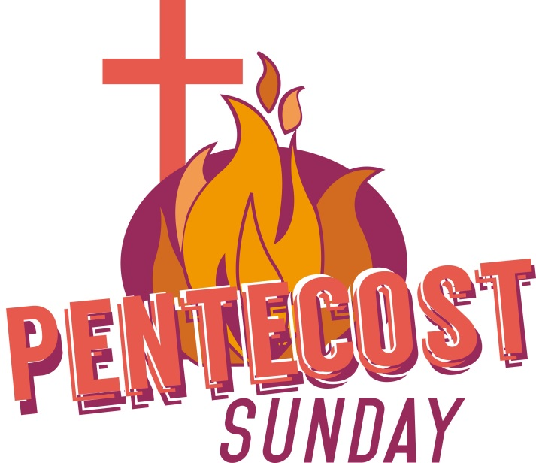

|  |
| --- |
| **Faith Lutheran Church**  420 Charles Road, Hebron, NE 68370  See St. Peter info below for Pastor’s Contact Info |

|  |  |
| --- | --- |
| **St. Peter Lutheran Church**  Church Office: 402-365-4341  Pastor Brian Francik Home: 402-365-4217  Cell/Email: 402-710-6679 [*pastorbfrancik@gmail.com*](mailto:pastorbfrancik@gmail.com)  Secretary Email: [*stpeterdeshler@gmail.com*](mailto:stpeterdeshler@gmail.com%20)  Street Address: 400 E. Hebron Ave.  Mailing Address: PO Box 69 Deshler, NE 68340  Website: *stpeterdeshler.org* | **Deshler Lutheran School**  School: 402-365-7858  [School Email:](mailto:%20School%20Email:%20) *deshlerluth@gpcom.net*  Street Address: 509 E. Hebron Ave.  Mailing Address: PO Box 340 Deshler, NE 68340  Mr. Todd Voss, Administrator  Todd Voss Cell: 402-720-5590  Website: *www.DeshlerLuth.org* |
| The Lutheran Church - Missouri Synod (LCMS) | |