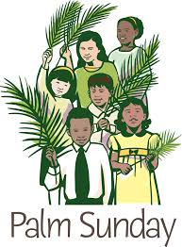
Palm Sunday Brunch
Sunday, April 9th
10:15 a.m. - Noon
Mission Trip Youth will serve and help clean up, but additional help will be needed!

3 Adults Needed
1. _________________________________
2. __________________________________
3. __________________________________

Youth Sign Up:
1. ___Matthew B._____________________
2. ___Hailee J.________________________
3. ___Jacob A.________________________
4.___Victoria L._______________________

