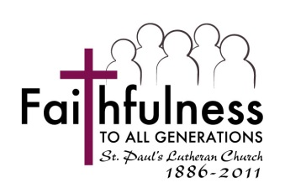
St. Paul’s Lutheran Church FOUNDATION
2020 Scholarship Application
Student Information
Student Name
Student Street Address
City, State, Zip Code
Phone
E-Mail Address
Parent/Guardian Name
Adult Sponsor Name*
*Adult sponsor need not be a relative of the applicant but must be a member of St. Paul’s as of 01Jul20. Adult sponsors are not required for adult applicants, nor for applicants with a parent member(s) of St. Paul’s. All scholarship applicants must be members of St. Paul’s as of 01Jul20.
Technical College/College/University Information
Name of School
Street Address
City, State, Zip Code
Phone
Web Address
Name of Degree Program

Essay
Please attach to this application a 300 word essay answering the question:
What does it mean to you to be a member of St. Paul’s congregation?

Submission
Please submit your completed essay and this application form by July 13th, 2020 to:
St. Paul’s Foundation
320 West Avenue
Red Wing, Minnesota 55066
St. Paul’s Foundation scholarships are open to students enrolled in accredited, post-secondary degree programs as determined by the Foundation Board of Directors. It is hoped that applicants be actively engaged in the life and ministry of St. Paul’s Church. Scholarship award winners will be decided by the Board and announced by July 31, 2020.
Limit one award per applicant. This scholarship program is one of equal opportunity.
Some of the information on this form may be considered of a confidential nature and will be treated as such by the Foundation.

