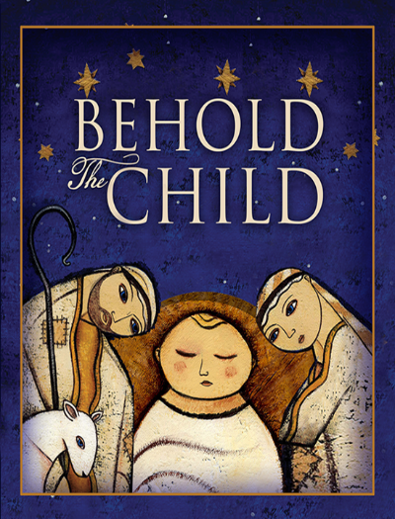**God’s own Son is born a child;**

**God the Father is reconciled.**

What peace is found in those words. As the Church draws nigh to the Nativity of Our Lord, many also draw nigh to the harsh reality of broken families and friendships. The sting of estrangement intensifies in this season as many delight in family gatherings—a delight that is glaringly absent for others.

We long for reconciliation—a marriage healed, the return of a prodigal child, the open arms of a formerly harsh parent. Advent is just the season for reconciliation. It is a penitential season, calling us to examine ourselves, acknowledge our sin with contrition, and trust that our sin is forgiven for the sake of Christ. Such self-examination reveals that the fault for our broken relationships is not one-sided. The sin visited upon me by another has driven a wedge between us, but so has my sin. Part of the distance between me and others is due to my sinful actions—my sinful refusal to forgive, my sinful pride that will not admit my fault, my sinful contentment with a cold shoulder.

Advent calls us to repent of our divisions. Advent calls us to rejoice in reconciliation. Though you can forgive another even when he refuses to acknowledge his fault, reconciliation is found when both parties are willing to admit their culpability, seek forgiveness, and amend their ways. That can seem so difficult. It is hard enough for one sinner to confess his sin and trust that the Lord purges it from his life. How much more challenging it is for two sinners to do so. Yet that is exactly what Christ works among and within us. He grants us confidence in His forgiveness so that we forgive one another, receive one another’s forgiveness, and are thus reconciled.

Reconciliation with some remains ever elusive. We hunger for it; we pray for it. Yet the distance remains. When a parent apologizes to a child so that they embrace for the first time in decades, we rightly rejoice. When our longing is not realized, sorrow results.

The only consolation amid such sorrow is the certainty of your reconciliation to the Father. It is certain because it is not dependent upon sinners humbling themselves in repentance. It is certain because it is dependent upon the sinless Son of God humbling Himself to take on human flesh and be born of a virgin.

**2019 Contribution Status Report**

In fiscal year 2019, St. Paul’s is in better shape than we’ve been in a long time. Though we have not always met our monthly budget in contributions, we have spent a total of $4,789.67 less than we have received overall. Praise God for growth, security, and the ability to bless others with our abundance.

|  |  |  |
| --- | --- | --- |
| **Month** | **Monthly Contribution Received** | **Monthly Budget Distributed** |
| February | $6,586.00 | $9,038.97 |
| March | $12,839.00 | $9,277.98 |
| April | $12,831.00 | $9,970.39 |
| May | $9,183.43 | $9,820.47 |
| June | $9,944.00 | $9,665.34 |
| July | $10,540.00 | $8,541.52 |
| August | $7,185.00 | $8,266.34 |
| September | $10,277.12 | $10,014.87 |
| **Annual Total** | $79,385.55 | $74,595.88 |

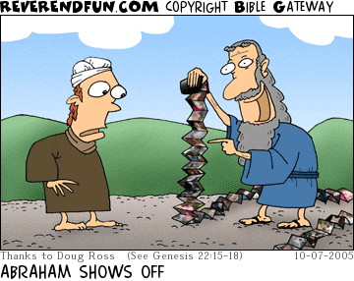

**~~~~abide** v.

There are some words in our English vocabulary that have fallen by the wayside. They aren’t used quite so often, and sometimes we’re worse off for it when there isn’t a suitable replacement. How often do you hear the word *abide* in ordinary language on a regular basis? I’m betting not very much. We have a general idea of what it might entail, but the full meaning is lost on us when it’s not part of our everyday conversation. And for children who have perhaps never heard it, well, now it’s just a word they’re likely to gloss over and skip!

But wait—it’s too good to miss. God tells us that we are to abide in His Word, and this sounds like something to consider. Here is what our Lord says in John 8:

So Jesus said to the Jews who had believed in Him, “If you abide in My word, you are truly My disciples, and you will know the truth, and the truth will set you free.” (John 8:31–32)

One definition of *abide* that might help shed some light here is “to accept or act in accordance with.” Sure! We certainly want to act in accordance with God’s Word. Of course, that is easier said than done. Plus, we Lutherans know that Scripture is more than just a rule book. Perhaps there is a better definition to share.

How about “to dwell or reside” in God’s Word? Now this—this is how we are to define this beautiful word. We know from other parts of Scripture that God desires for us to dwell, reside, live in His Word. His Word is life, so we breathe it in, stay in it, endure through it, persevere with it. We remain in His Word, no matter the circumstances. We *abide* in God’s Word.

 Of course, parents and grandparents like us might see this as a tall order. How can we abide in God’s Word—truly soak it in—when it feels like there is so little time in the day? Whether parents work outside of the home, stay at home with their children, or something in between, it can feel like being in the Word is just another thing *to do*. This is the opposite of the rest and dwelling and living and breathing of His Word that God desires for us.

So what does that look like?

Living—abiding—in God’s Word looks like your mealtime prayers. Your daily forgiveness of your child’s mistakes. And, yes, your confessing to your children that you, too, make mistakes and need their forgiveness. It’s talking to your children about Christ’s salvation, making it part of everyday conversation. It’s not thinking twice when Sunday comes and our Lord’s gifts are waiting in the pulpit and at the altar—we abide in this Word, and we desire to hear it regularly. It’s serving yet another meal and cleaning up yet another mess because God has made it known in His Word that raising up little ones is pleasing to Him. It’s serving your closest neighbor, which He frees us up to do.

See? You’re already doing it! You may not use the word *abide* in conversation each day, but you sure are living it. Living in it. Abiding in God’s Word. You are His disciple, and you know the truth, and it has made you free.

**Sunday School Schedule**

Mark your calendars! Here are the important upcoming Sunday school dates for the rest of the year!



|  |  |
| --- | --- |
| November 3rd, 2019 | All Saints Day - Children Sing in 10:30 church service after classes. |
| November 24th, 2019 | Christmas program practice. |
| December 1st, 2019 | Christmas program practice. |
| December 15th, 2019 | Christmas Musical Program - Children sing at 10:30.  Class time will be a dress rehearsal. |
| December 22nd and 29th, 2019 | No Classes - Christmas Break |

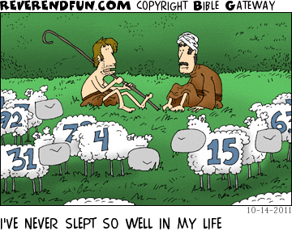

**Lcms Stewardship article** November 2019

St. Paul wrote to the Church of Christ in Corinth: “Each one must give as he has decided in his heart, not reluctantly or under compulsion, for God loves a cheerful giver” (2 Cor 9:7). *God loves a cheerful giver.* But who is a cheerful giver?

Abel was. By faith, Abel gave the firstborn of his flock, and it was acceptable in God’s sight. Abraham was. By faith, Abraham prepared cakes and a tender choice calf for God and entertained angels unaware. So also were David and Solomon. By faith, David would not make a sacrifice to God that cost him nothing, so he paid Araunah his due. By faith, Solomon built a house for God, where his name would dwell and thereby where He would dwell to be Israel’s God and they His people.

What more shall I say? For time would fail me to tell of all those who gave not simply for the joy of giving but for the joy of knowing the One to whom they gave.

So also our Lord, who for the joy set before Him, gave everything, yes, even His life, enduring the cross and scorning its shame. He gave to the shedding of His blood, willingly and resolutely setting His face toward Jerusalem to die for the life of the world. Though He was rich in every way, He became poor, so that by His poverty we might be rich beyond measure.

So then, let us – like Abel and Abraham, like David and Solomon, and even like our Lord Jesus Christ – give cheerfully to God for the work of His kingdom in our midst. Like them, let us decide in our heart – for the joy set before us – the joy of knowing the One to whom we give is the One who gives us all good things.



**November Mission Project**

For our November and December mission project, we will be a drop off location for Toys for Tots. Collection boxes will be delivered on Friday, November 8 and picked up on the morning of Monday, December 16. During that period we can collect all sorts of new toys of kids of all ages. These toys will be donated to needy children in our area. When you’re out shopping this year, consider picking up an extra toy or two so we can spread the love of Christ at Christmas!

**German Christmas Dinner**

Join the St. Paul’s Youth and the American Heritage Girls for the annual German Christmas Dinner! This year, the dinner will take place on Saturday, December 7th from 9am to 6pm in the church basement. We will be serving an assortment of German delicacies: German potato salad, brats, BBQ, and an assortment of delicious desserts. The American Heritage Girls will have a table of homemade desserts and gift items to sell as well!

Come help support our groups and enjoy a delicious dinner! Funds raised will support Youth events and the AHG troop activities. Volunteers are needed to cook, serve, bake, even make some crafty Christmas gifts for the kids to sell! Call Jenn Milner or Corinne Johnson if you are interested in helping out. We’ve got a job for everyone.

**Decorating the tree**

Join us on the first Sunday in Advent (December 1st) as we decorate the Christmas tree. Everyone will have the chance to come up to the tree during the service and put one of the church’s ornaments or a special ornament of yours up on the tree.

**creation: Extraterrestrial Life**

Rev. Erik Rottmann, Trinity Lutheran, Cole Camp, MO

*Be fruitful and multiply and fill the earth and subdue**it, and have dominion over the fish of the sea and**over the birds of the heavens and over every living**thing that moves on the earth. (Genesis 1:28)*

NASA reportedly spends billions of dollars annually in its search for extraterrestrial life. Let’s hope for success. Who knows what life forms we might be able to master and place into subjection? (For my part, I would love to have a highly skilled space alien as a personal assistant whose fondest desires, like my dog’s desires, amount to a regular bowl of kibble and a friendly pat on the head.)

* Penicillin was discovered in a petri dish in 1928. Since then, it has made life better for millions of people. Perhaps there are comparable life forms on

Mars, which will enable us to cure cancer, wipe out AIDS, or just erase beer belly.

* Horses have been domesticated for about 5,000 years. In many places today, horses still provide life-sustaining services such as food, transportation, shelter, and even recreation. Maybe we can find a similar, yet more versatile, beast of burden living on the dark side of the planet Zork.
* What if we were to receive a visit from highly developed extraterrestrial races? Let’s put them all to work! God’s command to Adam concerning everything on this earth should be applied equally to everything that might live and move in outer

space: “subdue it, and have dominion.”

One fatal flaw of most science fiction is its assumption that we humans are not the center of the universe. We are. When God created Adam and Eve, He placed His

humans at the very peak and pinnacle of everything else He made. The earth was made for us. The sun and the moon were made for us. Even the farthest subatomic particle in the most distant galaxy just beyond the edge of the universe was made for us.

The creation was not merely made so that we humans would have a place to live, either. The creation was made to be the stage, the landing pad, and the jewel setting for the incarnation of our Lord, when “very God of very God . . . was made man” (Nicene Creed). “He is before all things, and in Him all things hold together” (Colossians 1:17).

We humans have nothing to fear from a supposedly superior alien race from outer space. Such a race is merely the figment of an imagination that has been steeped in the assumptions of evolution. Here is all the proof and support we need

for our human-centric view of the universe:

*God said, “Let us make man in Our image, after Our likeness. And let them have dominion over the fish of the sea and over the birds of the heavens and over the livestock and over all the earth and over every creeping thing that creeps on the earth.” So God created man in His own image, in the image of God He created him; male and female He created them. (Genesis 1:26–27)*

Our human dominion over all things is, of course, no license to waste and destroy everything just because it belongs to us. When God said to us, “subdue it, and have dominion,” He gave us a sacred trust—one that we routinely defy and ignore and break because of our depravity and sin. But the destructiveness of human sin does not belie the point of the creation. It simply illustrates our ongoing need for a Savior.

Do not worry! One has come. He shall also come again.

**Painting the Sanctuary**

Painting has already begun! Check out the beautiful fresh paint in the Narthex!

Three colors for the sanctuary we approved at the October voter’s meeting and you can see a couple of them already on the walls. Look at the announcements for more specific dates and when we may need help shifting the pews and laying out tarps.

Joel Bartel or Jeff Taylor are your go-to guys for everything painting related! Let them know if you have any questions or would like to help.

**American Heritage Girls**

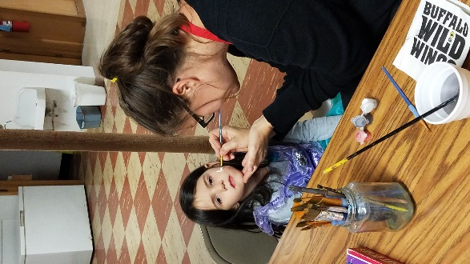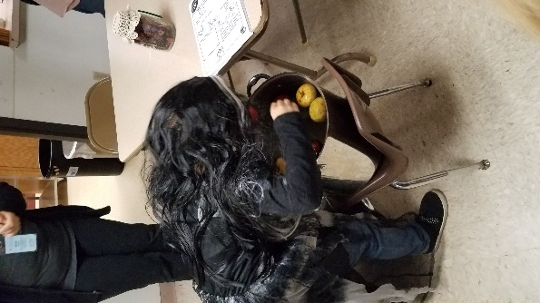 The American Heritage Girls had a great time in October. We learned how triangles are stronger than squares by building structures out of toothpicks and gumdrops and then seeing how many ARCH books each structure could hold. We made jump ropes out of old t-shirts and learned about Double Dutch jumping with friends. The Tenderhearts learned about baking cakes and the Explorers learned how to decorate them. We closed out the month with a Costume Party on October 31st, where friends and family were invited to come and meet our troop. We bobbed for apples, got our faces painted, played games, and ate delicious treats!

November and December are gearing up to be just as exciting for our troop. Our first meeting will have us packing shoeboxes for Operation Christmas Child. The girls have set a goal to try to fill 100 boxes—a lofty goal for sure. The jump ropes they made will be packed along with the many generous donations we have received. Thank you to everyone who helped make this project possible!

On **November 21st**, you can stop into Amherst Family Foods and find our girls taking turns ringing the bells for the Red Kettle Drive. When they are not ringing the bells, they will be back at church making gift jars to sell at the German Christmas dinner on **December 7th**. The girls will be selling desserts, and beautiful gift jars at the German Christmas Dinner in partnership with the St. Paul’s Youth Group to raise money to support future Christian Educational Programming.

You can also look for one of our lovely gifts at the Jensen Center Library during their Silent Auction Monday, **November 19th – Saturday, December 1st**.

Mark your calendars for **December 7th** (9am-6pm) and come do some Christmas shopping and share a meal with the girls at St Paul's Lutheran Church, Amherst.

**A month full of learning and trusting!**

*An update from Ashley Lehr, and LCMS Missionary to Puerto Rico who visited us last month.*

BIENVENIDOAS MIS AMIGOS! WELCOME MY FRIENDS! I am pleased to be on this journey with you. October has been a month of learning, building relationships, and giving presentations. At the beginning of October, I began taking Español (Spanish) classes over Zoom with one of the teachers in the Dominican Republic. For those who may not know, Zoom is a video chat service. These classes have been four hours a week in one to two-hour increments. I had previously taken Spanish classes in high school, and some of what I had learned is starting to come back. There is still so much I need to learn before I become fluent in Spanish, but I am continuing to make progress. I have started to listen to music and to watch my favorite TV show, The Flash, in Spanish to help continue practicing while not in class.

I have continued to travel to many different congregations in Wisconsin and North Minnesota sharing how I will be serving the Lord and how God is already at

work in Puerto Rico. I am grateful for the brothers and sisters in Christ that I have had the privilege of meeting over the last couple of months.

As I continue my service as a missionary, I have learned a lot about trusting the Lord’s Plan. Jeremiah 29:11-12 reads:

*For I know the plans I have for you, declares the Lord, plans to prosper you and not to harm you, plans to give you hope and a future. Then you will call on me and come and pray to me, and I will listen to you.*

This is a season of trust. I am continually learning to put my full trust in God. I trust him, but the process of building my support network has strengthened my trust. I continually come back to those verses in Jeremiah as a constant reminder that I need to put my trust in the Lord. This is a good reminder no matter where you are in life, God has a plan for you.

*Reformation Celebration at the church in Puerto Rico where I will be serving!*

**Annual Youth Lock-In Reflection**

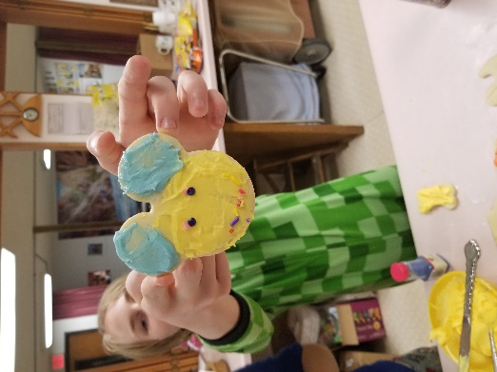 Once again this year we held a youth service day and lock-in. We had a total of 5 youth and 3 chaperones: Ethan Johnson, Jacob Johnson, John O’Connor, Tobin Rajkowski, Abby Marcy, Gabby Heiman, and Jenn and Marty Milner.

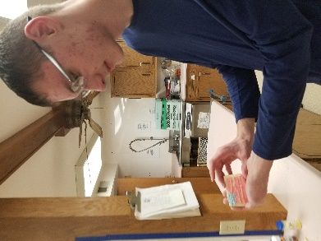 We were unable to go to our intended service project location, so we did some cleaning up around the church! In about 3 hours, we were able to dust and straighten up the Narthex bookshelf, treat the pews, communion rail, and lectern with lemon oil, wipe down the kitchen cabinets, vacuum the banner loft, and wipe down the stalls and floor boards in the bathroom. The church certainly smelled lemony fresh when we were done!

Once we were done with work, we were free to play! We ate pizza, played get-to-know-you games, had a very competitive NERF competition, played video games, played around with some string painting, and baked cut-out cookies at midnight! Eventually we settled down with some movies, snacks, and for everyone but Jacob and me, sleep!

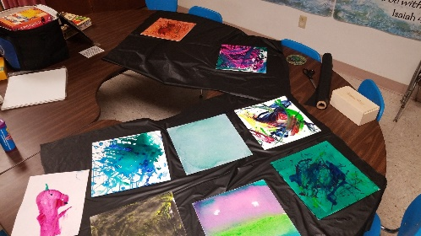 Even though we were tired, we got ourselves upstairs and worshiped together at the early service. I think, even through some bobbing heads, God’s word reaches our ears.

I think the lock-in was very successful overall. My decision to stay for Bible Study, late service, and a voter’s meeting was decidedly less successful. Haha! Next year I will make sure I have no more responsibilities after the lock in!

**The Shepherd’s Voice**

**November 2019**

# St. Paul’s Lutheran Church

**THE LUTHERAN CHURCH**

Missouri Synod

203 Grant Street, Amherst, WI 54406

Pastor Donald Johnson

Pastor’s e-mail:[donaldtjohnson@gmail.com](mailto:donaldtjohnson@gmail.com)

Pastor’s Cell phone: 715-498-7251

Church phone: 715-824-3314

Office email: [stpaul@wi-net.com](mailto:stpaul@wi-net.com)

FB: St. Paul’s Lutheran Church Amherst WI

Web site: http://stpauls.360unite.com

