St. John’s Child Development Center

pardeeville bEFORE AND aFTER scHOOL pROGRAM 2016-2017
.
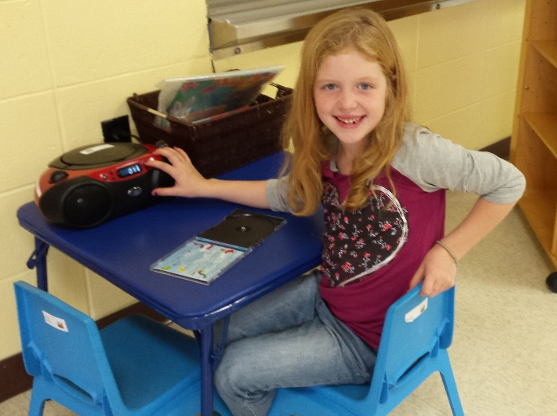

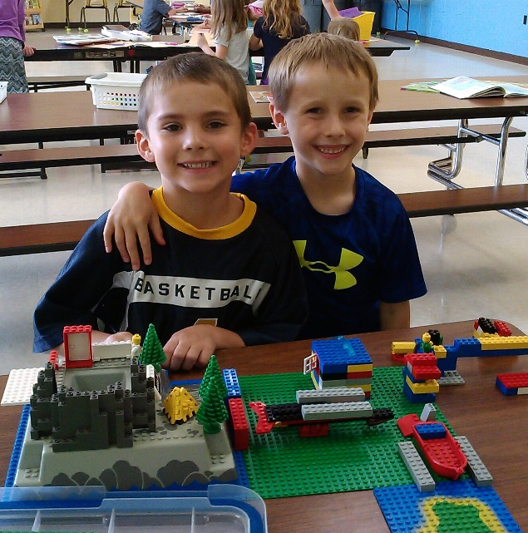

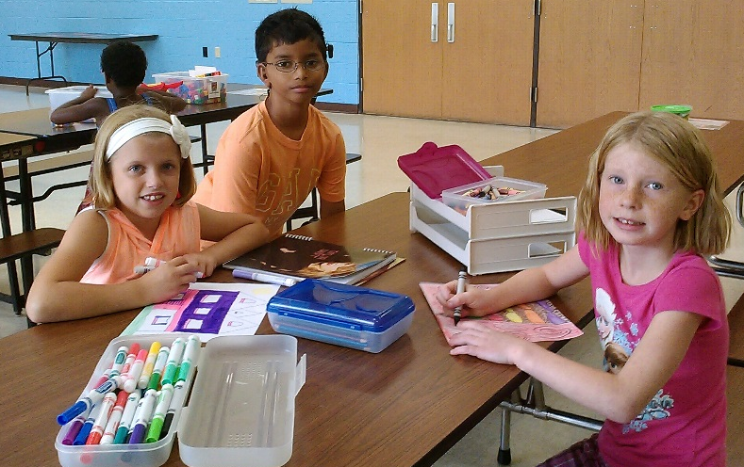

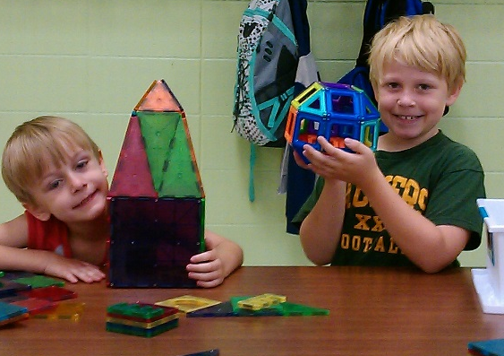

426 W. Emmett Street Portage, WI 53901 Phone: (608) 742-9000
Debbie ddrew@stjohnsportage.com Mary cdcoffice@stjohnsportage.com

St. John’s Child Development Center is excited to offer the children of the Pardeeville Public Schools before and after school care at Pardeeville Elementary during the 2016- 2017 school year. Registration for the new school year will begin August 2016.
Before School
The school will open for drop off starting at 6:00 am.
Hourly rate of $5.00 and $2.50 2nd Child
After School
After school program will start when school gets out and run until 5:30pm
A snack will be served after school
Hourly rate of $5.00 and $2.50 2nd Child
Late Start Days
The program will run for scheduled late start days
Breakfast will be served.
Hourly rate of $5.00 and $2.50 2nd Child
We will not be open for inclement weather closures both AM and PM
Spring Break and Winter Break
Care for children enrolled at Pardeeville Public School will be offered at our center. The children will combined with our St. John’s and Portage Before and After School Program located in our lower level.
Summer Program
Summer Camp is available at St. John’s Child Development Center. This is open to all children in the Portage, Pardeeville and surrounding communities between the ages of 5-11.

All registration paper work can be found online at our website
https://stjohnsportage.360unite.com/portage-before-and-after-care-program-registration

