St. John Lutheran Church
700 Heritage Road Luxemburg, WI
Phone & Fax (920) 845-5250
E-mail address: stjohnlux@centurylink.net
Website: www.stjohnlux.com

Pastor Carl Brewer
Home Phone (920) 845-1717
Cell Phone (920) 536-1041
E-mail: brewercj@centurytel.net
Vicar Craig VanPay

April 5, 2020
THE PRELUDE Organist: Raquel White

PRAISE SONG: Ride On, Ride On in Majesty LSB# 441
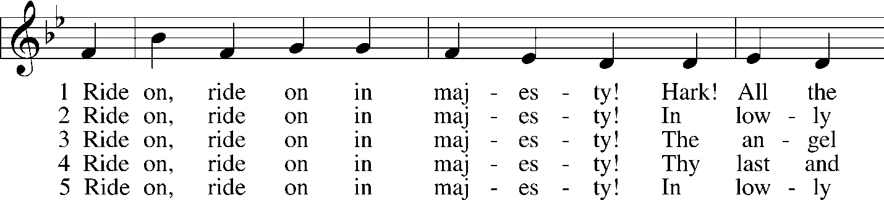
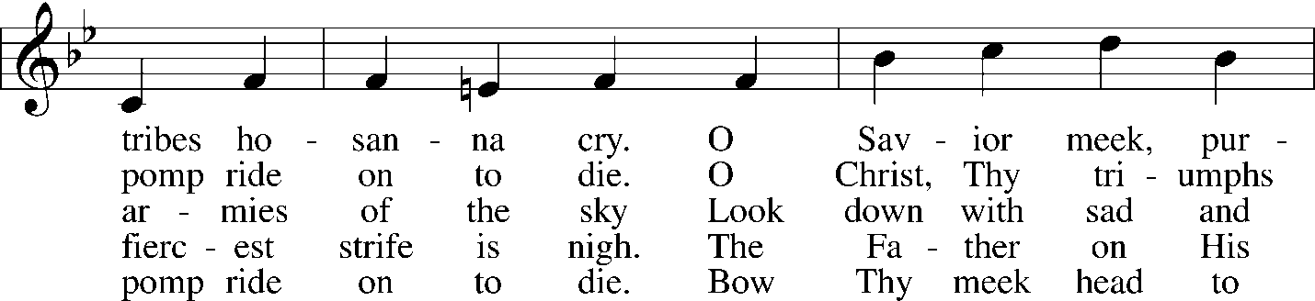
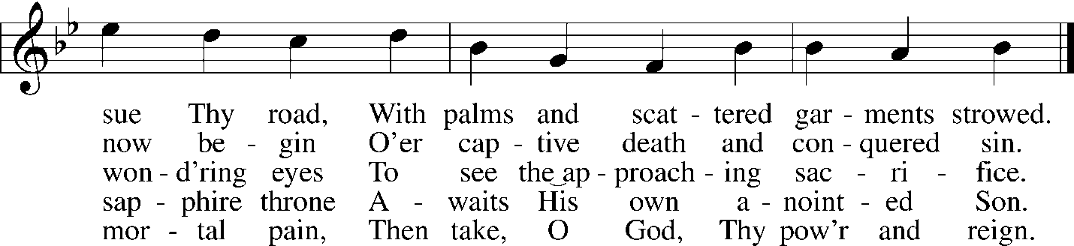

*THE INVOCATION
P In the name of the Father and of the Son and of the Holy Spirit.
C Amen.

*RESPONSIVE PSALM: Psalm 118:19-29
P ¹⁹Open to me the gates of righteousness, that I may enter through them and give thanks to
the Lord.
C ²⁰This is the gate of the Lord; the righteous shall enter through it.
P ²¹I thank you that you have answered me and have become my salvation.
C ²²The stone that the builders rejected has become the cornerstone.
P ²³This is the Lord’s doing; it is marvelous in our eyes.
C ²⁴This is the day that the Lord has made; let us rejoice and be glad in it.
P ²⁵Save us, we pray, O Lord! O Lord, we pray, give us success!
C ²⁶Blessèd is he who comes in the name of the Lord! We bless you from the house of the
Lord.
P ²⁷The Lord is God, and he has made his light to shine upon us. Bind the festal sacrifice with
cords, up to the horns of the altar!
C ²⁸You are my God, and I will give thanks to you; you are my God; I will extol you.
²⁹Oh give thanks to the Lord, for he is good; for his steadfast love endures forever!

*CONFESSION AND ABSOLUTION
P Let us then confess our sins to God our Father.
C Most merciful God, we confess that we are by nature sinful and unclean. We have sinned against You in thought, word, and deed, by what we have done and by what we have left undone. We have not loved You with our whole heart; we have not loved our neighbors as ourselves. We justly deserve Your present and eternal punishment. For the sake of Your Son, Jesus Christ, have mercy on us. Forgive us, renew us, and lead us, so that we may delight in Your will and walk in Your ways to the glory of Your holy name. Amen.
P Almighty God in His mercy has given His Son to die for you and for His sake forgives you all your sins. As a called servant of Christ, and by His authority, I therefore forgive you all your sins in the name of the Father and of the Son and of the Holy Spirit.
C Amen.

*PRAYER OF THE DAY
P The Lord be with you.
C And also with you.
P Let us pray.
C Almighty and everlasting God, You sent Your Son, our Savior Jesus Christ, to take upon Himself our flesh and to suffer death upon the cross. Mercifully grant that we may follow the example of His great humility and patience and be made partakers of His resurrection; through the same Jesus Christ, our Lord, who lives and reigns with You and the Holy Spirit, one God, now and forever. Amen.

OLD TESTAMENT READING: Isaiah 50:4–9
⁴The Lord God has given me the tongue of those who are taught, that I may know how to sustain with a word him who is weary. Morning by morning he awakens; he awakens my ear to hear as those who are taught. ⁵The Lord God has opened my ear, and I was not rebellious; I turned not backward. ⁶I gave my back to those who strike, and my cheeks to those who pull out the beard;
I hid not my face from disgrace and spitting. ⁷But the Lord God helps me; therefore I have not been disgraced; therefore I have set my face like a flint, and I know that I shall not be put to shame. ⁸He who vindicates me is near. Who will contend with me? Let us stand up together. Who is my adversary? Let him come near to me. ⁹Behold, the Lord God helps me; who will declare me guilty? Behold, all of them will wear out like a garment; the moth will eat them up.

EPISTLE READING: Philippians 2:5-11
⁵Have this mind among yourselves, which is yours in Christ Jesus, ⁶who, though he was in the form of God, did not count equality with God a thing to be grasped, ⁷but made himself nothing, taking the form of a servant, being born in the likeness of men. ⁸And being found in human form, he humbled himself by becoming obedient to the point of death, even death on a cross. ⁹Therefore God has highly exalted him and bestowed on him the name that is above every name, ¹⁰so that at the name of Jesus every knee should bow, in heaven and on earth and under the earth, ¹¹and every tongue confess that Jesus Christ is Lord, to the glory of God the Father.

Blessed Be Your Name by Matt Redman

Blessed Be Your Name
In the land that is plentiful
Where Your streams of abundance flow
Blessed be Your name
Blessed Be Your name
When I'm found in the desert place
Though I walk through the wilderness
Blessed Be Your name
Chorus:
Every blessing You pour out
I'll turn back to praise
When the darkness closes in, Lord
Still I will say
Blessed be the name of the Lord
Blessed be Your name
Blessed be the name of the Lord
Blessed be Your glorious name
Blessed be Your name
When the sun's shining down on me
When the world's 'all as it should be'
Blessed be Your name
Blessed be Your name
On the road marked with suffering
Though there's pain in the offering
Blessed be Your name
Chorus
You give and take away
You give and take away
My heart will choose to say
Lord, blessed be Your name

*HOLY GOSPEL: Matthew 21:1-11
P The Holy Gospel according to Matthew, the twenty-first chapter.
C Glory to You, O Lord.

¹Now when they drew near to Jerusalem and came to Bethphage, to the Mount of Olives, then Jesus sent two disciples, ²saying to them, “Go into the village in front of you, and immediately you will find a donkey tied, and a colt with her. Untie them and bring them to me. ³If anyone says anything to you, you shall say, ‘The Lord needs them,’ and he will send them at once.” ⁴This took place to fulfill what was spoken by the prophet, saying, ⁵“Say to the daughter of Zion, ‘Behold, your king is coming to you, humble, and mounted on a donkey, and on a colt, the foal of a beast of burden.’” ⁶The disciples went and did as Jesus had directed them. ⁷They brought the donkey and the colt and put on them their cloaks, and he sat on them. ⁸Most of the crowd spread their cloaks on the road, and others cut branches from the trees and spread them on the road. ⁹And the crowds that went before him and that followed him were shouting, “Hosanna to the Son of David! Blessed is he who comes in the name of the Lord! Hosanna in the highest!” ¹⁰And when he entered Jerusalem, the whole city was stirred up, saying, “Who is this?” ¹¹And the crowds said, “This is the prophet Jesus, from Nazareth of Galilee.”

P This is the Gospel of the Lord.
C Praise to You, O Christ.
*NICENE CREED
I believe in one God, the Father Almighty, maker of heaven and earth and of all things visible and invisible.
And in one Lord Jesus Christ, the only-begotten Son of God, begotten of His Father before all worlds, God of God, Light of Light, very God of very God, begotten, not made, being of one substance with the Father, by whom all things were made; who for us men and for our salvation came down from heaven and was incarnate by the Holy Spirit of the virgin Mary and was made man; and was crucified also for us under Pontius Pilate. He suffered and was buried. And the third day He rose again according to the Scriptures and ascended into heaven and sits at the right hand of the Father. And He will come again with glory to judge both the living and the dead, whose kingdom will have no end.
And I believe in the Holy Spirit, the Lord and giver of life, who proceeds from the Father and the Son, who with the Father and the Son together is worshiped and glorified, who spoke by the prophets. And I believe in one holy Christian and apostolic Church, I acknowledge one Baptism for the remission of sins, and I look for the resurrection of the dead and the life of the world to come. Amen.

SERMON HYMN Amazing Love (You Are My King) by Hillsong

I'm forgiven because You were forsaken,
I'm accepted, You were condemned.
I am alive and well, Your sprit is within me,
Because You died and rose again. (Repeat x1)

Amazing love,
How can it be?
That You, my King would die for me?
Amazing love,
I know it's true.
It's my joy to honour You, (Repeat x1)
In all I do, I honour You.

You are my King
You are my King
Jesus You are my King
Jesus You are my King

I'm forgiven because You were forsaken,
I'm accepted, You were condemned.
I am alive and well, Your spirit is within me,
Because You died and rose again.
(Chorus)

SERMON

OFFERING

*PRAYERS OF THE CHURCH
*LORD’S PRAYER
Our Father who art in heaven, hallowed be Thy name, Thy kingdom come, Thy will
be done on earth as it is in heaven; give us this day our daily bread; and forgive us our trespasses as we forgive those who trespass against us; and lead us not into temptation, but deliver us from evil. For Thine is the kingdom and the power and the glory forever and ever. Amen.

*WORDS OF INSTITUTION
The Words of Our Lord
P Our Lord Jesus Christ, on the night when He was betrayed, took bread, and when He had given thanks, He broke it and gave it to the disciples and said: “Take, eat; this is My T body, which is given for you. This do in remembrance of Me.”
In the same way also He took the cup after supper, and when He had given thanks, He gave it to them, saying: “Drink of it, all of you; this cup is the new testament in My T blood, which is shed for you for the forgiveness of sins. This do, as often as you drink it, in remembrance of Me.”
P The peace of the Lord be with you always.
C Amen.

COMMUNION - PERSONAL REFLECTION

*BENEDICTION
P The Lord bless you and keep you. The Lord make His face shine upon you and be gracious to you. The Lord look upon you with His favor and give you His peace.
C Amen.

CLOSING SONG: We Believe by Newsboys

In this time of desperation
When all we know is doubt and fear
There is only one foundation
We believe, we believe
In this broken generation
When all is dark, you help us see
There is only one salvation
We believe, we believe.

We believe in God the Father
We believe in Jesus Christ
We believe in the Holy Spirit
And He's given us new life
We believe in the crucifixion
We believe that He conquered death
We believe in the resurrection
And He's comin' back again, we believe
So, let our faith be more than anthems
Greater than the songs we sing
And in our weakness and temptations
We believe, we believe!
We believe in God the Father!
We believe in Jesus Christ!
We believe in the Holy Spirit!
And He's given us new life!
We believe in the crucifixion!
We believe that He conquered death!
We believe in the resurrection!
And He's comin' back again!
Let the lost be found and the dead be raised!
In the here and now, let love invade!
Let the church live loud our God we'll say
We believe, we believe!
And the gates of hell will not prevail!
For the power of God, has torn the veil!
Now we know Your love will never fail!
We believe, we believe!
We believe in God the Father
We believe in Jesus Christ
We believe in the Holy Spirit
And He's given us new life!
We believe in the crucifixion!
We believe that He conquered death!
We believe in the resurrection!
And He's comin' back,
He's comin' back again!
He's comin' back again!
We believe!
We believe

