ST. JAMES LUTHERAN CHURCH – HOLLAND, MN
VOLUME 2019 December, 2019–NEWSLETTER No. 12
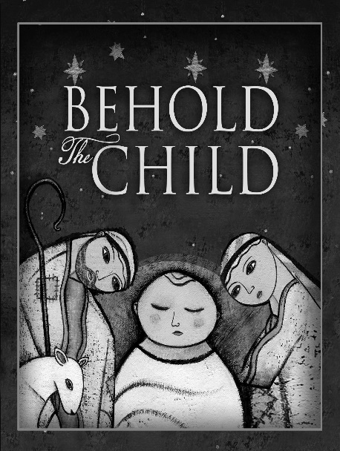
God’s own Son is born a child . . . .God the Father is reconciled.
What peace is found in those words. As the Church draws nigh to the Nativity of Our Lord, many also draw nigh to the harsh reality of broken families and friendships. The sting of estrangement intensifies in this season as many delight in family gatherings—a delight that is glaringly absent for others.
We long for reconciliation—a marriage healed, the return of a prodigal child, the open arms of a formerly harsh parent. Advent is just the season for reconciliation. It is a penitential season, calling us to examine ourselves, acknowledge our sin with contrition, and trust that our sin is forgiven for the sake of Christ. Such self-examination reveals that the fault for our broken relationships is not one-sided. The sin visited upon me by another has driven a wedge between us, but so has my sin. Part of the distance between me and others is due to my sinful actions—my sinful refusal to forgive, my sinful pride that will not admit my fault, my sinful contentment with a cold shoulder.
Advent calls us to repent of our divisions. Advent calls us to rejoice in reconciliation. Though you can forgive another even when he refuses to acknowledge his fault, reconciliation is found when both parties are willing to admit their culpability, seek forgiveness, and amend their ways. That can seem so difficult. It is hard enough for one sinner to confess his sin and trust that the Lord purges it from his life. How much more challenging it is for two sinners to do so. Yet that is exactly what Christ works among and within us. He grants us confidence in His forgiveness so that we forgive one another, receive one another’s forgiveness, and are thus reconciled.
Reconciliation with some remains ever elusive. We hunger for it; we pray for it. Yet the distance remains. When a parent apologizes to a child so that they embrace for the first time in decades, we rightly rejoice. When our longing is not realized, sorrow results.
The only consolation amid such sorrow is the certainty of your reconciliation to the Father. It is certain because it is not dependent upon sinners humbling themselves in repentance. It is certain because it is dependent upon the sinless Son of God humbling Himself to take on human flesh and be born of a virgin.
That is the glorious, biblical proclamation found in “The Quempas Carol.” We are blessed to hear therein the refrain, “God’s own Son is born a child . . . ; God the Father is reconciled.” This is not wishful thinking driven by our longings. It is reality driven by Christ.
You are reconciled to the Father. Each stanza of “The Quempas Carol” announces our reconciliation to the Father in Christ. Wednesday of the first week in Advent will greet us with the first stanza, in which the angel of the Lord makes known that reconciliation is had because Christ has come “For You and All the World.” The second stanza will serve us on Wednesday of the second week in Advent as we hear that Jesus reconciles us to the Father “To Set You Free from All Your Sorrow.” Then, our ears will be filled with the promise that we are reconciled to the Father because Christ comes “For You, to Bear Your Flesh in Weakness.” Our joy will find its climax at the Nativity of Our Lord, when we hear the fourth stanza’s message that Jesus’ birth is the Lord’s visitation of “All the World with His Free Grace Supplying.”
Behind it all is the Word of God that the Spirit might quicken in us faith to trust these promises.

Blessings in Christ this season, Pastor Petrich

