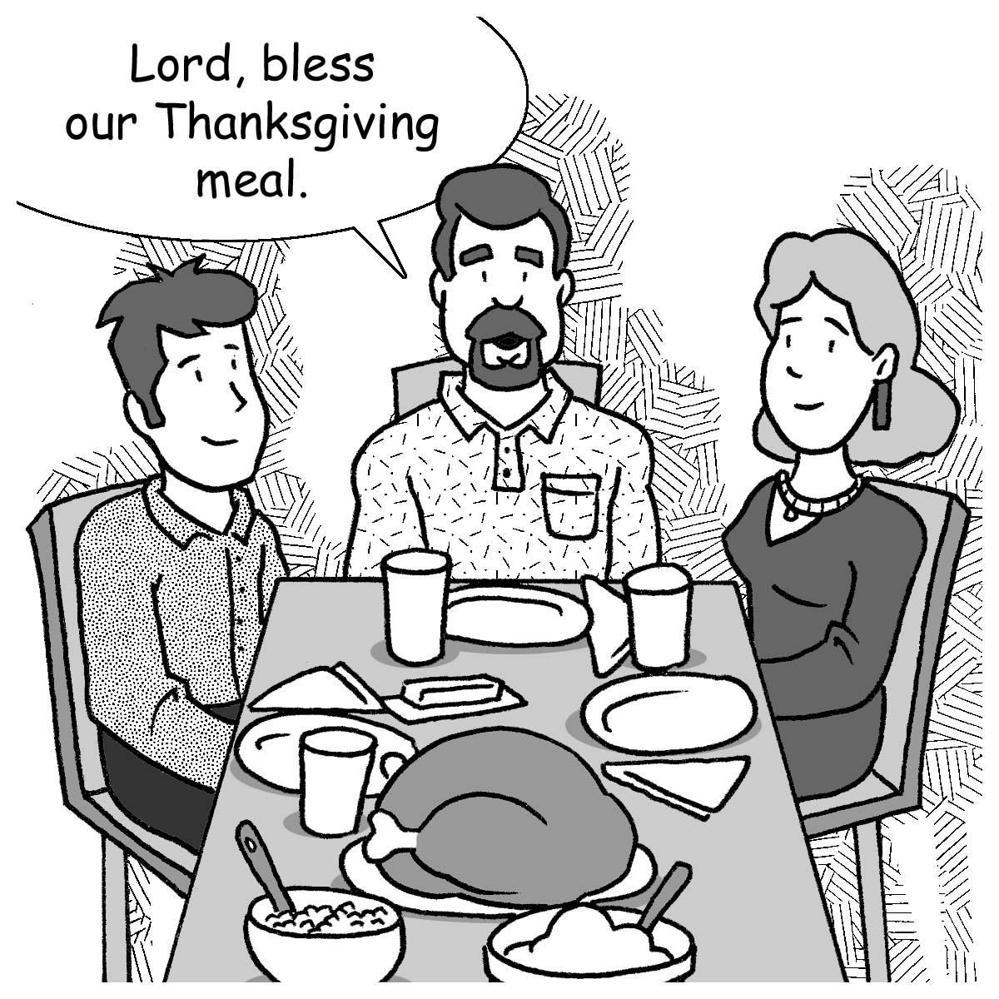
Mid-Week Stewardship Thought

Being Thankful in all Things
It’s easy to be thankful when we have plenty and are not in need – or is it? Thankfulness is an attitude of the heart and mind and is not necessarily dependent on the state of our financial affairs or even our health or general well-being. Those who rely on their Savior for all their needs have this attitude: “Though the fig tree does not bud and there are no grapes on the vines, though the olive crop fails and the fields produce no food, though there are no sheep in the pen and no cattle in the stalls, yet I will rejoice in the Lord. I will be joyful in God my Savior” (Habakkuk 3:17-18).

Prayer: Lord, You are the creator and the source of all good things. During this Thanksgiving Season and throughout the year, help me to be thankful for all the blessings You give so freely to me. I thank You for the most indescribable gift of all, the gift of Your Son. May all that I do give You honor and glory. In Jesus’ name I pray. Amen.

Blessings on your stewardship journey!

