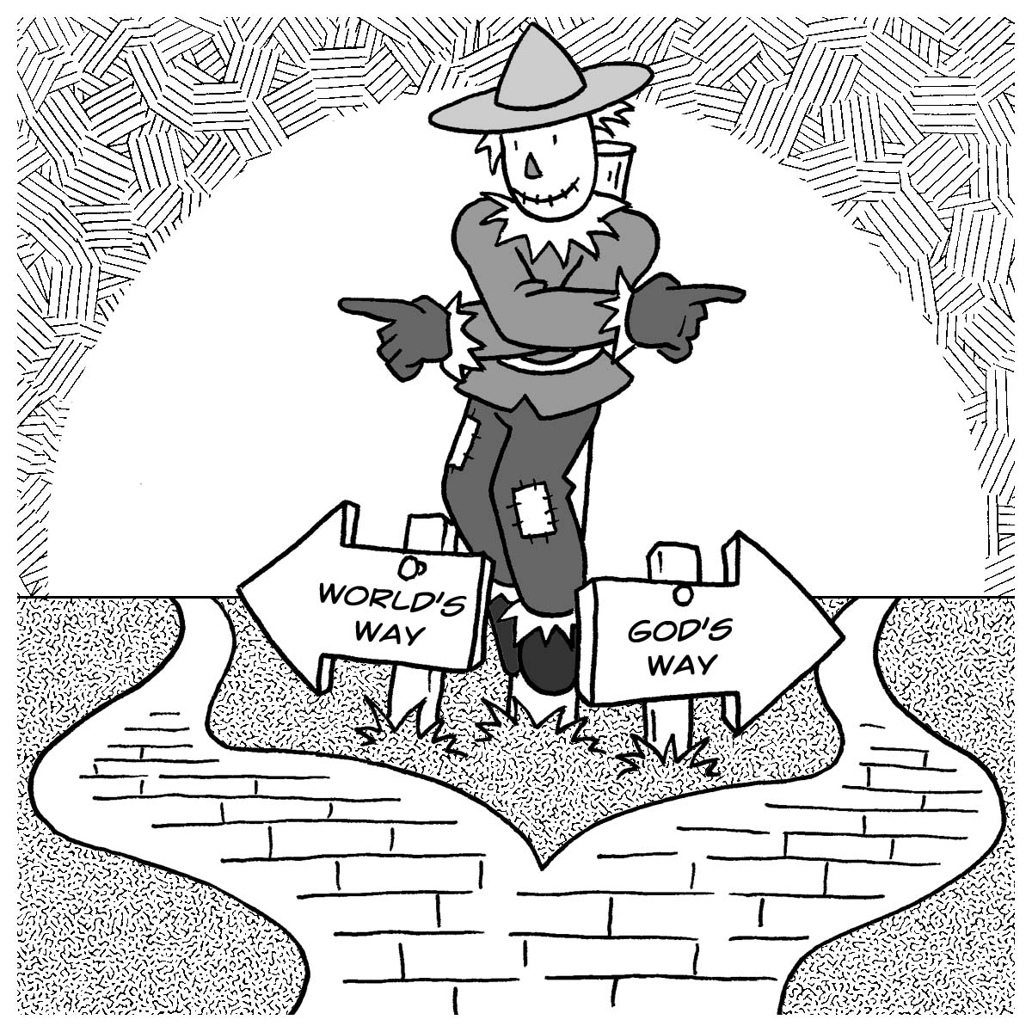
Mid-week Stewardship Thought

Choosing Our Path
God wants us to follow Him, but He gives us the freedom to choose what path we will take and whom we will serve. As we stand at the crossroads of life, God continually reaches out to us through His Word. In Jeremiah 6:16 we read, “This is what the Lord says: ‘Stand at the crossroads and look; ask for the ancient paths, ask where the good way is, and walk in it, and you will find rest for your souls.’ ” Daily we are at the crossroads of life. The choice we make is our own. As Yogi Berra said, "When you get to a fork in the road, take it.” The road we take will have eternal consequences. Will we choose God’s way or the ways of the world? With God’s help, our answer can be like Joshua’s. “But as for me and my household, we will serve the Lord” (Joshua 24:15).

Joshua’s choice was that he and his family would be servants and stewards of the Lord. When you reach the crossroads in life, you will hear God’s call, “Follow Me.” The call to serve yourself and the ways of the world will be loud and boisterous. If you don’t reject God’s call and you follow, as Jeremiah did, the ancient paths, you will turn away from your self-interests and focus on ways to serve the Lord. As followers of Jesus, we acknowledge God’s ownership and love. We become stewards of what He entrusts to us. As followers of the Lord, we see others as brothers and sisters in Christ. We live with an eternal perspective.

Prayer: Dear Lord, guide me in my choices. Keep me focused and dependent upon You so that I may follow Your ways. Amen.

Blessings on your journey as a steward

