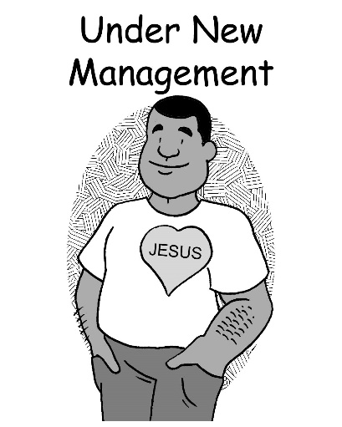
Mid-Week Stewardship Thought

Under New Management
When a business such as a restaurant changes ownership, we may see a sign that reads, “Under New Management.” The restaurant will often change the menu, the service, and even the décor. The old restaurant is hardly recognizable. So it is with our lives in Christ. St. Paul writes, “I have been crucified with Christ. It is no longer I who live, but Christ Who lives in me. And the life I now live in the flesh I live by faith in the Son of God, Who loved me and gave Himself for me” (Galatians 2:20). In essence, we live under new management. The old godless person is hardly recognizable as the new person in Jesus is created. “Therefore, if anyone is in Christ, he is a new creation” (2 Corinthians 5:17). God is now in control of our lives. We have a new master and a new purpose: to live for Christ.

Prayer: Dear Lord, thank You for changing my heart to be more like You. Keep me strong so I can continue to resist the temptations of Satan, the world, and my flesh. Thank You for forgiving and loving me. In Jesus’ name I pray. Amen.

Blessings on your stewardship journey!

