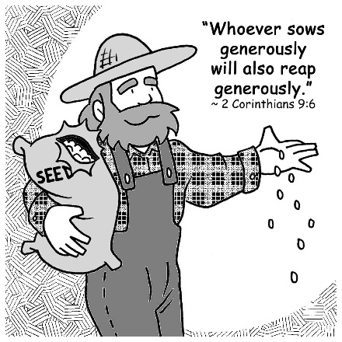
Mid-Week Stewardship Thought

“Sowing and Reaping”
You've probably been involved in planting a vegetable or flower garden, and you've realized that the more seeds you plant, the more plants you get. The Apostle Paul used the analogy of sowing and reaping (planting and harvesting) in relation to money. He wrote, "Whoever sows sparingly will also reap sparingly, and whoever sows bountifully will also reap bountifully" (2 Corinthians 9:6).

You know that, if you plant a seed here and there, you'll get a plant here and there, and the result will not be especially pleasing. Sowing sparingly yields sparse results. So, it is with money. If you give generously, you will reap for yourself and others great benefits.

Prayer: Dear God, thank You for Your love and generosity to me. Help me to show my gratitude by spending time, talents, and money faithfully in Your service. Amen.

Blessings on your journey as a steward!

