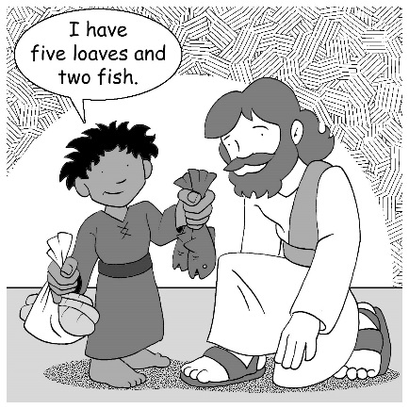
Mid-Week Stewardship Thought

Using our Resources Faithfully
The following two examples in Scripture clearly point out how God blesses people who freely put to work what they have and that using what we have for God’s purposes demonstrates our faithfulness and obedience. The Parable of the Talents teaches us to put God’s resources to work rather than hoard them in fear while our Master is away (Matthew 25:14-30). The two servants who grew their talents or gifts heard the Master tell them, “Well done, good and faithful servant.” Their faithfulness was rewarded with more responsibility. The boy who gave up his five loaves and two fish to Jesus so He could feed the 5,000 offers a beautiful picture of what happens when God’s people freely put to use what they have. Jesus multiplies the bread and fish in a manner that brings God glory and serves His people. May God grant us faithfulness to use our blessings faithfully and responsibly.

Prayer: Dear Lord, You are the creator and source of all good things. Thank You for Your gifts to me. Help me to be a faithful steward. In Jesus’ name I pray. Amen.

Blessings on your journey as a steward!

