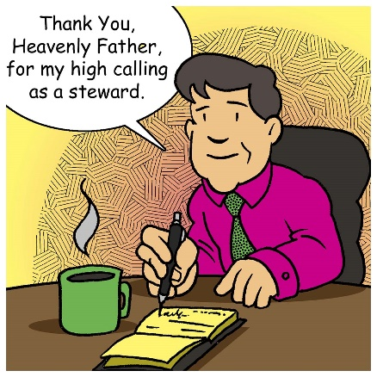
Mid-Week Stewardship Thought

Empowered to be God’s Stewards
God has given us freedom of choice. We were not created to act as robots who behave in predictable and certain ways. With our free will, we will all choose our own answers to this stewardship question: “How will you use the resources God has entrusted to you?” Some will be stewards for the Lord, whereas others will be interested only in serving themselves. In essence, we are all stewards. We will either be stewards for the Lord or for ourselves. When we spend time in God’s Word, He will strengthen our faith so we can fulfill the responsibilities He gives us. May God empower us to say as Joshua said, “But as for me and my household, we will serve the Lord” (Joshua 24:15).

Prayer: Heavenly Father, I pray for wisdom and guidance as I strive to be Your faithful steward. Help me to share Your love with others. May my words and actions give You the honor and praise that You deserve. In Jesus’ precious name I pray. Amen.

Blessings on your stewardship journey!

