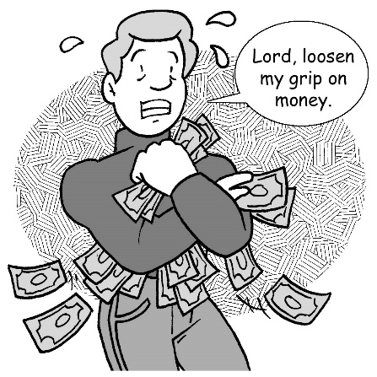
Mid-Week Stewardship Thought

Hold onto Things Loosely
A bumper sticker said, “Money isn’t everything, but it’s right up there with air and water.” We live in a money-driven culture that often associates a person’s value with how much he earns and possesses. In order to be labeled successful, many are driven to possess more and more. Gaining wealth is often an obsession. The Apostle Paul warns us, “The love of money is a root of all kinds of evil” (1 Timothy 6:10). Jesus cautions us about an undue desire for money and things: “Watch out! Be on your guard against all kinds of greed; a man’s life does not consist in the abundance of his possessions” (Luke 12:15). With God’s help, we can keep material things from becoming overly important.

Prayer: Lord, thank You for being with me through another day. Thank You for loving me in spite of myself. Thank You for allowing me to be Your steward. Help me to hold loosely all that You entrust to me and to manage all things responsibly. Use me as a light to those around me. In Jesus’ name I pray. Amen.

Blessings on your stewardship journey!

