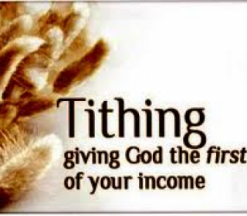
Mid-Week Stewardship Thought

Giving Proportionately
As we grow in our faith and trust in the Lord, our attitude toward tithing (giving one tenth of our incomes) changes, and we begin to see tithing as a privilege rather than as an obligation. By grace, we can give generously, joyfully, and sacrificially. Whether God gives us little or much, we are to give in proportion to what we have been given. “On the first day of every week, each one of you should set aside a sum of money in keeping with his income…” (1 Corinthians 16:2). We are never too poor to give. The tithe acts as a meaningful Biblical guide for our giving.

Prayer: Lord, You are the owner of all the animals in the forest and the cattle on a thousand hills (Psalm 50:10). Help me always to acknowledge Your ownership and grant me faith to be a responsible caretaker of all You entrust to me. Thank You for Your promise to be with me always. In Jesus’ name I pray. Amen.

Blessings on your stewardship journey!

