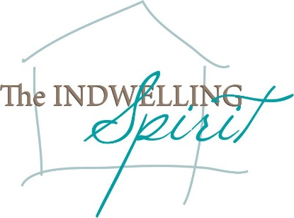
Mid-week Stewardship Thought

Resisting Temptations
God does not shield us from temptations, but He sustains us while we are facing them. Our faith is paramount if we are to stand up to temptations with courage and conviction. Peter urges us to stand firm in the faith knowing that our “brothers throughout the world are undergoing the same kind of sufferings” (1 Peter 5:9). When we stand firm in our faith, we can echo the words of the Apostle Paul’s testimony shortly before his death, “I have fought the good fight, I have finished the race, I have kept the faith” (2 Timothy 4:7). Paul showed that he had developed the character to withstand the powerful influences that threatened to take over his life. Just as Paul was tested hundreds of years ago and kept the faith, today our faith and character are being tested. The goal for all believers is to be men and women of integrity who, empowered by the Spirit through Word and Sacrament, combat temptations with the character that God has developed and nurtured within each of us. “The man of integrity walks securely, but he who takes crooked paths will be found out” (Proverbs 10:9). Remaining strong in our faith will bring us into God’s joy, peace, and freedom. Through the Holy Spirit, Who lives in us, we are capable of saying “no” to temptations. Making proper choices builds our Godly character and makes us more effective in our lives of service to Christ.

Prayer: Dear Father, send Your Holy Spirit to be with me so I can withstand the temptations that I face daily. You are my shield and armor. In the name of Jesus, I pray. Amen.

Blessing on your journey as a steward!

