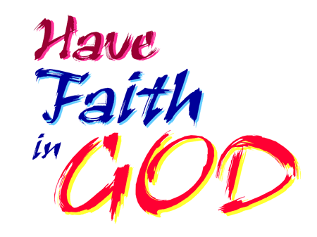
Mid-week Stewardship Thought

Through Faith We Obey
Faith is what makes obedience possible. Throughout Hebrews 11, the “Faith Chapter,” the writer makes it clear that all the “heroes of faith” he mentions were able to be obedient because they believed in God, Whom they knew to be faithful. Thus, when we talk about obedience, we must be aware that faith is the foundation.
Faith is more than a belief in God. It is a way of life. Heroes of faith, although imperfect, trusted God and gave their lives to Him, as this chapter points out. Faith is the belief, placed in our hearts by the Holy Spirit through Word and Sacrament, that God is real, and that He is good, and that the One who made it all hasn’t left it all. He still sends light into the shadows and responds to our obedience in faith. Because of faith, we believe that God will do what is right, and that He is always present to help. By telling about the faith of Old Testament characters, Hebrews Chapter 11 is an encouragement to us to be obedient.
Prayer: Dear Heavenly Father, thank You for loving me in spite of my sinful and evil ways. Grant me an obedient faith that seeks to honor You with all my thoughts and actions. In Jesus’ name I pray. Amen.

Blessings on your journey as a steward!

