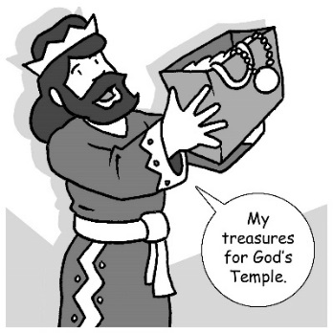
Mid-week Stewardship Thought

Lessons to Learn from King David’s Giving
(1 Chronicles 29:2-3). King David gave his personal fortune to the construction of God’s temple. Unlike many rich people who allow money to become their treasure, David’s devotion was to God rather than his money. He willingly gave a vast amount of gold and silver. After he had given his gifts, he appealed to the people to give to the temple. David possibly had the wealth to complete the temple himself, but we can assume he knew the importance of all people worshiping God through their giving.

David acknowledged God’s ownership of his blessings and maintained a proper attitude toward his material possessions. He realized that his riches were gifts from God. David knew that God had blessed him so he could be a blessing to the Lord and to others. His giving was far above what might be expected even from a very rich man. His example of outrageous giving, flowing out of a grateful heart for all God’s blessings to him and his family and his people, led to generous giving on the part of the leaders of the people as well (1 Chronicles 29:6-8), and there was much rejoicing throughout the country (1 Chronicles 29:9). Faithful giving results in praise to God Who makes it all possible (1 Chronicles 29:10-13).

Prayer: Dear Heavenly Father, I ask that You grant me a giving and generous heart that You gave to King David. Help me to be a faithful and generous giver. In Jesus’ name. Amen.

Blessings on your journey as a steward!

