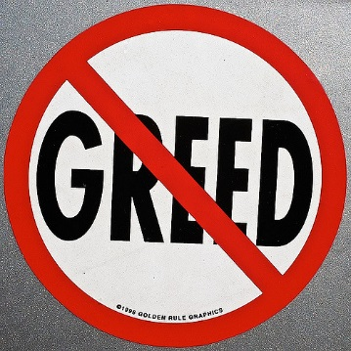
Mid-week Stewardship Thought

Beware of Materialism
Materialism is the love of money and possessions and that love of material stuff causes us to find our identity, meaning, and purpose outside of God. It is allowing money and possessions to become the center and the control of our lives. God created us to love people and use things, but our hearts have changed to loving things and using people. The love of material things will destroy our relationship with Jesus because the blessings that God has provided become more important than the giver Himself. John Calvin, a church leader in the Protestant Reformation, wisely wrote, “Where riches hold the dominion of the heart, God has lost authority.” When we focus on material things, we become independent and self-sufficient. We become very prideful in what we’ve accomplished and own, and our purpose in life is to gain more and more stuff of this world. Jesus warned us about a materialistic and greedy lifestyle when He said, “Take care, and be on your guard against all covetousness, for one’s life does not consist in the abundance of his possessions” (Luke 12:15).

Prayer: Dear Lord, help me to be thankful for all the blessings that You entrust to me. Place in me an attitude of contentment. In Jesus’ name I pray. Amen.

Blessings on your journey as a steward!

