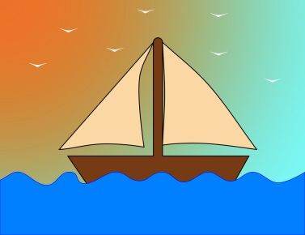
Mid-Week Stewardship Thought

Are You a Channel or a Terminal?
There are two large bodies of water in the Holy Land. The one to the north is filled up by the streams that run down from the mountains from the melting snow and the rains that come in their season. If you stand along the banks of that northern body of water called the Sea of Galilee, you will hear children splashing in the water, fishermen pulling in their catch, and birds flying overhead and diving down to get their fresh fish. Flowers are growing along the bank of the lake. It's a place of life, of celebration, a place of giving and receiving. Then the waters that collect in that lake make their way down the Jordan River. They head south until they finally come to a collecting place. If you stand on the bank of that body of water, you won't hear any children splashing. There won't be any flowers growing along the shore. There are no birds flying overhead dipping down for fresh fish and no fishermen on the lake. This is the Dead Sea. You see, it's one of those places that receives water, receives the gifts, receives the blessings, and then hoards and holds on. There's no escape, there's no outlet, and the waters turn stagnant, putrid, and unable to support life. The question for you and me is, "Are we like the Sea of Galilee, channels of God's love, or are we like the Dead Sea, terminal receptors of God's gifts?”

Prayer: Dear Lord, You created us to be givers. Show me opportunities and grant me the desire to share my money with those who are in need of support. In Jesus’ holy name I pray. Amen.

Blessings on your journey as a steward!

