Mid-week Stewardship Thought
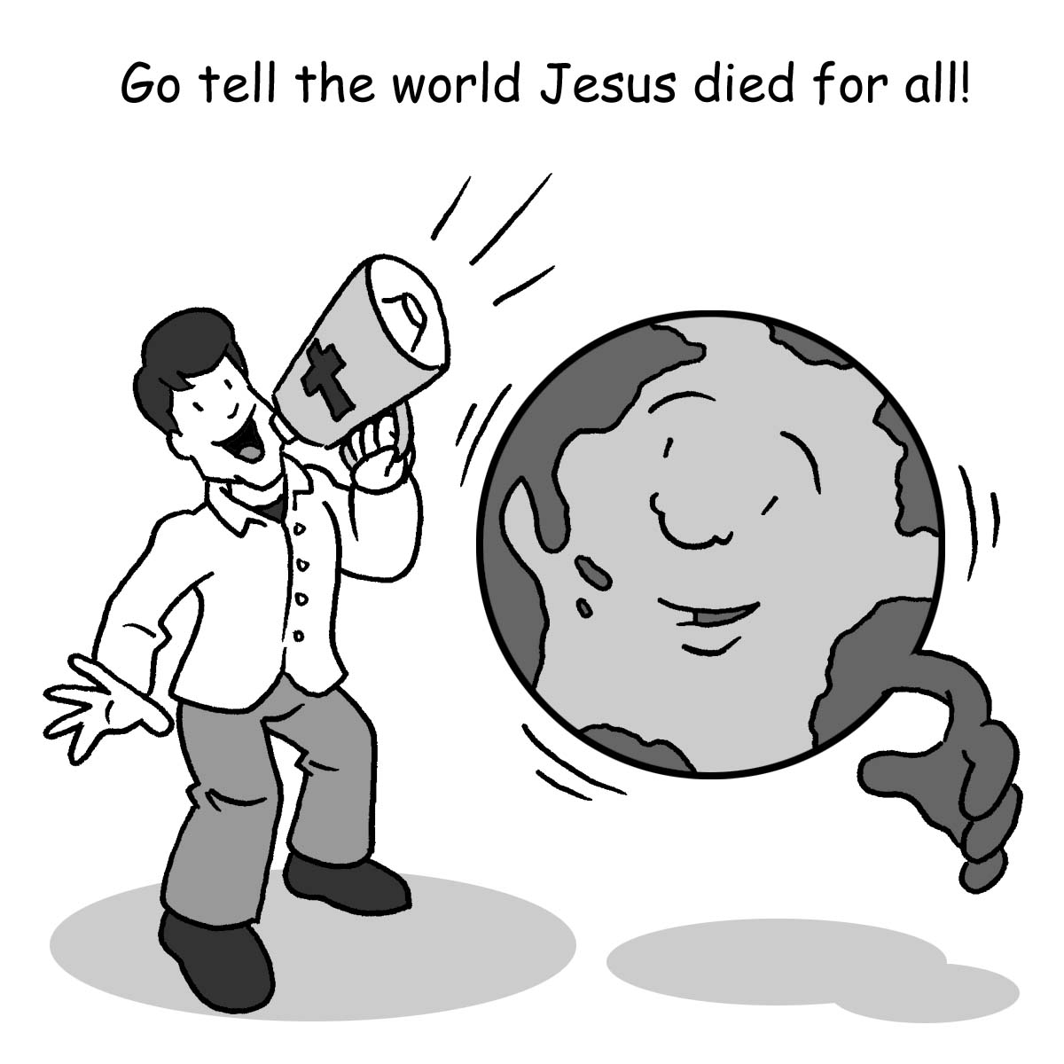
Therefore, Go!
Each December, we celebrate the greatest miracle ever to occur. The Son of God condescended to come to earth, to be humiliated for the sake of those He loves, and then to rise victoriously, the “first fruits of those who have fallen asleep” (1 Corinthians 15:20). We celebrate this miracle every Easter.
This is not a daylong miracle, however. The reality of Easter changes us forever. We no longer spend our days in hopelessness and defeat. We no longer go through our daily routines wondering, “Is this all there is?” No, we are new creations through this miracle. We are now “more than conquerors through Him Who loved us” (Romans 8:37).
This miracle is one to be shouted from the housetops, for it is meant not just for you and me, but for all humankind. That’s what the “Therefore” in the Great Commission (Matthew 28:19) means. Christ has died for our sins and risen again so that we might live forever with Him. He has authority to issue this command. “THEREFORE GO!” Don’t keep this miracle a secret. Take time to tell it to your neighbors and friends. Use your talents to build up your church so that its mission and ministry might be enhanced. Spend your resources so that others (if not you yourself) are enabled to be “[His] witnesses…to the ends of the earth” (Acts 1:8).

Prayer: Dear good and gracious Heavenly Father, place in me a passion to share Your love and goodness to all those in my midst. Use me as Your instrument to share Your love, grace, and mercy to all. In Jesus’ precious name I pray. Amen.

Blessings on your journey as a steward!

