Mid-week Stewardship Thought
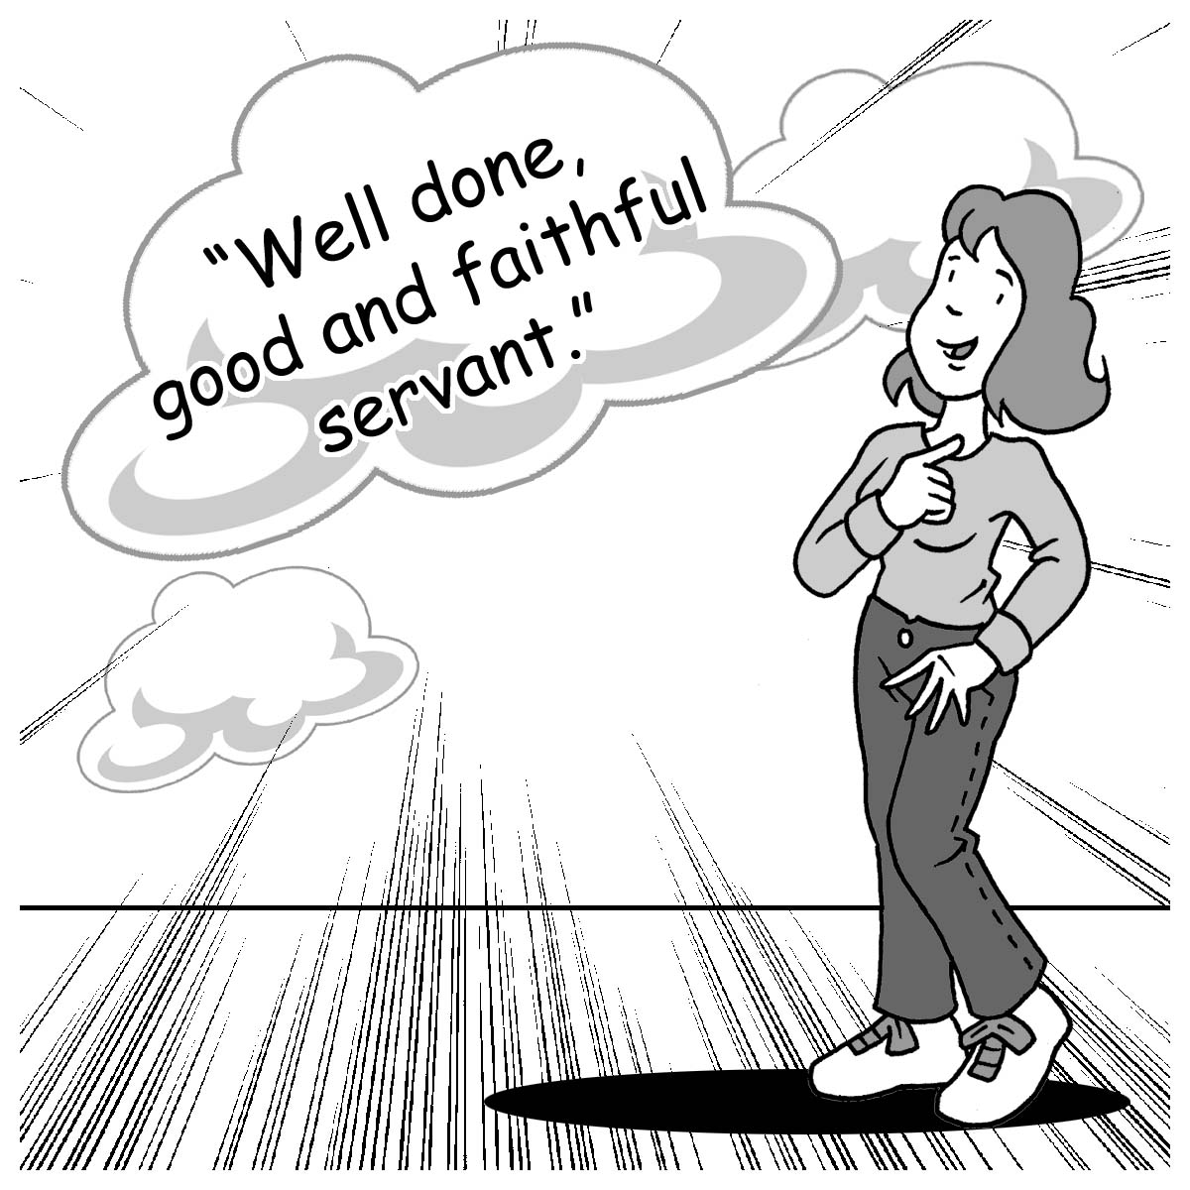
Giving God our Best
To be Christian implies that we act as Christians. Being a Christian is not a part-time position. Scripture is clear that God expects and deserves our best. “Therefore, my beloved brothers, be steadfast, immovable, always abounding in the work of the Lord, knowing that in the Lord your labor is not in vain” (1 Corinthians 15:58). God wants us to “walk in a manner worthy of the Lord, fully pleasing to Him, bearing fruit in every good work and increasing in the knowledge of God” (Colossians 1:10). God wants us to do our best so we can be productive people in His kingdom. When we commit our lives and resources to His service, we will hear Him say, “Well done, good and faithful servant!” (Matthew 25:23). God’s praise is not on our success but on our faithfulness.

Prayer: Dear Lord, grant me the desire and the strength to serve You at all times and in all places. You deserve my praise and gratitude. Thank You for Who You are and what You have done for me especially through Your Son. In Jesus’ precious name I pray. Amen.

Blessings on your journey as a steward!

