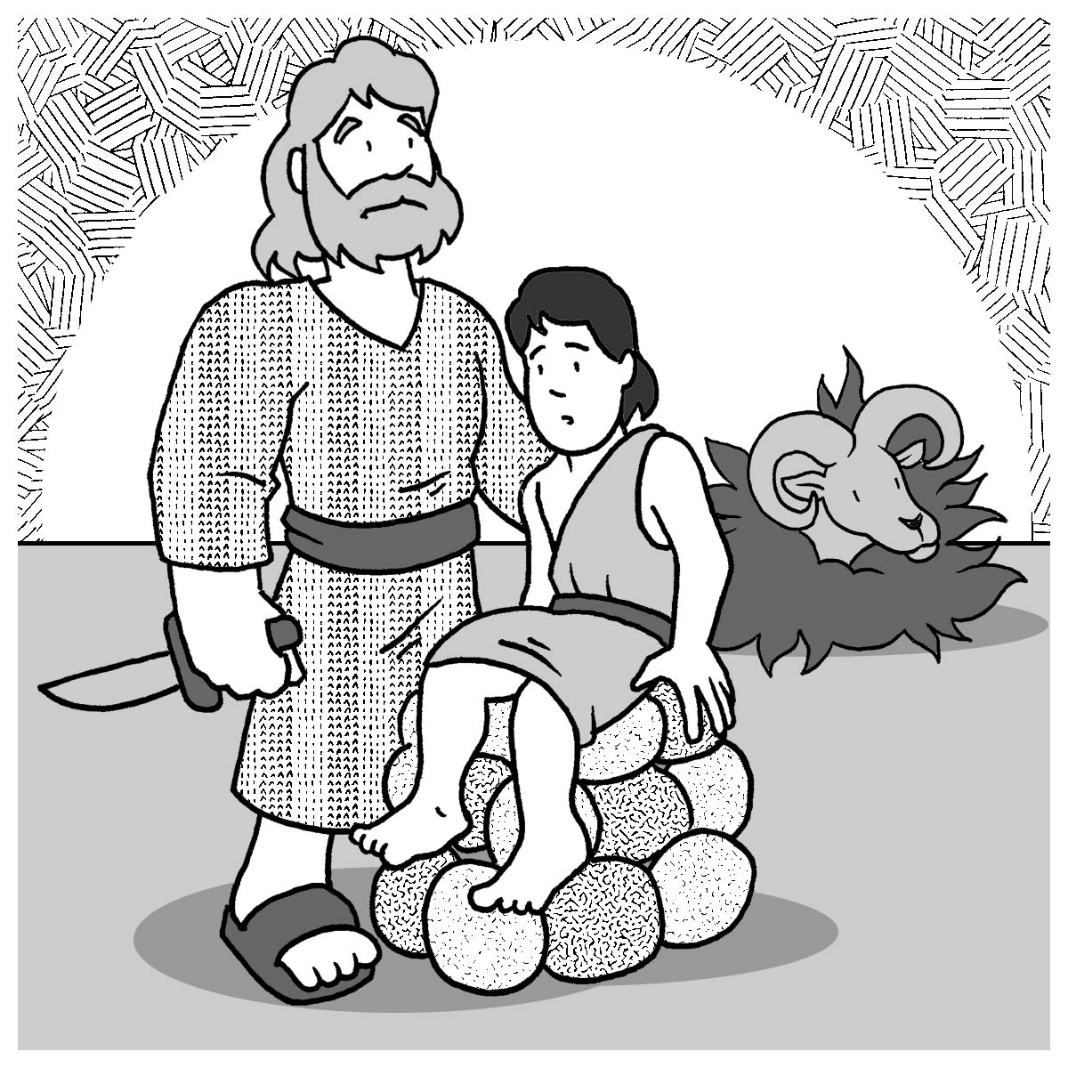
Mid-week Stewardship Thought

Abraham’s Gift of Isaac (Genesis 22:1-18)
“Then God said, ‘Take your son, your only son, Isaac, whom you love, and go to the region of Moriah. Sacrifice him there as a burnt offering on one of the mountains I will tell you about’ ” (Genesis 22:2). Abraham’s willingness to sacrifice his son demonstrated the following:
Obedience: Since Abraham embraced God as the Lord of His life, he was willing to accept God’s control. Promptly he obeyed God’s calling, even with this most difficult request. Faithfulness: God asked Abraham to sacrifice his own son, and Abraham obeyed faithfully. He gave his own son, putting God’s will before his own, faithfully honoring and obeying God’s instructions to sacrifice his son.
Trust: Abraham trusted God’s provisions. God saw in Abraham a person who put his entire trust in the Lord’s hands. Abraham knew that God was in control and was trustworthy.
God tested Abraham, and Abraham proved his faithfulness to Him. When we are tested, may we also give evidence of our obedience, faithfulness, and trust.
Prayer: Lord, I thank You for this wonderful story in Scripture about Abraham who showed his obedience, faithfulness, and trust in You. Bless me with these virtues. In Your precious name I pray. Amen.
Blessings on your Journey as a Steward!

