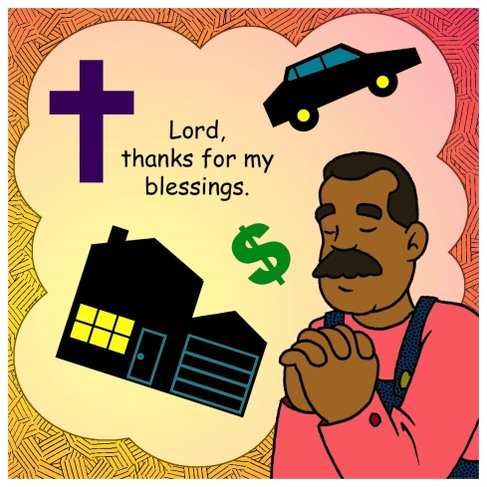
Mid-week Stewardship Thought

Staying Free of Distractions
When we are blessed with many material things, we can be tempted to rely on these things rather than God. God’s Word encourages us to pray that we will not be given too many riches and deny God by saying “Who is the Lord?” (Proverbs 30:9). John R. W. Stott, an Anglican cleric who was noted as a leader of the worldwide Evangelical movement, expands on this concern, “Simplicity is the first cousin of contentment. Its motto is: We brought nothing into this world, and we can certainly carry nothing out. It recognizes that we are pilgrims. It concentrates us on what we need, and measures this by what we use. It rejoices in the good things of creation, but hates waste and greed and clutter. It knows how easily the seed of the Word is smothered by the ‘cares and riches of this life.’ It wants to be free of distractions, in order to love and serve God and others.” With the help of the Holy Spirit, we can handle our money and possessions faithfully.

Prayer: Dear Heavenly Father, grant me wisdom to manage and handle my money in ways that give You honor and glory. In Jesus name I pray. Amen

Blessings on your journey as a steward!

