Mid-week Stewardship Thought
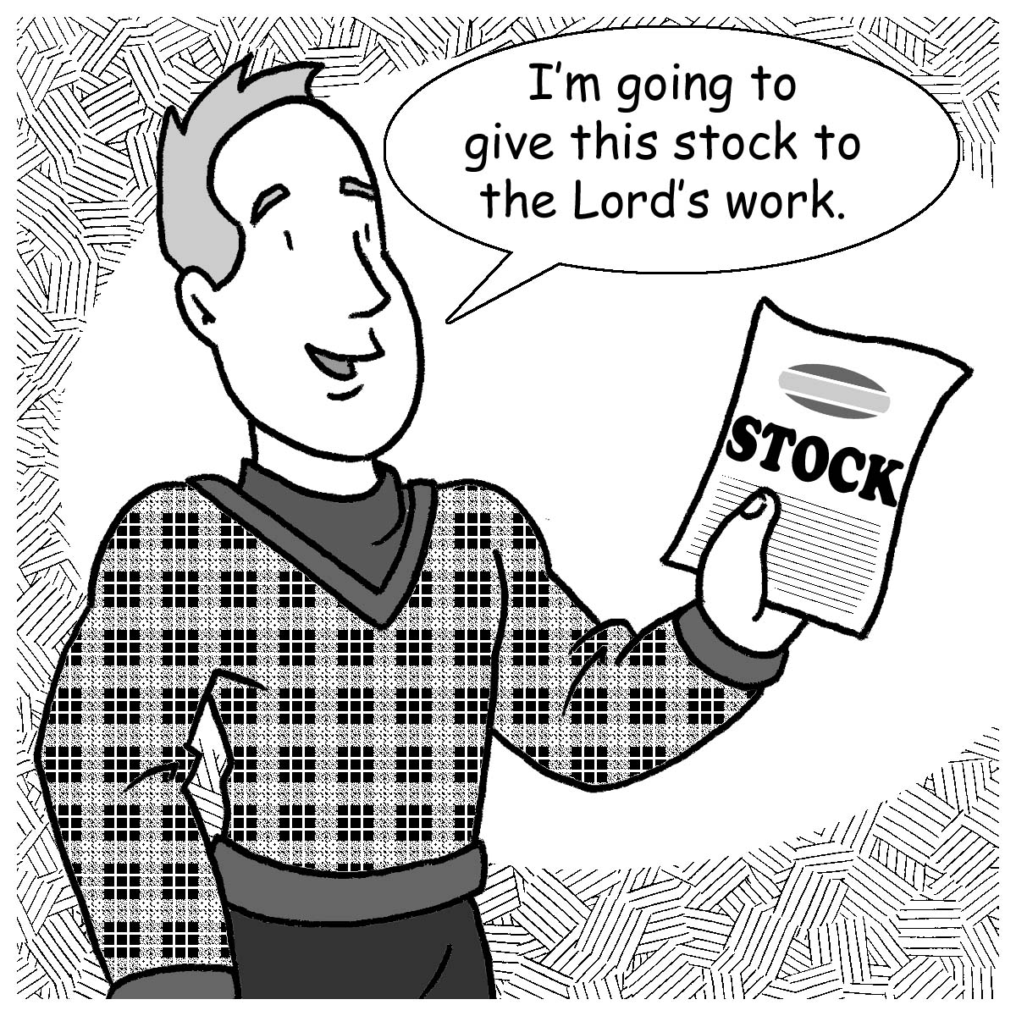
Developing a Christian Estate Plan
If you want to control how your assets at death will be distributed, you need a will or trust. Those who don’t have a will or trust will not have the final opportunity to share some of their accumulated assets for the work of the Lord. Without a will or trust, your entire estate will be transferred according to state laws rather than how you would want your estate to be distributed. In your final estate plan, you can make a provision for a gift to your church through a bequest. Your bequest can be made as a specific dollar amount or as a percentage of your estate as valued at death. It may be preferable to consider a percentage gift, because you don’t know what your estate will be worth at death. Through a bequest, you can continue your faithful stewardship of your accumulated assets after the Lord takes you to your eternal home.

Another advantage to a bequest is the estate tax savings that you could possibly receive through a gift. For large estates, the bequest to your church has the potential of reducing the portion of your estate that could be subject to federal estate taxes.
Prayer: Dear Heavenly Father, the earth and everything in it is Yours. You are the source of all good things. Guide me in my plans to be a faithful steward of my accumulated possessions. Amen.

Blessings on your Journey as a Steward

