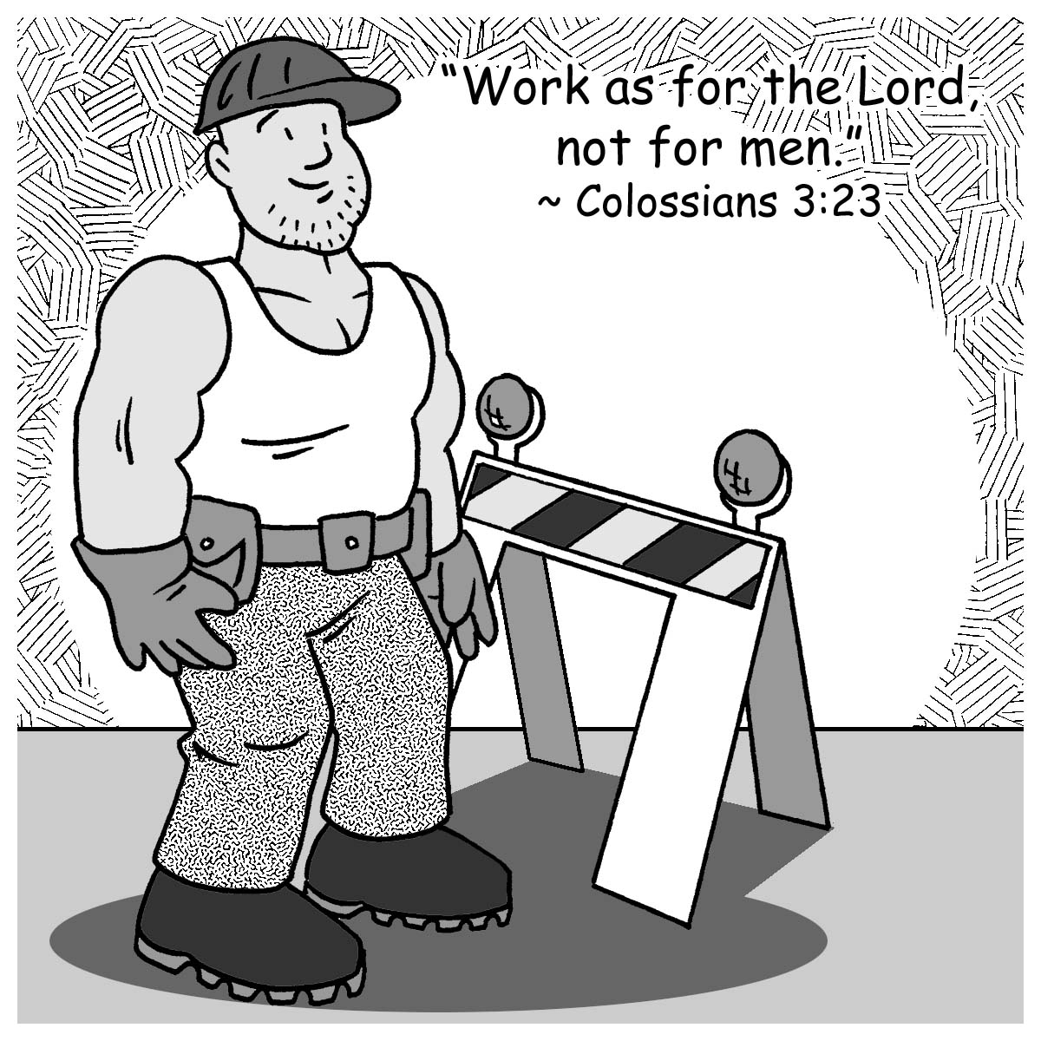
Mid-week Stewardship Thought

Stewards in our Vocations
God places us in our vocations, and He equips us for the vocations in which we are called and placed. In his letter to the Church in Corinth, Paul wrote, “Only let each person lead the life that the Lord has assigned to him, and to which God has called him” (1 Corinthians 7:17). As believers, we are placed into three vocations:
- Our vocation is our place in our families: father, mother, brother, sister, son, or daughter, etc.
- We are called to a vocation in the world or society: salesman, teacher, farmer, accountant, policeman, plumber, etc.
- The church is also an area in which we have a vocation: pastor, member, giver, singer, teacher, etc.
May God grant us the motivation and strength to be faithful and responsible stewards in the vocations in which God places us.

Prayer: Dear Heavenly Father, thank You for giving me the opportunity to serve You in the different vocations in which You have placed me. In Your precious name I pray. Amen.

Blessings on your journey as a steward!

