Genesis

What Goes Around, Comes Around (41:45-42:20)
From a study of Luther’s Works: Lectures on Genesis, Paul Kretzmann’s Popular Commentary of the Bible, and the Lutheran Study Bible
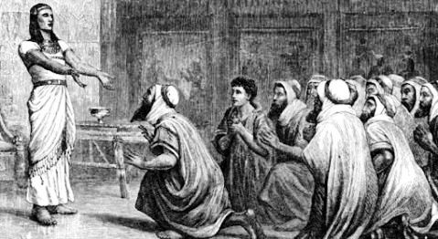
Jeremiah 8:14 Why do we sit still? Gather together; let us go into the fortified cities and perish there, for the LORD our God has doomed us to perish and has given us poisoned water to drink, because we have sinned against the LORD.
Acts 1:10-11 And while they were gazing into heaven as he went, behold, two men stood by them in white robes, ¹¹ and said, "Men of Galilee, why do you stand looking into heaven? This Jesus, who was taken up from you into heaven, will come in the same way as you saw him go into heaven."
Genesis 3:19 By the sweat of your face you shall eat bread, till you return to the ground, for out of it you were taken; for you are dust, and to dust you shall return."
Genesis 37:9-10 Then he dreamed another dream and told it to his brothers and said, "Behold, I have dreamed another dream. Behold, the sun, the moon, and eleven stars were bowing down to me." ¹⁰ But when he told it to his father and to his brothers, his father rebuked him and said to him, "What is this dream that you have dreamed? Shall I and your mother and your brothers indeed come to bow ourselves to the ground before you?"
Luke 24:13-16 That very day two of them were going to a village named Emmaus, about seven miles from Jerusalem, ¹⁴ and they were talking with each other about all these things that had happened. ¹⁵ While they were talking and discussing together, Jesus himself drew near and went with them. ¹⁶ But their eyes were kept from recognizing him.
Matthew 15:23-26 But he did not answer her a word. And his disciples came and begged him, saying, "Send her away, for she is crying out after us." ²⁴ He answered, "I was sent only to the lost sheep of the house of Israel." ²⁵ But she came and knelt before him, saying, "Lord, help me." ²⁶ And he answered, "It is not right to take the children's bread and throw it to the dogs."
Hebrews 12:5-7 And have you forgotten the exhortation that addresses you as sons? "My son, do not regard lightly the discipline of the Lord, nor be weary when reproved by him. ⁶ For the Lord disciplines the one he loves, and chastises every son whom he receives." ⁷ It is for discipline that you have to endure. God is treating you as sons. For what son is there whom his father does not discipline?
Psalm 17:7 ⁷ Wondrously show your steadfast love, O Savior of those who seek refuge from their adversaries at your right hand.
Philippians 4:4 Rejoice in the Lord always; again I will say, Rejoice.
John 7:18 The one who speaks on his own authority seeks his own glory; but the one who seeks the glory of him who sent him is true, and in him there is no falsehood.
Hebrews 6:16 For people swear by something greater than themselves, and in all their disputes an oath is final for confirmation.
Genesis 20:11 Abraham said, "I did it because I thought, There is no fear of God at all in this place, and they will kill me because of my wife.

