Genesis

With Great Power Comes Great Responsibility (41:33-55)
From a study of Luther’s Works: Lectures on Genesis, Paul Kretzmann’s Popular Commentary of the Bible, and the Lutheran Study Bible
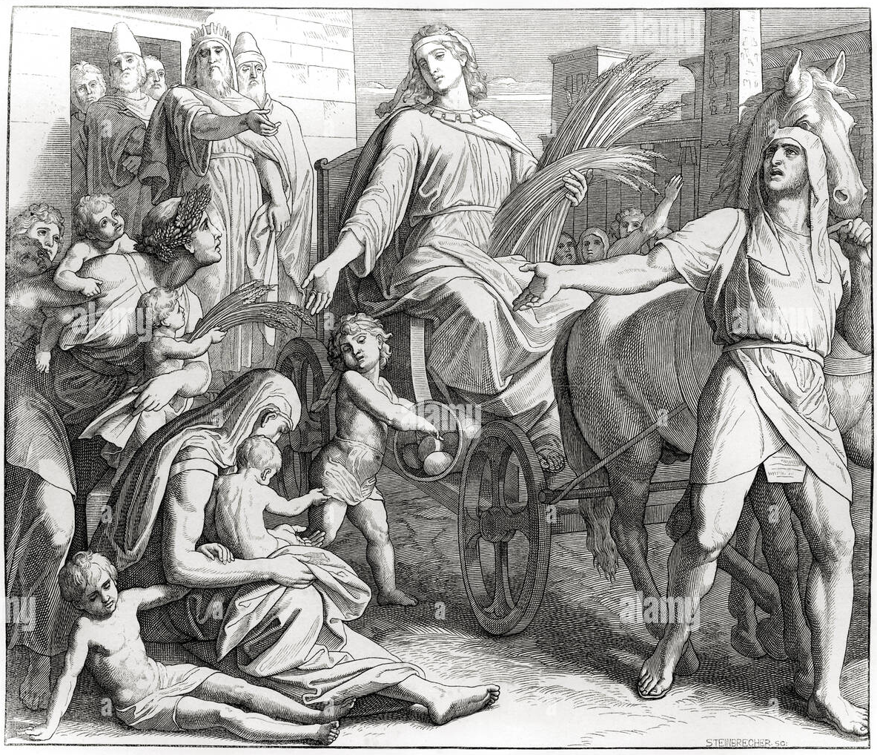
1 Samuel 17:8-10 ⁸ He stood and shouted to the ranks of Israel, "Why have you come out to draw up for battle? Am I not a Philistine, and are you not servants of Saul? Choose a man for yourselves, and let him come down to me. ⁹ If he is able to fight with me and kill me, then we will be your servants. But if I prevail against him and kill him, then you shall be our servants and serve us." ¹⁰ And the Philistine said, "I defy the ranks of Israel this day. Give me a man, that we may fight together."
Daniel 4:18 This dream I, King Nebuchadnezzar, saw. And you, O Belteshazzar, tell me the interpretation, because all the wise men of my kingdom are not able to make known to me the interpretation, but you are able, for the spirit of the holy gods is in you."
Romans 7:24-25 Wretched man that I am! Who will deliver me from this body of death? ²⁵ Thanks be to God through Jesus Christ our Lord! So then, I myself serve the law of God with my mind, but with my flesh I serve the law of sin.
Psalm 113:5-8 ⁵ Who is like the LORD our God, who is seated on high, ⁶ who looks far down on the heavens and the earth? ⁷ He raises the poor from the dust and lifts the needy from the ash heap, ⁸ to make them sit with princes, with the princes of his people.
John 8:39 They answered him, "Abraham is our father." Jesus said to them, "If you were Abraham's children, you would be doing the works Abraham did,
Philippians 2:9-11 Therefore God has highly exalted him and bestowed on him the name that is above every name, ¹⁰ so that at the name of Jesus every knee should bow, in heaven and on earth and under the earth, ¹¹ and every tongue confess that Jesus Christ is Lord, to the glory of God the Father.
Romans 13:1-4 Let every person be subject to the governing authorities. For there is no authority except from God, and those that exist have been instituted by God. ² Therefore whoever resists the authorities resists what God has appointed, and those who resist will incur judgment. ³ For rulers are not a terror to good conduct, but to bad. Would you have no fear of the one who is in authority? Then do what is good, and you will receive his approval, ⁴ for he is God's servant for your good. But if you do wrong, be afraid, for he does not bear the sword in vain. For he is the servant of God, an avenger who carries out God's wrath on the wrongdoer.
Esther 8:1-2 On that day King Ahasuerus gave to Queen Esther the house of Haman, the enemy of the Jews. And Mordecai came before the king, for Esther had told what he was to her. ² And the king took off his signet ring, which he had taken from Haman, and gave it to Mordecai. And Esther set Mordecai over the house of Haman.
Daniel 5:29 Then Belshazzar gave the command, and Daniel was clothed with purple, a chain of gold was put around his neck, and a proclamation was made about him, that he should be the third ruler in the kingdom.
Luke 15:22 But the father said to his servants, 'Bring quickly the best robe, and put it on him, and put a ring on his hand, and shoes on his feet.
Genesis 3:17-19 ¹⁷ And to Adam he said, "Because you have listened to the voice of your wife and have eaten of the tree of which I commanded you, 'You shall not eat of it,' cursed is the ground because of you; in pain you shall eat of it all the days of your life; ¹⁸ thorns and thistles it shall bring forth for you; and you shall eat the plants of the field. ¹⁹ By the sweat of your face you shall eat bread, till you return to the ground, for out of it you were taken; for you are dust, and to dust you shall return."

