Genesis

What to do when sitting in jail (40:1-41:32)
From a study of Luther’s Works: Lectures on Genesis, Paul Kretzmann’s Popular Commentary of the Bible, and the Lutheran Study Bible
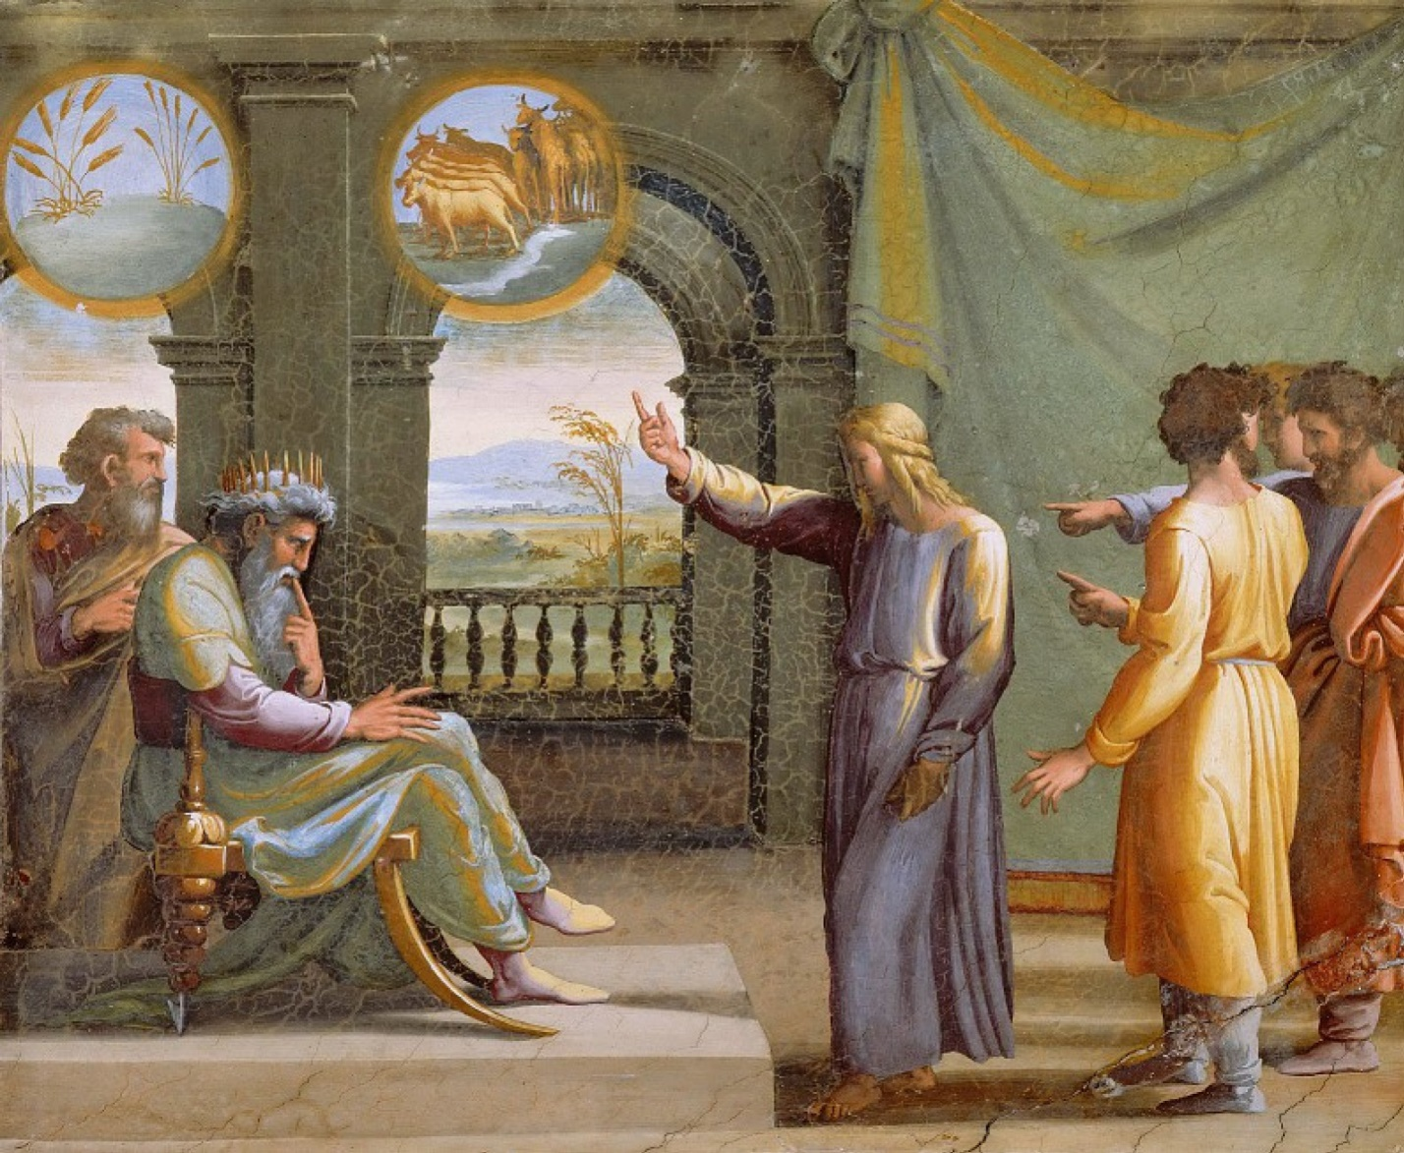
Isaiah 40:26 Lift up your eyes on high and see: who created these? He who brings out their host by number, calling them all by name, by the greatness of his might, and because he is strong in power not one is missing.
Ezekiel 33:25 Therefore say to them, Thus says the Lord GOD: You eat flesh with the blood and lift up your eyes to your idols and shed blood; shall you then possess the land?
Luke 23:42 And he said, "Jesus, remember me when you come into your kingdom."
2 Corinthians 12:7-10 ⁷ So to keep me from becoming conceited because of the surpassing greatness of the revelations, a thorn was given me in the flesh, a messenger of Satan to harass me, to keep me from becoming conceited. ⁸ Three times I pleaded with the Lord about this, that it should leave me. ⁹ But he said to me, "My grace is sufficient for you, for my power is made perfect in weakness." Therefore I will boast all the more gladly of my weaknesses, so that the power of Christ may rest upon me. ¹⁰ For the sake of Christ, then, I am content with weaknesses, insults, hardships, persecutions, and calamities. For when I am weak, then I am strong.
1 Corinthians 7:20-21 Each one should remain in the condition in which he was called. ²¹ Were you a slave when called? Do not be concerned about it. (But if you can gain your freedom, avail yourself of the opportunity.)
Romans 14:8 For if we live, we live to the Lord, and if we die, we die to the Lord. So then, whether we live or whether we die, we are the Lord's.
Deuteronomy 21:22-23 "And if a man has committed a crime punishable by death and he is put to death, and you hang him on a tree, ²³ his body shall not remain all night on the tree, but you shall bury him the same day, for a hanged man is cursed by God. You shall not defile your land that the LORD your God is giving you for an inheritance.
Job 19:14 ¹⁴ My relatives have failed me, my close friends have forgotten me.
Psalm 27:14 Wait for the LORD; be strong, and let your heart take courage; wait for the LORD!
Psalm 37:7 Be still before the LORD and wait patiently for him; fret not yourself over the one who prospers in his way, over the man who carries out evil devices!
Psalm 37:34 Wait for the LORD and keep his way, and he will exalt you to inherit the land; you will look on when the wicked are cut off.
Zephaniah 3:8 Therefore wait for me," declares the LORD, "for the day when I rise up to seize the prey. For my decision is to gather nations, to assemble kingdoms, to pour out upon them my indignation, all my burning anger; for in the fire of my jealousy all the earth shall be consumed.
Matthew 2:1 Now after Jesus was born in Bethlehem of Judea in the days of Herod the king, behold, wise men from the east came to Jerusalem,
Psalm 113:7-8 He raises the poor from the dust and lifts the needy from the ash heap, ⁸ to make them sit with princes, with the princes of his people.
Daniel 5:16 But I have heard that you can give interpretations and solve problems. Now if you can read the writing and make known to me its interpretation, you shall be clothed with purple and have a chain of gold around your neck and shall be the third ruler in the kingdom."
Daniel 2:28 but there is a God in heaven who reveals mysteries, and he has made known to King Nebuchadnezzar what will be in the latter days. Your dream and the visions of your head as you lay in bed are these:

