Genesis

Dreams of the Future (35:23-37:11)
From a study of Luther’s Works: Lectures on Genesis, Paul Kretzmann’s Popular Commentary of the Bible, and the Lutheran Study Bible

The Sons of Jacob who Were Born (35:23-26)
- Note that these are the sons of “Jacob”
  - “Israel” is not used.
    - “Israel” on account of God’s promises.
    - “Jacob” on account of his works among men.
  - The time of fathering children has come to a close

The family reunion- (35:27-29)
- Jacob is finally reunited with his father
  - It is estimated that Isaac lived 13 years after Jacob’s return from Mesopotamia
  - Joseph was 30, and Isaac died 13 years after Joseph was sold
- Hebron
  - Genesis 23:2
- Isaac dies
  - 180 years old
  - Gathered to his people
    - Bears witness to a future resurrection
    - Isaac/we are not scattered, but God gathers us together for a purpose.
  - Esau and Jacob bury him
    - A show that there is no animosity between brothers

The descendants of Esau (36:1-43)
- Why such time devoted to Esau if the promise was not with him?
  - A separation of Jew and Gentile
    - Psalm 18:50
    - God has mercy on all, even apart from the promise.
      - It is necessary to distinguish between the promise and truth and accidental mercy. We have mercy without the promise; the Jews have mercy with the promise.
      - John 4:22
      - For not the sons of the flesh are the sons of God, but the sons of the promise.
- A few side notes of Esau’s lineage:
  - V.4 Eliphaz
    - One of Job’s three friends?
      - Probably not
      - Job would have had to live a long time before the children of Israel left Egypt.
  - V.6-7
    - Note the move because they are too blessed
  - V.11 Teman
    - Jeremiah 49:7
  - V.12 Amalek
    - Amalekites
    - 1 Samuel 15:2-3
  - V.33 Jobab
    - Augustine and Ambrose think that this Jobab is of the family of Esau and that he is Job, and there are many conjectures linked with this opinion. For the letters agree and also the names of his friends, and of these Eliphaz the Temanite seems to have had his origin from Teman in the land of Edom, and likewise Bildad and Zophar. If this is true, it agrees well with history, for Job was very wise in God’s Law and embraced the doctrine and circumcision of his father Esau.
    - Because of the epithet Temanite, however, I rather incline to this view, that Job was descended from Esau, because Arabia is closer to Judea and better known there, although Mesopotamia is also close by.
  - The kings listed more than likely were of the time of Moses and not beyond.

Joseph’s Adventures Begin (37:1-11)
- Brought back to Jacob
  - Note the name
    - We deal with the issues of the house.
- Joseph
  - Seventeen
  - Shepherd
    - Who/what does this remind us of?
    - Who is Joseph hanging out with?
      - Who is missing?
        - But to whom does he join himself as a companion? He does not associate with the chief sons of Leah, with Judah, Simeon, Reuben, and Levi. For these men very proudly despise this son of Rachel. The young man of excellent character also sees that the sons of the maidservants are cast off and despised and regarded by the four sons of Leah as the vilest of slaves. Therefore he finds delight especially in associating with them.
    - Tattletale
      - Someone is always watching
        - Ephesians 5:15
        - Colossians 4:5
        - The same perversity is also today running through all ranks in the church, state, and home. For all men are grumbling against those who remind them of what is right, and they are indignant with those who reprove faults and sins, even enormous public sins. One must not oppose anyone but allow everyone to do what he likes!
- “Israel loved Joseph”
  - Note the name change
    - Why?
  - Why the favoritism?
    - Did Jacob believe that Joseph and Benjamin were his only real sons?
      - I for my part, then, interpret this text in accordance with the feelings of the father’s heart. After so many troubles and crosses he had found rest in this son, who had been born from his legitimate and chief wife, who to his great grief had died in childbirth.
  - The robe with many thread
    - A not-so technicolor dream coat?
    - In the Hebrew it says: “He made for him פַּסִּים,” that is, a coat of threads, or a linen coat, which the Greek version has translated πολύμιτον, that is, having many threads.
    - Luther argues for a “beautiful white smock”
      - For the priesthood in light of Jacob’s hopes for Joseph.
        - Jealousy will arise, not because Joseph got a fancy coat, but because of what it showed Joseph was being prepared for.
      - Similar to the clothing depicted for the angels
      - Similar to Christ’s cloak wove without seam and shone brightly at the transfiguration.
- The brothers hated Joseph
  - Silent treatment
    - 1 John 2:11
  - A foreshadowing
    - Saul/David
    - Jews/Jesus
    - World/Christians
  - A foreshadowing which God allows?
    - To allow His purpose to come about.
      - Genesis 50:20
- Dream #1
  - On dreams
    - Joel 2:28
    - I have concluded a pact with my Lord God that He should not send me visions or dreams or even angels. For I am content with this gift which I have, Holy Scripture, which abundantly teaches and supplies all things necessary both for this life and also for the life to come.
    - But when the Spirit Himself is the interpreter of those things which He suggests, then there can be no doubt about outcome and certitude. You will find nothing like this in the dreams of the heathen except that keen disturbance of the heart.
  - Bringing in the sheaves
    - All the brothers in the field
      - Has a bearing on the land
    - When Joseph’s sheaf stands up…
      - The brother’s sheaves bow down
  - Told in innocence.
    - And the fire within the brothers really starts to burn!
    - Psalm 118:22
    - Luke 19:14
    - Hebrews 10:29
  - Note Jacob’s silence
    - If Jacob heard of this dream, it only reinforced his own opinion of Joseph.
- Dream #2
  - Compared to the first, this is not lowly but heavenly.
  - Sun, moon, and eleven stars bowing down not to a heavenly body, but to Joseph.
    - Brothers certainly do not like it
    - Jacob really does not like it.
      - Is it a bad or well-intended rebuke?
        - Bad
          - Selfish reasons like the brothers
          - Rachel is dead!
        - Well-intended
          - Acknowledgment of heavenly beings
            - Rachel is included!
          - Jacob is a Seed bearer…
            - And he hopes Joseph is as well.
            - Unless Joseph is the Seed fulfilled…
          - No one should receive adoration but God/the promised One!
      - But the father remembers
        - Luke 2:19
        - Luke 2:51
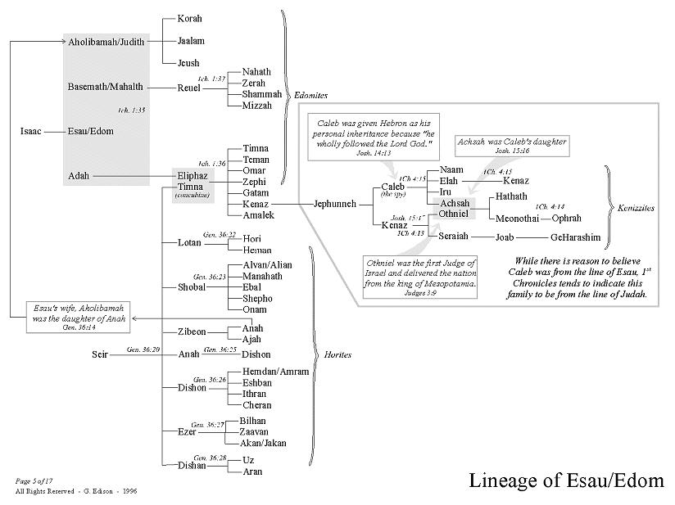

Martin Luther, Luther’s Works, Vol. 6: Lectures on Genesis: Chapters 31-37, ed. Jaroslav Jan Pelikan, Hilton C. Oswald, and Helmut T. Lehmann, vol. 6 (Saint Louis: Concordia Publishing House, 1999), 282.
Martin Luther, Luther’s Works, Vol. 6: Lectures on Genesis: Chapters 31-37, ed. Jaroslav Jan Pelikan, Hilton C. Oswald, and Helmut T. Lehmann, vol. 6 (Saint Louis: Concordia Publishing House, 1999), 284.
Martin Luther, Luther’s Works, Vol. 6: Lectures on Genesis: Chapters 31-37, ed. Jaroslav Jan Pelikan, Hilton C. Oswald, and Helmut T. Lehmann, vol. 6 (Saint Louis: Concordia Publishing House, 1999), 284.
Martin Luther, Luther’s Works, Vol. 6: Lectures on Genesis: Chapters 31-37, ed. Jaroslav Jan Pelikan, Hilton C. Oswald, and Helmut T. Lehmann, vol. 6 (Saint Louis: Concordia Publishing House, 1999), 307.
Martin Luther, Luther’s Works, Vol. 6: Lectures on Genesis: Chapters 31-37, ed. Jaroslav Jan Pelikan, Hilton C. Oswald, and Helmut T. Lehmann, vol. 6 (Saint Louis: Concordia Publishing House, 1999), 308.
Martin Luther, Luther’s Works, Vol. 6: Lectures on Genesis: Chapters 31-37, ed. Jaroslav Jan Pelikan, Hilton C. Oswald, and Helmut T. Lehmann, vol. 6 (Saint Louis: Concordia Publishing House, 1999), 316.
Martin Luther, Luther’s Works, Vol. 6: Lectures on Genesis: Chapters 31-37, ed. Jaroslav Jan Pelikan, Hilton C. Oswald, and Helmut T. Lehmann, vol. 6 (Saint Louis: Concordia Publishing House, 1999), 320.
Martin Luther, Luther’s Works, Vol. 6: Lectures on Genesis: Chapters 31-37, ed. Jaroslav Jan Pelikan, Hilton C. Oswald, and Helmut T. Lehmann, vol. 6 (Saint Louis: Concordia Publishing House, 1999), 322.
Martin Luther, Luther’s Works, Vol. 6: Lectures on Genesis: Chapters 31-37, ed. Jaroslav Jan Pelikan, Hilton C. Oswald, and Helmut T. Lehmann, vol. 6 (Saint Louis: Concordia Publishing House, 1999), 323.
Martin Luther, Luther’s Works, Vol. 6: Lectures on Genesis: Chapters 31-37, ed. Jaroslav Jan Pelikan, Hilton C. Oswald, and Helmut T. Lehmann, vol. 6 (Saint Louis: Concordia Publishing House, 1999), 329.
Martin Luther, Luther’s Works, Vol. 6: Lectures on Genesis: Chapters 31-37, ed. Jaroslav Jan Pelikan, Hilton C. Oswald, and Helmut T. Lehmann, vol. 6 (Saint Louis: Concordia Publishing House, 1999), 333.

